PROJECT REPORT ON

WIKIPEDIA ARTICLE READER

**BY: SIDDHANT TYAGI -191349**

**INTRODUCTION:**

Wikipedia Article Generator is GUI that fetches a random article on Wikipedia, made using a GUI library ,TKINTER. If the user is interested to view the article, he may click on the button that displays the topic of the article, it will redirect him to that Wikipedia page, else if he/she wants to look for some other page, the button “LOOK FOR SOME OTHER PAGE” will display another random topic of an article in a new similar window, else the user may click on the button “QUIT” to exit the window.

**AlGORITHM:**

STEP 1: Creating a list that contains the link address of some Wikipedia articles.

You can even import the Wikipedia module instead of creating a list of URL’S like above. It is a python library that makes it easy to import and parse data from Wikipedia. For doing so, write **import wikipedia** in the code editor.

STEP 2: importing modules :Tkinter,random and web browser.

STEP 3: Creating an instance of Tk , creates the master window.

STEP 4: define a function, openNewwindow(), set the geometry of the window, give it a title , style it the way you want.

STEP 5: create the function open web(). It will open the wikipedia page when the **Btn**; button is clicked.

STEP 6: creating a **LABEL:** This widget implements a display box where you can place text or images. The text displayed by this widget can be updated any time you want.

STEP 7: calling a **mainloop**():  it is an infinite loop **used** to run the **application**, wait for an event to occur and process the event as long as the window is not closed.

**CODE:**

ur = []

for i in range(0, 7):

ur.append("0")

ur[0] = "https://en.wikipedia.org/wiki/Sachin_Tendulkar"

ur[1] = "https://species.wikimedia.org/wiki/Heliconia_angusta"

ur[2] = "https://en.wikipedia.org/wiki/India"

ur[3] = "https://species.wikimedia.org/wiki/Agama_sinaita"

ur[4] = "https://species.wikimedia.org/wiki/Phyllidia_varicosa"

ur[5]= "https://species.wikimedia.org/wiki/Aepyceros_melampus"

ur[6] = "https://en.wikipedia.org/wiki/Ancient_Aliens"

from tkinter import *

import random

import webbrowser

master = Tk()

master.geometry("400x400")

master.title("WIKIPEDIA WEBPAGE GENERATOR")

def openNewWindow():

newWindow = Toplevel(master)

newWindow.title("WIKIPEDIA WEBPAGE GENERATOR")

newWindow.geometry("400x400")

num = random.randint(0, 6)

print(num)

url = str(ur[num])

newWindow.config(bg="black")

def openweb():

webbrowser.open(url)

Btn = Button(newWindow, text= str(url[35:]) + " page", command=openweb)

Btn.pack(padx=10,pady=19)

btn2 = Button(newWindow, text="LOOK FOR ANOTHER ARTICLE", command=openNewWindow)

btn2.pack(padx=10,pady=19)

Btn3 = Button(newWindow, text="QUIT", command=newWindow.destroy)

Btn3.pack(padx=10,pady=19)

label = Label(master, text="Wikipedia Webpage Generator")

label.pack(pady=20,padx=20)

btn = Button(master, text="START", command=openNewWindow)

btn.pack(pady=10)

master.config(bg="black")

mainloop()

**DESIGN:**

1.To start with it, import 3 modules:

1)**random**: random variable generator.

2)**tkinter**: This module provides classes to allow using Tk themed widget set.

3) **web browser**: Interfaces for launching and remotely controlling Web browsers.

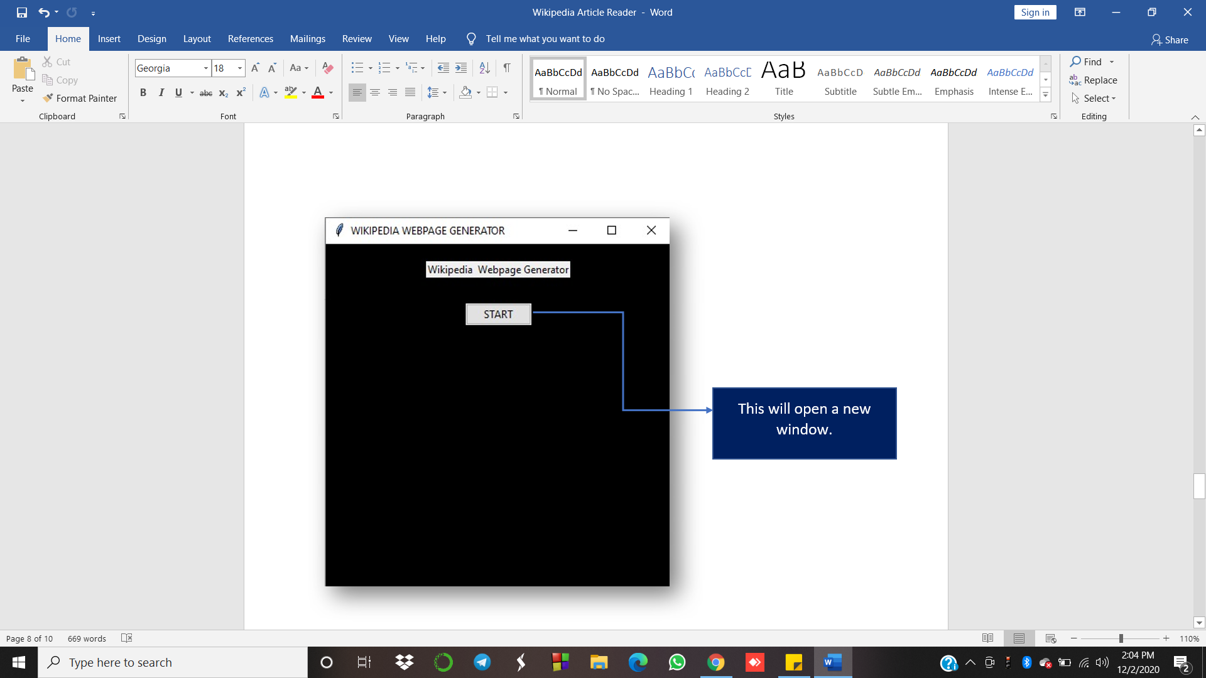

2.The main window as shown above has a start button made using a widget Button(in tkinter library) that opens up a new window when clicked.

3.If the user wants to look for some other article, he/she may click on the button, “Look for some other article”.

4.Clicking on this button, a new similar window will be opened up as shown below.This is because of the opennewWindow() function.

**Num will be printed every time a new window is opened. The same indexed URL from the list would be stored in url and opened up. So, we can get to know which page has been displayed.**

5.The openweb() function is made to open the wikipedia page of a certain article when the button having the title of an article is clicked.

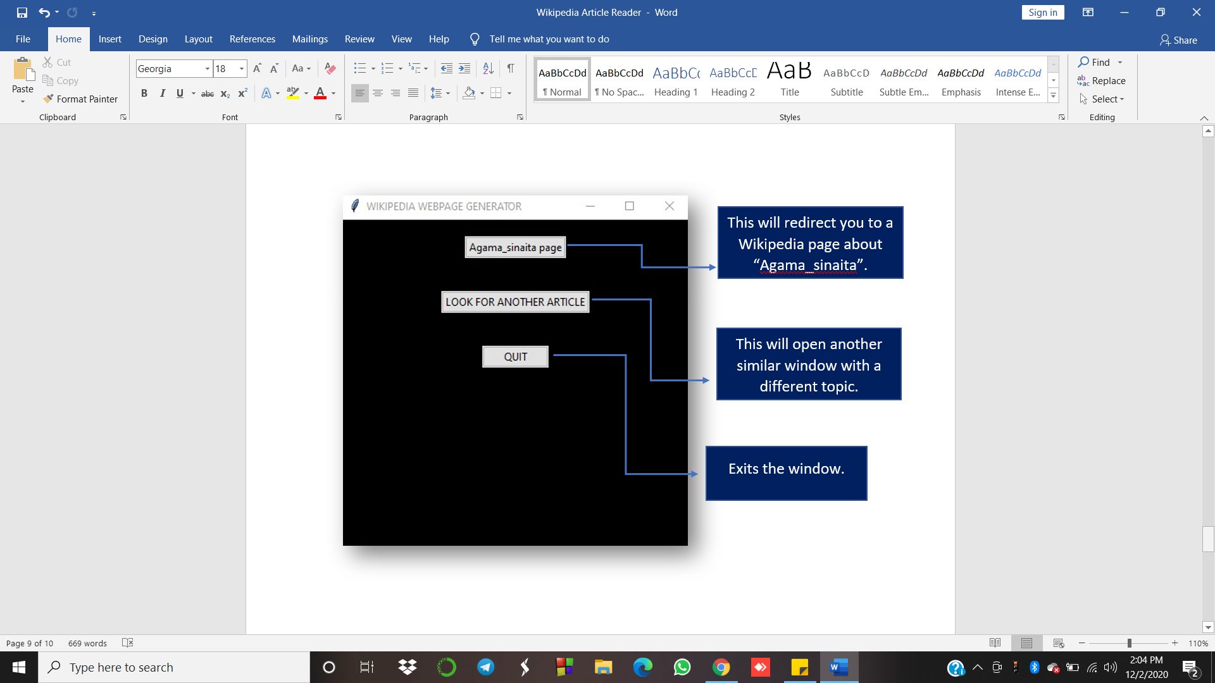

5.If the user wants to exit the window,click on the button “QUIT”.This ends the mainloop.

**Output:**

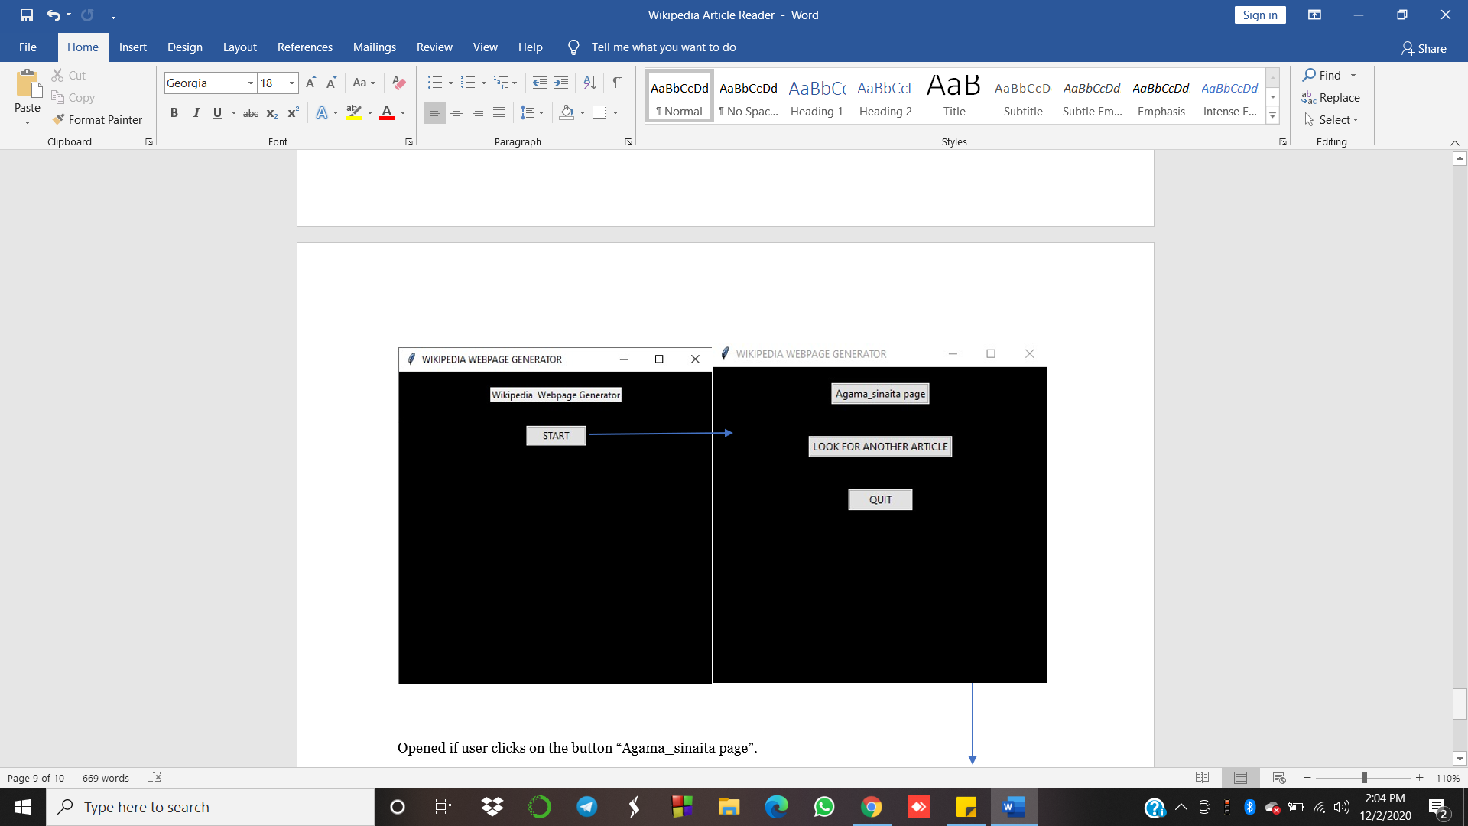

Opened if user clicks on the button “Agama_sinaita page”.

