**SENSOR LAB MINI PROJECT REPORT**

on

**“SMART STICK FOR BLIND PEOPLE”**

Submitted in partial fulfillment of the requirements of the degree

**BACHELORS OF INFORMATION TECHNOLOGY**

**BY**

Siddhant vishwakarma 63

Dipesh Yadav 65

Milan Rajani 48

Dharshan Sojitra 58

### UNDER THE GUIDANCE OF

Mr. Sandeep Dubey



### DEPARTMENT OF INFORMATION TECHNOLOGY UNIVERSAL COLLEGE OF ENGINEERING, KAMAN.

**UNDER UNIVERSITY OF MUMBAI**

**2022-23**

i

**CERTIFICATE**

This is to certify that the T.E. a sensor lab mini-project entitled “**SMART STICK FOR BLIND PEOPLE** " is a Bonafede work of “Siddhant Vishwakarma” (63) , “Milan Rajani” (48), “Dipesh Yadav"(65) and “Dharshan Sojitra” (58) submitted to University of Mumbai in partial fulfillment of the requirement for the award of the degree of “Information Technology Engineering” during the academic year 2022-2023.

Mr. Sandeep Dubey

[PROJECT GUIDE]

Dr. Yogita Mane Dr. J.B. Patil

Head of Department Principal

ii

**APPROVAL**

T.E. Mini-Project Report Approval This mini-project synopsis entitled Automatic Street Light by Siddhant Vishwakarma, Milan Rajani, Deepesh Yadav and Dharshan sojitrao is approved for the degree of Information Technology Engineering from University of Mumbai.

***Examiners***

1.----------------------------

2.----------------------------

Date: _ _ _ _ _ _ _ _ _ _ _

Time: _ _ _ _ _ _ _ _ _ _

iii

**Acknowledgement**

This is great pleasure and immense satisfaction to express our deepest sense of gratitude and thanks to everyone who has helped us in completing our work successfully. We are presenting this Project report on **“SMART STICK FOR BLIND PEOPLE”** as part of the curriculum of T.E. Information Technology. Inspiration and guidance are invaluable in every aspect of life especially in the field of academics, which we have received from our respected **Project Guide: Sandeep Dubey** and **Head of Information Technology:** Dr. Yogita D. Mane. Besides, we take this opportunity to express our sincere gratitude to the **Principal:** Dr. J. B. Patil, UCoE for providing a good environment and facilities to complete this project. We would also like to thank all our staff and friends who have directly or indirectly guided and helped us in the preparation of this report and also for giving us an unending support right from the stage this idea was conceived.

Siddhant Vishwakarma

Milan Rajani

Dipesh Yadav

Dharshan sojitarao

iv

**Abstract**

A smart cane for the blind is a device designed to help people who are blind or partially sighted navigate their surroundings more easily and safely. The cane is equipped with ultrasonic sensors that detect obstacles and other hazards in the user's path, as well as buzzers, LEDs and vibrators that provide tactile and audible feedback to alert users of potential hazards. Additionally, the device includes a vibration feature that can be used to communicate with deaf-blind people.

The Smart Stick is constructed from an Arduino microcontroller and various electronic components including ultrasonic sensors, buzzers, LEDs and vibrators. The device is designed to be lightweight and portable so that users can easily take it with them as they move around their environment.

Smart canes have the potential to dramatically improve the quality of life for blind and deaf people. By providing real-time information about obstacles and hazards in the user's path, the device can help prevent accidents and increase user confidence and independence. With further developments and improvements, the smart cane could become an essential tool for the visually and hearing impaired.

V

**CONTENTS**

**Title Page ……………………………………………………………………….. i**

**Certificate ………………………………………………………………………. ii**

**Acknowledgements …………………………………………………………….. iv**

**Abstract …………………………………………………………………………** **v**

**List of Figures ………………………………………………………………….. vi****i**

**List of Abbreviations and Symbols ………………………………………...…. viii**

1. **Introduction …………………………………………………………….**

1.1 Smart stick for blind people……………………………………… 1

1. **Aims and Objective …………………………………………………….**

2.1 Objective ……….…………………………………………… **2**

2.2 Aim ……………………………………………………………. **2**

1. **Literature Survey… …………………………………………………….**

3.1 Literature survey ……………………………………………… **3**

1. **Existing system ………………………………………………………… 4**
2. **Problem Statement …………………………………………………… 5**
3. **Scope …………………………………………………………………… 6**
4. **Proposed System….. ……………………………………………………**  7.1 System Architecture………………………………………….….. 7
5. **Methodology………………………………………………………….....**

8.1 List of component …………………………………………………. . 8

8.1 Circuit diagram …………………………………………………. . 10

1. **Design Details …… ……………………………………………………** 
   1. Coding …….. ……………………..…………………………..… 11
   2. Screenshots ……………………..……………………………. 13
   3. Flowchart ………………………..……………………………. 15
2. **Details of Hardware and Software …………………………………… 16**
3. **Advantages …………………………………………………………… 17**
4. **Conclusion ………..……………………………………………………. 18**

**References …………….………………………………………………………….. 19**

vi

**LIST OF FIGURES**

|  |  |  |
| --- | --- | --- |
| **Fig no.** | **Figures** | **Page No.** |
| 7.1 | Block diagram | 7 |
| 7.2 | Model image | 7 |
| 8.1.1 | Ultrasonic sensor | 8 |
| 8.1.2 | Arduino UNO | 8 |
| 8.1.3 | Arduino Buzzer | 8 |
| 8.1.4 | LED | 9 |
| 8.1.5 | 9V Battery | 9 |
| 8.1.6 | Vibrator | 9 |
| 8.1.7 | Switch | 10 |
| 8.2.1 | Circuit Diagram | 10 |
| 8.3.1 | Image of device | 11 |
| 8.3.2 | Switch Image | 12 |
| 8.3.3 | Device sensor | 12 |
| 8.3.4 | Device buzzer | 13 |
| 8.3.5 | Device LED | 13 |
| 8.3.6 | Device slide button | 14 |
| 8.3.7 | Device vibrato | 14 |
| 9.4.1 | Flowchart | 15 |

vii

##### LIST OF ABBREVIATIONS

|  |  |  |
| --- | --- | --- |
| **Sr. No** | **Short form** | **Abbreviation** |
| 1 | UNO | Universal Networking Object |
| 2 | LED | Light Emitting Diode |
| 3 | USB | universal serial bus |
|  |  |  |

viii

## INTRODUCTION

### 1.1 Smart stick for blind people

### Visual impairment is a common disability that affects millions of people around the world, preventing them from navigating their surroundings with confidence and independence. Although there are various assistive technologies available to help with mobility, they can be expensive, cumbersome and not always practical for everyday use. To solve this problem, we have developed a smart cane for the blind, a lightweight and inexpensive portable device that helps blind people navigate their surroundings safely and efficiently.

### The Smart Cane features ultrasonic sensors that detect obstacles and hazards in the user's path, as well as buzzers, LEDs and vibrators that provide tactile and audible feedback to alert the user of hazards potentials. The device is also designed with a vibration feature which can be used to communicate with deaf and blind people. A smart cane is built using an Arduino microcontroller and various electronic components

### This project aims to provide an affordable and easy-to-use solution to the mobility problems of the visually impaired. The project is a simple, user-friendly design, and the smart cane has the potential to dramatically improve the quality of life for those who use it.

### Aim & Objectives

* 1. **Objective:**

The objective of the smart stick for blind people project is to develop a low-cost, lightweight, and portable device that helps individuals with visual impairments to navigate their surroundings safely and efficiently

* 1. **AIM:**
* Develop a device that can detect obstacles in the user's path using an ultrasonic sensor.
* Provide haptic and auditory feedback to alert the user to potential danger, including a buzzer, LED, and vibrator.
* Incorporate a vibration feature that can be used to communicate with individuals who are both deaf and blind.
* Design the device using an Arduino microcontroller and various electronic components that are affordable, easy to obtain, and easy to modify.
* Test and evaluate the device to determine its accuracy and effectiveness in improving the quality of life for individuals with visual impairments

1. **LITERATURE REVIEW**

### 3.1 Literature Survey

***Table no. 3.1 literature survey***

|  |  |  |  |  |
| --- | --- | --- | --- | --- |
| **Sr. No:** | **Author** | **Project title** | **Publication** | **Difference** |
| 1. | Siddhant Vishwakarma.  Milan Rajani.  Dipesh Yadav,  Dharshan sojitrao | Smart stick for blind people | 2023 | The system consists of an ultrasonic sensor fixed to the user's stick. While the user moves the stick in the forward direction, the ultrasonic sensor with Arduino UNO fixed to the stick tries to detect the obstacle if any present in the path. |
| 2. | A. Satam,  Ihab & Al-Hamadani, Mokhaled & Ahmed, Alaa. | Design and Implement A Smart Blind Stick | 2019 | The One sensor has been placed in front of the stick and the other  two have been placed on both sides, left and right. To detect the motion from almost every side, it has been used  vibrating motor and buzzer alarms to alert the person if some obstacle is detected near him. |
| 3. | Tirupal, Talari & Murali, B & Sandeep, M & Kumar, K & Kumar, C & Head. | Smart Blind Stick Using Ultrasonic Sensor | 2021 | This stick recognizes the article before the individual and offers a reaction to the client either by vibrating or through the order. |

1. **Existing system**
2. "The SmartCane" by the Indian Institute of Technology Delhi: The SmartCane is a handheld device that uses ultrasonic sensors to detect obstacles in the user's path. The device provides haptic feedback to the user through a vibrating handle to alert them to obstacles ahead. The SmartCane also includes a GPS system that can provide directions to the user.
3. "The WeWALK" by the WeWALK Company: The WeWALK is a smart cane that connects to a user's smartphone through Bluetooth. It uses ultrasonic sensors to detect obstacles and provides haptic feedback through a vibrating handle. The WeWALK also includes a voice assistant and can be controlled through voice commands.
4. "The Sunu Band" by Sunu Inc.: The Sunu Band is a smartwatch-like device that uses echolocation technology to detect obstacles in the user's path. The device provides haptic feedback through vibrations on the wrist to alert the user to obstacles. The Sunu Band also includes a compass, step counter, and mobile app integration.
5. **Problem Statement**

The problem is that people who are blind have difficulty navigating their environment and avoiding obstacles, which can lead to physical injury and reduced mobility. Although traditional white sticks are useful, they have limitations in detecting certain obstacles, such as low tree branches or overhead obstacles. There is a need for a smart cane that can improve mobility and safety for the visually impaired by providing accurate obstacle detection and real-time directional guidance, while being portable and affordable.

1. **Scope**

The primary objective of the project would be to design and develop a smart stick that can improve the mobility and safety of visually impaired individuals.

The smart stick would include features such as obstacle detection, real-time guidance, and portability. It may also include additional features such as voice alert, and vibration alerts.

The project would involve researching and selecting appropriate technologies for the smart stick, such as sensors, microcontrollers, and Sensor modules. The smart stick would need to be thoroughly tested and validated to ensure that it meets the project objectives and performs as intended. The system consists of an ultrasonic sensor fixed to the user's stick. While the user moves the stick in the forward direction, the ultrasonic sensor with Arduino UNO fixed to the stick tries to detect the obstacle if any present in the path

1. **Proposed System**

Arduino UNO

LED

Buzzer

Ultrasonic Sensor

Power Supply

***Fig no. 7.1 Block Diagram***

The electronic system has been controlled using Arduino UNO. When the switch on the top of the stick; the Ultrasonic is immediately sending the signal from the transmitter. However, when the signal impacts the level surface it reflects back to the sensor`s receiver. Therefore, the Arduino will send a pulse to the actuators (in this case, the vibrating motor and the buzzer) to work as the uploaded code. Fig no 7.1 shows the working principles of the system

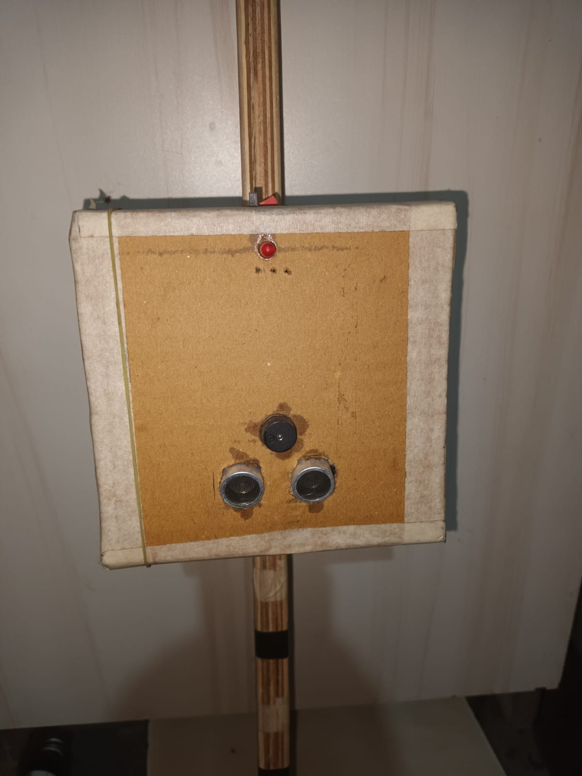

***Fig no. 7.2 model image***

1. **Methodology**

**8.1 List of components**

1. Ultrasonic sensor

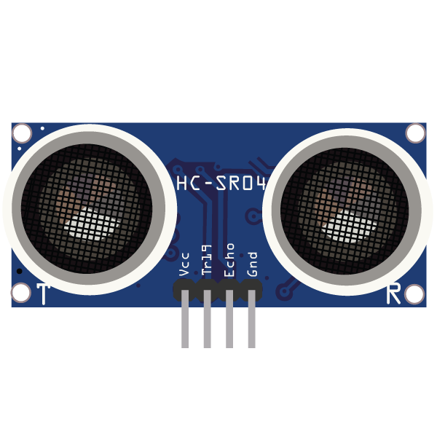

***Fig no 8.1.1 ultrasonic sensor***

An ultrasonic sensor is a type of sensor that uses high frequency sound waves to detect the distance to an object. In the context of a smart stick for blind people, an ultrasonic sensor can be used to detect obstacles and provide haptic or audio feedback to the user to help them navigate their environment safely

1. Arduino UNO

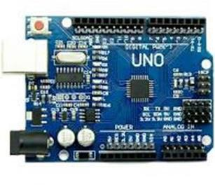

***Fig no 8.1.2 Arduino UNO***

Arduino Uno is an open-source microcontroller board that can be programmed to control various electronic devices and systems. In the context of a smart stick for blind people, Arduino Uno can be used as the main processing unit to control the sensors and actuators of the device.

1. Buzzer

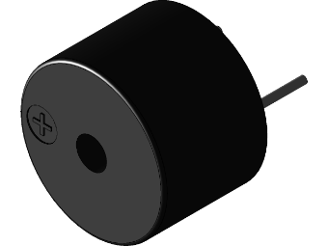

***Fig no 8.1.3 Buzzer***

A buzzer is an electronic device that generates sound. In the context of a smart stick for blind people, a buzzer can be used as an audio feedback mechanism to indicate the presence of an obstacle or other important information to the user.

1. Vibration motor

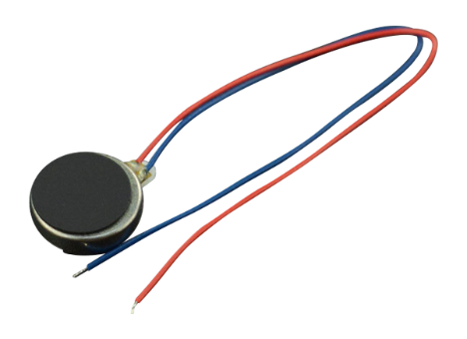

***Fig no 8.1.4 vibrator***

A vibrator, also known as a haptic motor or vibration motor, is an electronic device that produces vibration when an electrical signal is applied to it. In the context of a smart stick for blind people, a vibrator can be used as a haptic feedback mechanism to alert the user of an obstacle or other important information

1. LED

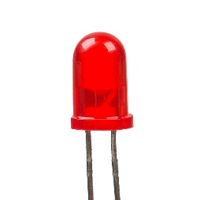

***Fig no 8.1.5 LED***

An LED (Light Emitting Diode) is a semiconductor device that emits light when an electric current is passed through it. In the context of a smart stick for blind people, LEDs can be used as visual feedback mechanisms to indicate the presence of an obstacle or other important information to the user.

1. Battery

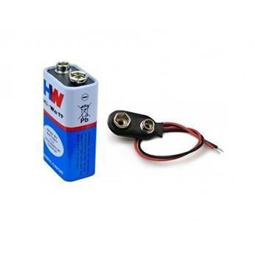

***Fig no 8.1.6 Battery***

A battery is an electrochemical device that stores electrical energy and can convert that energy into a useful form of power to operate electronic devices. In the context of a smart stick for blind people, a battery can be used as a power source to operate the various electronic components of the device.

1. Switch

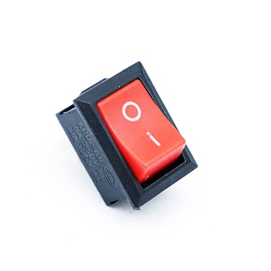

***Fig no 8.1.7 Switch***

A switch is an electronic component that controll the flow of electricity. In the context of a smart stick for blind people, a switch can be used as a user interface to control various functions of the device

1. Other components
2. Jumper wire, 2. Resistor, 3. USB cable, 4. Slide switch

**8.2 Circuit diagram**

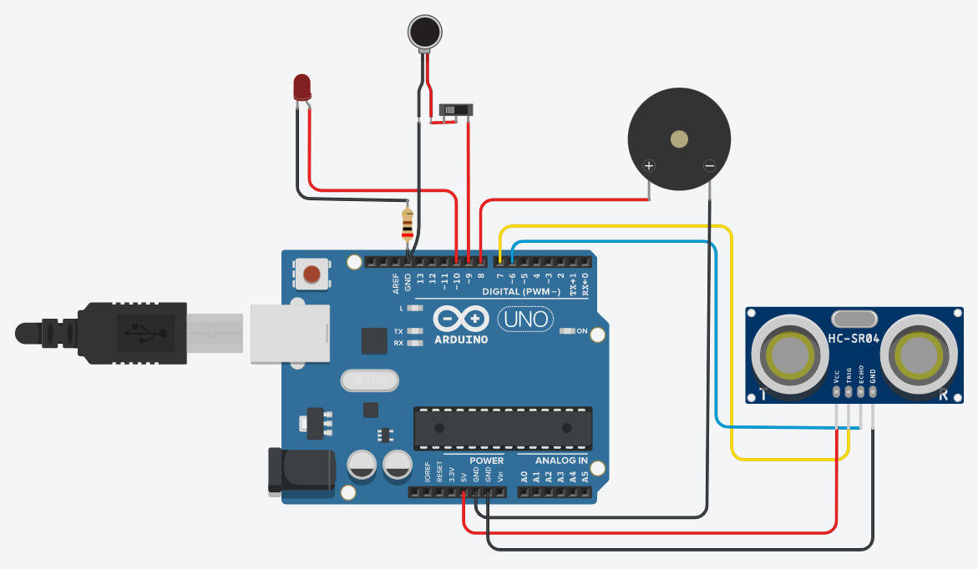

***Fig no. 8.2.1 Circuit Diagram***

The above circuit diagram shows the connection of different component to the Arduino, the main component is ultrasonic sensor, there are 4 main pin in ultrasonic sensor 1. Vcc, 2.GND, 3. Trig and 4. Echo. The Vcc pin of sensor is connected to Vcc of Arduino and GND is connected to GND of Arduino. The second main component is buzzer it have two terminal +ve and -ve pin, the positive pin of buzzer is connected to pin no 8 in Arduino and -ve pin is connected to GND of Arduino. The next component is LED the positive pin is connected to pin no 10 of Arduino and -ve pin is connect to GND. The next component is vibrator, it have 2 pin, the +ve pin is connected to pin no 9 of Arduino via a slide switch to ON/OFF the vibrator when required

**8.3 Working**

The complete model looks like this:

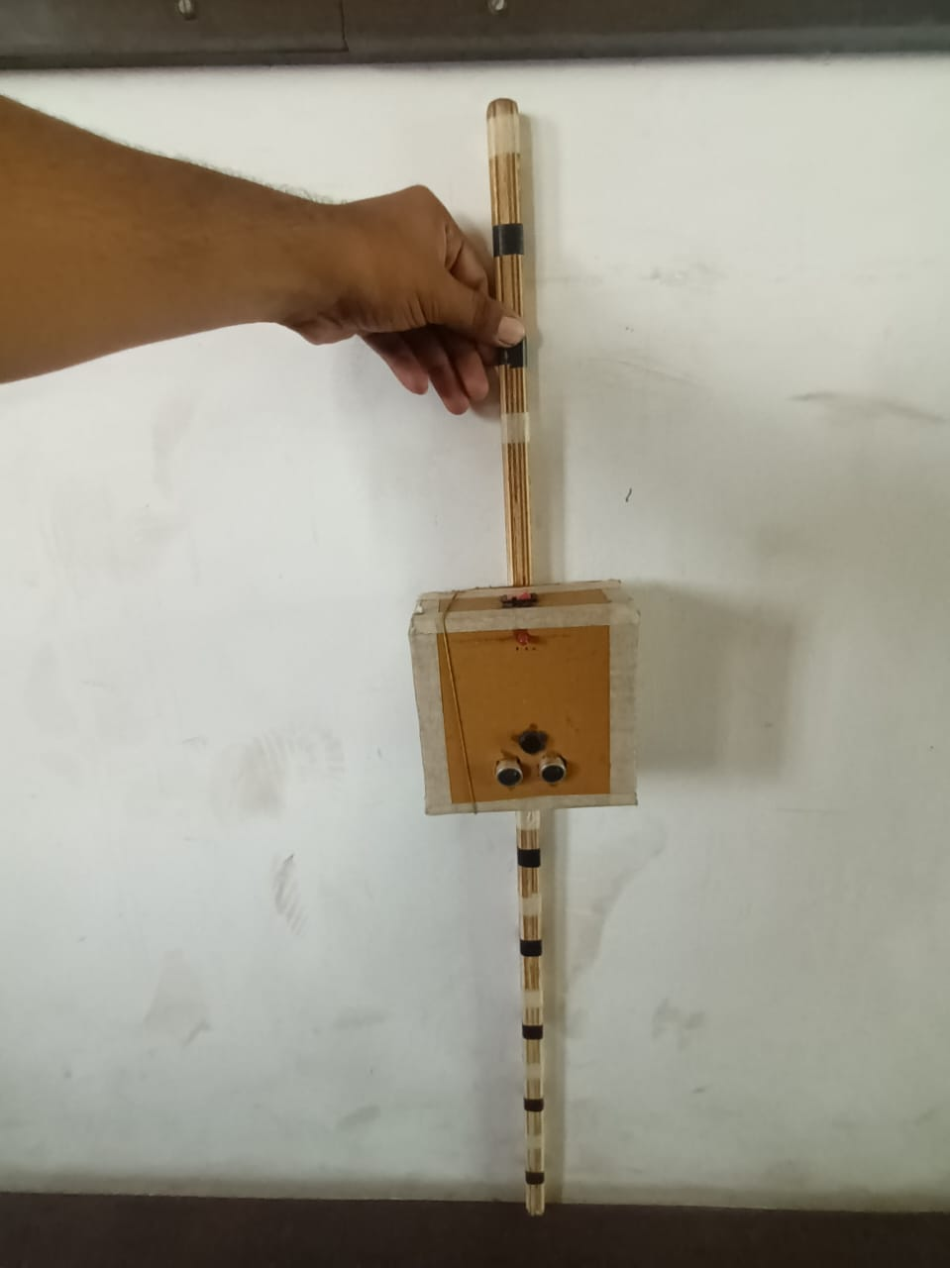

***Fig no. 8.3.1 device model image***

The device consists of 4 main component Arduino uno, Ultrasonic sensor, Buzzer, Vibrator. The working of this device is very simple, the device is on from the below red switch

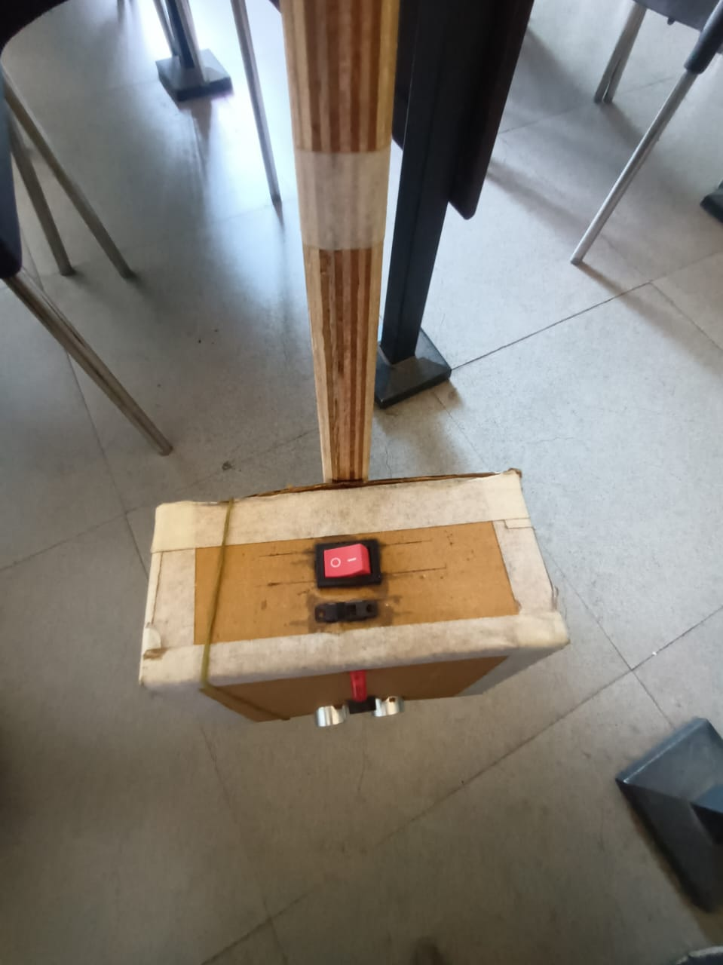

***Fig no. 8.3.2 device power Switch***

Once the power supply ON the ultrasonic sensor’s trigger pin get HIGH, Ultrasonic sensor transmits the sound wave for 10ms and this sound wave may get reflected by any object in front of device then echo pin get HIGH and receive the transmitted sound and detect if there is any object in from of it. Below figure shows the position of ultrasonic sensor

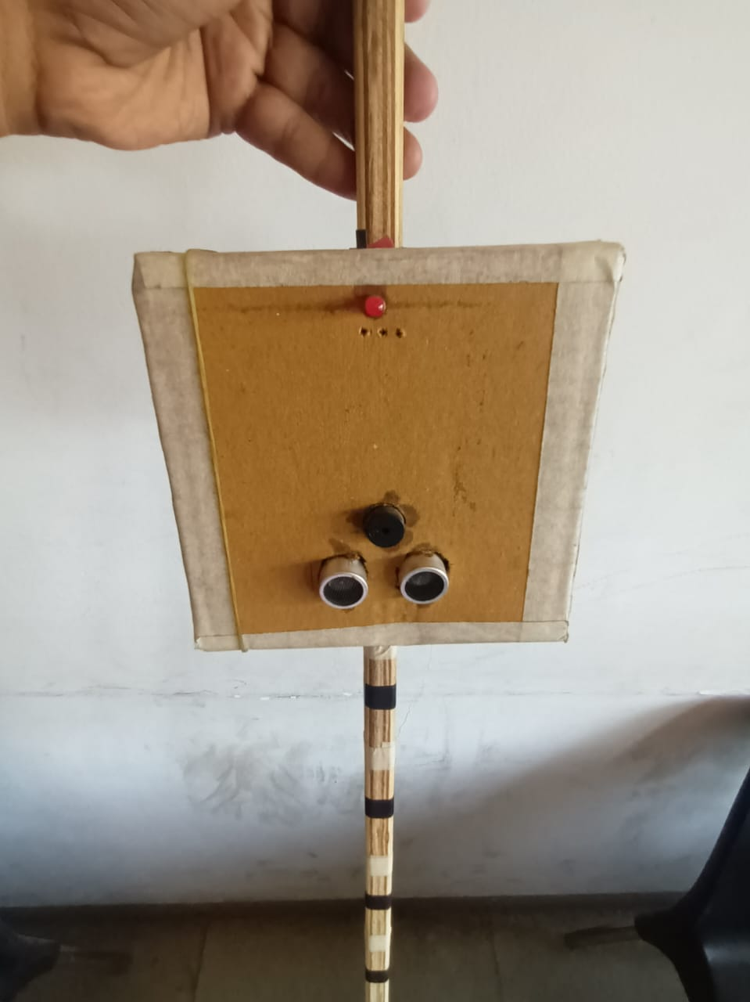

***Fig no. 8.3.3 device sensor image***

After receiving the ultrasonic wave the Arduino calculate the distance with formula Centimeters = ((Microseconds / 2) / 29), where microsecond is time in which receiver in ultrasonic sensor receives the transmitted wave. Now based on distance that Arduino is calculated, it checks the three conditions, first condition1 is distance of obstacle from stick is <=45cm.the buzzer gets HIGH for 100ms and then gets LOW. This buzzer speed is continued until the object us at a distance of 45 cm from stick. Similarly, there are 2 more condition 1. Distance <= 60, 2. Distance <=75



***Fig no. 8.3.4 device buzzer image***

same as above for buzzer there is a led and a vibrator. LED is just to know that for other people, that this sound is coming from this person stick



***Fig no. 8.3.5 device LED image***

In this device we used vibrator for blind people who is deaf means the persons can sense the vibration type to observe any obstacles as like non deaf blind people use buzzer to observe the obstacle. The person can ON/OFF the vibrator with a slide key



***Fig no. 8.3.6 Device Slide Switch***

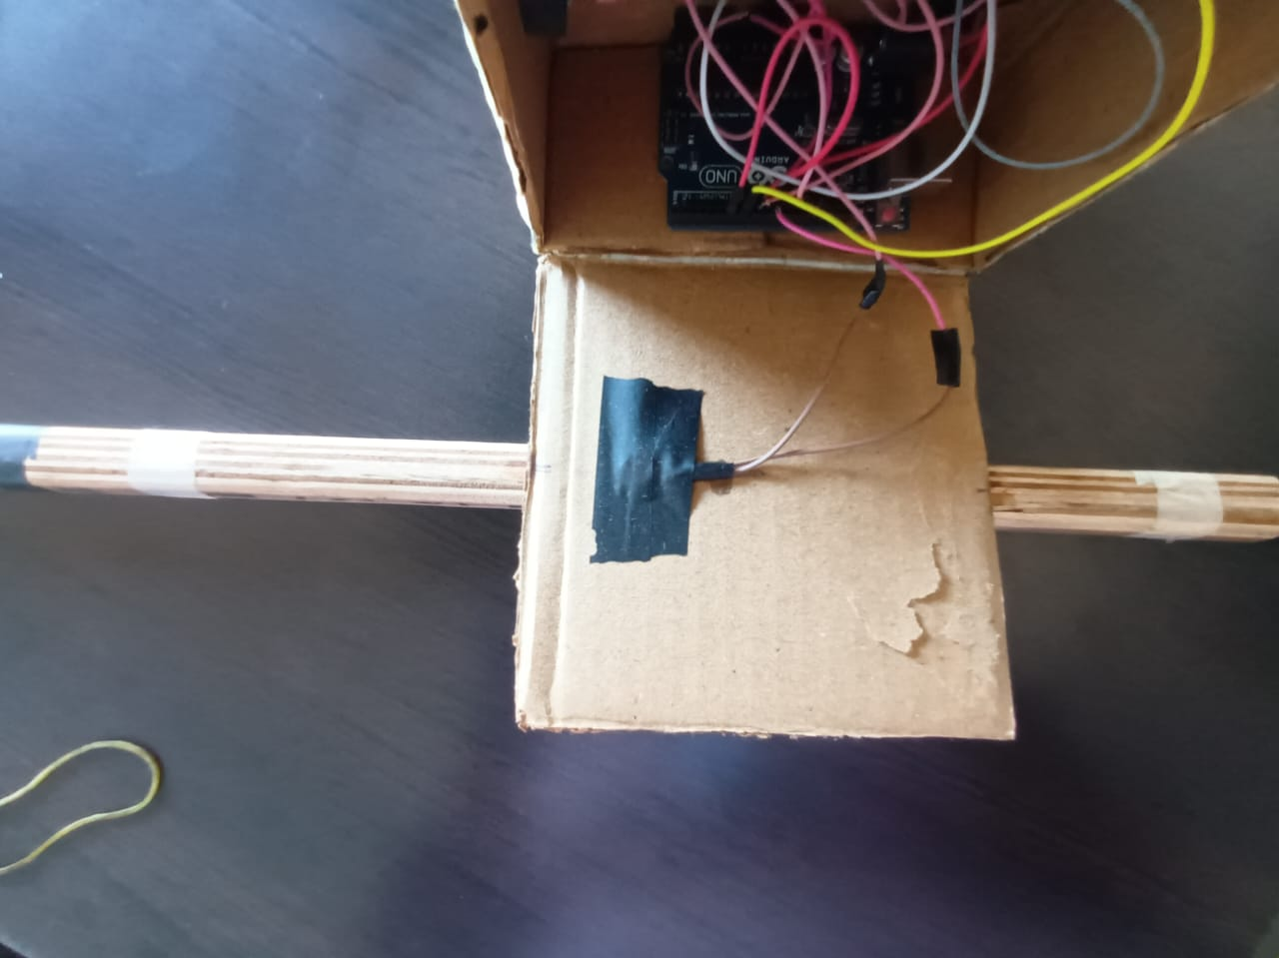

***Fig no. 8.3.7 device LED image***

### Design detail

### 9.1 Arduino program

int echopin = 6;

int trigpin = 7;

const int buzzer = 8;

int vib = 9;

int led = 10;

int mesafe;

int sure;

void setup()

{

    Serial.begin(9600);

    pinMode(buzzer, OUTPUT);

    pinMode(led, OUTPUT);

    pinMode(vib, OUTPUT);

    pinMode(trigpin, OUTPUT);

    pinMode(echopin, INPUT);

}

void loop()

{

    digitalWrite(trigpin, LOW);

    delayMicroseconds(2);

    digitalWrite(trigpin, HIGH);

    delayMicroseconds(10);

    digitalWrite(trigpin, LOW);

    sure = pulseIn(echopin, HIGH);

    mesafe = (sure / 2) / 29.0;

    if (mesafe <= 45)

    {

        digitalWrite(buzzer, HIGH);

        digitalWrite(led, HIGH);

        digitalWrite(vib, HIGH);

        delay(100);

        digitalWrite(vib, LOW);

        digitalWrite(led, LOW);

        digitalWrite(buzzer, LOW);

        delay(50);

    }

    else if (mesafe <= 60)

    {

        digitalWrite(buzzer, HIGH);

        digitalWrite(led, HIGH);

        digitalWrite(vib, HIGH);

        delay(250);

        digitalWrite(vib, LOW);

        digitalWrite(led, LOW);

        digitalWrite(buzzer, LOW);

        delay(125);

    }

    else if (mesafe <= 75)

    {

        digitalWrite(buzzer, HIGH);

        digitalWrite(led, HIGH);

        digitalWrite(vib, HIGH);

        delay(500);

        digitalWrite(vib, LOW);

        digitalWrite(led, LOW);

        digitalWrite(buzzer, LOW);

        delay(250);

    }

    else

    {

        digitalWrite(buzzer, LOW);

        digitalWrite(led, LOW);

        digitalWrite(vib, LOW);

    }

    Serial.print("uzaklik = ");

    Serial.print(mesafe);

    Serial.println("cm");

    delay(500);

}

**9.2 Code snippets**

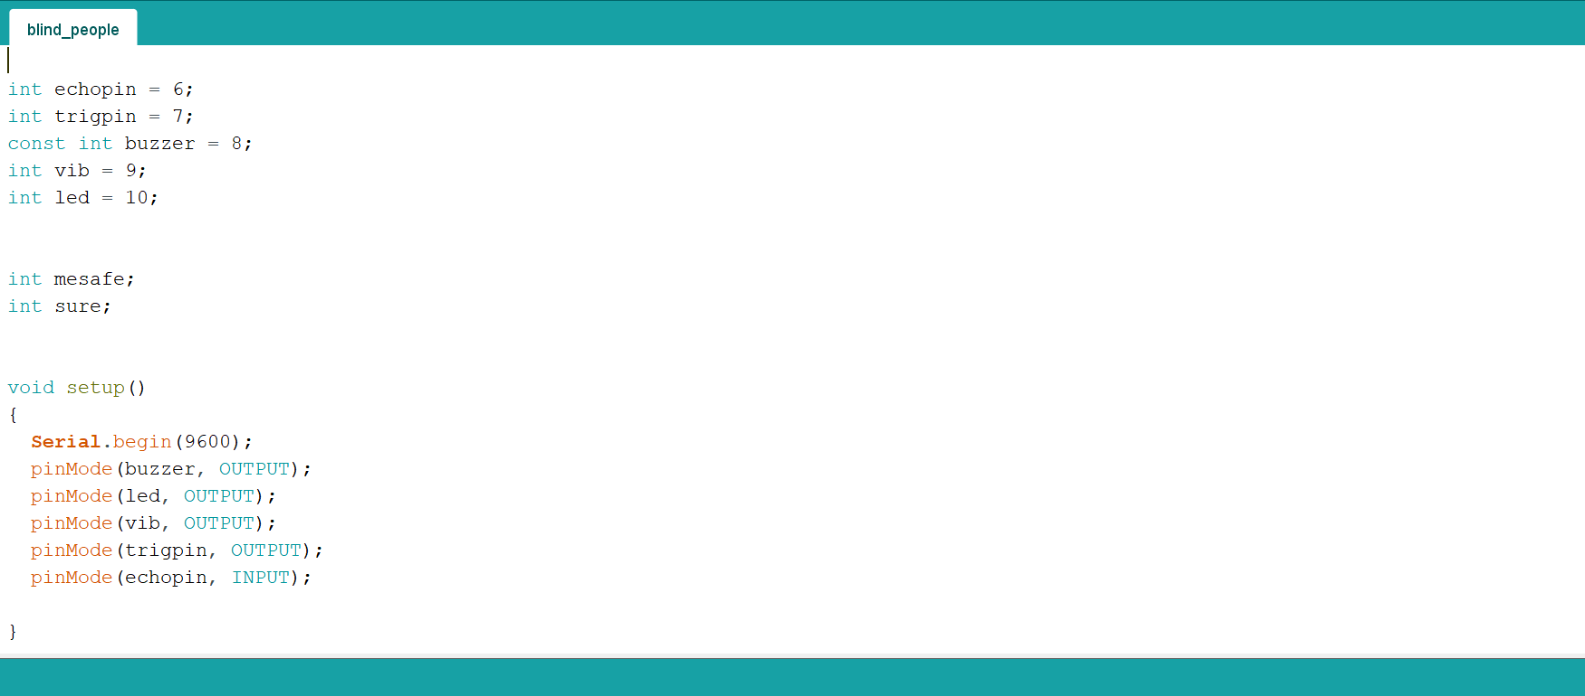

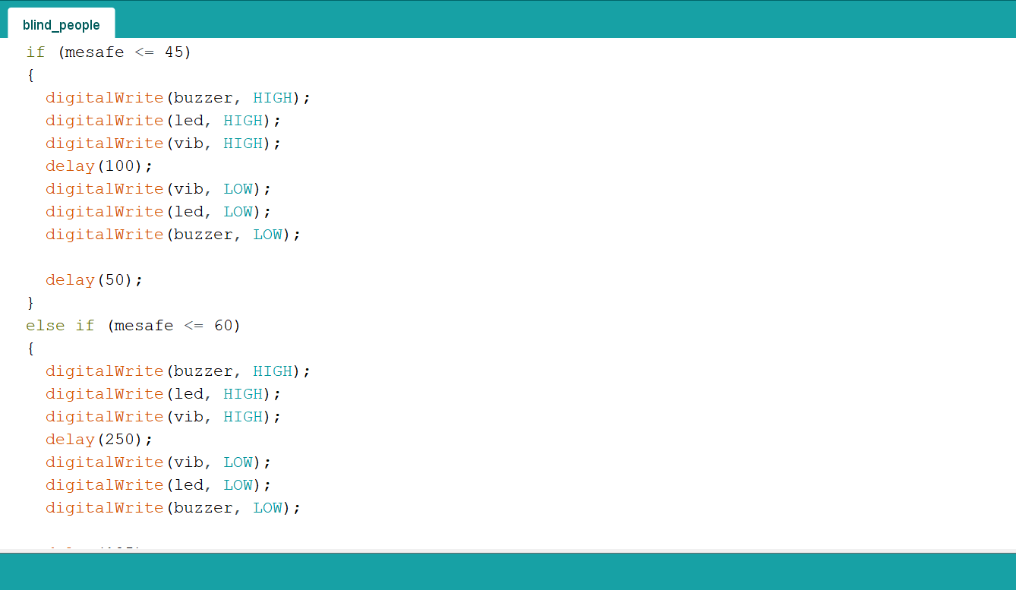

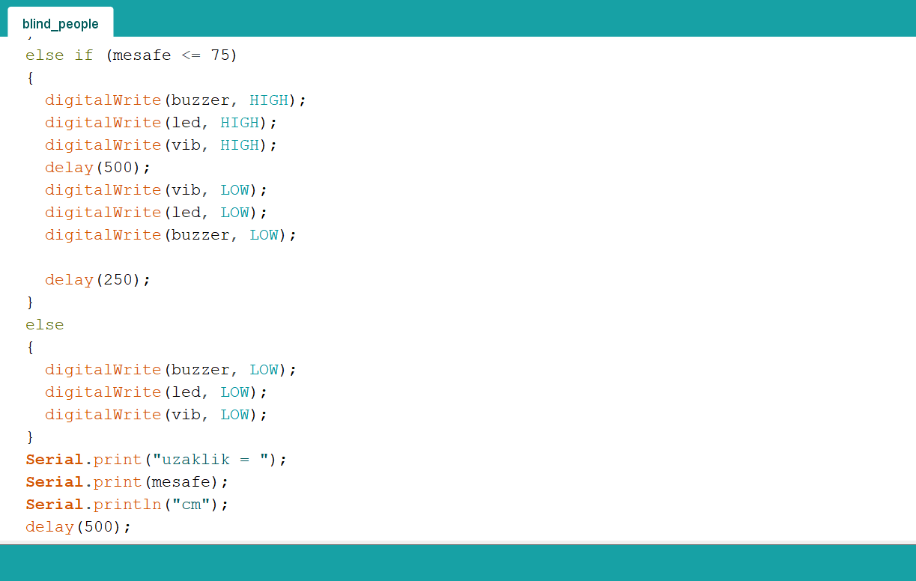

* 1. **Flowchart**

The below figure shows the flow of program, firstly the variables is get initialized. In the next step ultrasonic sensor send pulse to Arduino and it calculate the distance. Now after calculating the distance and based on if condition the whole device works

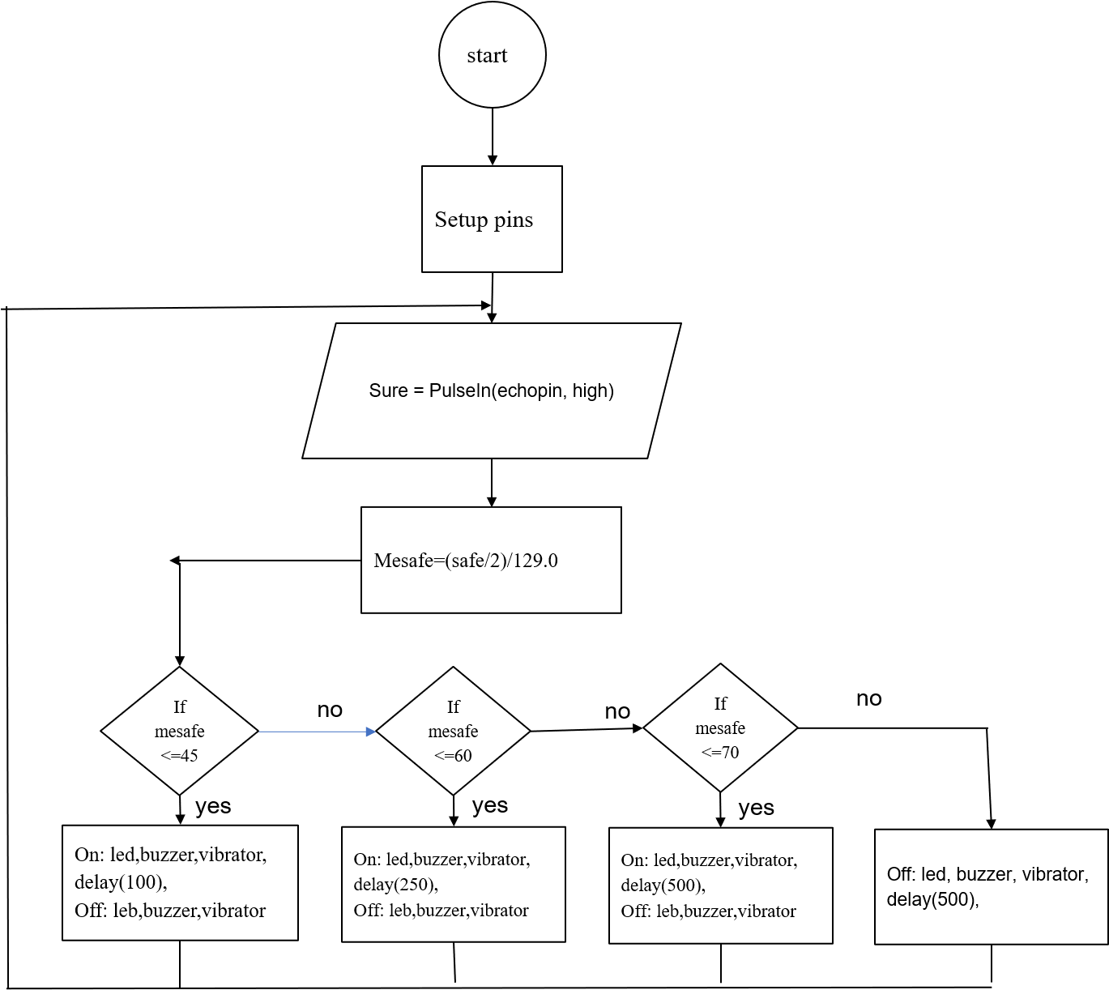

***Fig no. 9.4.1 Flowchart***

1. **Hardware and softwares**
2. Hardware:

System : Intel Core i3 2.00 GHz.

Disk : 1 TB.

Monitor : 14’ Color Monitor.

Mouse : Mouse.

Ram : 2 GB.

Keyboard : Keyboard.

1. Software:

Operating system : Windows 10.

Coding Language : C, CPP

Software’s used : Arduino IDE, Thinker cad.

## Advantages

There are several advantages of a smart stick for blind people, including:

* This smart stick can help blind people navigate their surroundings more independently, without the need for assistance from others.
* This smart stick equipped with sensors and feedback mechanisms can help blind people detect obstacles, navigate unfamiliar terrain, and avoid hazardous situations.
* This smart stick can be designed and built using relatively inexpensive off-the-shelf components, making it an affordable solution for blind people who may not have access to expensive assistive technologies.
* This smart stick can be designed with simple and intuitive user interfaces, such as switches or buttons, making it easy for blind users to operate and customize the device.

Overall, a smart stick for blind people has the potential to significantly improve the quality of life for blind individuals, providing them with greater independence, safety, and autonomy in their daily lives.

### Conclusions

This a smart stick for blind people is a highly beneficial and practical solution that can help blind individuals navigate their surroundings with greater independence and safety. The use of ultrasonic sensors, Arduino boards, vibrators, buzzers, LEDs, and other electronic components can provide blind users with haptic and audio feedback. Additionally, a smart stick can be designed and built using relatively inexpensive and easily accessible components, making it an affordable solution for individuals who may not have access to expensive assistive technologies. Ultimately, a smart stick for blind people has the potential to greatly enhance the quality of life for blind individuals, providing them with greater autonomy, independence, and safety in their daily lives.

### References

**Journals**

1. A. Satam, Ihab & Al-Hamadani, Mokhaled & Ahmed, Alaa. (2019). Design and Implement A Smart Blind Stick. Journal of Advanced Research in Dynamical and Control Systems. 11. 42-47.
2. Tirupal, Talari & Murali, B & Sandeep, M & Kumar, K & Kumar, C & Head,. (2021). Smart Blind Stick Using Ultrasonic Sensor. 7. 34-42.

**Online reference**

1. CIRCUIT DIGEST: <https://circuitdigest.com/microcontroller-projects/arduino-smart-blind-stick>
2. TECHATRONIC: <https://techatronic.com/smart-blind-stick-using-arduino-and-ultrasonic-sensor/>