;l

Foundations of Programming

Assignment No. : 4 NAME - SARANSH PARIHAR

DIV-11 PRN-1262253066
- PROBLEM STATEMENT: Write a C Program to calculate the salary of an employee given his basic pay (taken as input from the user). Calculate gross salary of employee. Let HRA be 10 % of basic pay and TA be 5% of basic pay. Let employees pay professional tax as 2% of total salary. Calculate net salary payable after deductions.

OBJECTIVE:

- To understand the importance of flowchart for any programming model.
- To learn simple flowchart symbols and arrows to define relationships.
- To understand and develop visual representations of flow of data.

THEORY:
- Define Algorithm.
- What are the different characteristics of an algorithm.
PLATFORM: Linux

INPUT:
OUTPUT:
CONCLUSION: Thus, we have learned to write algorithms and to draw its representation in terms of flowchart.

FAQs:
- Describe various symbols and their use in flowchart.
- Difference between Algorithm and Flowchart.

Code:
#include <stdio.h>

int main() {
float basic, hra, ta, gross, tax, net;

printf("Enter Basic Salary: ");
scanf("%f", &basic);

hra = 0.10 * basic;
ta = 0.05 * basic;
gross = basic + hra + ta;
tax = 0.02 * gross;
net = gross - tax;

printf("\nHRA = %.2f", hra);
printf("\nTA = %.2f", ta);
printf("\nGross Salary = %.2f", gross);
printf("\nProfessional Tax = %.2f", tax);
printf("\nNet Salary = %.2f\n", net);

return 0;
}

Code screenshot:
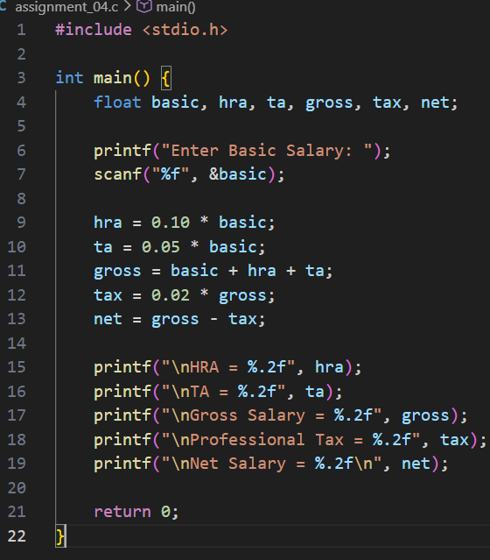

Output screenshot:
