

Foundations of Programming

Assignment No. : 06
Prn-1262250237 div-11
PROBLEM STATEMENT:Write a C function to compute the factorial of a number with and without recursion.

OBJECTIVE:

To demonstrate two different approaches for calculating the factorial of a number: iterative (non-recursive) and recursive, showcasing the versatility of problem-solving methods in programming.

THEORY:
- Explain the difference between the iterative and recursive approaches to calculating the factorial of a number.
- What is the base case in the recursive function for computing factorials, and why is it necessary?
- How does the program handle invalid input, such as negative numbers, and why is this important?
PLATFORM: Linux

INPUT:
OUTPUT:
CONCLUSION: Thus, we have successfully executed factorial of a number with and without recursion.

FAQs:
1. What is the purpose of calculating factorial in programming?
2. What is the difference between recursive and non-recursive (iterative) methods?

Code:
#include<stdio.h>
int main(){

int n;
int i;
int factorial=1;
printf("Enter any number : ");
scanf("%d",&n);

if(n>0){
for(i=1;i<=n;i++){
factorial=factorial*i;
}}
else{
printf("Factorial is not defined for negative numbers.");

}
printf("Factorial of %d = %d",n,factorial);
return 0;

}

Code screenshot:
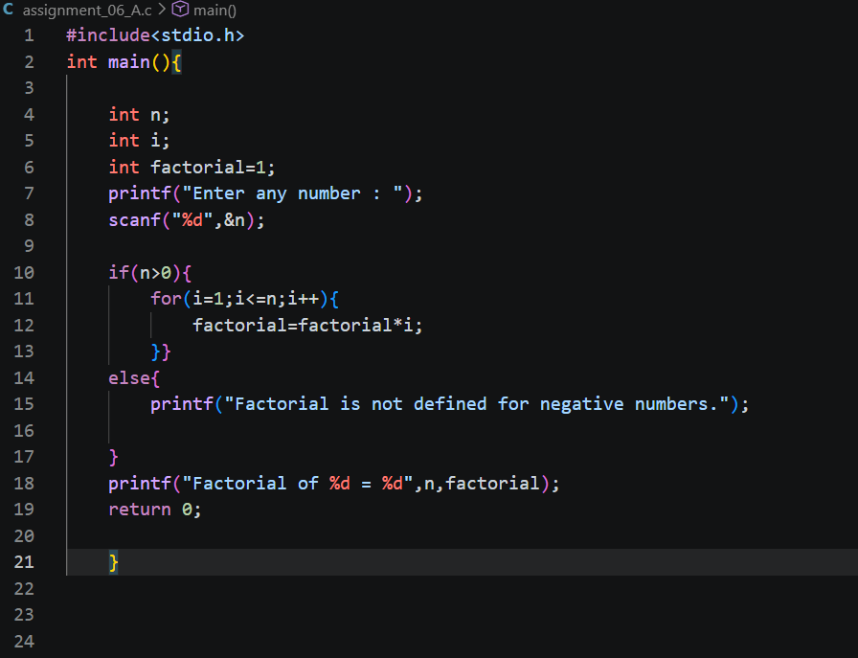

Output screenshot:
