SE LAB 2

MULTI-CLOUD ASSET COST OPTIMISATION PORTAL
NAME: P MANAS SIDDHARDHA
SRN: PES1UG24AM186

EPICS AND USER STORIES
Epic ID | Epic Name | Epic Priority | Story ID | User Story Title | User Story | Story Priority
MCACOP-1 | Cloud Billing & Cost Management | High | MCACOP-6 | Upload Cloud Billing Data | As a FinOps Analyst, I want to upload AWS, Azure, and GCP billing data so that cloud costs can be analyzed in one portal. | High
MCACOP-1 | Cloud Billing & Cost Management | High | MCACOP-7 | Categorize Cloud Costs | As a FinOps Analyst, I want cloud costs to be categorized by service and project so that I can understand where spending is occurring. | High
MCACOP-1 | Cloud Billing & Cost Management | High | MCACOP-8 | View Cloud Cost Dashboard | As a FinOps Analyst, I want to view a consolidated cloud cost dashboard so that I can monitor spending across cloud providers. | High
MCACOP-2 | Idle Compute Detection | High | MCACOP-9 | Detect Idle Compute Instances | As a FinOps Analyst, I want the system to identify idle compute instances so that unnecessary compute spending can be reduced. | High
MCACOP-3 | Unattached Storage Optimization | High | MCACOP-10 | Detect Unattached Storage Volumes | As a FinOps Analyst, I want the system to detect unattached storage volumes so that unused storage costs can be identified and optimized. | High
MCACOP-4 | Budget Monitoring & Alerts | Medium | MCACOP-11 | Set Budget Thresholds | As a Cloud Administrator, I want to define budget thresholds so that cloud spending can be monitored against planned limits. | Medium
MCACOP-4 | Budget Monitoring & Alerts | Medium | MCACOP-12 | Detect Budget Breaches | As a Cloud Administrator, I want the system to detect budget breaches so that excessive cloud spending can be identified promptly. | Medium
MCACOP-4 | Budget Monitoring & Alerts | Medium | MCACOP-13 | Send Budget Breach Alerts | As a Cloud Administrator, I want to receive alerts when a budget threshold is breached so that I can take corrective action quickly. | Medium
MCACOP-2 | Idle Compute Detection | Medium | MCACOP-14 | Estimate Idle Compute Savings | As a FinOps Analyst, I want to see estimated savings from idle compute instances so that I can prioritize optimization opportunities. | Medium
MCACOP-3 | Unattached Storage Optimization | Medium | MCACOP-15 | Estimate Storage Savings | As a FinOps Analyst, I want to see estimated savings from unattached storage so that I can prioritize storage cleanup. | Medium
MCACOP-2 | Idle Compute Detection | Low | MCACOP-16 | View Compute Optimization Recommendations | As a FinOps Analyst, I want optimization recommendations for idle compute resources so that I can decide which resources to right-size or remove. | Low
MCACOP-3 | Unattached Storage Optimization | Low | MCACOP-17 | View Storage Optimization Recommendations | As a FinOps Analyst, I want optimization recommendations for unattached storage so that I can decide which unused resources should be removed. | Low

- EPICS
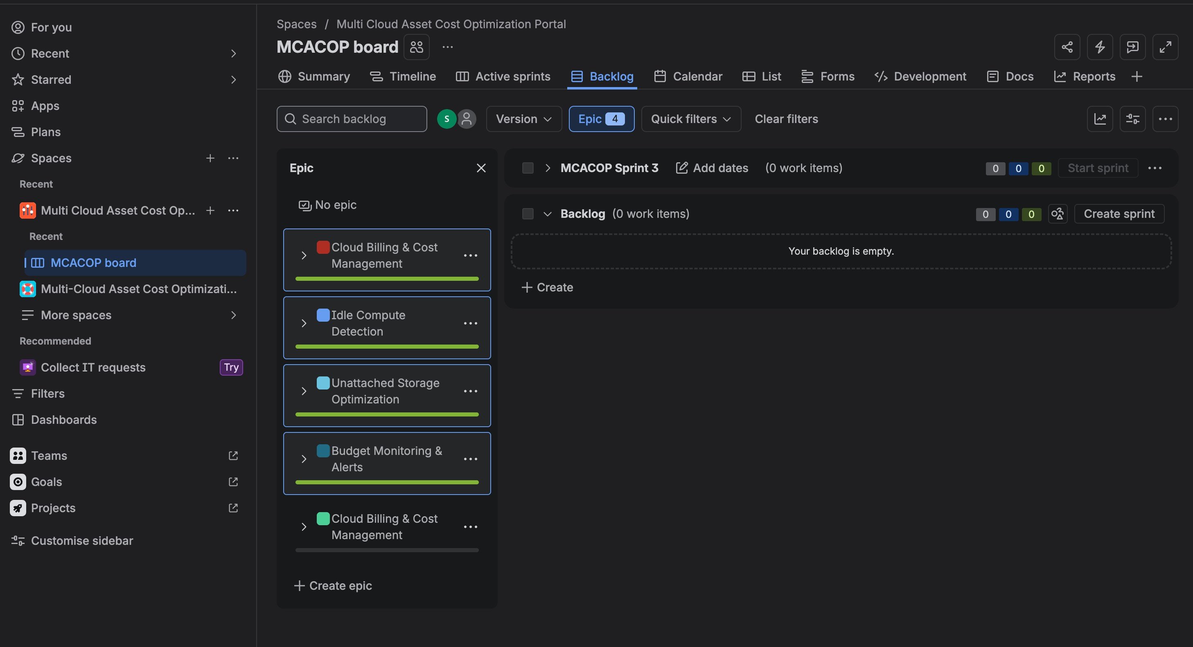

- SPRINT BOARD
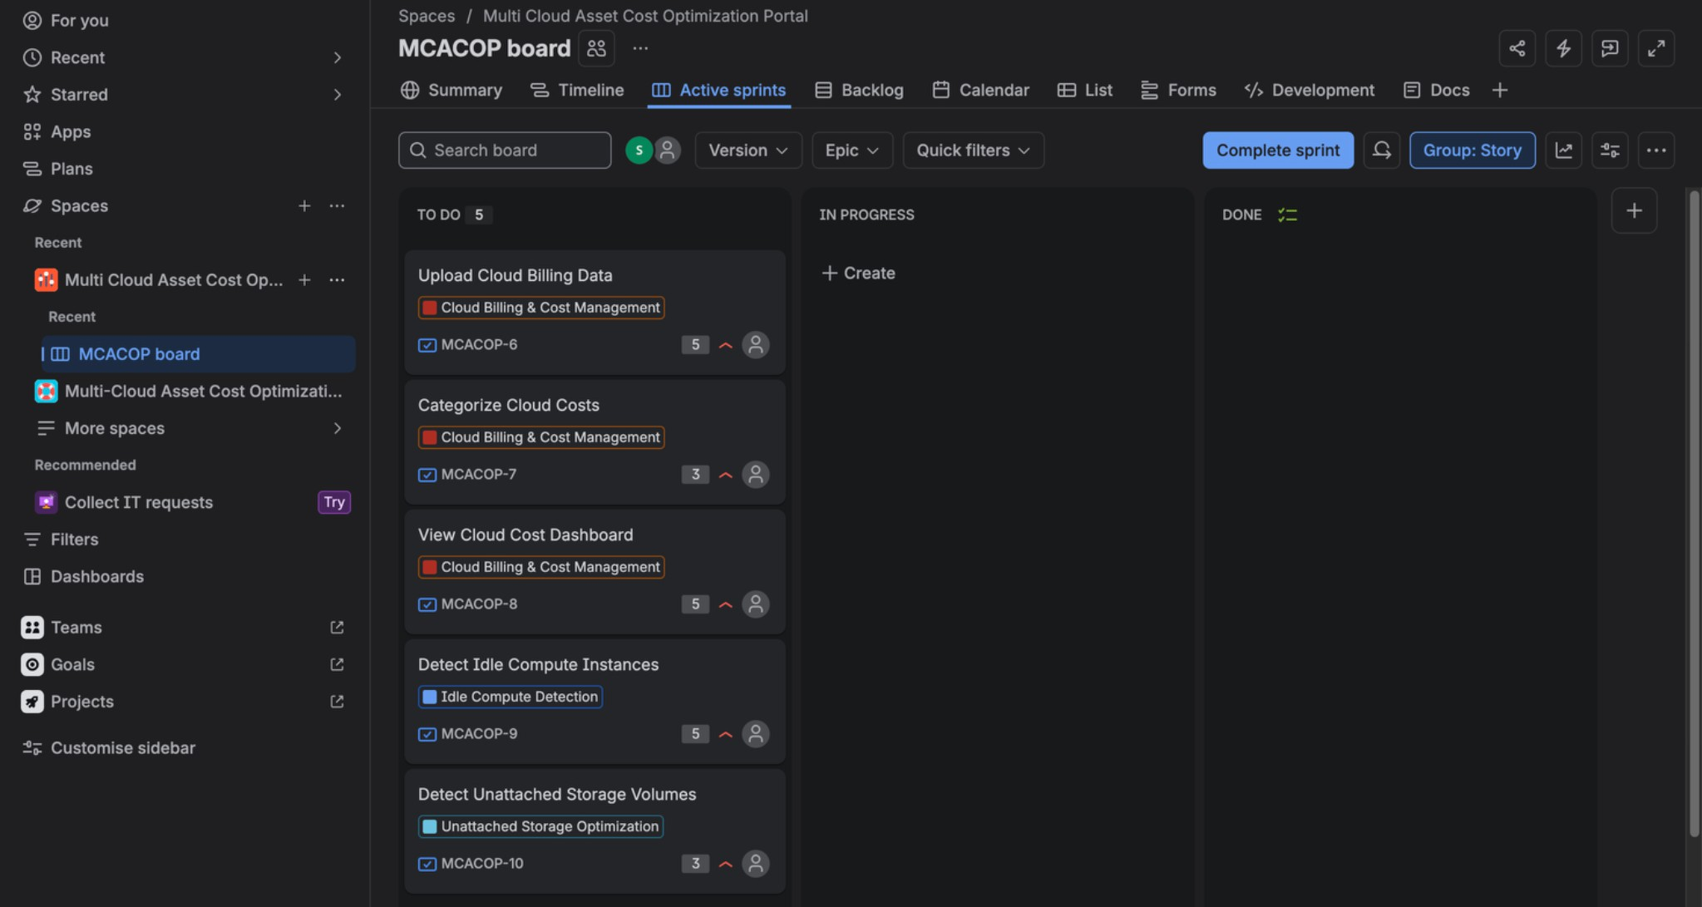

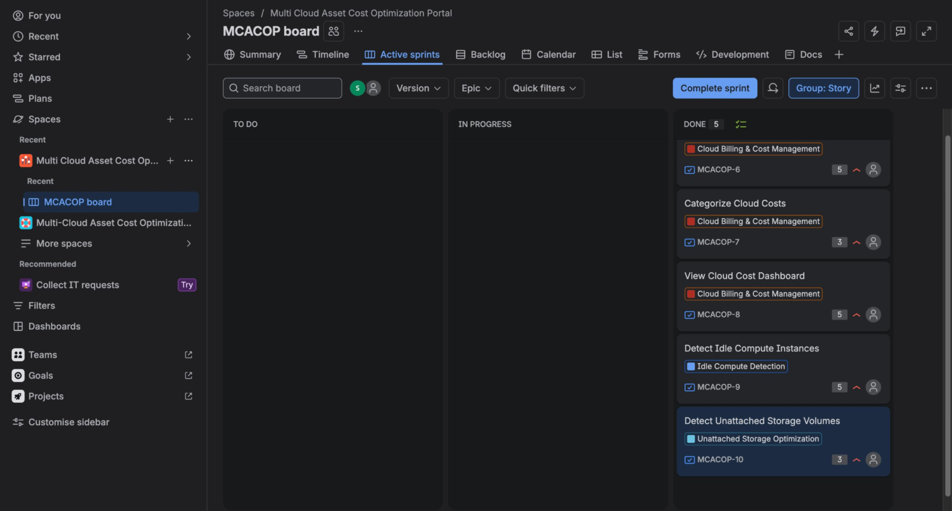

- BURNDOWN CHART FOR SPRINT 1
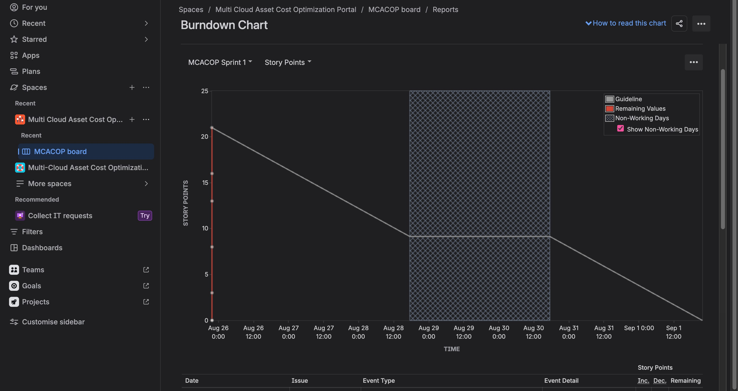

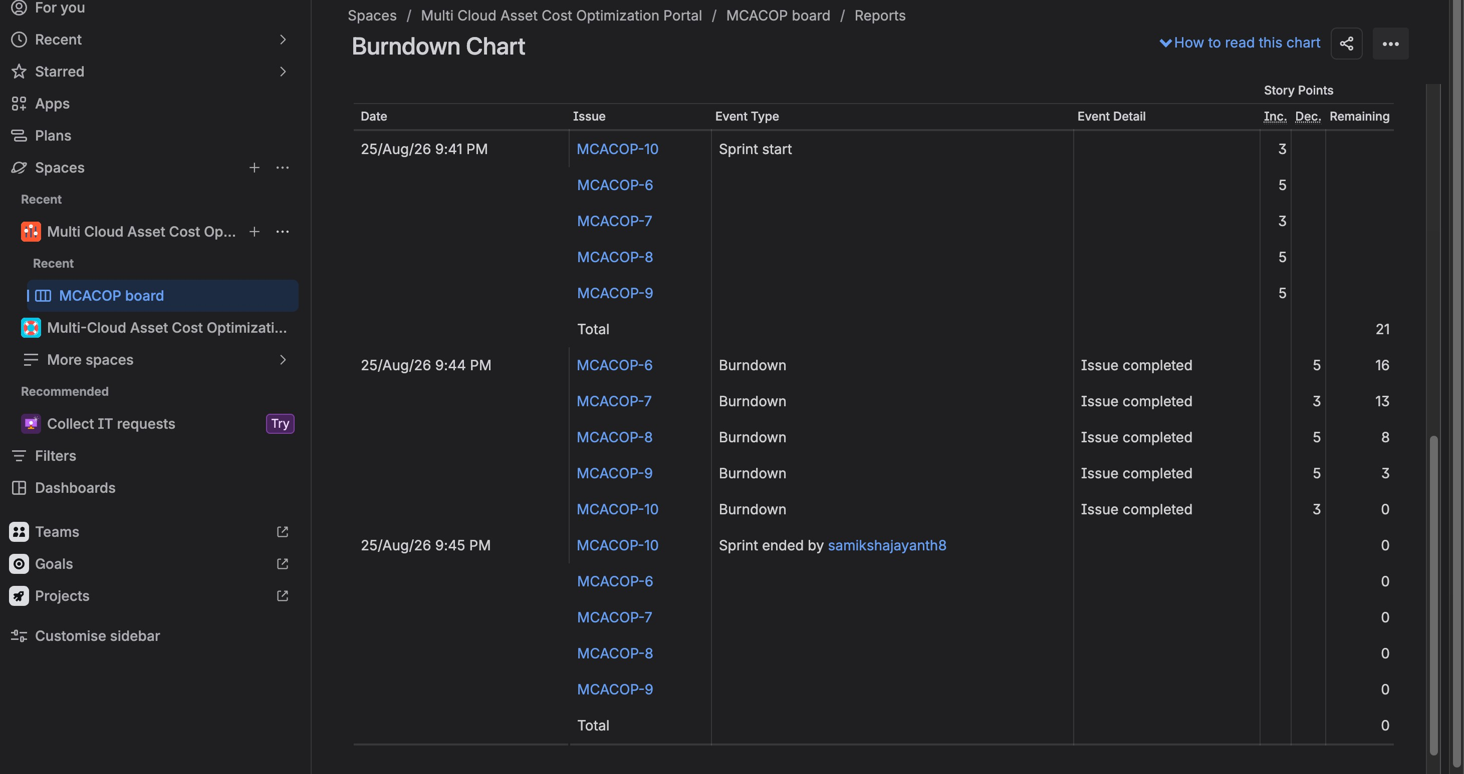

BURNDOWN CHART FOR SPRINT 2

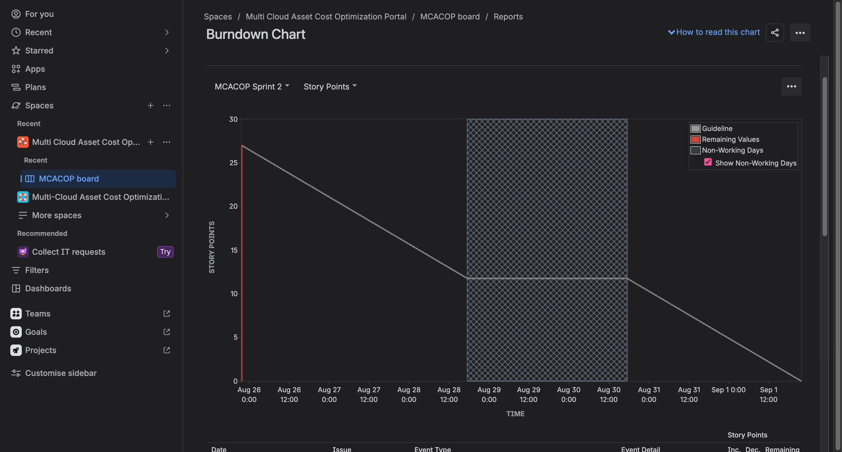

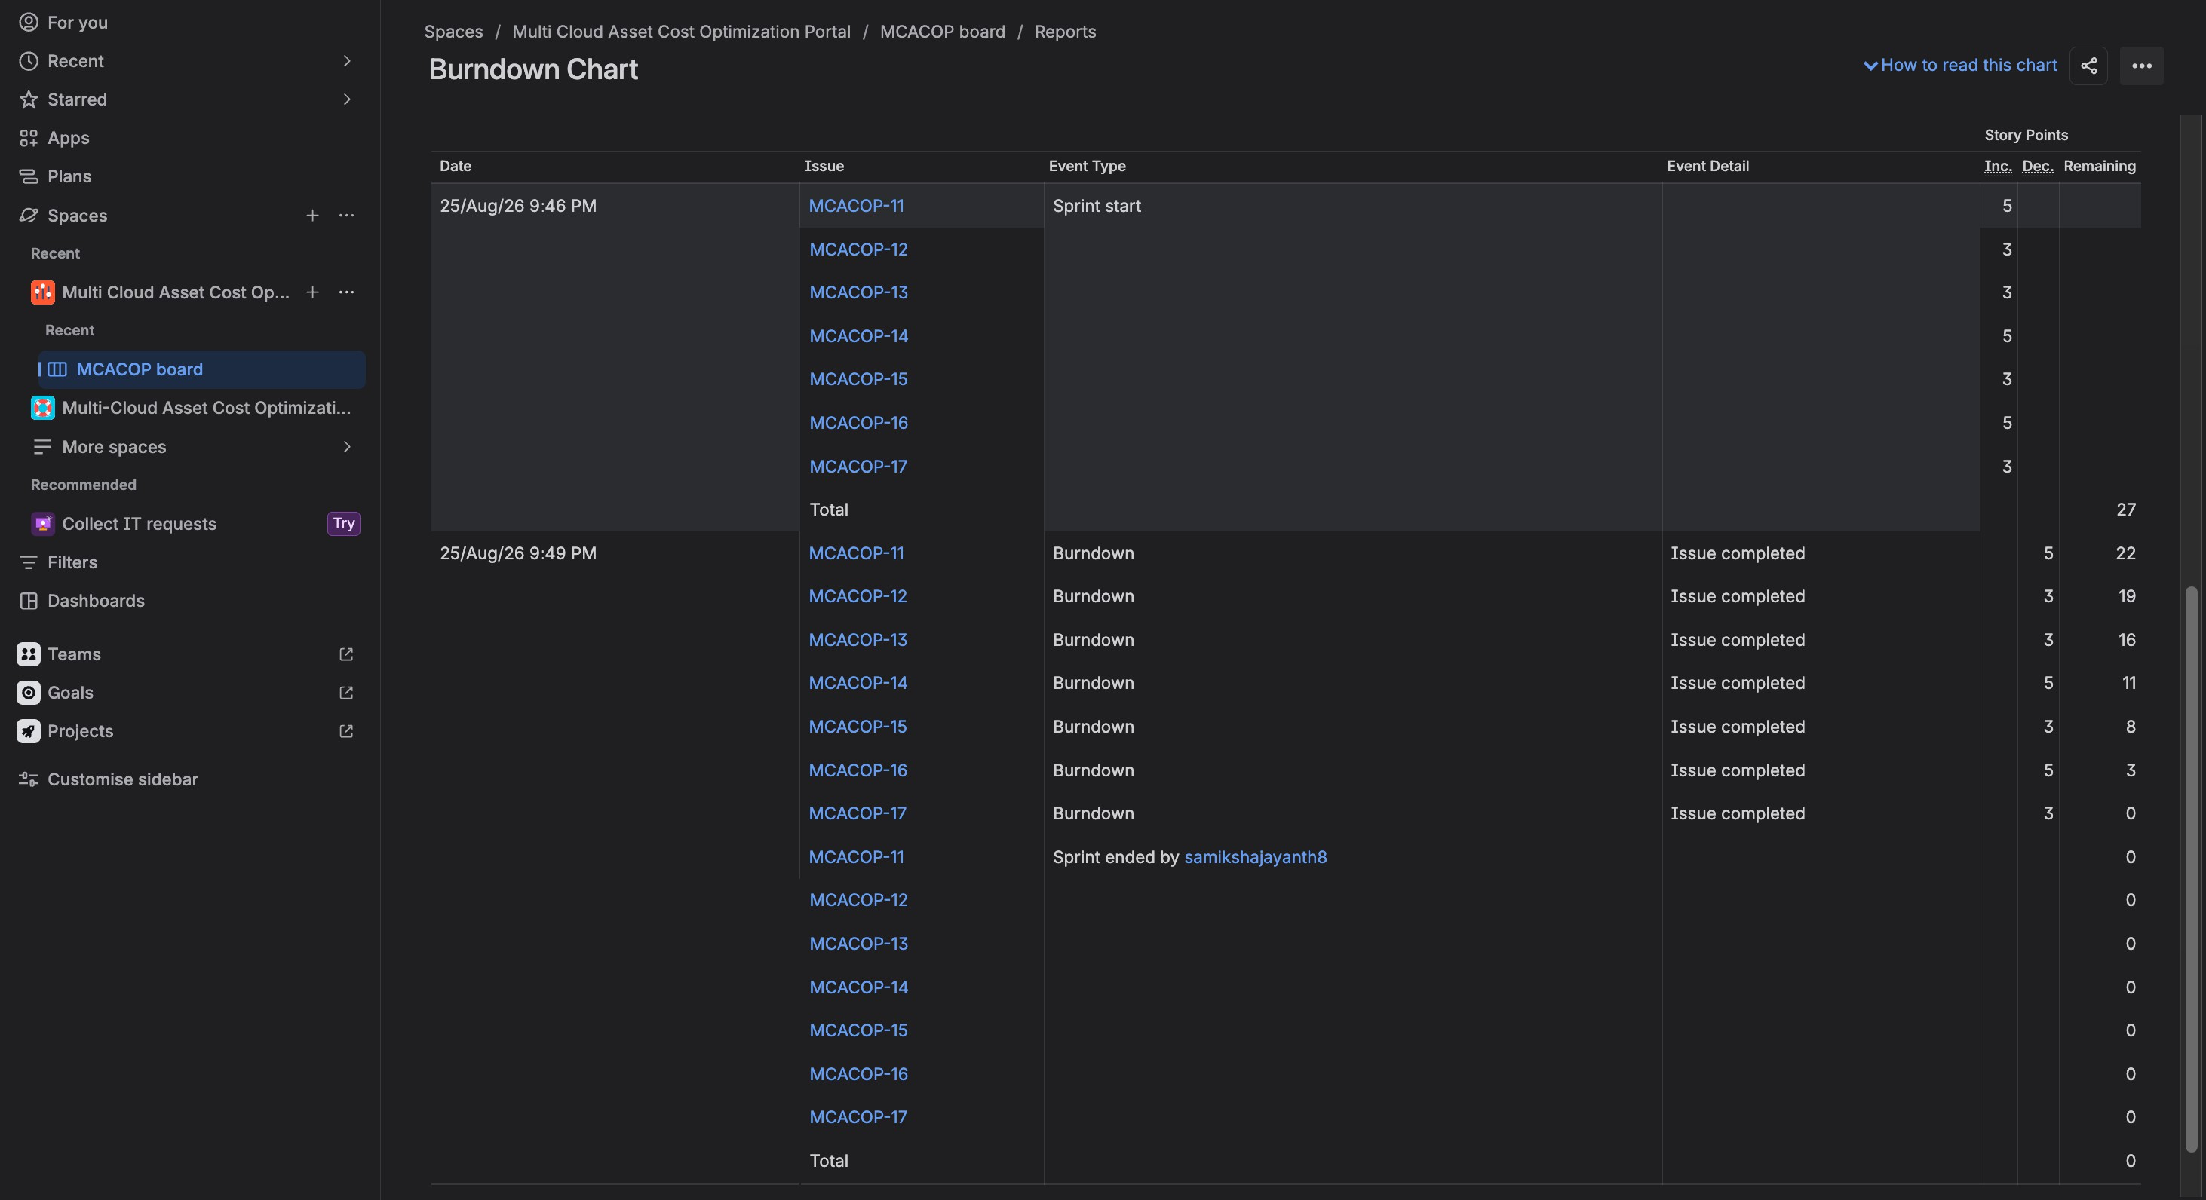

- ANSWERS

Did your estimations reflect the actual effort?
My estimations were reasonably close to the actual effort. Most tasks were completed within their estimated story points, although some tasks required slightly more effort than expected. This helped me understand the importance of considering task complexity when estimating.

Was your backlog well-prioritized?
Yes, I prioritized the backlog based on the importance of the features. I focused on the core cloud cost management and optimization features first, followed by the less critical features.

How did your simulated sprint align with your plan?
My simulated sprints generally aligned with my original plan. I was able to organize the tasks into sprints and move them through the workflow from To Do → In Progress → Done. The simulation helped me understand how sprint planning works in practice.

What insights did the burndown chart give about your capacity?
The burndown chart showed how my remaining story points decreased during the sprint. Since I completed the tasks progressively, it gave me an idea of how much work I could realistically handle within a sprint and helped me understand the importance of maintaining a consistent pace.

