SE LAB-1

NAME: P MANAS SIDDHARDHA
CLASS: D
SRN: PES1UG24AM186

PROBLEM STATEMENT #45 | Developer Tools & IT Operations
Multi-Cloud Asset Cost Optimization Portal

Requirements Table
REQUIREMENTS | Type | Description | Priority | Acceptance Criteria | Rationale
FR-001 | Functional | The system shall ingest cloud billing CSV exports from AWS, Azure, and GCP, categorize costs by service and project tag, and flag compute instances with < 5% CPU utilization over 14 days. | High | Pass: Idle cloud asset flagged with monthly savings estimate.  Fail: Active instance misclassified as idle. | Automated ingestion and idle-instance detection is the core value proposition of a FinOps portal, replacing slow manual spreadsheet analysis.
FR-002 | Functional | The system shall identify unattached (orphaned) storage volumes across AWS, Azure, and GCP accounts that have recorded zero I/O operations for more than 7 consecutive days. | High | Pass: Orphaned volume flagged with size, age, and estimated monthly cost.  Fail: An attached/in-use volume is misclassified as unattached. | Unattached storage volumes continue to incur cost with zero business value; detecting them is one of the fastest ROI wins in cloud FinOps.
FR-003 | Functional | The system shall let a FinOps Analyst define a monthly budget threshold per cloud account or project, and shall dispatch an alert (email/webhook) when actual spend crosses that threshold. | High | Pass: Alert dispatched within 15 minutes of the threshold being crossed, containing account, current spend, and threshold.  Fail: Spend exceeds threshold by more than 10% with no alert sent. | Timely budget-breach notification prevents cost overruns from going unnoticed until the next billing cycle.
FR-004 | Functional | The system shall let a Cloud Administrator execute a remediation action (e.g. Stop Instance, Delete Volume, Snooze Recommendation) directly on a flagged idle or unattached asset from the portal, and log the action taken. | Medium | Pass: Action executed against the correct cloud resource and logged with timestamp and user.  Fail: Action applied to the wrong resource, or not logged. | Giving administrators direct remediation controls closes the loop between detection and actual realized cost savings.
FR-005 | Functional | The system shall generate a monthly cost-savings report summarizing total potential savings identified, savings realized through remediation, and a cost breakdown by cloud provider and project tag. | Medium | Pass: Report totals reconcile with underlying flagged-asset records for the period.  Fail: Report omits a remediated asset or double-counts savings. | Analysts and finance leadership need a consolidated, auditable summary to demonstrate the FinOps program's value.
NFR-001 | Nonfunctional  (Performance & Security) | The portal must parse multi-gigabyte cloud billing files and update cost dashboards in under 2 minutes. | High | Pass: Benchmarking tests confirm target latency and security standards under simulated peak load. | Large enterprises generate multi-GB billing exports daily; slow processing would make the dashboard stale and unusable for timely decisions.
NFR-002 | Nonfunctional  (Security & Access Control) | The system shall enforce role-based access control so that only authenticated Cloud Administrators can execute remediation actions, and all billing data in transit and at rest must be encrypted (TLS 1.2+ / AES-256). | High | Pass: An unauthorized user attempting a remediation action is denied and the attempt is logged.  Fail: A user without administrator role can execute a remediation action, or billing data is stored/transmitted unencrypted. | Billing data is commercially sensitive, and remediation actions (like stopping an instance) can cause outages if performed by unauthorized users, so strict access control and encryption are essential.

UML Use-Case Diagram
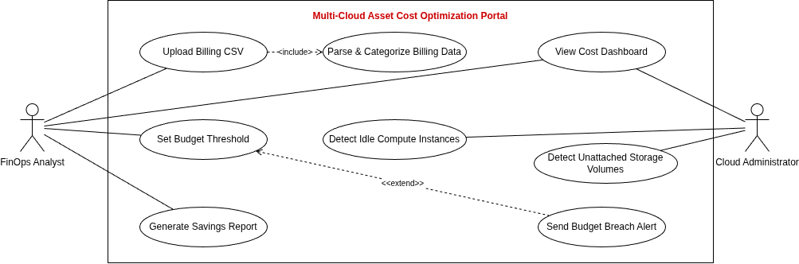
Relationships modeled:
• «include» — Upload Billing CSV includes Parse & Categorize Billing Data (parsing is a mandatory step of every upload).
• «extend» — Send Budget Breach Alert extends Set Budget Threshold (an alert is an optional trigger that only fires once a configured threshold is breached).

Use-Case Flow Specification

Use Case: Upload Billing CSV
Primary Actor: Fin-Ops Analyst
Secondary Actor: Cloud Administrator
Includes: Parse & Categorize Billing Data, Detect Idle Compute Instances, Detect Unattached Storage Volumes
Related: Set Budget Threshold is extended by Send Budget Breach Alert

Preconditions
• The FinOps Analyst is authenticated and holds upload permissions on the portal.
• A cloud provider billing export (AWS, Azure, or GCP) is available as a CSV file.
• The portal holds valid, reachable API credentials to query real-time CPU-utilization and I/O metrics for the connected cloud accounts.

Main Success Scenario
1. The FinOps Analyst uploads a billing CSV export via the portal.
2. The system validates the file format and acknowledges the upload.
3. The system includes Parse & Categorize Billing Data to extract line items and tag costs by service and project.
4. The system includes Detect Idle Compute Instances to flag compute resources with < 5% CPU utilization over the trailing 14 days.
5. The system includes Detect Unattached Storage Volumes to flag storage volumes with zero I/O for more than 7 days.
6. The system computes an estimated monthly savings figure for each flagged asset.
7. The system updates the Cost Dashboard with categorized costs and flagged assets within 2 minutes (NFR-001).
8. The Cloud Administrator reviews the flagged assets on the dashboard.
9. The use case ends successfully.

Alternate Flow
4a. Utilization Data Unavailable
4a1. The system detects that CPU-utilization metrics are missing or unreachable for one or more compute instances during step 4.
4a2. The system marks those instances as “Utilization Unknown” rather than idle.
4a3. The system logs the metric-collection gap and notifies the Cloud Administrator to check API connectivity.
4a4. Processing continues for all instances with available utilization data; flow resumes at step 5.

Post conditions
• Billing data for the uploaded file has been parsed, categorized, and persisted.
• All idle compute instances and unattached storage volumes present in the billing period are flagged with savings estimates.
• The Cost Dashboard reflects the updated data within the 2-minute NFR-001 target.
• Instances with unavailable utilization data are marked “Utilization Unknown” rather than silently omitted.

