Lab 3: Component Modelling & Architectural Pattern Selection

Objective
Evaluate different architectural styles, select the most appropriate one for a given scenario, and create a comprehensive UML Component Diagram showing modules, interfaces, and dependencies. This lab focuses on understanding how components interact within a system and how architectural decisions impact system design.

Duration
90 minutes

Software Requirements
- UML tool (draw.io, LucidChart, StarUML or any online UML tool)

Learning Outcomes for Lab 3
By the end of this lab, you will be able to:
- Evaluate architectural styles:
- Compare and contrast different architectural patterns (Layered, Microservices, Client-Server)
- Analyse pros and cons of each pattern relative to specific scenarios
- Select appropriate architecture:
- Choose the most suitable architectural style based on system requirements
- Justify architectural decisions with concrete reasoning
- Design component diagrams:
- Create UML component diagrams with proper notation
- Show provided and required interfaces between components
- Demonstrate understanding of component dependencies
- Document architectural decisions:
- Write clear, technical justifications for architectural choices
- Explain security and performance implications

Note: Students may be randomly called for a presentation after completing the lab. Please be prepared to present and discuss your lab deliverables.

Introduction:

Component modelling Fundamentals
What is a Component?
A component is a replaceable and executable piece of a system whose implementation details are hidden. Key characteristics:
- Modular: Encapsulates specific functionality
- Replaceable: Can be swapped with other components that provide the same interface
- Black Box: External behavior is defined by interfaces, internal implementation is hidden
- Executable: Participates in system execution
Component Diagram Elements
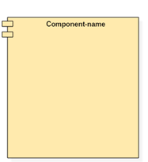
1. Component Notation
- Represented as a rectangle with <<component>> stereotype
- Component name placed at center
- Optional component icon in upper-right corner
- Implementation details are hidden from external view

2. Interfaces
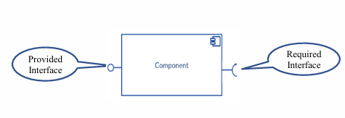
Provided Interface (Ball notation):
- Services that a component offers to other components
- Shown as a circle connected to the component
- Represents what the component can do for others
Required Interface (Socket notation):
- Services that a component needs from other components
- Shown as a semicircle connected to the component
- Represents what the component needs from others

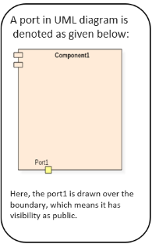
3. Ports
- Interaction points between components and external environment
- Group related provided and required interfaces
- Can be public (drawn on boundary) or private (drawn inside)

4. Dependencies
- Usage Dependencies: Shown as dashed arrows with <<use>> stereotype
- Assembly Connectors: Connect provided interfaces to required interfaces
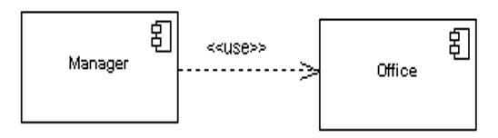

Example Component diagram:
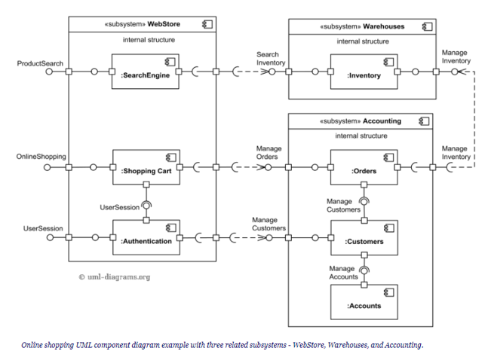

Architectural Styles Overview
1. Layered Architecture
- Structure: Organized in horizontal layers (Presentation, Business, Data)
- Pros: Clear separation of concerns, easy to understand, good for traditional applications
- Cons: Performance overhead, tight coupling between layers, difficult to scale individual components
2. Microservices Architecture
- Structure: Small, independently deployable services
- Pros: Independent scaling, fault isolation, technology diversity, independent deployment
- Cons: Operational complexity, network latency, data consistency challenges
3. Client-Server Architecture
- Structure: Centralized server with multiple clients
- Pros: Centralized control, simple deployment, easy data consistency
- Cons: Single point of failure, scalability bottleneck, limited fault tolerance

Scenario:

Self-Service Coffee Kiosk System
You are designing the software architecture for a Self-Service Coffee Kiosk system in a busy café. The kiosk must provide a complete coffee ordering experience with the following requirements:
Core Functionality:
- Customers can select from 3 coffee types (Espresso, Americano, Latte)
- Customers can choose from 2 drink sizes (Small, Large)
- Customers can pay via credit card only
- System prints receipts with order details
Technical Constraints:
- Must handle touch screen interface interactions
- Must connect to receipt printer hardware
- Must store menu data and pricing information

Deliverables
1. Component Diagram (PNG or PDF)
Your diagram must include atleast 5 components (Adding attributes is optional).

Interface Requirements:
- Show atleast 4 interfaces between components:
- Use proper UML notation for provided/required interfaces
- Show data flow and component interactions

2. Written Justification (Word document, max 1 page)

Lab 3 Steps (90 minutes)
Step 1: Scenario Review (10 minutes)
- Read the scenario thoroughly
- Identify key functional and non-functional requirements
- List the main challenges (performance, usability, security)

Step 2: Architectural Style Analysis (20 minutes)
Analysis (10 minutes): Analyse each architectural style.

Step 3: Architecture Selection & Component Identification (15 minutes)
Select Architecture (5 minutes)
Identify Components (10 minutes): Based on your chosen architecture, identify all necessary components (Two components are given below, please identify the remaining 3):
- Order Manager Component
- Payment Service Component

Step 4: Component Diagram Creation (35 minutes)
Setup (5 minutes):
- Open your UML tool (draw.io recommended)
- Set up the canvas with adequate space
Draw Components (15 minutes):
- Create component rectangles for each of the 5 identified components
- Use <<component>> stereotype or clear component notation
- Arrange components logically on the canvas
- Group related components (e.g., customer-facing, data storage)

Add Interfaces (15 minutes): Define and draw the required interfaces between components:

Key Interfaces to Show (Min 4):
Given:
- Order Manager ↔ Payment Service: Payment processing requests

Interface Notation Guidelines:
- Use solid lines for internal service communications
- Label interfaces with protocol/technology (API calls, hardware interfaces, database queries)
- Use provided interface (ball) and required interface (socket) notation where appropriate

Create a one-page Word document with the following structure:
Architecture Selection: "We chose [ Architecture] for the Self-Service Coffee Kiosk System."
Your justification must include:
- Architectural Choice: State which architectural style you selected
- Two Reasons: Provide two specific, scenario-related reasons for your choice
- Security Advantage: Explain one way your architecture addresses security concerns
- Performance Benefit: Describe one performance advantage of your chosen architecture

Step 6: Diagram Finalization & Export (5 minutes)
- Review diagram for completeness
- Ensure all required components are present
- Verify interface directions and labels are correct
- Check UML notation compliance
- Export as PNG or PDF
- Save justification document as PDF

