

Data Structures and Algorithms -23CSE203

Lab Manual

Submitted By

NAME | T.Naga Siddhardha
ROLL NO | AV.SC.U4CSE25151
YEAR/SEM/SECTION | 2nd YEAR/ SEM-3/CSE-B
CREDITS | 05

Submitted to
NAME | DR. RAJ KUMAR BATCHU
DESIGNATION | ASST.PROFFESSOR (Sl. Grade)
DEPARTMENT | SCHOOL OF COMPUTING

Index
week |  | Page-numbers
1 | - A rocket launch system displays a count down before launch. Instead of using a loop, implement the count down using recursion. Write a recursive python program to display countdown from n to 1 followed by launch.  - Banks calculate the growth of investment using compound interest. The formula requires calculating powers, which can be implemented recursively. Write a recursive program to calculate P^n where P = Principal growth factor, n = number of years  - A HR department stores employee details in a list. Develop a recursive program to search for a given employee ID. Write a recursive function to search for an employee ID in a list.  - In a logistic department, the no of possible ways to arrange n diff parcels are calculated using the factorial formula(n!). Write a recursive formula to find the factorial of a given number  - Print first n terms in a fibanocci number series
2 | - Write the implementation for the linear search algorithm  - Write the implementation for the binary search algorithm  - Write the implementation for the binary search algorithm along with the sorting the input elements if they are not sorted.
3 | - Write a python program to implement bubble sort where the input elements are taken from the user.  - Write a python program to implement insertion sort where the input elements are taken from the user.  - Write a python program to implement selection sort where the input elements are taken from the user.
4

Week-1
- A rocket launch system displays a count down before launch. Instead of using a loop, implement the count down using recursion. Write a recursive python program to display countdown from n to 1 followed by launch.
Input:
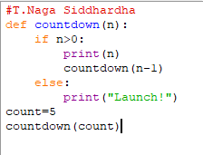
OUTPUT:
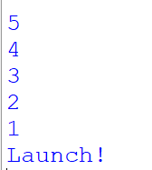
Explanation:
The program uses recursion to display the countdown from n to 1. The function calls itself with n-1 until n becomes 0. After reaching the base condition, it displays "Launch!". This performs the countdown without using a loop.
- Banks calculate the growth of investment using compound interest. The formula requires calculating powers, which can be implemented recursively. Write a recursive program to calculate P^n where P = Principal growth factor, n = number of years
Input:
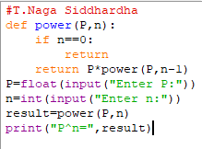
Output:
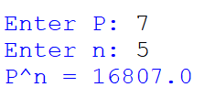
Explanation:
The recursive function power() calculates by multiplying P with . The recursion stops when n becomes 0, where the result is 1.
- A HR department stores employee details in a list. Develop a recursive program to search for a given employee ID. Write a recursive function to search for an employee ID in a list.
Input:
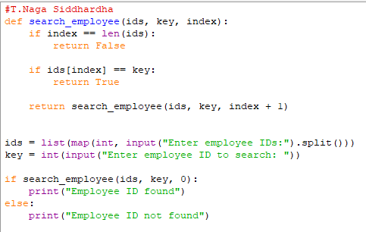
Output:
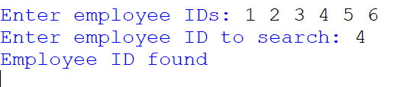
Explanation:
The function checks each employee ID recursively. If the ID matches the given ID, it returns True. If the end of the list is reached without a match, it returns False.
- In a logistic department, the no of possible ways to arrange n diff parcels are calculated using the factorial formula(n!). Write a recursive formula to find the factorial of a given number
Input:
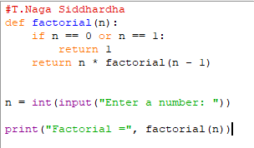
Output:
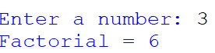
Explanation:
The recursive function factorial() calculates by multiplying n with the factorial of n-1. The recursion stops when n becomes 0 or 1.
- Print first n terms in a fibanocci number series
Input:
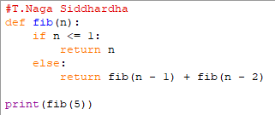
Output:
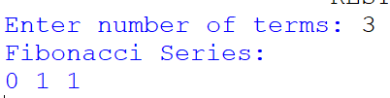
Explanation:
The recursive function fibonacci() returns the sum of the previous two Fibonacci terms. The first two terms are 0 and 1. The program calls the function for each term from 0 to n-1.

WEEK-2
- Write the implementation for the linear search algorithm
INPUT:
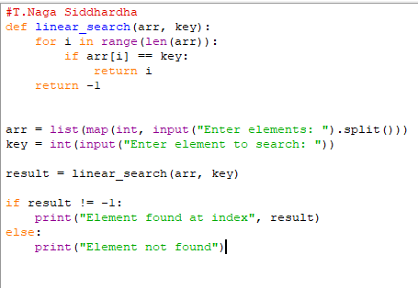
OUTPUT:
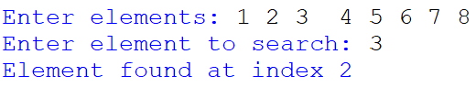
EXPLANATION:
Linear search checks each element one by one from the beginning of the list until the required element is found or the list ends.

- Write the implementation for the binary search algorithm
INPUT:
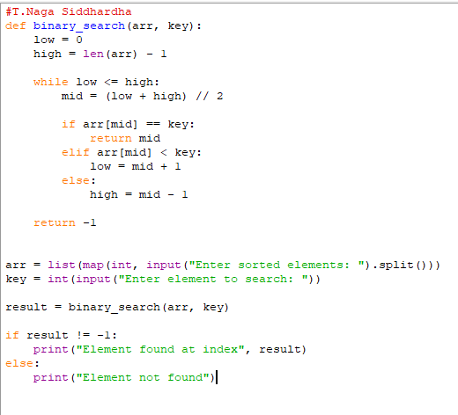
OUTPUT:
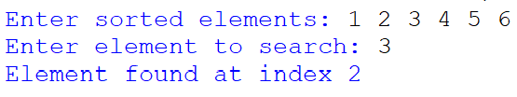
EXPLANATION:
Binary search works only on a sorted list. The program first sorts the input elements using sort(). It then repeatedly checks the middle element and eliminates half of the search range until the element is found or the range becomes empty.

WEEK-3
- Write a python program to implement bubble sort where the input elements are taken from the user.
Input:
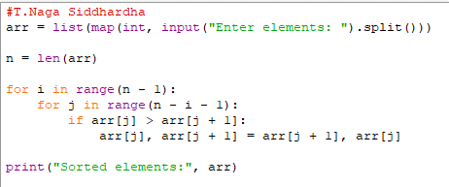
Output:
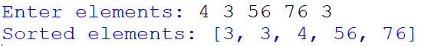
Explanation:
Bubble sort repeatedly compares adjacent elements and swaps them if they are in the wrong order. After each pass, the largest unsorted element moves to its correct position.

- Write a python program to implement insertion sort where the input elements are taken from the user.
Input:
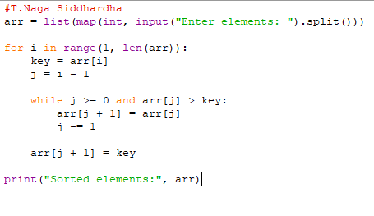
Output:
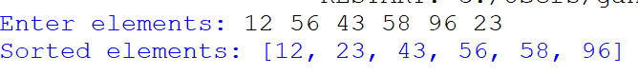
Explanation:
Insertion sort takes one element at a time and inserts it into its correct position among the already sorted elements.

C) Write a python program to implement selection sort where the input elements are taken from the user.
Input:
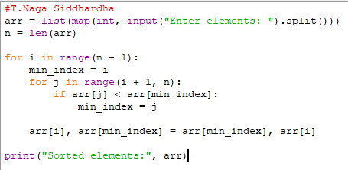
Output:
Explantion:
Selection sort finds the smallest element from the unsorted portion and swaps it with the first element of that portion. This process continues until the entire list is sorted.

