Introduction

Purpose of the Document

The purpose of this document is to present a description of the online grievance forum – sortmeout. It will explain the system’s purpose, key features, brief interfaces, operations and design. This document is intended for both the stakeholders and the developers of the system.

Motivation for the Project

The online forums already available today either commit themselves to specific domains or propose solutions that are not personalized based on the user’s level of understanding of his problem/grievance.

Our first aim is to keep the project entirely user-centric i.e. the user must be in a position to express his problem and his level of its understanding fully. The user may be an expert in the field in which his grievance lies, or he may be a total newbie. Our aim is to give him a solution that exactly matches his expectations. The proposed solutions should be such that it can be well comprehended by the user and shouldn’t be too complex for a novice or too basic for an expert.

Also, at sortmeout, a user can post a grievance to any category – including a special category “unlisted”. This means that if sortmeout currently lacks the expertise to tender to the user’s grievance, experts may be contacted and collaborated through external means by the moderators for serving the user.

Scope of the Project

sortmeout is an online grievance forum for a wide range of grievance categories. It primarily facilitates a categorization of user grievances and walk-through resolution of the same through the medium of domain experts (preferably) and/or other Internet users (not necessarily part of the sortmeout userbase). Apart from the functional aspects this forum presents a solid yet easy-to-understand user interface.

More specifically, sortmeout is designed as a link between a user and experts, who expertise in the domain(s) of the user’s grievance. It then allows the user to walk himself through to the resolution of his grievance through a path of solutions and interim grievances.

Glossary of Key Terms

|  |  |
| --- | --- |
| Term | Definition |
| Administrator | Site Administrator |
| Moderator | Person who reviews incoming grievances and solutions for inappropriate content |
| Expert | Site user who specializes in some domain(s) and has completed the registration as an expert |
| Registered user/ Member | Site user who has completed the registration as a normal member |
| Internet user/ Visitor | Site user who has not completed the registration process |
| Grievance | A member-originated description of his problem |
| Solution | A viable action intended to solve a member’s grievance |
| Interim Grievance | A restatement of a member’s partially-solved grievance |
| Closing a Grievance | Closing a grievance permanently by selecting a solution that best solves the grievance fully/partially (disallow selection and posting of more solutions to the grievance) |
| Finalizing a Grievance | Closing a grievance thread permanently by selecting a solution that completely solves the last interim grievance fully (disallow selection and posting of more solutions and interim grievances to the grievance thread) |
| Public forum | A view of all the grievances marked as “public” by the originators of the grievances |
| Private forum | A member’s personal view of his self-originated grievances marked as “private” |
| Category | Domain of expertise that closely classifies a grievance |

Overall Description

System Architecture

Category Management

Signin

User (Member/Expert)

Posts Review Management

Private Forum

Moderator

Search

Keyword Management

Public Forum

Administrator

Visitor

User Management

Signup

db

sortmeout server

System block diagram

The sortmeout system has 3 major types of actors.

1. Administrator – complete access to the User Management Subsystem
2. Moderator – access to the User Management and Forum Subsystems for validating purposes
3. User
   1. Visitor – can only post solutions in public forum
   2. Member – can post grievances in public and private forums; solutions in public forum
   3. Expert – can post grievances of their own and post solutions to even category-specific private forums of other Members/Experts

System Modules and Core Functionality

1. User Management – Member and Expert Signup, Signin
2. Forums – User’s Private Forum, Public Forum (with and without search results), Expert Domain-Grievances View
3. Content Management – Posts Management, Solution Grading
4. Review – Post Review, Expert Registration Review, New Category/Keyword Review/Add/Update
5. Search/Ranking – Relevance algorithm for searching and sorting of grievances

Data Model

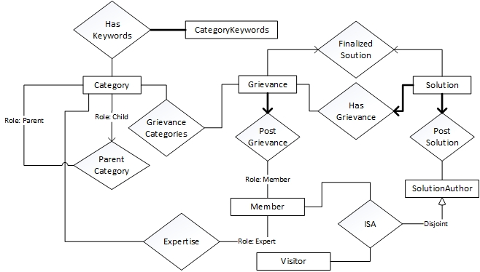

sortmeout ER model

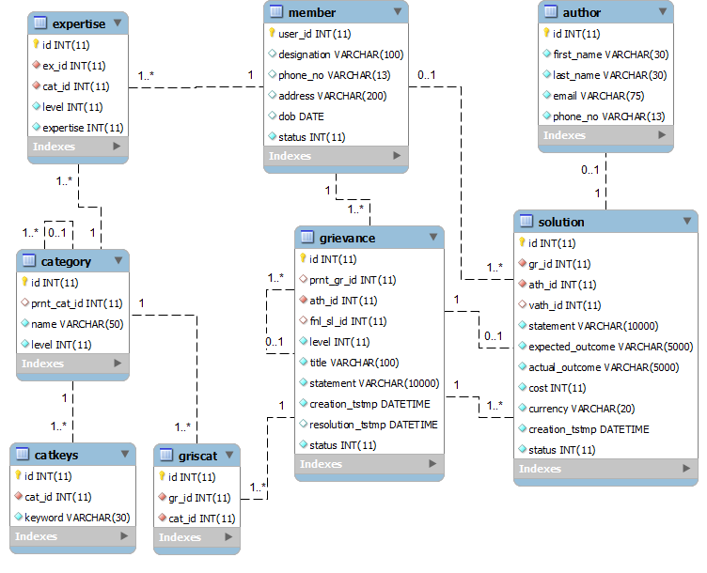

sortmeout relational model

Design Considerations

Key Constraints

|  |  |
| --- | --- |
| **author** (id) | identification data entered voluntarily by a visitor while posting a Solution |
| **member** (id) | identification data of registered users (Member/Expert) |
| **expertise** (id, ex_id, cat_id,  FOREIGN KEY (ex_id) REFERENCES member(user_id),  FOREIGN KEY (cat_id) REFERENCES category(id)) | an Expert signs up as an expert in select categories with his (expertise) level in each; whenever a Solution is finalized fully/partially, expertise points are awarded to the Member authoring the Solution |
| **grievance** (id, prnt_gr_id, ath_id, fnl_sl_id,  FOREIGN KEY (fnl_sl_id) REFERENCES solution (id),  FOREIGN KEY (ath_id) REFERENCES member (id),  FOREIGN KEY (prnt_gr_id) REFERENCES grievance (id)) | Only a registered user can post a Grievance. A new Grievance posted by a Member creates a new Grievance-thread. A Grievance can have at most one finalized Solution, which either closes the Grievance-thread (awards full expertise points to the authoring Member) or prompts for an interim Grievance (awards partial expertise points to the authoring Member). An interim Grievance has one and only one parent Grievance.  (levelnew grievance = 0  levelinterim grievance = levelparent grievance + 1) |
| **griscat** (id, gr_id, cat_id,  FOREIGN KEY (gr_id) REFERENCES grievance (id),  FOREIGN KEY (cat_id) REFERENCES category(id)) | A Grievance can fall into multiple Categories. |
| **solution** (id, gr_id, ath_id, vath_id,  FOREIGN KEY (vath_id) REFERENCES author(id),  FOREIGN KEY(ath_id) REFERENCES member(id),  FOREIGN KEY (gr_id) REFERENCES grievance (id)) | A Solution can be posted by either a registered user (authoring Member) or a visitor (authoring Author). Every Solution is associated with one and only one Grievance. |
| **category** (id, prnt_cat_id,  FOREIGN KEY (prnt_cat_id) REFERENCES category (id)) | A Category may have at most one parent Category  (levelsubcategory = levelparent category + 1) |
| **catkeys** (id, cat_id,  FOREIGN KEY (cat_id) REFERENCES category(id)) | A Category may have some pre-defined set of keywords |

Participation Constraints

|  |  |
| --- | --- |
| **grievance** | Every Grievance has an authoring Member |
| **solution** | Every Solution has an associated Grievance |
| **solution** | Every Solution has an author (Author/Member) |
| **catkeys** | Every CategoryKeyword (Catkeys) has an associated Category |

Other Non-trivial Considerations

A new Grievance starts at level 0. Every interim Grievance is parented by a Grievance at the level immediately above it.

Categories at level 0 do not have parent Categories. Every Category is parented by a Category at the level immediately above it.

The currently chosen Solution to a Grievance appears in the finalized solution with the status flag of Grievance as *open* – indicating it is welcome to more Solutions. Once a Solution is finalized, the status of the Grievance is changed to *closed* – indicating that it is will not accept any more Solutions but might lead to an interim Grievance.

The relevance algorithm invoked for presenting sorted Solutions and Grievance-search results makes use of the Members’ Expertise (level and expertise), term frequencies of Catkeys and level of Categories.

The Administrator is a Django System Administrator, who uses the Django Admin Interface. The Moderator use cases including Review and Category/Keyword Management are not modeled in the data model since they can be easily handled within the Django Admin Interface without additional data models.

The Forums are different views of the system’s Grievances personalized for different users. A Member and Visitor can view a full list of public Grievances (called the Public Forum without search results). A user can narrow down this list with search criteria (called the Public Forum of search results). A Member can view his full list of self-originated private Grievances (called his Private Forum). An Expert can have a Private Forum, can access the Public Forums and has a view of Grievances that fall within the Categories (totaling the Domain) of his Expertise.

Main System Functionalities

Visitor Scenarios

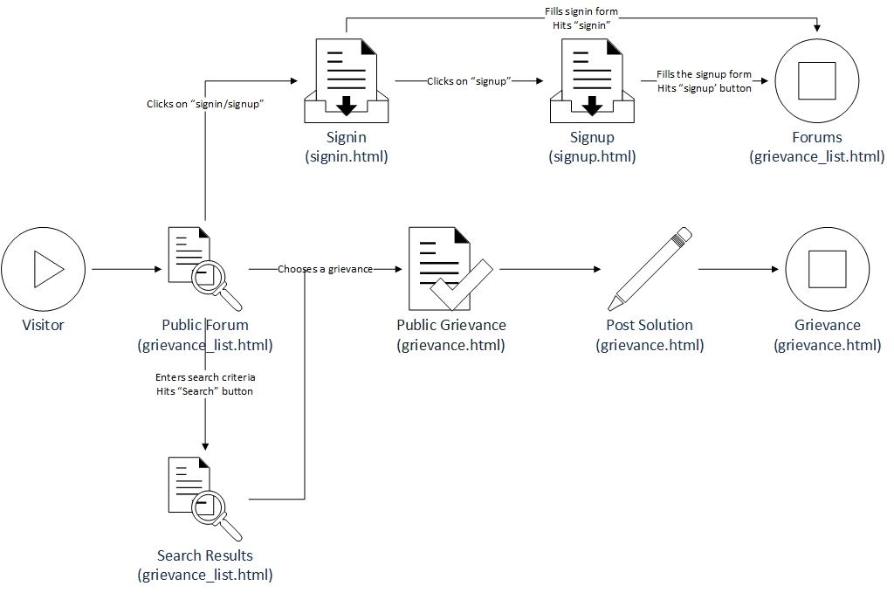

A Visitor to sortmeout first finds himself at the Public Forum. He may choose to search for a Grievance using the keyword based search tool. From the resulting grievance list generated by the system he may choose to view an expanded Grievance thread, which contains a flow of Grievance and interim Grievances together with their finalized Solutions at each level. If there is an outstanding Grievance he may post a Solution to the same. This Solution will be associated with the outstanding Grievance.

Alternatively the Visitor can choose to signup with/ signin into the sortmeout system. He may signup as an Expert or a normal Member. There are different registration forms for the different types of Members. An Expert registration form is posted to the system’s Moderators for review and approval.

Grievance Search Functionality

When a user enters category based search criteria, the system looks up the relevant terms from the search string into the predefined set of category keywords. Keywords of the most specific category(ies) carries the highest weightage, which trails off with Category level. Miscellaneous terms could be ranked using tf/idf by making use of the database tool’s full text indexing on entered Grievances (now available in MySQL’s InnoDB).

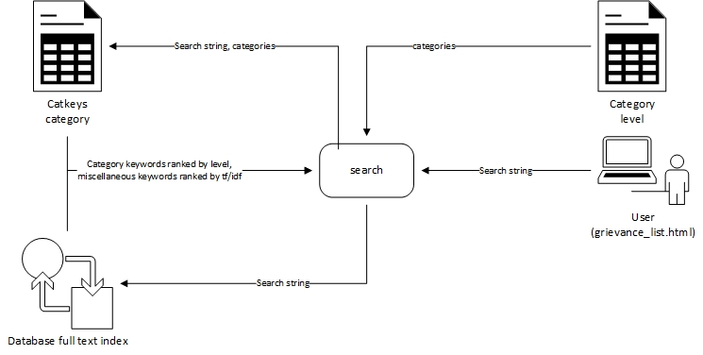

Grievance Solving (Walk-Through) Process

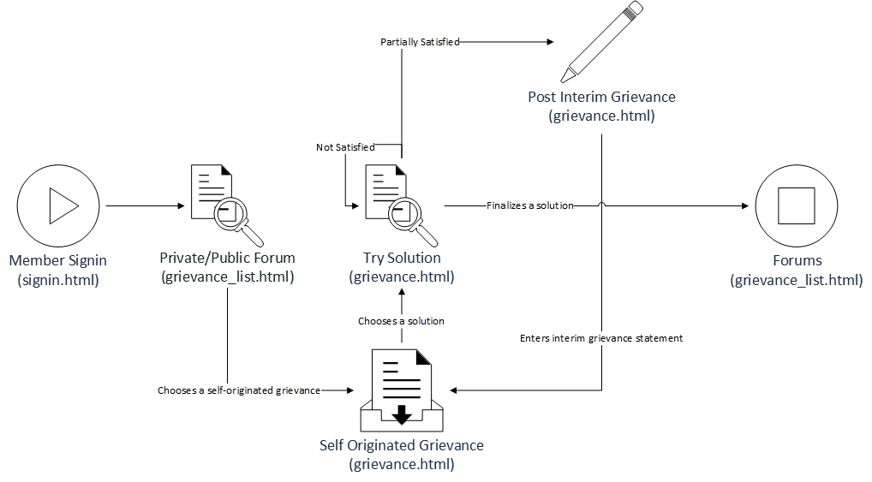

Once a Visitor signs in as a Member, sortmeout presents him with his Private Forum. He can choose any of his self-originated Grievances to expand its thread. If there Solutions have been posted to any of his outstanding Grievances, he may choose and try or request the execution (offline) of any of them one at a time until he encounters one of the Solutions that solves his Grievance. He may then continue the thread by writing a next level interim Grievance or close the thread by finalizing a Solution.

Solution ranking and sorting

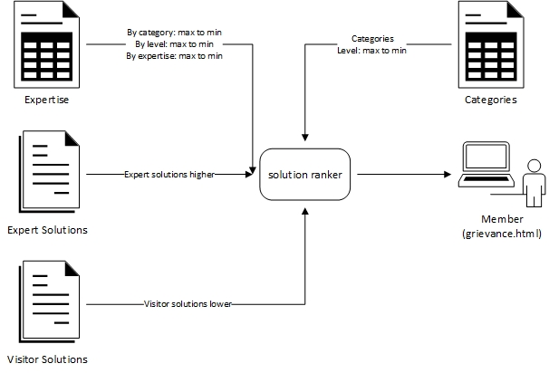

Whenever a Member expands his Grievance thread he would want any outstanding Solutions to be ranked for his comfort. The Solution Ranking module fetches the Category(ies) of the Grievance thread and identifies Solutions from Experts who have the highest Expertise (level + expertise) in the most specific Category(ies) and trailing off with Grievance level, and Expertise level and finally expertise. An unsorted list of Solutions from Visitors (i.e. simply Authors) may follow the list of Expert Solutions.