SMART CITIES • CIVIC TECHNOLOGY
CITY ISSUE
REPORTING DASHBOARD
Project Report
Report. Track. Resolve. Build Better Cities.

Project detail | Information
Domain | Smart Cities / Civic Technology / Urban Management
Technology | MongoDB • Express.js • React.js • Node.js (MERN)
Project type | Full-Stack Web Application
Team | Team name: 20
Institution | College name: Malla Reddy Technical Campus
Event | Hackathon : APEX Backend Engineering & Systems Challenge

Prepared as a college-level technical project report.
Project User interface Link : https://rampant-city-pulse-link.base44.app

02 | ABSTRACT

Abstract
Urban communities regularly encounter potholes, damaged roads, overflowing waste bins, broken streetlights, water leakage and blocked drainage. When reports are scattered across calls, messages or office visits, citizens may not know whether a complaint was received, and municipal teams may lack a single queue for review.
The City Issue Reporting Dashboard is proposed as a full-stack web application that centralizes civic issue reporting and management. A report can contain a title, description, category, location and optional image. Issues are presented in a dashboard and tracked through statuses such as Reported, In Progress and Resolved.
The MERN stack provides the technical foundation: React.js for the interface, Node.js and Express.js for server-side APIs, and MongoDB for persistent document storage. Image files should be stored in a dedicated service, with URLs and metadata recorded in MongoDB.

Keywords
Smart city, civic technology, issue reporting, MERN, REST API, CRUD, status tracking.

03 | INTRODUCTION

Introduction

Background
Cities depend on roads, drainage, streetlights, public spaces and waste services that need ongoing maintenance. Residents often notice issues first, but a useful process must capture the details, route the report to a responsible team and communicate progress.

Civic technology
Civic technology uses digital tools to improve public-service interaction. A centralized application can provide structured reports, consistent records and shared status visibility. It supports coordination but does not itself perform physical repairs.

Project overview
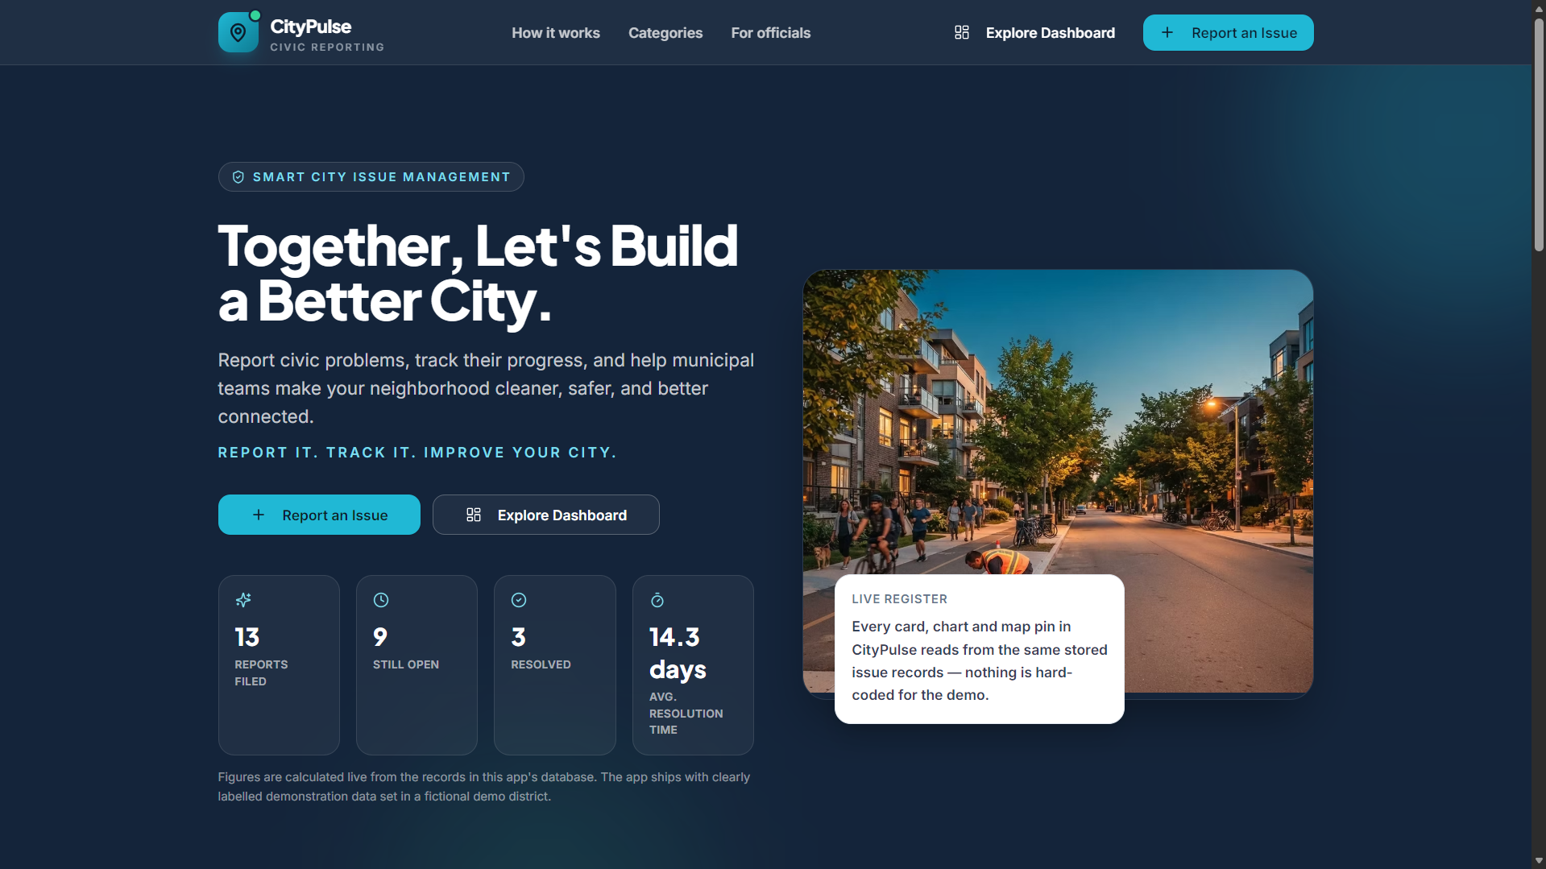
Figure 1. CityPulse public landing page introducing civic issue reporting.
Citizens submit and view reports; administrators review and update them. The backend enforces business rules, and MongoDB stores issue records and timestamps.

Report organization
The report covers requirements, architecture, data model, algorithms, implementation, testing, limitations, future enhancements and references.

04 | MOTIVATION AND CONTEXT

Motivation and Context

Why centralize?
A consistent reporting format makes records easier to search, filter and manage. Status updates can reduce uncertainty and provide a traceable history.

Example issues
Potholes and damaged roads; overflowing waste bins; broken streetlights; water leaks; blocked drains; damaged footpaths.

Stakeholder value
Citizens gain a clear reporting path. Administrators gain an organized queue. Evaluators can inspect a practical full-stack design. Future versions can add mapping and analytics.

Boundary
The application manages digital records. Physical inspection and repair depend on municipal operations and cannot be guaranteed by the software.

05 | PROBLEM STATEMENT

Problem Statement

Core problem
Citizens need a reliable way to report civic problems, while municipal teams need a structured way to receive, review, prioritize and update reports.

Challenges
No unified reporting channel; incomplete details; limited status visibility; difficulty filtering by category or area; inconsistent timestamps; limited structured data for analysis.

Problem definition
Design a secure, user-friendly web application for submitting structured civic reports and allowing authorized administrators to manage them through a centralized dashboard.

Constraints
Keep the solution feasible for a college project. Use common web technologies and distinguish implemented features from planned capabilities. Do not claim government integration without evidence.

06 | OBJECTIVES AND SCOPE

Objectives and Scope

Objectives
Provide a centralized report form; capture consistent fields; track status; enable authorized administration; persist data; build clear API boundaries; define repeatable tests.

In scope
Reporting form, issue list, categories, location, status tracking, filtering, administrative updates, REST APIs and MongoDB persistence.

Conditional scope
Authentication, analytics and image upload depend on actual implementation and configuration.

Out of scope
Guaranteed repairs, live government-system integration, AI classification, GPS routing or production-scale guarantees unless implemented and verified.

Success criteria
Valid reports can be created and retrieved; invalid input is rejected; restricted actions require permission; updates persist; errors are understandable.

07 | STAKEHOLDERS AND USE CASES

Stakeholders and Use Cases

Stakeholders
Citizens submit and track reports. Administrators review and update issues. Maintainers configure and secure the system. Municipal teams may integrate later. Evaluators review the demo and evidence.

Use cases
Register/sign in if supported; create report; view permitted issues; filter by category, location or status; administrator reviews; administrator updates; system rejects invalid or unauthorized requests.

Use-case boundary
The app manages the digital workflow. Field inspection, work assignment outside the app and confirmation of physical repairs remain external responsibilities unless integrated.

Example workflow
A resident reports a pothole with location and image. An administrator reviews it and changes status. The resident refreshes the report to see the latest recorded status.

08 | FEATURES AND FUNCTIONAL REQUIREMENTS

Features and Functional Requirements

Core features
Structured reporting; issue dashboard; status tracking; filtering; admin review; optional account authentication; optional analytics; optional image upload.

FR-01
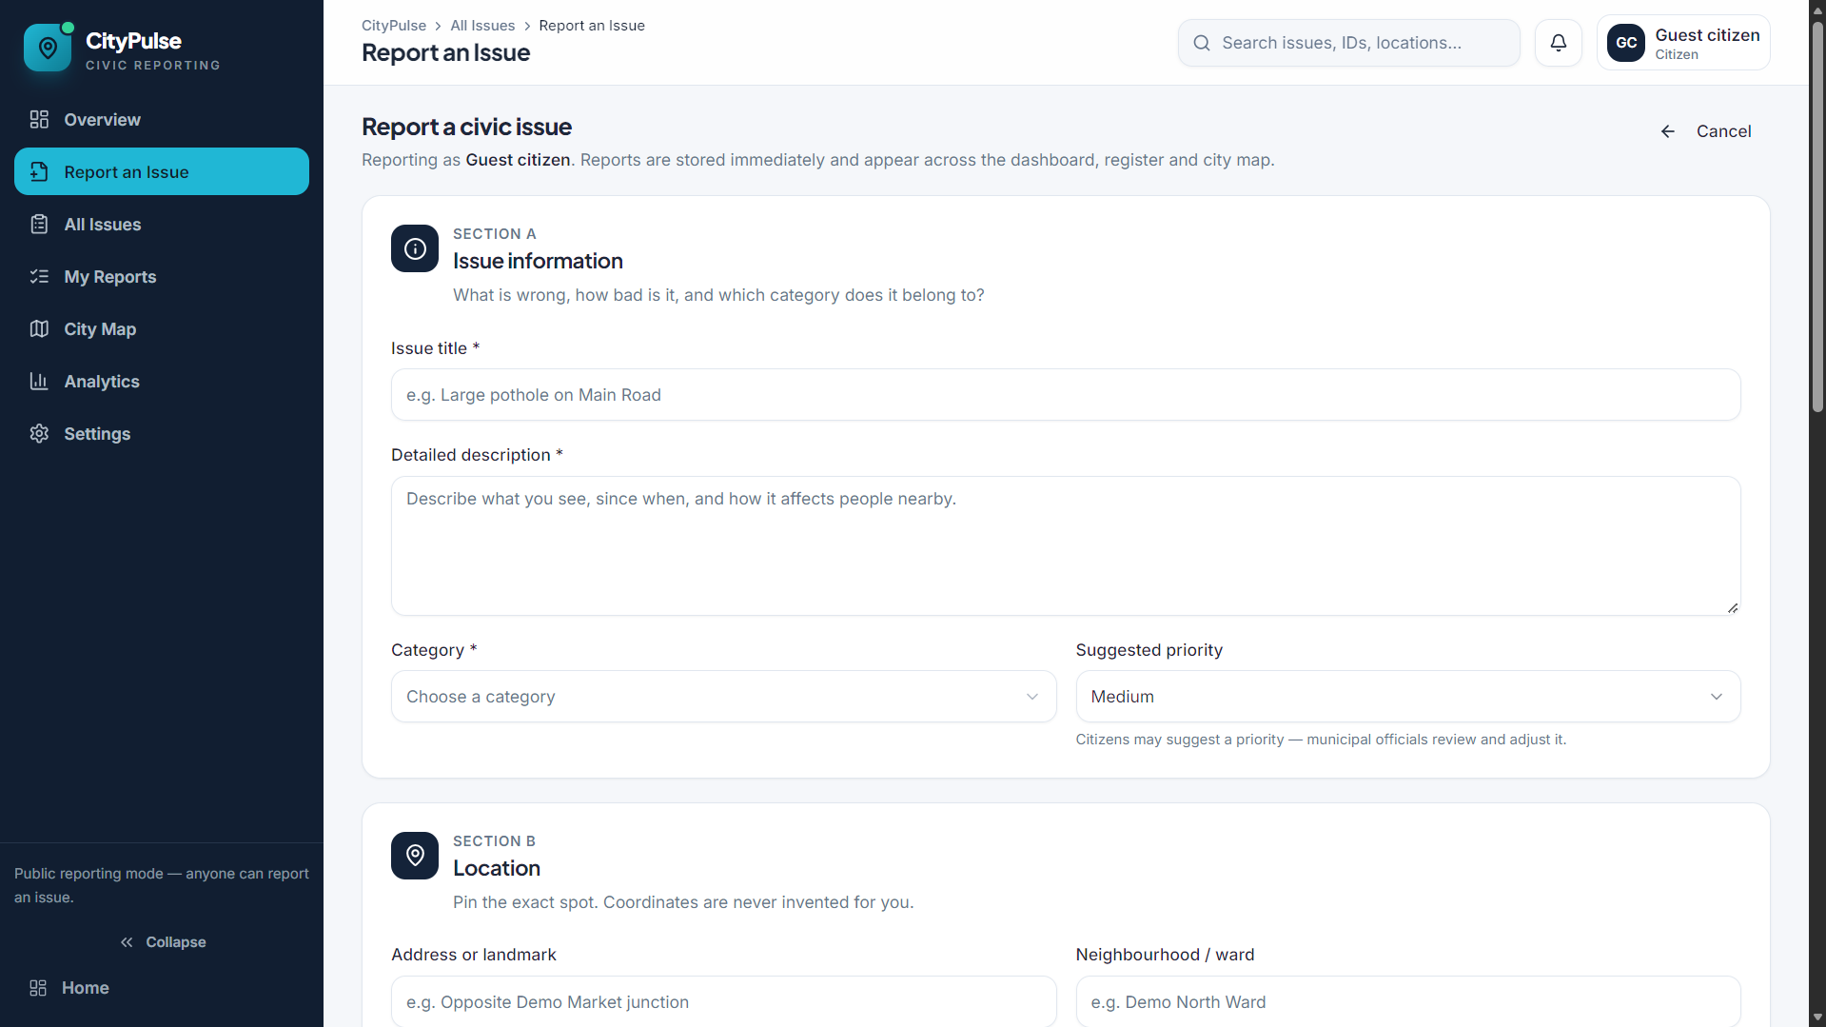
Figure 3. Civic issue submission form capturing issue details, category, priority and location.
The system shall accept a report only when required fields pass server-side validation.

FR-02
The system shall persist valid issue data in MongoDB and provide retrieval endpoints.

FR-03
The system shall support retrieval of a single issue by identifier.

FR-04
The system shall allow authorized updates to issue fields and status.

FR-05
The system shall restrict deletion and administrative actions according to policy.

FR-06
The system shall return useful validation and error responses.

Implementation note
Mark authentication, analytics and image upload as implemented only after inspecting the actual source code.

09 | NON-FUNCTIONAL REQUIREMENTS

Non-Functional Requirements

Usability
Use clear labels, required-field indicators, meaningful errors and responsive layouts. Status must be conveyed with text as well as color.

Reliability
Validate on the server, use consistent status values, record timestamps and handle missing records or database failures safely.

Security and privacy
Hash passwords if stored; protect routes; validate input; restrict uploads; keep secrets in environment variables; collect only necessary personal information.

Maintainability
Separate UI, routes, business logic, models and configuration. Add indexes and pagination when justified by real query patterns.

Accessibility
Use semantic headings, visible focus, sufficient contrast, keyboard-accessible controls and descriptive labels.

10 | SYSTEM ARCHITECTURE

System Architecture

Layers
React.js presentation layer; Node.js and Express.js API layer; MongoDB persistence layer; optional cloud image storage.

Request flow
React sends HTTP requests. Middleware validates identity, permission and payload. Application logic reads or updates MongoDB. Image flows store files externally and save their URL. The API returns a structured response.

Frontend responsibilities
Report form, citizen dashboard, admin dashboard, filters and status display.

Backend responsibilities
REST routing, validation, authentication, authorization, CRUD operations, error handling and image-storage coordination.

Architecture principle
The frontend must not connect directly to MongoDB. Credentials and business rules stay on the server.

11 | ALGORITHMS AND METHODOLOGY

Algorithms and Methodology

Overview
The baseline is a data-management workflow. Core logic includes validation, CRUD operations, filtering, status transitions and authorization checks.

Create algorithm
Receive payload; validate required fields and types; normalize text; check identity; set initial status; save record and timestamps; return record or safe error.

Update algorithm
Authenticate requester; verify permission; find issue; validate new status; update status and updatedAt; persist; return updated record.

Development method
Iteratively define requirements, design schema and API contract, build UI, connect backend, test each operation, fix defects and refine usability.

Methodology note
These are proposed algorithms and implementation guidance. Confirm actual behavior against the source code.

12 | VALIDATION, FILTERING AND STATUS LOGIC

Validation, Filtering and Status Logic

Validation
Client checks improve usability, but server-side validation is authoritative. Validate required fields, category, location format, image references, allowed status and user identity.

Filtering
Accept validated query parameters such as category, status and location. Build a predictable query and add pagination for large datasets.

Status model
A new report begins as Reported. An authorized administrator may move it to In Progress and then Resolved. Reopening a resolved issue requires a defined policy.

Data consistency
Set timestamps on the server. Derive reportedBy from the authenticated identity instead of trusting arbitrary client input.

Caution
Actual allowed transitions must match the implemented business rules.

13 | DATABASE DESIGN

Database Design

Issue fields
_id, title, description, category, location, imageUrl, status, reportedBy, createdAt and updatedAt.

Related collections
Users may contain a unique login identifier, password hash, role and timestamps. Categories may be stored separately or as controlled values.

Integrity
Use schema validation, consistent references, allowed status values and server-managed timestamps. Avoid unnecessary personal data.

Indexes
Consider indexes on fields used frequently for filtering, based on observed query patterns. Use pagination rather than returning every issue.

Example record
A synthetic issue could use title “Pothole near Main Road”, category “Road Damage”, location “Demo Ward 04” and status “Reported”. This is sample data, not a real complaint.

Illustrative JSON record
{
"title": "Pothole near Main Road",
"category": "Road Damage",
"location": "Demo Ward 04",
"status": "Reported",
"createdAt": "<server timestamp>"
}

14 | REST API DESIGN

REST API Design

Suggested endpoints
POST /api/issues — create; GET /api/issues — list/filter; GET /api/issues/:id — retrieve one; PUT /api/issues/:id — update; DELETE /api/issues/:id — delete when authorized.

Authentication endpoints
POST /api/auth/register and POST /api/auth/login may be included only if account authentication is implemented.

Conventions
Use JSON for ordinary request/response bodies. Return suitable status codes for success, validation failures, unauthorized requests and missing records.

CRUD mapping
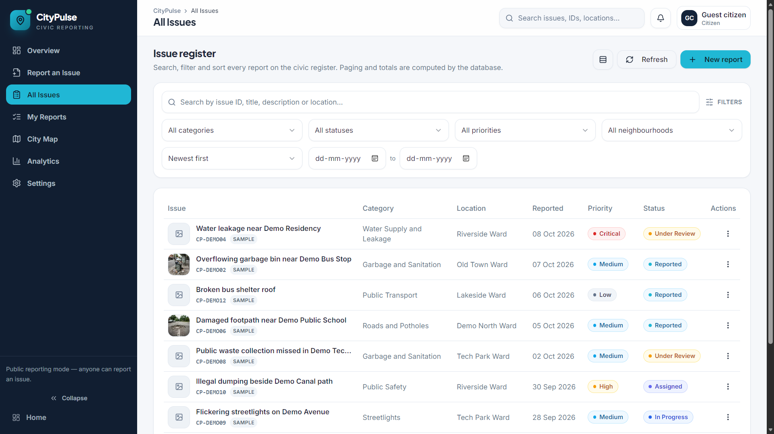
Figure 4. Issue register with search, filters, status, priority and report actions.
Create maps to POST; Read maps to GET; Update maps to PUT or PATCH; Delete maps to DELETE.

Verification
These paths are a proposed API contract. Reconcile them with the actual route definitions before submission.
Method | Endpoint | Purpose
POST | /api/issues | Create report
GET | /api/issues | List / filter
GET | /api/issues/:id | Read one
PUT | /api/issues/:id | Update
DELETE | /api/issues/:id | Delete if authorized

15 | FRONTEND IMPLEMENTATION

Frontend Implementation

React structure
Separate reusable components, page views, API calls and form logic.

Suggested components
IssueReportForm; IssueList or IssueCard; StatusBadge; IssueFilters; CitizenDashboard; AdminDashboard; API service module.

User experience
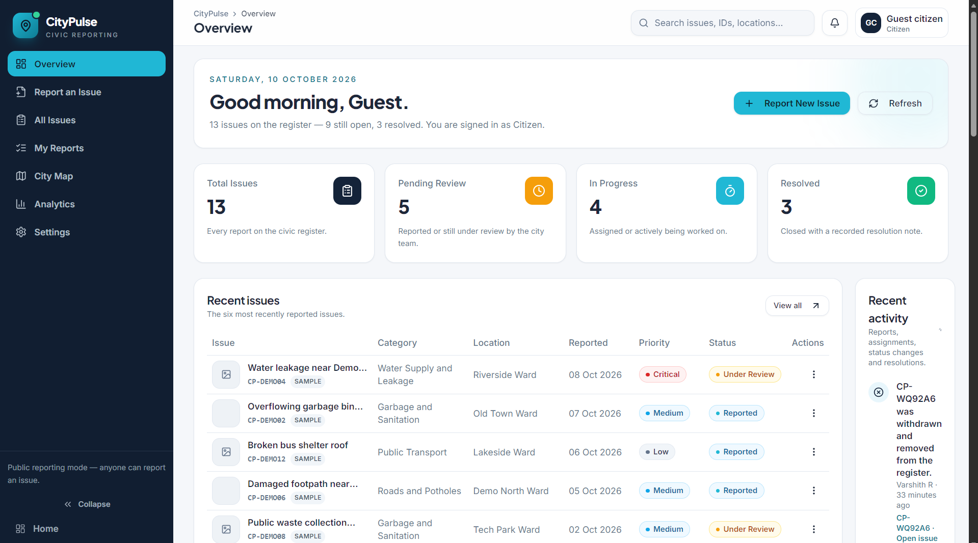
Figure 2. Overview dashboard with issue summary cards, recent reports and activity.
Show loading, success, empty and error states. Confirm destructive actions. Keep layouts responsive and status labels readable.

API integration
Use a configured API base URL, handle failed responses and network errors, and update the UI only when the backend confirms changes.

Visual design
A dark navy, white and cyan theme can provide a modern civic-tech identity. Prioritize issue title, category, location, status and last update.

16 | BACKEND IMPLEMENTATION

Backend Implementation

Node and Express
Node.js runs server-side JavaScript; Express provides routing and middleware. The backend enforces rules, validates requests and coordinates storage.

Suggested modules
Routes map paths to handlers; controllers shape responses; models define documents; middleware handles auth and parsing; services hold reusable logic; configuration manages environment values.

Error handling
Use consistent error responses. Expected errors should be clear. Unexpected errors should be logged server-side without exposing stack traces or secrets.

Configuration
Store connection strings and signing secrets in environment variables. Keep local secret files out of version control and use least-privilege credentials.

Image handling
If implemented, validate size and file type, generate safe names and use dedicated storage. Save the URL or identifier and relevant metadata in MongoDB.

17 | SECURITY AND PRIVACY

Security and Privacy

Authentication vs authorization
Authentication establishes identity; authorization controls permitted actions. Backend role checks must prevent citizens from invoking administrator functions.

Credential protection
Never store plaintext passwords. Use a recognized password-hashing library. Validate JWT claims or configure secure session cookies according to the chosen design.

Request protection
Validate fields and statuses; avoid unsafe query construction; limit body and upload sizes; verify uploaded content; protect administrative endpoints.

Privacy
Location and images can expose sensitive context. Collect only necessary data and define access, retention and deletion policies.

Status of controls
Security items are requirements until verified in code and tested. Do not describe them as completed without evidence.

18 | TESTING STRATEGY

Testing Strategy

Objectives
Test normal behavior, invalid input, persistence, filtering, permissions and error handling. The cases below are a test plan, not proof of passing results.

TC-01
Submit valid issue — expected: record is saved and returned.

TC-02
Submit without title — expected: validation error and no invalid record.

TC-03
Retrieve issue list — expected: permitted records returned.

TC-04
Retrieve unknown ID — expected: not-found response.

TC-05
Admin updates status — expected: valid update persists.

TC-06
Unauthorized citizen updates status — expected: request rejected.

TC-07
Unsupported upload — expected: upload rejected safely.

Test levels
Unit tests for validation; API integration tests; UI tests; authorization tests; manual end-to-end acceptance tests.

19 | TEST DATA AND ACCEPTANCE

Test Data and Acceptance

Synthetic data
Pothole near junction / Road Damage / Demo Ward 04; overflowing public bin / Sanitation / Demo Park Entrance; streetlight not working / Electrical / Demo Street 02; leaking pipe / Water Supply / Demo Block B; blocked drain / Drainage / Demo Lane 7.

Acceptance checklist
Valid report appears after creation; direct API requests cannot bypass validation; filters return matching records; status persists; unauthorized actions fail; errors do not expose internals; UI works on mobile and desktop.

Defect tracking
Record title, reproduction steps, expected and actual behavior, severity, environment and fix. Re-run related tests after changes.

Evidence
Use real app screenshots, API test output and database records when available. Clearly distinguish prototype mockups from live application evidence.

20 | RESULTS, TESTING AND PERFORMANCE

Results, Testing and Performance

Evidence status
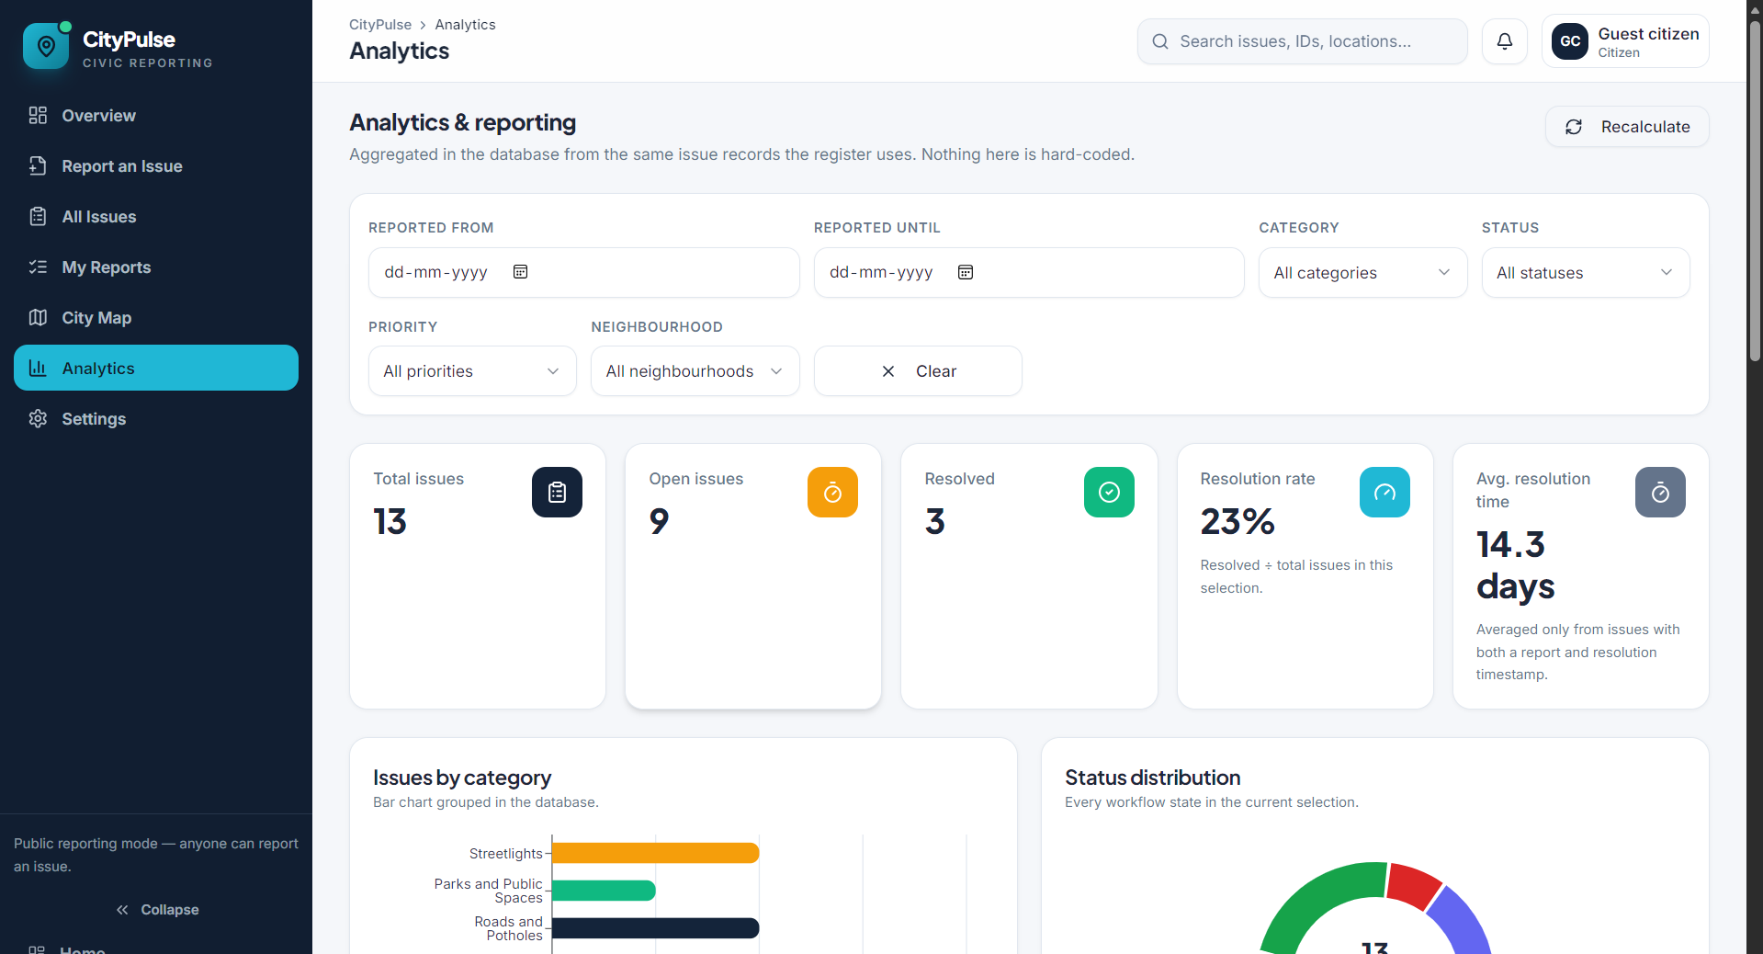
Figure 6. Analytics dashboard showing issue totals, status distribution and category summaries.
No source repository, running app, test logs or measured performance data were supplied for this report. Therefore, no tests are claimed to have passed and no deployment or performance metrics are asserted.

Measures to record
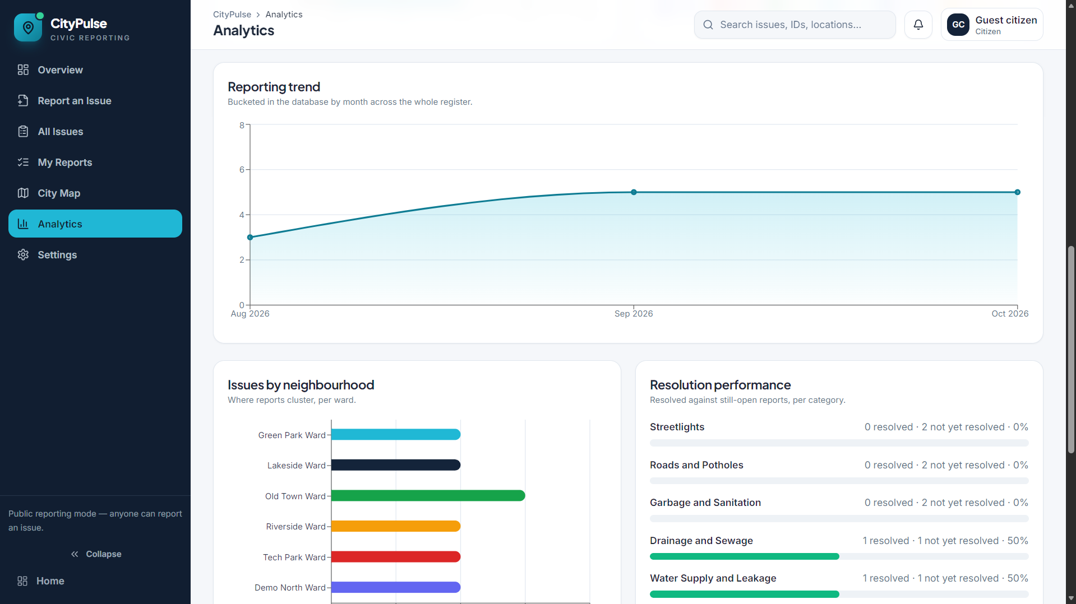
Figure 7. Analytics trend, neighbourhood distribution and resolution performance views.
Functional coverage; API response time; request error rate; filtering correctness; authorization outcomes; responsive behavior.

Method
Define device, browser, host, database tier and network. Use repeatable data. Measure repeated requests and report median and high-percentile latency where appropriate.

Performance considerations
Test common list and filter queries at documented data volumes. Record resource use only when monitoring is available.

Interpretation
Correctness, clear architecture, validation and access control are useful initial criteria. Quantitative claims should follow measurements, not assumptions.
Measure | Result
Functional coverage | Not measured
API response time | Not measured
Error rate | Not measured
Authorization tests | Not measured

21 | DISCUSSION AND LIMITATIONS

Discussion and Limitations

Expected strengths
Centralized records; clearer status visibility; modular JavaScript stack; flexible document storage; separate frontend and backend testing.

Limitations
The app cannot guarantee physical repair. Reports may be inaccurate or duplicated. Location can be imprecise. Image storage requires correct configuration. Analytics depend on accurate records.

Operational considerations
A municipal rollout needs department ownership, categories, escalation rules, privacy policy, retention, accessibility and staff training.

Ethical considerations
Support residents with different accessibility and connectivity needs. Avoid unnecessary exposure of personal details. A digital status is not proof of physical repair unless verified.

Production readiness
A real deployment needs further security, accessibility, operational and load testing.

22 | IMPLEMENTATION PLAN AND FEASIBILITY

Implementation Plan and Feasibility

Phase 1 — Requirements
Confirm roles, fields, status rules and scope.

Phase 2 — Data and API
Design schemas, routes, validation and API contract.

Phase 3 — Frontend
Build reporting form, issue list, filters and status views.

Phase 4 — Integration
Connect interface to API and database.

Phase 5 — Security and tests
Verify authentication, roles, upload restrictions and test cases.

Phase 6 — Demo
Prepare synthetic records and explain implemented versus planned features.

Feasibility
MERN is suitable for a college-scale web application. Tools include a code editor, Node.js, package manager, MongoDB, browser and API testing tool. Hosted image storage is optional for a local demo.

23 | FUTURE SCOPE

Future Scope

Interactive map
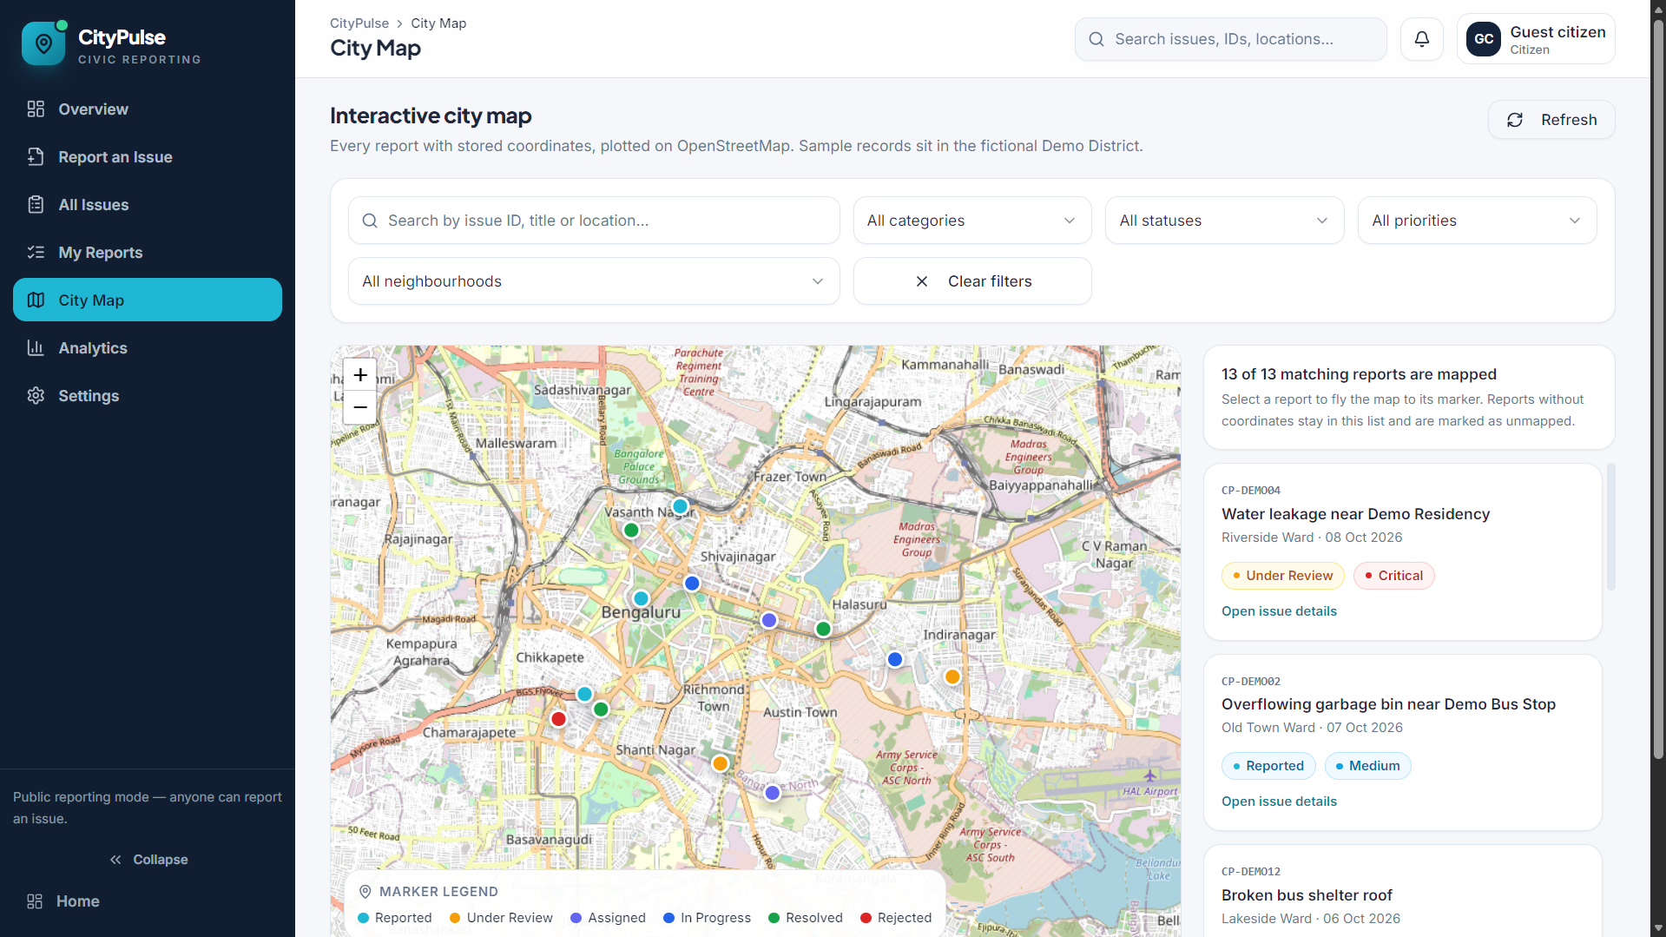
Figure 5. City map showing issue markers and a matching report list.
Display issue markers, cluster nearby reports and reveal spatial patterns; requires coordinates, map integration and privacy controls.

Priority scoring
Combine category, risk, affected area, age and verified urgency. Scores should be explainable and support, not replace, human judgment.

Duplicate detection
Compare text, category, time and geographic proximity. Suggest potential matches for human review rather than silently discarding reports.

Mobile PWA
Improve mobile access and potentially support offline drafting with explicit synchronization and conflict rules.

Notifications and analytics
Add status notifications, department assignment, escalation, resolution-time reports, privacy-aware summaries and audit trails.

Roadmap
Prioritize enhancements by user value, feasibility, privacy and maintenance cost.

24 | CONCLUSION

Conclusion

Summary
The City Issue Reporting Dashboard addresses the need to capture civic problems consistently and make digital progress easier to follow. It connects a citizen-facing reporting interface with an administrative workflow.

Technology
React.js supports the UI, Express.js and Node.js handle APIs and business logic, and MongoDB stores issue records. A dedicated image service is appropriate for uploaded media.

Quality factors
The solution depends on validation, status logic, secure authentication, role-based authorization, error handling and repeatable testing—not just visual design.

Honest reporting
Actual test outcomes and performance measurements must be added after execution in a documented environment. Prototype visuals must not be represented as live application screenshots.

Final statement
Smarter Reporting. Faster Action. Better Cities.

25 | REFERENCES AND APPENDIX

References and Appendix

Technical references
MongoDB Manual — https://www.mongodb.com/docs/

Technical references
Express.js documentation — https://expressjs.com/

Technical references
React documentation — https://react.dev/

Technical references
Node.js documentation — https://nodejs.org/docs/

Technical references
MDN Web Docs, HTTP — https://developer.mozilla.org/en-US/docs/Web/HTTP

Security reference
OWASP Top 10 — https://owasp.org/www-project-top-ten/

Security reference
OWASP File Upload Cheat Sheet — https://cheatsheetseries.owasp.org/cheatsheets/File_Upload_Cheat_Sheet.html

Security reference
OWASP Password Storage Cheat Sheet — https://cheatsheetseries.owasp.org/cheatsheets/Password_Storage_Cheat_Sheet.html

Submission checklist
Fill team and college details; verify routes against code; execute tests and record outcomes; add genuine screenshots; report performance only with methodology; check formatting and references.

Implementation note
Suggested endpoints, controls and future features are guidance unless confirmed by the actual implementation. Update the report to reflect the final application honestly.

