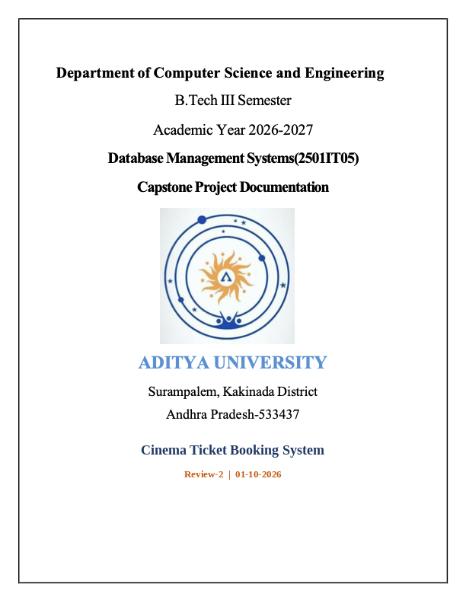

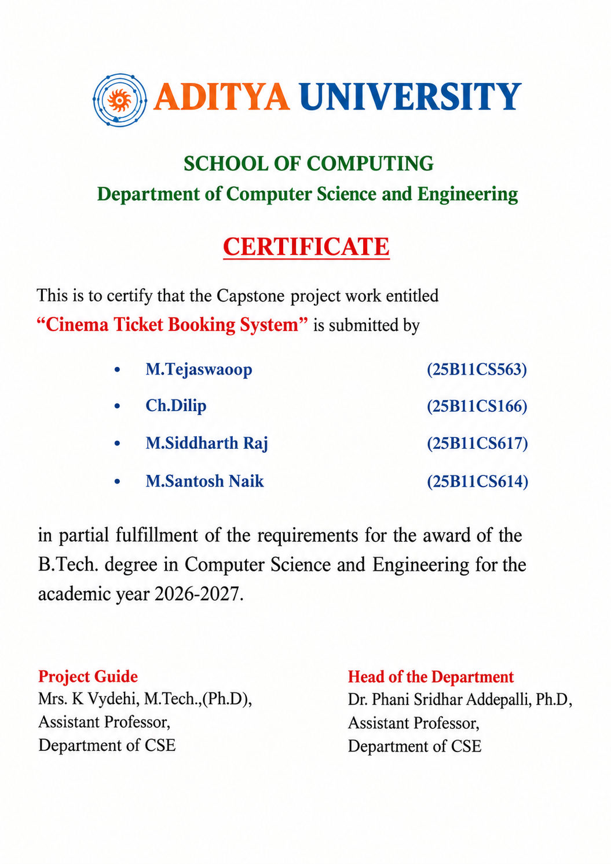

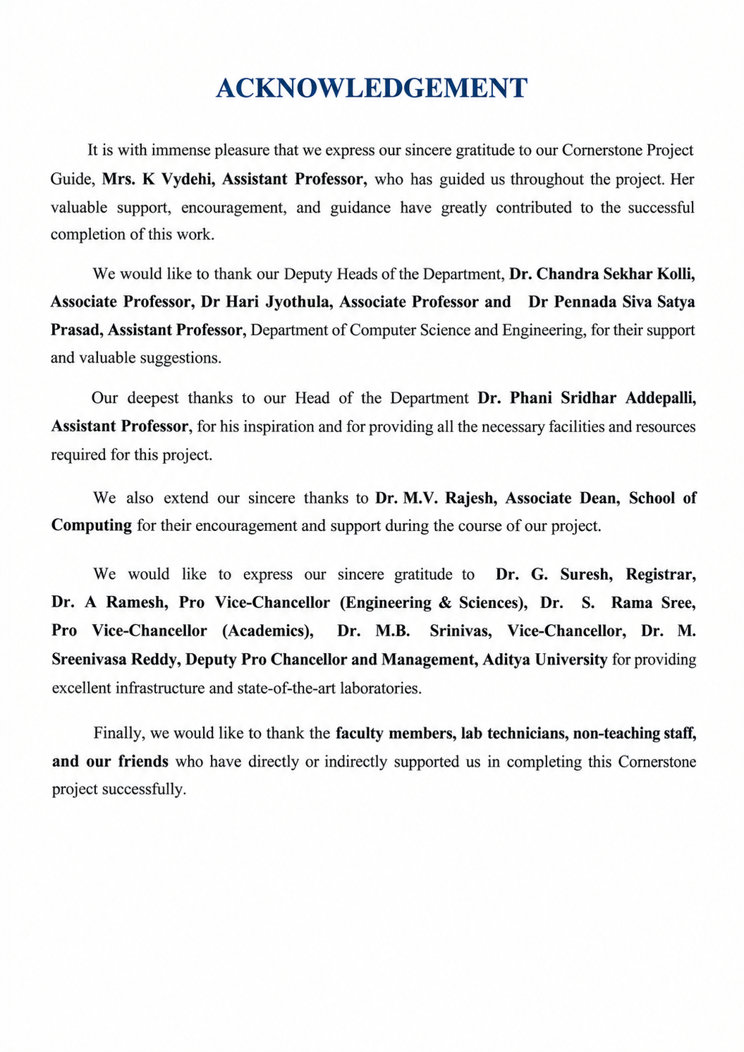
TABLE OF CONTENTS
1. Abstract
2. Introduction
3. System Analysis
4. Database Design
5. ER Diagram
6. Relational Schema
7. Table Design
8. Normalization
9. SQL Implementation
10. SQL Queries and Outputs
11. Conclusion
12. Future Enhancements
13. References
LIST OF FIGURE
Figure 1. ER representation of the Cinema Ticket Booking System

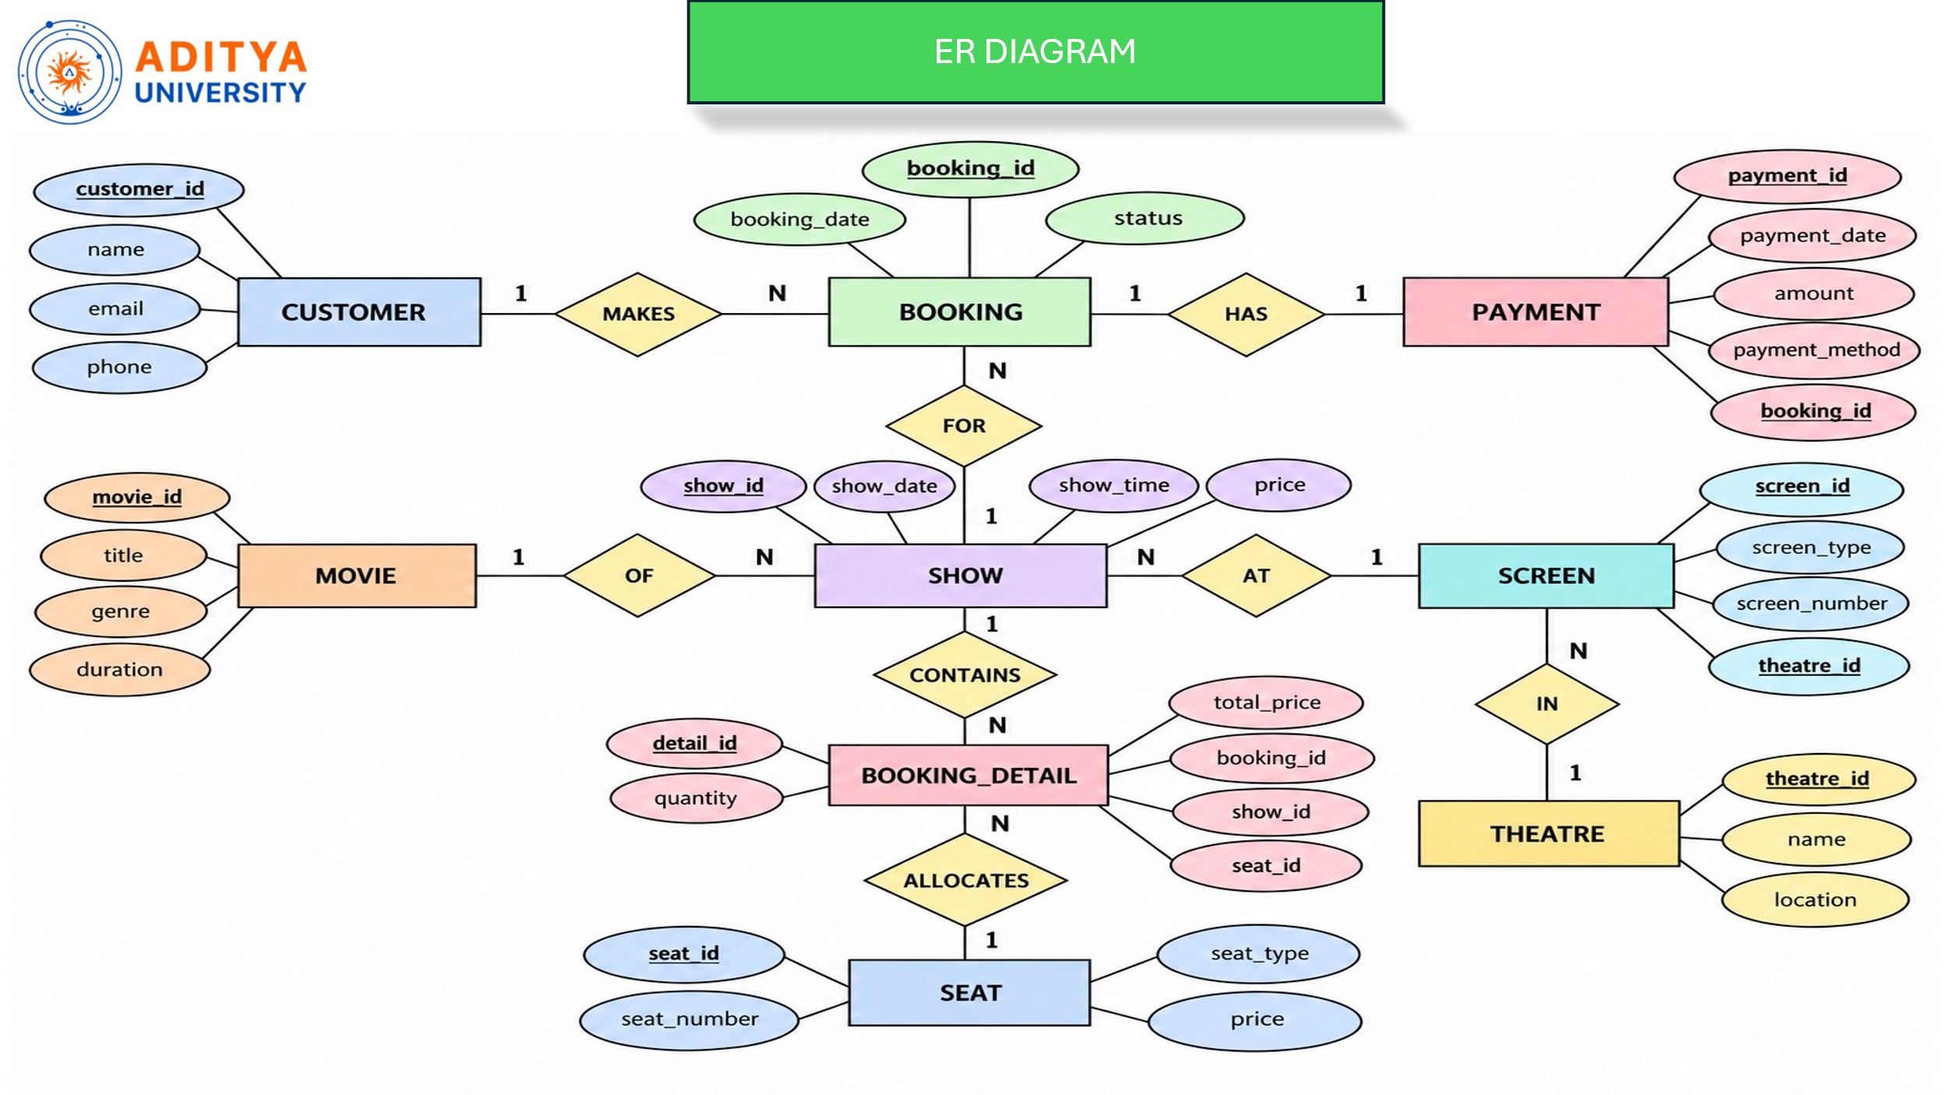
LIST OF TABLES
Table 1. Major functional modules and requirements
Table 2. Major entities and their purposes
Table 3. Relationships and cardinalities
Table 4. Relational schema
Table 5. CUSTOMER table structure
Table 6. BOOKING table structure
Table 7. PAYMENT table structure
Table 8. MOVIE table structure
Table 9. SHOW table structure
Table 10. SCREEN table structure
Table 11. THEATRE table structure
Table 12. BOOKING_DETAIL table structure
Table 13. SEAT table structure
Table 14. Constraints used
Table 15. Anomalies addressed through normalization
Table 16. Sample record counts
Table 17. Key SQL outputs
ACRONYMS
DBMS — Database Management System
ER — Entity Relationship
SQL — Structured Query Language
DDL — Data Definition Language
DML — Data Manipulation Language
DQL — Data Query Language
PK — Primary Key
FK — Foreign Key
1NF — First Normal Form
2NF — Second Normal Form
3NF — Third Normal Form

1. ABSTRACT
The Cinema Ticket Booking System is a centralized relational database designed to manage customers, movies, shows, theatres, screens, seats, bookings, booking details, and payments. The supplied project identifies common problems in manual cinema ticket operations, including long queues, difficulty checking seat availability, incorrect seat allocation, duplicate reservations, manual show management, scattered payment records, and complicated cancellation tracking. The proposed database organizes these activities using related tables connected through primary and foreign keys.
The implementation follows a structured relational design and demonstrates SQL operations for data definition, insertion, filtering, ordering, joins, grouping, aggregation, subqueries, and existence checks. The project contains nine entities and documents normalization through 1NF, 2NF, and 3NF to reduce redundancy and prevent insertion, update, and deletion anomalies. The query set reports customer bookings, movie duration, show pricing, payment methods, theatre and screen information, unpaid customers, theatres without shows, and total booking amounts, providing a practical DBMS representation of cinema operations.

2. INTRODUCTION

2.1 Project Overview
The Cinema Ticket Booking System provides a structured database for managing ticket-booking activities in a cinema environment. It maintains customer details, movie information, show schedules, theatre and screen details, seat information, bookings, booking details, and payment records. A centralized database enables these related records to be stored consistently and retrieved through SQL queries instead of relying on separate manual records.

2.2 Problem Statement
• Long queues: Manual ticket booking can require customers to wait at the theatre counter.
• Seat availability issues: Customers may not have a convenient way to know which seats are available before booking.
• Booking errors: Manual booking can lead to incorrect seat allocation or duplicate reservations.
• Difficulty managing shows: Managing movies, show timings, screens, and seat availability manually can be time-consuming.
• Payment and booking records: Maintaining customer booking and payment records manually can be difficult.
• Cancellation management: Tracking cancelled tickets and updating seat availability can become complicated.
• Data management: A centralized database makes it easier to store, update, search, and retrieve cinema and booking information.

2.3 Objectives
• Develop a simple and user-friendly cinema ticket booking system.
• Maintain customer details efficiently using a database.
• Manage movie information and available show timings.
• Provide easy seat selection and booking facilities.
• Maintain accurate booking and payment records.
• Reduce errors and duplicate seat reservations.
• Allow administrators to manage movies, shows, theatres, and bookings.
• Use SQL database operations for efficient storage, updating, searching, and retrieval of cinema-related information.

2.4 Scope
The project scope covers customer, movie, show, theatre, screen, seat, booking, booking-detail, and payment management. The database provides the foundation for ticket search, seat selection, reservation recording, payment tracking, booking-status management, and administrative reporting. The system can later be connected to a web or mobile user interface and extended with live seat locking, automated notifications, refund processing, richer security controls, and operational analytics.

3. SYSTEM ANALYSIS

3.1 Existing System
• Manual record maintenance for customers, shows, seats, and bookings.
• Customers may need to depend on counter staff for current seat availability.
• Repeated customer and booking information increases the possibility of inconsistent records.
• Manual handling can produce duplicate or incorrect seat allocations.
• Payment and cancellation information may be scattered across separate records.
• Generating consolidated reports for shows, theatres, payments, and booking amounts is time-consuming.

3.2 Proposed System
The proposed system uses a centralized relational database in which each major real-world object is represented by a table. Customer, booking, payment, movie, show, screen, theatre, booking-detail, and seat information are stored separately and linked through primary and foreign keys. This structure makes it possible to retrieve related information through JOIN operations while maintaining clear ownership of each data item.

3.3 Functional Requirements
Module | Functional Requirement
User Registration/Login | Manage customer accounts and identify customers for booking activities.
Movie & Show Management | Add, update, and view movies and show timings.
Seat Booking | View available seats and record seat selections for a show.
Payment Management | Record ticket payments and payment methods associated with bookings.
Booking Management | Create, view, and cancel bookings while maintaining booking status.
Theatre & Screen Management | Maintain theatres, screen numbers, screen types, and their relationships.
Reporting | Use SQL queries to generate booking, payment, show, theatre, and customer reports.

3.4 Non-Functional Requirements
• Usability: The database-backed system should support simple and user-friendly booking operations.
• Security: Customer and booking information should be protected through controlled access and appropriate authorization.
• Reliability: Booking records should be maintained accurately and should prevent duplicate or incorrect reservations.
• Performance: Customer, movie, show, theatre, seat, and booking queries should return records efficiently.
• Data Integrity: Primary-key and foreign-key constraints should maintain valid relationships among the nine tables.
• Scalability: The design should allow the number of customers, shows, seats, and bookings to grow without changing the core relational structure.

3.5 End Users
User | Main Interaction
Customers | Search movies, select seats, make bookings, review booking status, and make payments.
Administrator | Manage movies, shows, seats, theatres, screens, customers, bookings, and payments.

3.6 Development Methodology
• Requirement analysis identifies the operational problems, system objectives, user roles, and required functions.
• Conceptual design represents cinema objects as entities and defines their relationships and cardinalities.
• Relational mapping converts the ER model into tables with primary and foreign keys.
• Normalization organizes the relations through 1NF, 2NF, and 3NF to reduce redundancy and anomalies.
• SQL implementation creates the tables, loads sample data, and demonstrates retrieval through 15 queries.
• Validation compares the displayed query results with the sample records and the relationships shown in the supplied presentation.

3.7 Requirements Specification
The following requirements describe the minimum recommended setup for working with the cinema ticket booking database project.
Category | Requirement
Processor | Intel i3 or above
RAM | Minimum 4 GB
Storage | Adequate storage for the Oracle database, SQL scripts, and sample records
Operating System | Windows 10/11 or equivalent
Database | Oracle Database
Development Environment | Oracle SQL Developer / SQL*Plus

4. DATABASE DESIGN

4.1 Major Entities
Entity | Purpose
CUSTOMER | Stores customer identity and contact information.
BOOKING | Stores each customer booking, booking date, status, and customer reference.
PAYMENT | Stores payment date, amount, payment method, and booking reference.
MOVIE | Stores movie title, genre, and duration.
SHOW | Stores show date, show time, price, and references to the movie and screen.
SCREEN | Stores screen type, screen number, and theatre reference.
THEATRE | Stores theatre name and location.
BOOKING_DETAIL | Stores quantity, total price, and references to booking, show, and seat.
SEAT | Stores seat number, price, and seat type.

4.2 Relationships and Cardinality
Relationship | Cardinality | Description
CUSTOMER → BOOKING | 1 : N | One customer can make many bookings; each booking belongs to one customer.
BOOKING → PAYMENT | 1 : 1 | One booking has one payment; each payment is associated with one booking.
BOOKING → SHOW | N : 1 | Many bookings can be associated with the same show; booking details identify the show involved.
MOVIE → SHOW | 1 : N | One movie can have many shows; each show is for one movie.
SHOW → SCREEN | N : 1 | Many shows can occur on the same screen; each show takes place on one screen.
SCREEN → THEATRE | N : 1 | A theatre can have many screens; each screen belongs to one theatre.
SHOW → BOOKING_DETAIL | 1 : N | One show can have many booking details; each booking detail belongs to one show.
BOOKING_DETAIL → SEAT | N : 1 | Many booking details can refer to a seat at different shows; each booking detail refers to one seat.

5. ER DIAGRAM
The following diagram is the documentation representation derived directly from the nine entities, foreign keys, and relationship cardinalities presented in the supplied cinema-ticket-booking project.
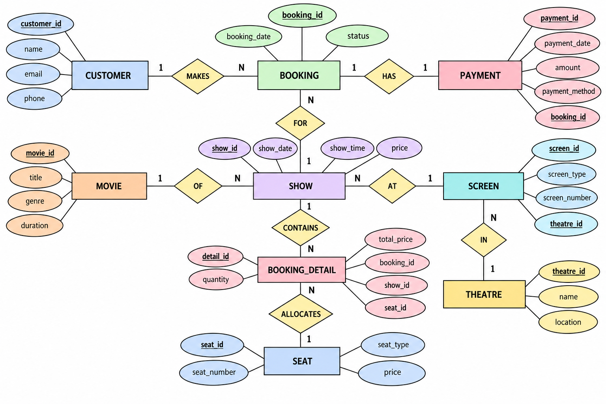
Figure 1. ER representation of the Cinema Ticket Booking System
The ER model shows CUSTOMER making BOOKING records; BOOKING is associated with PAYMENT and SHOW activity; MOVIE defines SHOW content; SHOW occurs on a SCREEN; SCREEN belongs to a THEATRE; and BOOKING_DETAIL connects bookings and shows to individual SEAT records. Primary-key attributes are underlined in the supplied diagram, while foreign-key references connect related entities.

6. RELATIONAL SCHEMA
Relation | Relational Schema
CUSTOMER | customer_id (PK), name, email, phone
BOOKING | booking_id (PK), booking_date, status, customer_id (FK)
PAYMENT | payment_id (PK), payment_date, amount, payment_method, booking_id (FK)
MOVIE | movie_id (PK), title, genre, duration
SHOW | show_id (PK), show_date, show_time, price, movie_id (FK), screen_id (FK)
SCREEN | screen_id (PK), screen_type, screen_number, theatre_id (FK)
THEATRE | theatre_id (PK), name, location
BOOKING_DETAIL | detail_id (PK), quantity, total_price, booking_id (FK), show_id (FK), seat_id (FK)
SEAT | seat_id (PK), seat_number, price, seat_type

PK = Primary Key; FK = Foreign Key. The relational schema preserves the entity attributes stated in the supplied presentation and carries relationship references through foreign keys.

7. TABLE DESIGN

7.1 CUSTOMER
Attribute | Data Type | Constraint | Description
customer_id | INT | PK | Unique customer identifier
name | VARCHAR2(30) | — | Customer name
email | VARCHAR2(30) | — | Customer email address
phone | VARCHAR2(15) | — | Customer contact number

7.2 BOOKING
Attribute | Data Type | Constraint | Description
booking_id | INT | PK | Unique booking identifier
booking_date | DATE | — | Date on which the booking is recorded
status | VARCHAR2(30) | — | Booking status such as CONFIRMED, PENDING, or CANCELLED
customer_id | INT | FK | References CUSTOMER(customer_id)

7.3 PAYMENT
Attribute | Data Type | Constraint | Description
payment_id | INT | PK | Unique payment identifier
payment_date | DATE | — | Date on which payment is recorded
amount | INT | — | Payment amount
payment_method | VARCHAR2(30) | — | Method used for payment
booking_id | INT | FK | References BOOKING(booking_id)

7.4 MOVIE
Attribute | Data Type | Constraint | Description
movie_id | INT | PK | Unique movie identifier
title | VARCHAR2(30) | — | Movie title
genre | VARCHAR2(30) | — | Movie genre
duration | INT | — | Movie duration in minutes

7.5 SHOW
Attribute | Data Type | Constraint | Description
show_id | INT | PK | Unique show identifier
show_time | TIMESTAMP | — | Scheduled show date and time
price | INT | — | Ticket price for the show
show_date | DATE | — | Date of the show
movie_id | INT | FK | References MOVIE(movie_id)
screen_id | INT | FK | References SCREEN(screen_id)

7.6 SCREEN
Attribute | Data Type | Constraint | Description
screen_id | INT | PK | Unique screen identifier
screen_type | VARCHAR2(30) | — | Screen type such as IMAX, 2D, or 3D
screen_number | INT | — | Screen number within the theatre
theatre_id | INT | FK | References THEATRE(theatre_id)

7.7 THEATRE
Attribute | Data Type | Constraint | Description
theatre_id | INT | PK | Unique theatre identifier
name | VARCHAR2(40) | — | Theatre name
location | VARCHAR2(40) | — | Theatre location

7.8 BOOKING_DETAIL
Attribute | Data Type | Constraint | Description
detail_id | INT | PK | Unique booking-detail identifier
quantity | INT | — | Number of seats/items represented by the detail
total_price | INT | — | Total price for the booking detail
booking_id | INT | FK | References BOOKING(booking_id)
show_id | INT | FK | References SHOW(show_id)
seat_id | INT | FK | References SEAT(seat_id)

7.9 SEAT
Attribute | Data Type | Constraint | Description
seat_id | INT | PK | Unique seat identifier
seat_number | INT | — | Seat number within a screen
price | INT | — | Base seat price
seat_type | VARCHAR2(30) | — | Seat type such as REGULAR, PREMIUM, or RECLINER

7.10 Constraints Used
Constraint | Where Used | Purpose
PRIMARY KEY (PK) | All 9 tables | Uniquely identifies each record.
FOREIGN KEY (FK) | SCREEN, SEAT, SHOW, BOOKING, BOOKING_DETAIL, PAYMENT | Connects related tables and maintains referential relationships.
NOT NULL | Not explicitly used in the supplied code | Prevents a column from having NULL values.
UNIQUE | Not explicitly used | Prevents duplicate values when defined.
CHECK | Not explicitly used | Restricts values according to a defined condition.

8. NORMALIZATION
Normalization is applied step-by-step to organize the cinema database, reduce data redundancy, and prevent insertion, update, and deletion anomalies. The presentation demonstrates the process using 1NF, 2NF, and 3NF with examples involving CUSTOMER and BOOKING relations.

8.1 Unnormalized Form (UNF)
An unnormalized cinema booking record can combine customer, booking, payment, movie, show, screen, theatre, booking-detail, and seat facts in one large record. Such a flat structure repeats customer and booking information whenever the same customer makes more than one booking and mixes facts that have different dependencies.
CINEMA_BOOKING_DATA(
customer_id, name, email, phone,
booking_id, booking_date, status,
payment_id, payment_date, amount, payment_method,
movie_id, title, genre, duration,
show_id, show_date, show_time, price,
screen_id, screen_type, screen_number,
theatre_id, theatre_name, location,
detail_id, quantity, total_price,
seat_id, seat_number, seat_price, seat_type
)

8.2 First Normal Form (1NF)
• All attributes contain atomic (single) values.
• There are no repeating groups or multi-valued attributes.
• Each record can be identified by a primary key.
• Separate relations are used for entities such as CUSTOMER, MOVIE, BOOKING, and SEAT.
• Appropriate data types are assigned to each column.
In the supplied presentation, CUSTOMER and MOVIE are shown as 1NF relations with atomic attributes. CUSTOMER stores one customer per row, while MOVIE stores one movie per row with a single title, genre, and duration value.
CUSTOMER_ID | NAME | EMAIL | PHONE
1 | Rahul | rahul@gmail.com | 9876543210
2 | Priya | priya@gmail.com | 9876543211
3 | Arjun | arjun@gmail.com | 9876543212
4 | Sneha | sneha@gmail.com | 9876543213
5 | Kiran | kiran@gmail.com | 9876543214

MOVIE_ID | TITLE | GENRE | DURATION
301 | Interstellar | Sci-Fi | 169
302 | Inception | Sci-Fi | 148
303 | Avengers | Action | 143
304 | Joker | Drama | 122

8.3 Second Normal Form (2NF)
The supplied normalization example shows a combined 1NF relation containing BOOKING and CUSTOMER information. Customer attributes are stored separately in CUSTOMER, while BOOKING retains customer_id as a foreign key. This removes the repeated customer details from every booking record and produces a cleaner dependency structure.
BOOKING_ID | BOOKING_DATE | STATUS | CUSTOMER_ID
501 | 09-SEP-26 | CONFIRMED | 1
502 | 09-SEP-26 | CONFIRMED | 2
503 | 09-SEP-26 | CANCELLED | 3
504 | 09-SEP-26 | CONFIRMED | 4

8.4 Third Normal Form (3NF)
The 3NF design stores each non-key fact with the entity whose primary key determines that fact. CUSTOMER stores name, email, and phone under customer_id; MOVIE stores title, genre, and duration under movie_id; THEATRE stores its name and location under theatre_id; and BOOKING references the customer through customer_id rather than repeating customer attributes. The same principle is applied to SHOW, SCREEN, SEAT, PAYMENT, and BOOKING_DETAIL.
CUSTOMER(customer_id, name, email, phone)
BOOKING(booking_id, booking_date, status, customer_id)
MOVIE(movie_id, title, genre, duration)
SHOW(show_id, show_date, show_time, price, movie_id, screen_id)
SCREEN(screen_id, screen_type, screen_number, theatre_id)
THEATRE(theatre_id, name, location)
SEAT(seat_id, seat_number, price, seat_type)
PAYMENT(payment_id, payment_date, amount, payment_method, booking_id)
BOOKING_DETAIL(detail_id, quantity, total_price, booking_id, show_id, seat_id)

8.5 Anomalies Removed
Anomaly | Before Normalization | After 3NF
Insertion | Customer information cannot be added without booking-related data in an unnormalized table. | Normalization separates CUSTOMER and BOOKING, allowing a new customer to be inserted independently.
Update | Customer details may be repeated across multiple booking records. Updating one customer may require multiple row changes. | Customer details are stored once in CUSTOMER and referenced from BOOKING.
Deletion | Deleting a booking may also remove customer information in an unnormalized table. | A booking can be deleted without losing customer details because the relations are separated.
Redundancy | Movie, theatre, customer, screen, and seat facts can be repeated across flat booking records. | Information is stored once in its own entity relation and connected through keys.

Normalization therefore produces a well-structured, consistent, and maintainable database while keeping the relationships needed for ticket booking through primary and foreign keys.

9. SQL IMPLEMENTATION
The supplied presentation contains Oracle-style CREATE TABLE and INSERT examples for the cinema database. The following code blocks document the nine-table implementation using the attributes stated in the presentation. The PAYMENT table definition is included from the stated nine-entity schema because a complete row-level PAYMENT creation screenshot is not visible in the supplied presentation; the presentation does, however, use PAYMENT in multiple SQL queries.

9.1 DDL — Core Entity Tables
CREATE TABLE CUSTOMER (
customer_id INT PRIMARY KEY,
name VARCHAR2(30),
email VARCHAR2(30),
phone VARCHAR2(15)
);
CREATE TABLE THEATRE (
theatre_id INT PRIMARY KEY,
name VARCHAR2(40),
location VARCHAR2(40)
);
CREATE TABLE MOVIE (
movie_id INT PRIMARY KEY,
title VARCHAR2(30),
genre VARCHAR2(30),
duration INT
);

9.2 DDL — Relationship-Dependent Tables
CREATE TABLE SCREEN (
screen_id INT PRIMARY KEY,
screen_type VARCHAR2(30),
screen_number INT,
theatre_id INT,
FOREIGN KEY (theatre_id) REFERENCES THEATRE(theatre_id)
);
CREATE TABLE SEAT (
seat_id INT PRIMARY KEY,
seat_number INT,
price INT,
seat_type VARCHAR2(30),
screen_id INT,
FOREIGN KEY (screen_id) REFERENCES SCREEN(screen_id)
);
CREATE TABLE BOOKING (
booking_id INT PRIMARY KEY,
booking_date DATE,
status VARCHAR2(30),
customer_id INT,
FOREIGN KEY (customer_id) REFERENCES CUSTOMER(customer_id)
);
CREATE TABLE "SHOW" (
show_id INT PRIMARY KEY,
show_time TIMESTAMP,
price INT,
show_date DATE,
movie_id INT,
screen_id INT,
FOREIGN KEY (movie_id) REFERENCES MOVIE(movie_id),
FOREIGN KEY (screen_id) REFERENCES SCREEN(screen_id)
);
CREATE TABLE PAYMENT (
payment_id INT PRIMARY KEY,
payment_date DATE,
amount INT,
payment_method VARCHAR2(30),
booking_id INT,
FOREIGN KEY (booking_id) REFERENCES BOOKING(booking_id)
);
CREATE TABLE BOOKING_DETAIL (
detail_id INT PRIMARY KEY,
quantity INT,
total_price INT,
booking_id INT,
show_id INT,
seat_id INT,
FOREIGN KEY (booking_id) REFERENCES BOOKING(booking_id),
FOREIGN KEY (show_id) REFERENCES "SHOW"(show_id),
FOREIGN KEY (seat_id) REFERENCES SEAT(seat_id)
);

9.3 Sample Data
The supplied presentation displays sample rows for CUSTOMER, THEATRE, SCREEN, SEAT, MOVIE, SHOW, BOOKING, and BOOKING_DETAIL. It also uses payment data through the aggregate query output. The rows below reproduce the visible sample data needed for the documented queries.
CUSTOMER_ID | NAME | EMAIL | PHONE
1 | Rahul | rahul@gmail.com | 9876543210
2 | Priya | priya@gmail.com | 9876543211
3 | Arjun | arjun@gmail.com | 9876543212
4 | Sneha | sneha@gmail.com | 9876543213
5 | Kiran | kiran@gmail.com | 9876543214
6 | Ananya | ananya@gmail.com | 9876543215
7 | Rohit | rohit@gmail.com | 9876543216
8 | Meera | meera@gmail.com | 9876543217
9 | Vikram | vikram@gmail.com | 9876543218
10 | Divya | divya@gmail.com | 9876543219

THEATRE_ID | NAME | LOCATION
101 | PVR Cinemas | Hyderabad
102 | INOX | Bangalore
103 | Cinepolis | Chennai
104 | Miraj Cinemas | Mumbai
105 | Asian Cinemas | Vizag

SCREEN_ID | SCREEN_TYPE | SCREEN_NUMBER | THEATRE_ID
201 | IMAX | 1 | 101
202 | 2D | 2 | 101
203 | 3D | 1 | 102
204 | 2D | 2 | 102
205 | IMAX | 1 | 103
206 | 2D | 2 | 103
207 | 3D | 1 | 104
208 | 2D | 2 | 104
209 | IMAX | 1 | 105
210 | 2D | 2 | 105

MOVIE_ID | TITLE | GENRE | DURATION
301 | Interstellar | Sci-Fi | 169
302 | Inception | Sci-Fi | 148
303 | Avengers | Action | 143
304 | Joker | Drama | 122

SHOW_ID | SHOW_TIME | PRICE | SHOW_DATE | MOVIE_ID | SCREEN_ID
401 | 2026-09-10 10:00:00 | 250 | 2026-09-10 | 301 | 201
402 | 2026-09-10 14:00:00 | 200 | 2026-09-10 | 302 | 203
403 | 2026-09-10 18:00:00 | 300 | 2026-09-10 | 303 | 205
404 | 2026-09-10 21:00:00 | 220 | 2026-09-10 | 304 | 207

BOOKING_ID | BOOKING_DATE | STATUS | CUSTOMER_ID
501 | 2026-09-09 | CONFIRMED | 1
502 | 2026-09-09 | CONFIRMED | 2
503 | 2026-09-09 | CANCELLED | 3
504 | 2026-09-09 | CONFIRMED | 4
505 | 2026-09-09 | PENDING | 5
506 | 2026-09-09 | CONFIRMED | 6
507 | 2026-09-09 | CONFIRMED | 7
508 | 2026-09-09 | CANCELLED | 8
509 | 2026-09-09 | CONFIRMED | 9
510 | 2026-09-09 | CONFIRMED | 10

DETAIL_ID | QUANTITY | TOTAL_PRICE | BOOKING_ID | SHOW_ID | SEAT_ID
701 | 1 | 250 | 501 | 401 | 601
702 | 1 | 200 | 502 | 402 | 605
703 | 1 | 300 | 503 | 403 | 609
704 | 1 | 220 | 504 | 404 | 613
705 | 1 | 250 | 505 | 401 | 602
706 | 1 | 200 | 506 | 402 | 606
707 | 1 | 300 | 507 | 403 | 610
708 | 1 | 220 | 508 | 404 | 614
709 | 1 | 250 | 509 | 401 | 603
710 | 1 | 200 | 510 | 402 | 621

SEAT_ID | SEAT_NUMBER | PRICE | SEAT_TYPE | SCREEN_ID
601 | 1 | 250 | PREMIUM | 201
602 | 2 | 200 | REGULAR | 201
603 | 1 | 250 | PREMIUM | 202
604 | 2 | 200 | REGULAR | 202
605 | 1 | 300 | RECLINER | 203
606 | 2 | 250 | PREMIUM | 203
607 | 1 | 250 | PREMIUM | 204
608 | 2 | 200 | REGULAR | 204
609 | 1 | 300 | RECLINER | 205
610 | 2 | 250 | PREMIUM | 205
611 | 1 | 250 | PREMIUM | 206
612 | 2 | 200 | REGULAR | 206
613 | 1 | 300 | RECLINER | 207
614 | 2 | 250 | PREMIUM | 207
615 | 1 | 250 | PREMIUM | 208
616 | 2 | 200 | REGULAR | 208
617 | 1 | 300 | RECLINER | 209
618 | 2 | 250 | PREMIUM | 209
619 | 1 | 250 | PREMIUM | 210
620 | 2 | 200 | REGULAR | 210
621 | 3 | 250 | PREMIUM | 203
622 | 4 | 200 | REGULAR | 203

9.4 Sample Record Counts
Table | Records in supplied project
CUSTOMER | 10
THEATRE | 5
SCREEN | 10
SEAT | 22
MOVIE | 4 visible rows in the table-creation snapshot
SHOW | 4
BOOKING | 10
BOOKING_DETAIL | 10
PAYMENT | Row-level count not explicitly displayed in the presentation

Source consistency note: the presentation contains more than one theatre snapshot. The documented sample uses theatre IDs 101–105 because those values are the ones referenced by the SCREEN records shown in the same presentation. Query outputs are reproduced as displayed even where a query snapshot shows additional movie rows not visible in the table-creation snapshot.

10. SQL QUERIES AND OUTPUTS
The supplied presentation demonstrates 15 SQL queries, beginning with basic single-table selection and continuing through filtering, ordering, aggregate functions, joins, subqueries, NOT EXISTS, LEFT JOIN, GROUP BY, and NVL. Each query below includes its purpose or concept followed by the displayed output.

Q1. Display the details of all customers.
Purpose / concept: Simple projection of a single table; confirms the CUSTOMER records are available.
SELECT *
FROM CUSTOMER;
CUSTOMER_ID | NAME | EMAIL | PHONE
1 | Rahul | rahul@gmail.com | 9876543210
2 | Priya | priya@gmail.com | 9876543211
3 | Arjun | arjun@gmail.com | 9876543212
4 | Sneha | sneha@gmail.com | 9876543213
5 | Kiran | kiran@gmail.com | 9876543214
6 | Ananya | ananya@gmail.com | 9876543215
7 | Rohit | rohit@gmail.com | 9876543216
8 | Meera | meera@gmail.com | 9876543217
9 | Vikram | vikram@gmail.com | 9876543218
10 | Divya | divya@gmail.com | 9876543219

10 rows selected.

Q2. Display movies with a duration greater than 140 minutes.
Purpose / concept: WHERE filters movies using a numeric condition on duration.
SELECT title, genre, duration
FROM MOVIE
WHERE duration > 140;
TITLE | GENRE | DURATION
Interstellar | Sci-Fi | 169
Inception | Sci-Fi | 148
Oppenheimer | Biography | 180
The Dark Knight | Action | 152

4 rows selected.

Q3. Display all customers in alphabetical order.
Purpose / concept: ORDER BY sorts the customer names in ascending alphabetic order.
SELECT customer_id, name, email
FROM CUSTOMER
ORDER BY name;
CUSTOMER_ID | NAME | EMAIL
6 | Ananya | ananya@gmail.com
3 | Arjun | arjun@gmail.com
10 | Divya | divya@gmail.com
5 | Kiran | kiran@gmail.com
8 | Meera | meera@gmail.com
2 | Priya | priya@gmail.com
1 | Rahul | rahul@gmail.com
7 | Rohit | rohit@gmail.com
4 | Sneha | sneha@gmail.com
9 | Vikram | vikram@gmail.com

10 rows selected.

Q4. Find the highest show price.
Purpose / concept: MAX() returns the largest ticket price stored in the SHOW relation.
SELECT MAX(price) AS highest_price
FROM "SHOW";
HIGHEST_PRICE
300

1 row selected.

Q5. Find the average duration of all movies.
Purpose / concept: AVG() calculates the mean movie duration; ROUND() displays two decimal places.
SELECT ROUND(AVG(duration), 2) AS average_duration
FROM MOVIE;
AVERAGE_DURATION
145.50

1 row selected.

Q6. Display all confirmed bookings.
Purpose / concept: WHERE filters BOOKING records whose status is CONFIRMED.
SELECT booking_id, booking_date, customer_id
FROM BOOKING
WHERE status = 'CONFIRMED';
BOOKING_ID | BOOKING_DATE | CUSTOMER_ID
501 | 09-SEP-26 | 1
502 | 09-SEP-26 | 2
504 | 09-SEP-26 | 4
506 | 09-SEP-26 | 6
507 | 09-SEP-26 | 7
509 | 09-SEP-26 | 9
510 | 09-SEP-26 | 10

7 rows selected.

Q7. Display different payment methods.
Purpose / concept: DISTINCT returns each payment method only once.
SELECT DISTINCT payment_method
FROM PAYMENT;
PAYMENT_METHOD
UPI
CREDIT CARD
CASH
DEBIT CARD
NET BANKING

5 rows selected.

Q8. Display customer names with their booking details.
Purpose / concept: INNER JOIN combines CUSTOMER and BOOKING through customer_id and sorts by booking_id.
SELECT c.name, b.booking_id, b.status
FROM CUSTOMER c
JOIN BOOKING b
ON c.customer_id = b.customer_id
ORDER BY b.booking_id;
NAME | BOOKING_ID | STATUS
Rahul | 501 | CONFIRMED
Priya | 502 | CONFIRMED
Arjun | 503 | CANCELLED
Sneha | 504 | CONFIRMED
Kiran | 505 | PENDING
Ananya | 506 | CONFIRMED
Rohit | 507 | CONFIRMED
Meera | 508 | CANCELLED
Vikram | 509 | CONFIRMED
Divya | 510 | CONFIRMED

10 rows selected.

Q9. Display movie, show, screen and theatre details.
Purpose / concept: Multiple JOIN operations traverse MOVIE → SHOW → SCREEN → THEATRE to produce a consolidated schedule report.
SELECT m.title, s.show_id, s.show_time, sc.screen_number,
t.name AS theatre_name
FROM MOVIE m
JOIN "SHOW" s ON m.movie_id = s.movie_id
JOIN SCREEN sc ON s.screen_id = sc.screen_id
JOIN THEATRE t ON sc.theatre_id = t.theatre_id
ORDER BY s.show_id;
TITLE | SHOW_ID | SHOW_TIME | SCREEN_NUMBER | THEATRE_NAME
Interstellar | 401 | 10:00 | 1 | PVR Cinemas
Inception | 402 | 14:00 | 1 | INOX
Avengers | 403 | 18:00 | 1 | Cinepolis
Joker | 404 | 21:00 | 1 | Miraj Cinemas

4 rows selected.

Q10. Count the number of screens in each theatre.
Purpose / concept: JOIN combines theatre and screen records; COUNT() and GROUP BY aggregate screen totals per theatre.
SELECT t.name AS theatre_name, COUNT(sc.screen_id) AS total_screens
FROM THEATRE t
JOIN SCREEN sc ON t.theatre_id = sc.theatre_id
GROUP BY t.name
ORDER BY t.name;
THEATRE_NAME | TOTAL_SCREENS
Asian Cinemas | 2
Cinepolis | 2
INOX | 2
Miraj Cinemas | 2
PVR Cinemas | 2

5 rows selected.

Q11. Calculate total payment amount for each payment method.
Purpose / concept: SUM() with GROUP BY calculates payment totals for every payment method.
SELECT payment_method, SUM(amount) AS total_amount
FROM PAYMENT
GROUP BY payment_method
ORDER BY total_amount DESC;
PAYMENT_METHOD | TOTAL_AMOUNT
UPI | 750
NET BANKING | 250
CASH | 220
CREDIT CARD | 200
DEBIT CARD | 200

5 rows selected.

Q12. Display movies whose duration is greater than the average movie duration.
Purpose / concept: A subquery computes AVG(duration) and the outer query selects movies above that average.
SELECT title, duration
FROM MOVIE
WHERE duration > (
SELECT AVG(duration)
FROM MOVIE
);
TITLE | DURATION
Interstellar | 169
Inception | 148

2 rows selected.

Q13. Find customers who have not made a payment.
Purpose / concept: NOT EXISTS identifies customers for whom no booking with a related PAYMENT record exists.
SELECT c.customer_id, c.name
FROM CUSTOMER c
WHERE NOT EXISTS (
SELECT 1
FROM BOOKING b
JOIN PAYMENT p ON b.booking_id = p.booking_id
WHERE b.customer_id = c.customer_id
);
CUSTOMER_ID | NAME
3 | Arjun
5 | Kiran
8 | Meera

3 rows selected.

Q14. Find theatres that currently have no shows.
Purpose / concept: LEFT JOIN preserves theatres without matching screens/shows; IS NULL filters theatres with no show record.
SELECT t.theatre_id, t.name AS theatre_name
FROM THEATRE t
LEFT JOIN SCREEN sc ON t.theatre_id = sc.theatre_id
LEFT JOIN "SHOW" s ON sc.screen_id = s.screen_id
WHERE s.show_id IS NULL;
THEATRE_ID | THEATRE_NAME
105 | Asian Cinemas

1 row selected.

Q15. Display the total booking amount for each customer.
Purpose / concept: LEFT JOIN retains customers even without bookings; NVL(SUM(...), 0) produces a zero total when no booking detail exists.
SELECT c.customer_id, c.name, NVL(SUM(bd.total_price), 0) AS total_booking_amount
FROM CUSTOMER c
LEFT JOIN BOOKING b ON c.customer_id = b.customer_id
LEFT JOIN BOOKING_DETAIL bd ON b.booking_id = bd.booking_id
GROUP BY c.customer_id, c.name
ORDER BY total_booking_amount DESC;
CUSTOMER_ID | NAME | TOTAL_BOOKING_AMOUNT
1 | Rahul | 250
2 | Priya | 200
3 | Arjun | 300
4 | Sneha | 220
5 | Kiran | 250
6 | Ananya | 200
7 | Rohit | 300
8 | Meera | 220
9 | Vikram | 250
10 | Divya | 200

10 rows selected.

10.1 Key Outputs from the Supplied Data
Query / Measure | Supplied Result
Highest show price | 300
Average movie duration | 145.50 minutes
Confirmed bookings | 7
Distinct payment methods | 5
Customers without a payment | Arjun (3), Kiran (5), Meera (8)
Theatre with no shows | 105 — Asian Cinemas
Screens per theatre in the shown result | 2 each

Source note: Query snapshots reproduce the presentation output, including additional movie rows not visible in the separate table-creation snapshot.

11. CONCLUSION
The Cinema Ticket Booking System converts common cinema-ticket activities into a structured relational database. The design separates customer, booking, payment, movie, show, screen, theatre, booking-detail, and seat information and connects them through primary and foreign keys. This makes the database easier to maintain and supports consistent retrieval of related cinema data.
The SQL implementation demonstrates practical DBMS concepts including DDL, table creation, foreign-key relationships, INSERT-based sample loading, SELECT statements, WHERE filters, ORDER BY sorting, JOIN operations, GROUP BY, aggregate functions, subqueries, NOT EXISTS, LEFT JOIN, DISTINCT, and NVL. The 15 queries provide reports for customers, movies, show prices, booking status, payment methods, theatre and screen usage, unpaid customers, theatres without shows, and total booking amounts.
Normalization through 1NF, 2NF, and 3NF reduces repetition and supports clear functional dependencies. Separating customer, booking, theatre, movie, screen, seat, payment, and booking-detail information also helps prevent insertion, update, deletion, and redundancy anomalies. Overall, the project provides a structured, consistent, and maintainable database model for cinema ticket-booking operations.

12. FUTURE ENHANCEMENTS
The following enhancements are proposed extensions consistent with the stated project objectives and non-functional requirements. They are not presented as completed features of the supplied implementation.
• Live seat availability and temporary seat locking during the booking transaction.
• Integrated online payment gateway support with payment confirmation and refund status.
• Web and mobile interfaces connected to the relational database for customer self-service.
• Automated SMS or email notifications for booking confirmation, cancellation, and show reminders.
• Role-based access for customers, booking staff, theatre administrators, and database administrators.
• Audit logging, automated backups, and recovery procedures for booking and payment records.
• Analytics dashboards for show occupancy, theatre usage, revenue, and booking trends.
• Stored procedures, triggers, and validation rules to strengthen booking integrity and reduce duplicate seat reservations.

13. REFERENCES
• Supplied PowerPoint: “Cinema Ticket Booking System BATCH-15 TT-3 121”, Review-2, 01-10-2026.
• Supplied cinema database screenshots containing DDL, sample data, normalization illustrations, and SQL query outputs.
• Korth, H. F., Silberschatz, A., and Sudarshan, S., Database System Concepts, McGraw Hill.
• Elmasri, R. and Navathe, S. B., Fundamentals of Database Systems, Pearson.

APPENDIX — PROJECT TEAM
• M.Tejaswaoop — 25B11CS563
• Ch.Dilip — 25B11CS166
• M.Siddharth Raj — 25B11CS617
• M.Santosh Naik — 25B11CS614
Project Guide: K. Vydehi Madam, Department of Computer Science and Engineering, Aditya University.

