User Functionality

**Login Screen://**

* Sign In via Username and Password
* Sign In via Facebook
* Forgotten Password Recovery
  + Using this feature will email a link to reset password via Web

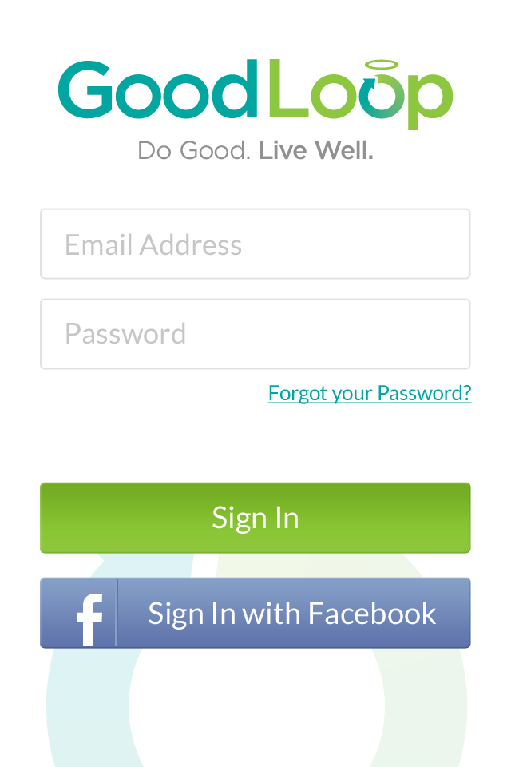

**User “Main” Screen://**

* Browse Offers in My Loop
* Offers I’ve Selected
* Search Function
  + Developer Note: This screen has a detail view provided, which depicts a scenario where “Pi” has been typed and all available results are being displayed in hierarchical order.

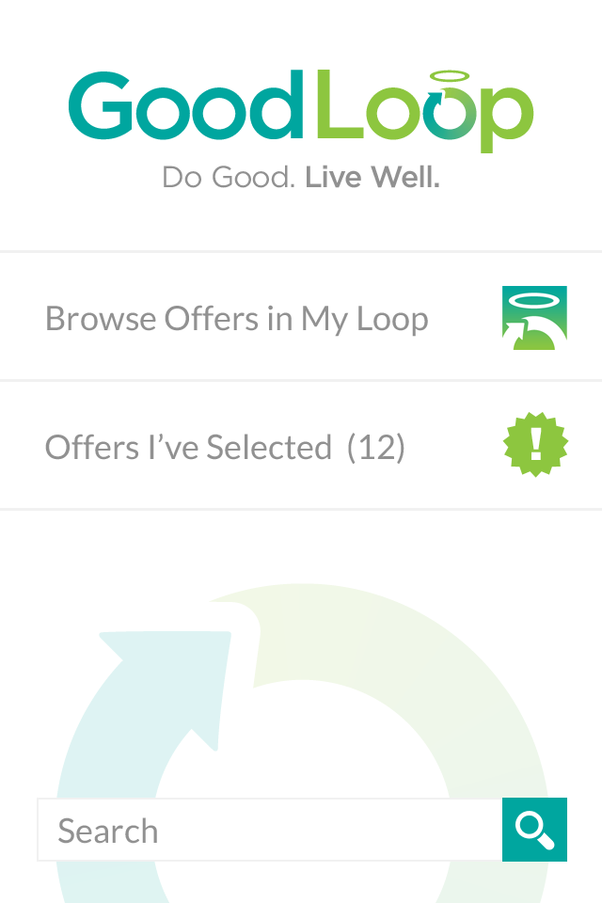

**Offer Screens://**

**1) Browse Offer in My Loop (Screen Title Bar reads “Available Offers”)**

* User able to scroll through list of offers available to them
  + Toggle button at top of screen allows User to switch views between offers that are “Available Now” and those “Coming Soon”

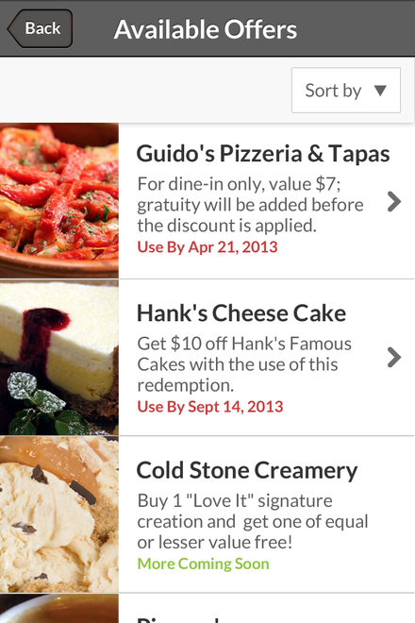

* Filtering by Three Types (*User may choose one or all three filters*)
* Filter by Name
  + A-Z
  + Z-A
* Filter by Category
* Filter by Location
  + 1 mile
  + 5 miles
  + 10 miles
  + 25 Miles

Developer Note: In all of these cases, the returned results may then be:

* Viewed in Detail (Screen Title Bar reads “Offer Detail”)
* Selected and placed into “Offers I’ve Selected”
* Shared via Social Media (Example of Sharing options provided)

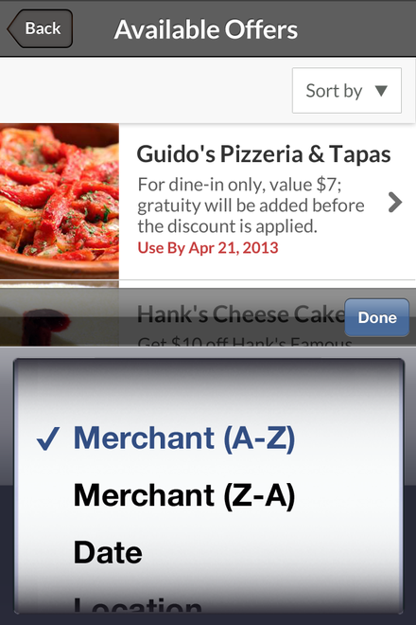

**2) Offers I’ve Selected (Screen Title Bar reads “My Offers”)**

* User able to scroll through list of their Selected Offers
  + Toggle button at top of screen allows User to switch views between offers that are “Ready to Use” and those “Already Redeemed”

Developer Note: In both cases, offers do not appear with an image like they did when browsing, prior to selection.

and:

In both cases, the returned results may then be:

* + - Viewed in Detail (Screen Title Bar reads “Offer Detail”)
    - Shared via Social Media (Example of Sharing options provided)
    - Redeemed

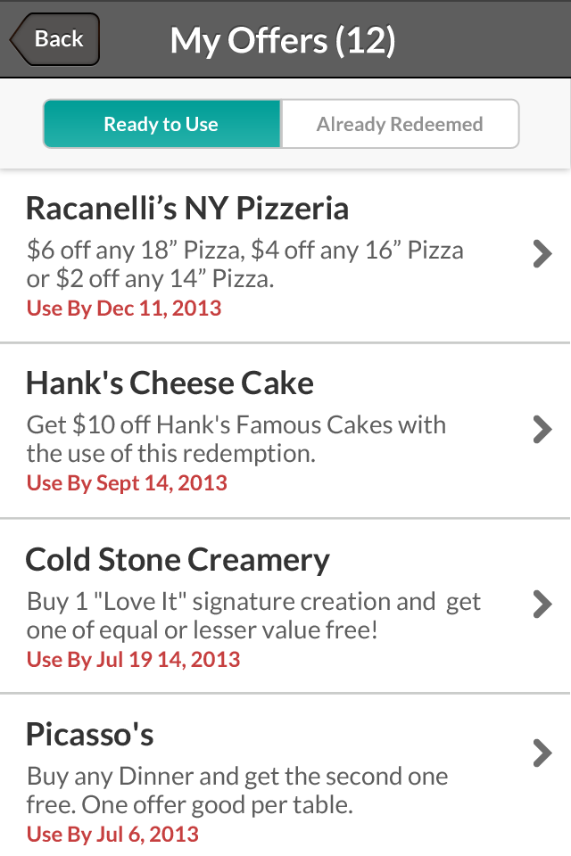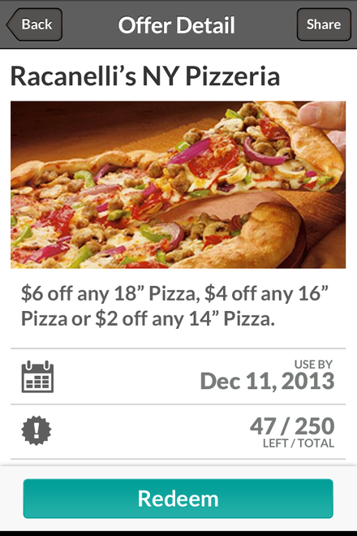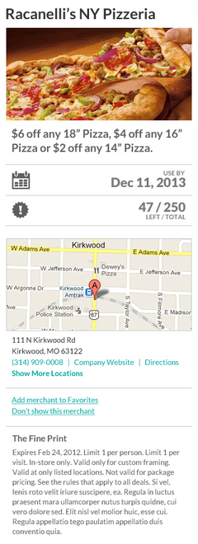

**Search Screen://**

* Search box – Standard “type ahead” Search feature
  + Developer Note: As noted previously, this screen has a detail view provided, which depicts a scenario where “Pi” has been typed and all available results are being displayed in hierarchical order.
  + Once results are returned, User may browse offers, view details and select offers for placement into their “My Offers” list

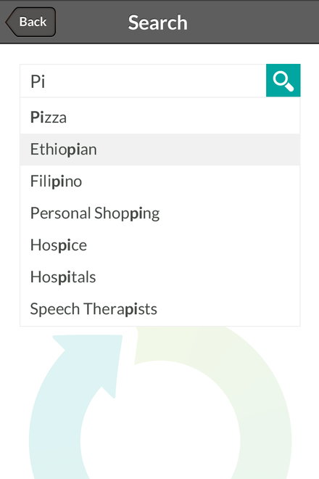

**Redemption Screen://**

* Once a User is ready to redeem an offer using the “Redeem” button at bottom of any selected offer, they are presented with two options (Screen Title Bar reads “Redeem Offer”)
* Redeem the offer via QR code in center of screen
* Redeem the offer manually via “Mark as Redeemed” function
  + Developer Note: If this option is selected, a dialogue box will appear that prompts the User to enter the redemption code in the field provided and then click Submit

