SIMATS ENGINEERING
ASSESSMENT TOOL 2
COURSE NAME: Cryptography and Network Security
COURSE CODE: CSA51
COURSE OUTCOME COVERED
CO1: Apply classical encryption techniques using symmetric and asymmetric ciphers to encrypt and decrypt data for the ensuring data security. (BL3, BL4)
Assessment Tool Weightage: 20%
QUESTIONS: 5 Total Marks: 50
Annexure A
CONCEPT MAPPING

Code of Conduct:
I siddharth.k(192521205) certify that this submission is my original work and that I have adhered to the guidelines specified for this assessment.
I understand that any violation of academic integrity rules will result in disciplinary action.


Signature of the student:

Question 1: Security Attacks, Threats, Risks and Security Goals
Concept map linking specific security attacks to the threats and risks they create, and showing which CIA security goal mitigates each chain.
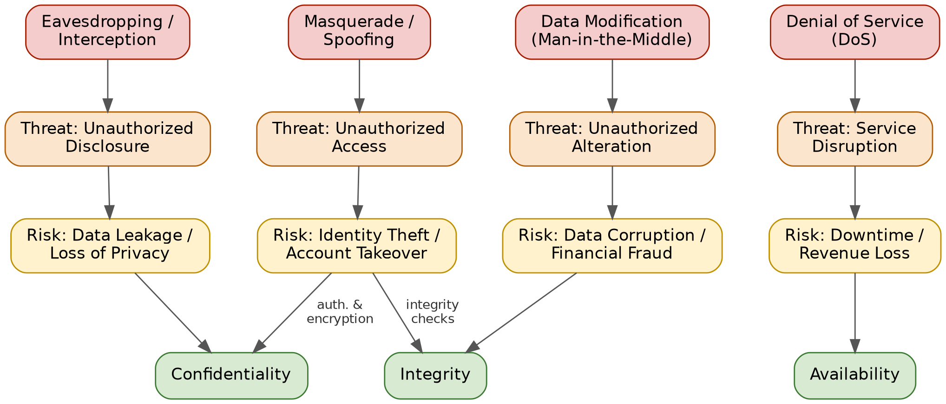
Figure 1: Attack → Threat → Risk → Security Goal mapping.

(a) How each attack leads to specific threats and risks
Attack | Threat it creates | Resulting risk
Eavesdropping / Interception | Unauthorized disclosure of data in transit | Data leakage, loss of privacy
Data modification (Man-in-the-Middle) | Unauthorized alteration of data | Data corruption, financial fraud
Denial of Service (DoS) | Disruption of service availability | Downtime, revenue and reputation loss
Masquerade / Spoofing | Unauthorized access using a false identity | Identity theft, account takeover

(b) How security goals mitigate them, with real-world examples
Confidentiality mitigates eavesdropping: encrypting traffic with TLS prevents a wiretapped connection (e.g., intercepted Wi-Fi traffic) from exposing readable data.
Integrity mitigates data modification: banks attach HMACs/digital signatures to transaction messages so any in-flight tampering (e.g., altering a transfer amount) is detected before execution.
Availability mitigates Denial of Service: content-delivery networks and load balancers absorb traffic floods (e.g., large-scale DDoS attacks on e-commerce sites) so the service stays reachable.
Confidentiality + Integrity mitigate masquerade: multi-factor authentication stops attackers who obtained a phished password (e.g., a phishing email leading to account takeover) from completing a fraudulent login.

Question 2: Comparing Substitution Techniques
Concept map connecting Caesar Cipher, Monoalphabetic Cipher, Vigenère Cipher and Hill Cipher based on key usage, complexity and security strength.
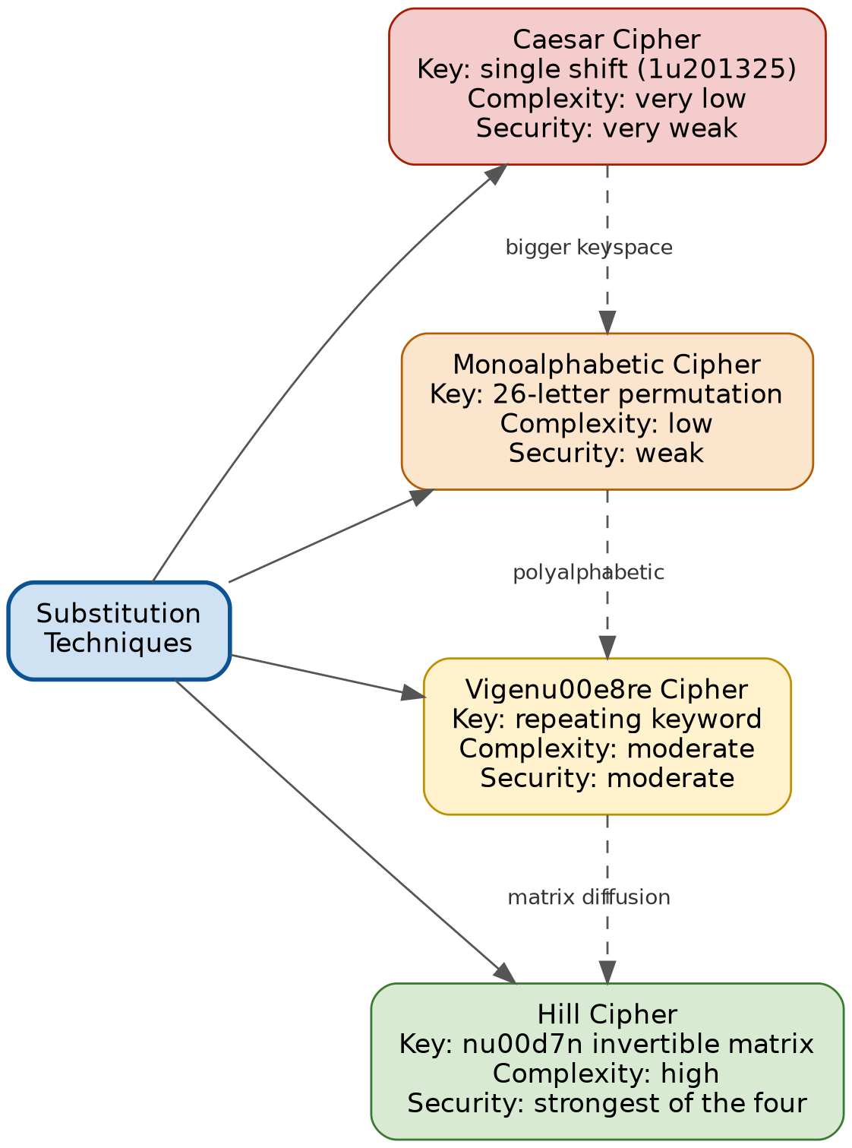
Figure 2: Substitution cipher family compared by key usage, complexity and security strength.
Cipher | Key usage | Complexity | Security strength
Caesar Cipher | Single numeric shift (1–25) applied to all letters | Very low — one parameter | Very weak — only 25 possible keys, broken instantly by brute force
Monoalphabetic Cipher | One fixed 1-to-1 letter-substitution table (26! possible keys) | Low — large keyspace but simple mechanism | Weak — huge keyspace is irrelevant because frequency analysis reveals the mapping
Vigenère Cipher | Repeating keyword; each letter shifted by a different amount | Moderate — polyalphabetic, position-dependent | Moderate — flattens single-letter frequencies, but breakable via Kasiski/index-of-coincidence if keyword is short
Hill Cipher | n×n invertible matrix over mod 26 arithmetic | High — requires linear algebra (matrix multiplication/inversion) | Strongest of the four — diffuses letter frequency across blocks, though vulnerable to known-plaintext attack

Analysis: which technique is most secure, and why
Among these four, the Hill Cipher offers the strongest security because it operates on blocks of letters simultaneously through matrix multiplication, which diffuses the statistical signature of the plaintext across multiple ciphertext letters rather than mapping one letter to one symbol. This defeats simple frequency analysis, which is what breaks the Caesar, Monoalphabetic, and (for short keywords) Vigenère ciphers. However, the Hill Cipher's linear-algebra structure is itself its weakness: if an attacker obtains enough matching plaintext-ciphertext letter blocks (a known-plaintext attack), the key matrix can be solved directly using linear equations. In practice, the overall security ranking from weakest to strongest is: Caesar < Monoalphabetic < Vigenère < Hill, with Hill Cipher being the most resistant to classical frequency-based cryptanalysis among the four, though none of them are secure by modern standards.

Question 3: Substitution vs. Transposition Techniques
Concept map contrasting the two families of classical encryption schemes.
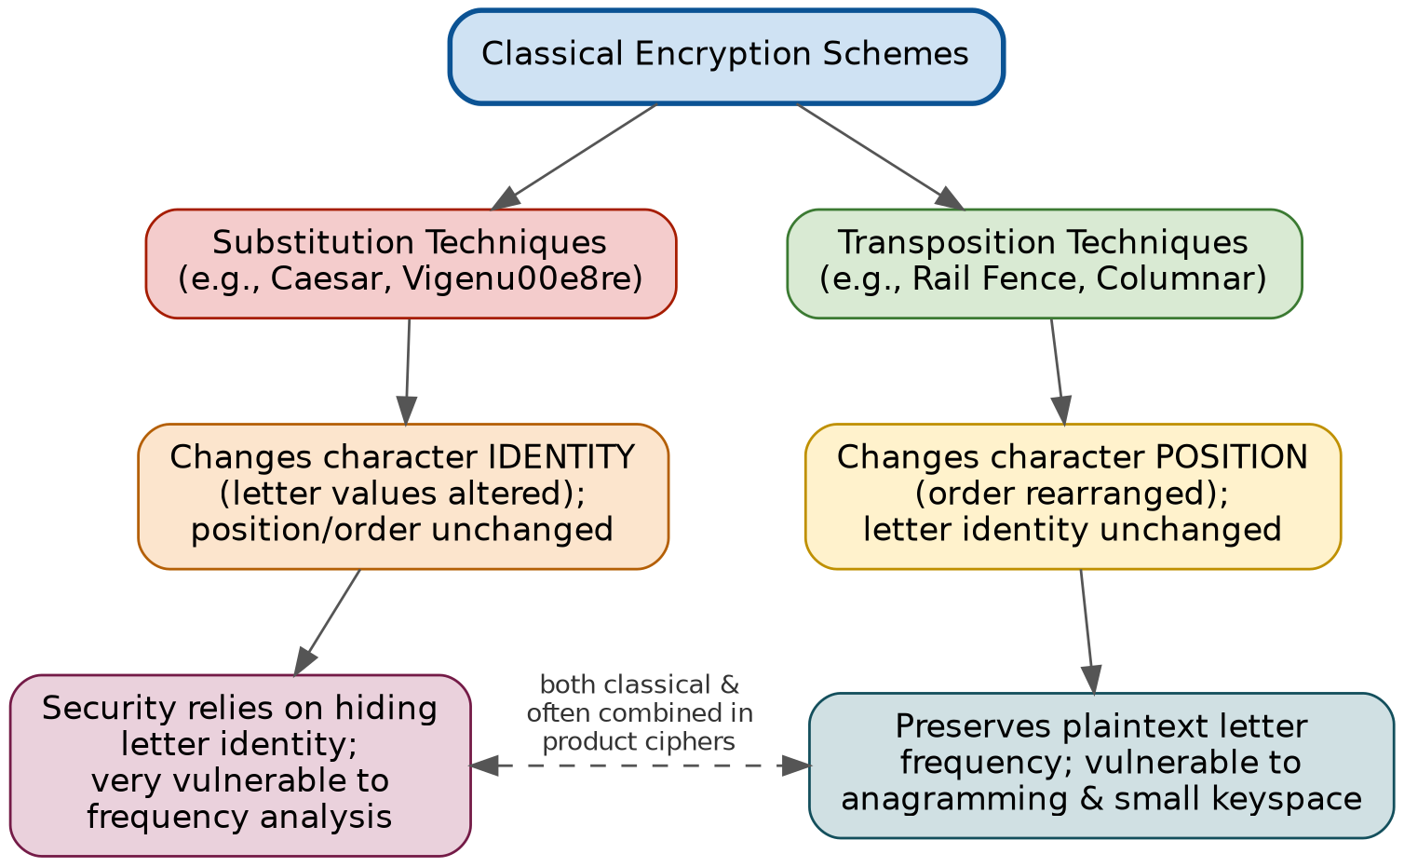
Figure 3: Substitution vs. Transposition — effect on data structure and security level.

(a)(i) Differences, similarities, and effect on data structure & security level
Aspect | Substitution techniques | Transposition techniques
Effect on data structure | Replaces each character's identity with another symbol; character order/position is unchanged | Rearranges the position/order of characters; character identity (the letters themselves) is unchanged
Effect on security level | Security depends on concealing the identity mapping; a fixed one-to-one map is easy to attack once patterns are noticed | Security depends on concealing the arrangement/order; the underlying letter frequencies of the plaintext remain fully visible
Similarity | Both are classical, key-based, symmetric techniques operating at the character level, and both are commonly combined together (as in a product cipher) for stronger security | (same as adjacent cell)

(a)(ii) Which is more vulnerable to attacks, and why
Substitution techniques — particularly simple monoalphabetic substitution — are generally more vulnerable, because the ciphertext directly preserves the plaintext's letter-frequency distribution under a fixed mapping: the most frequent ciphertext symbol almost always corresponds to the most frequent plaintext letter (e.g., 'E' in English), so straightforward frequency analysis reconstructs the entire substitution table with relatively little ciphertext. Transposition techniques, in contrast, keep the original letters themselves intact, so frequency analysis on symbol identity fails immediately; however, transposition is still weak because it typically has a very small keyspace (limited by block/rail size) and can be broken by anagramming or trying all reasonable arrangements. Overall, textbook cryptanalysis treats substitution as more directly exploitable via frequency analysis, while transposition requires an added combinatorial search — which is why classical cryptography combines both techniques (substitution + transposition) into product ciphers to compensate for each other's weaknesses.

Question 4: Steganography — Data Hiding, Watermarking, Survivability
Concept map connecting the core steganographic concepts and their contribution to secure communication.
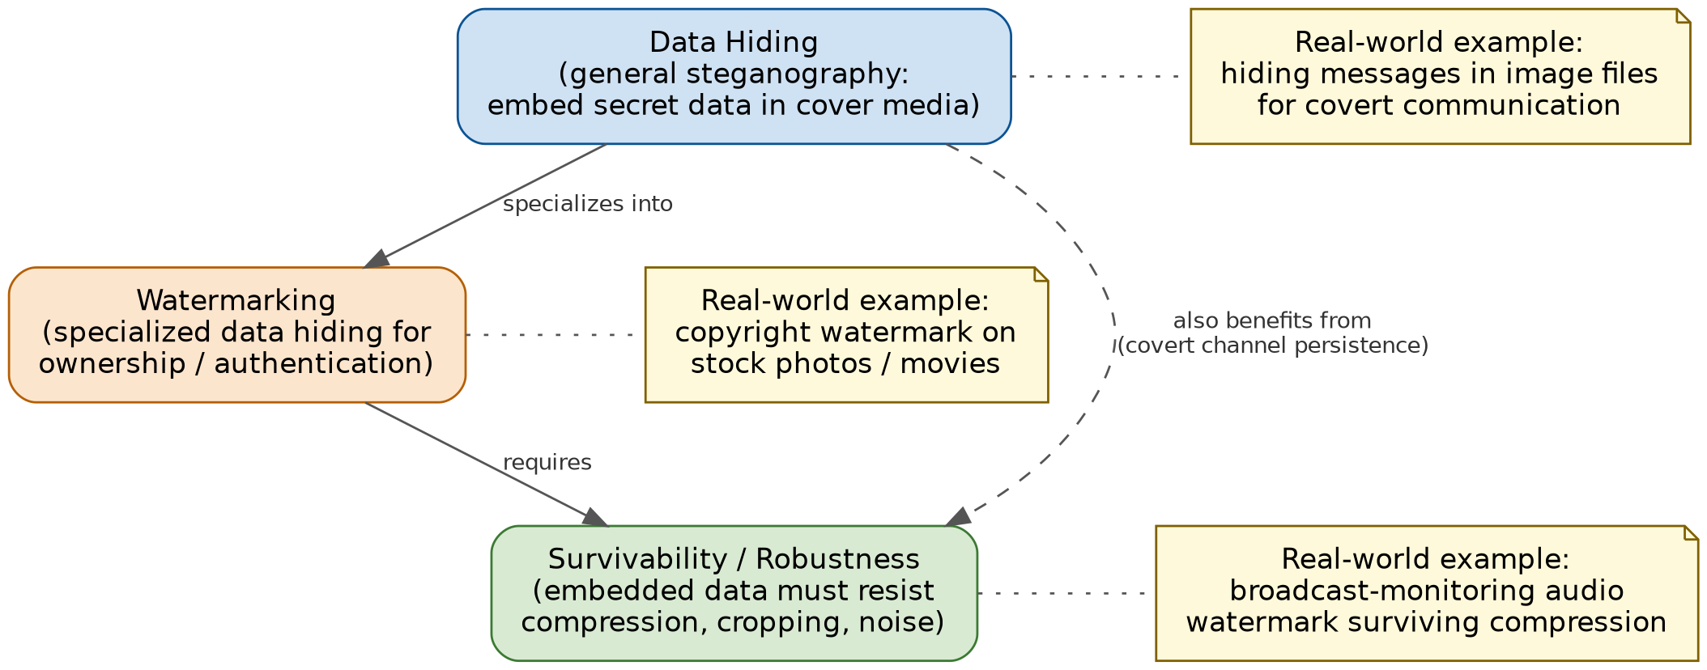
Figure 4: Data Hiding specializes into Watermarking, which requires Survivability to remain effective.

(a) Relationships between the concepts
Data Hiding is the umbrella concept: embedding secret or auxiliary information inside a cover medium (image, audio, video, text) so its presence is not obvious. Watermarking is a specialized form of data hiding whose purpose is ownership, authentication, or copyright marking rather than pure secrecy. Survivability (robustness) is a property required of a good watermark (and, to a lesser extent, of hidden covert data): the embedded information must remain recoverable even after the cover file is compressed, cropped, re-encoded, or otherwise processed — including deliberate attempts to strip it out.

(b) How each contributes to secure communication
- Data Hiding contributes confidentiality by concealing the very existence of a communication channel, so an observer does not even know secret data is present.
- Watermarking contributes integrity and authenticity by allowing the origin, ownership, or authenticity of content to be verified, and by making unauthorized tampering or copying detectable.
- Survivability contributes reliability/availability of the protection mechanism itself — without it, a watermark or hidden message would be destroyed by routine processing (compression, format conversion), making the protection worthless when it is actually needed (e.g., in a legal ownership dispute).

(c) One real-world application for each
Data Hiding: covert messages embedded in images shared over public/social platforms to communicate discreetly, bypassing plain-text surveillance.
Watermarking: visible or invisible copyright watermarks embedded in stock photography and streaming video to assert ownership and deter unauthorized redistribution.
Survivability: audio watermarks embedded in broadcast music/radio signals that survive re-recording and compression, used by services such as royalty/broadcast-monitoring systems to track airplay.

Question 5: Number Theory Concepts in Public-Key Cryptography
Concept map linking Modular Inverse, Extended Euclid Algorithm, Fermat's Little Theorem, Euler's Phi Function and Euler's Theorem, and how they converge in public-key (RSA) cryptography.
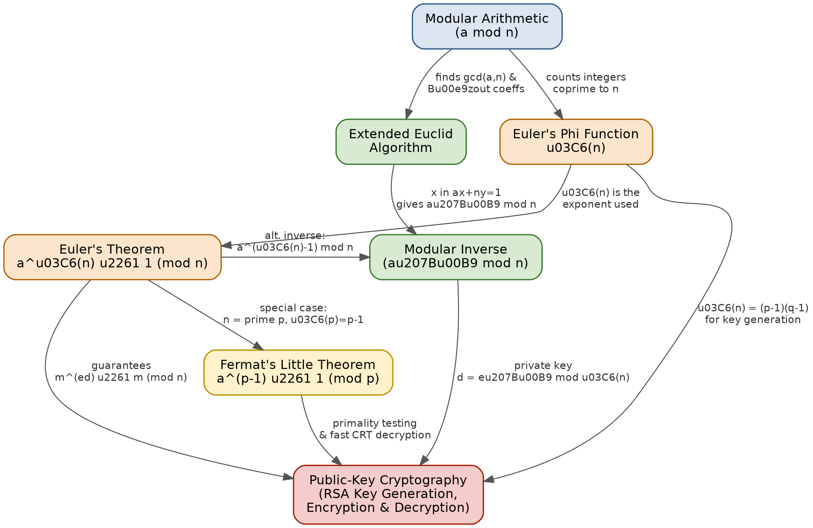
Figure 5: Number-theory foundations underlying RSA public-key cryptography.

(a) How each concept is mathematically connected
Concept | Mathematical connection
Modular Arithmetic | Base framework: all other concepts operate on residues 'a mod n', the remainder when a is divided by n.
Extended Euclid Algorithm | Extends the Euclidean GCD algorithm to also return integers x, y with ax + ny = gcd(a, n); when gcd(a, n) = 1, this x equals a⁻¹ mod n.
Modular Inverse | a⁻¹ mod n exists only when gcd(a, n) = 1, found via the Extended Euclid Algorithm or via Euler's Theorem as a^(φ(n) – 1) mod n.
Euler's Phi Function φ(n) | Counts integers in [1, n] coprime to n. For prime p, φ(p) = p – 1; for n = p·q, φ(n) = (p – 1)(q – 1).
Euler's Theorem | States a^φ(n) ≡ 1 (mod n) whenever gcd(a, n) = 1 — generalizes modular exponentiation to any modulus n.
Fermat's Little Theorem | The special case of Euler's Theorem when n is a prime p: since φ(p) = p – 1, it reduces to a^(p–1) ≡ 1 (mod p).

(b) Their role in encryption/decryption
- Euler's Phi Function: computes φ(n) = (p–1)(q–1) from the two secret primes p, q chosen during RSA key generation — this value defines the modulus for key arithmetic.
- Extended Euclid Algorithm / Modular Inverse: derives the private exponent d as the modular inverse of the public exponent e modulo φ(n): d = e⁻¹ mod φ(n).
- Euler's Theorem: because e·d ≡ 1 (mod φ(n)), it guarantees m^(ed) ≡ m (mod n) — the proof that RSA decryption (cᵈ mod n) recovers the original plaintext m exactly.
- Fermat's Little Theorem: used in probabilistic primality testing to efficiently confirm that large candidate numbers are prime before they are used as p and q, and underlies the CRT optimisation that speeds up RSA decryption.

(c) Which concept is most critical for public-key cryptography, and why
Euler's Theorem is the most critical concept for public-key cryptography. It is the single mathematical result that proves RSA actually works: it guarantees that decryption exactly inverts encryption, i.e., (mᵉ)ᵈ ≡ m (mod n), whenever e and d satisfy e·d ≡ 1 (mod φ(n)). Every other concept in the map exists to feed this theorem — Euler's Phi Function supplies the exponent φ(n) that the theorem needs; the Extended Euclid Algorithm and Modular Inverse compute a key pair (e, d) that satisfies the theorem's condition; and Fermat's Little Theorem is simply this same theorem restricted to a prime modulus. Without Euler's Theorem, there would be no guarantee that a message encrypted with the public key can be correctly recovered with the private key, so the entire correctness argument behind RSA — and public-key cryptography built on it — would collapse.

