**CHAPTER 1**

**INTRODUCTION**

**1.1 OVERVIEW**

A home automation system is a technological solution that enables automating the bulk of electronic, electrical and technology-based tasks within a home.It uses a combination of hardware and software technologies that enable control and management over appliances and devices within a home. Home automation is also known as domotics, and a home with an automation system is also known as a smart home.

An automated home is sometimes called a smart home. It is meant to save the electric power and human energy. The home automation system differs from other system by allowing the user to operate the system from anywhere around the world through internet connection

The proposed home automation is built using NODEMCU ESP8266 with google assistant which present in smart mobile. An online server Adafruit is used to store the data from the google assistant.

**1.2 HOME AUTOMATION**

Home automation or domotics is building automation for a home, called a smart home or smart house. A home automation system will control lighting, climate, entertainment systems, and appliances. It may also include home security such as access control and alarm systems.

**1.3EXISTING METHODOLOGY**

The existing method of smart home is consist of mobile app that has unique web page and in some cases GSM is used to transmit the data. The controller has to connect with iot gateway. So that the home appliances can be controlled.

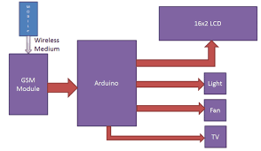

Figure 1.3 Existing Methodology

**1.4 PROPOSED METHODOLOGY**

1. The proposed idea of home automation is by using Internet of things that the user can give the command for their own home appliance on the basis of user command the respective appliances will perform the operations .
2. This is done using google assistant by interfacing with adafruit and NODE MCU . The NODEMCU is connected with relay which acts as switch for the home appliances
3. The adafruit online server is used the store the data in feed from the google assistant and sends it to the microcontroller.
4. The NODEMCU this insist the respective relay to perform ON and OFF operation.

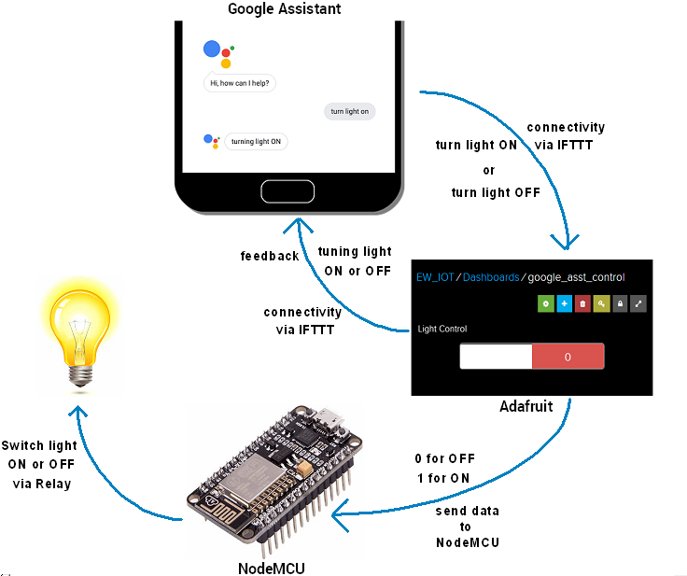

Figure 1.4 proposed Methodology

**1.5OBJECTIVES OF PROPOSED SYSTEM**

* To control the home appliance with the help of google assistant this improves the comfort of the user and better quality of life.
* The voice controlled home automation on the esp8266 nodemcu computer, it performs accordingly on the basis of adafruit feed, the feed in the adafruit changes when the google assistant transmit the data.
* The implementation of the smart home is based on the internet of things which provides user to control their home appliances from anywhere using the google assistant.

**1.7 INTERNET**

The Internet ([contraction](https://en.wikipedia.org/wiki/Contraction_(grammar)) of the interconnected network) is the global system of interconnected [computer networks](https://en.wikipedia.org/wiki/Computer_network) that use the [Internet protocol suite](https://en.wikipedia.org/wiki/Internet_protocol_suite) (TCP/IP) to link devices worldwide. It is a network of networks that consists of private, public, academic, business, and government networks of local to global scope, linked by a broad array of electronic, wireless, and optical networking technologies.

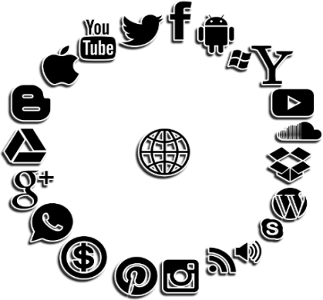

Figure1.7 Internet

The 1990s marked the beginning of the transition to the modern Internet and generated a sustained exponential growth as generations of institutional, [personal](https://en.wikipedia.org/wiki/Personal_computer), and [mobile](https://en.wikipedia.org/wiki/Mobile_device) computers were connected to the network. Although the Internet was widely used by [academia](https://en.wikipedia.org/wiki/Academia), [commercialization](https://en.wikipedia.org/wiki/Commercialization_of_the_Internet) incorporated its services and technologies into virtually every aspect of modern life.

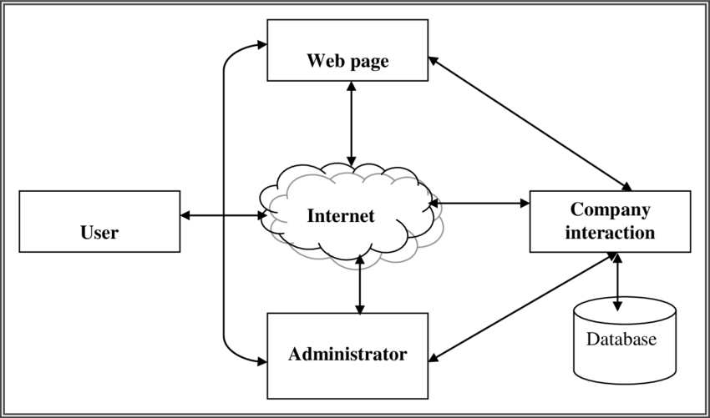

Figure1.8 Internet communication

Most traditional communications media, including telephony, radio, television, paper mail and newspapers are reshaped, redefined, or even bypassed by the Internet, giving birth to new services such as [email](https://en.wikipedia.org/wiki/Email), [Internet telephony](https://en.wikipedia.org/wiki/Internet_telephony), [Internet television](https://en.wikipedia.org/wiki/Internet_television), [online music](https://en.wikipedia.org/wiki/Online_music), digital newspapers, and [video streaming](https://en.wikipedia.org/wiki/Video_streaming) websites. Newspaper, book, and other print publishing are adapting to [website](https://en.wikipedia.org/wiki/Web_site) technology, or are reshaped into [blogging](https://en.wikipedia.org/wiki/Blogging), [web feeds](https://en.wikipedia.org/wiki/Web_feed) and online [news aggregators](https://en.wikipedia.org/wiki/News_aggregator). The Internet has enabled and accelerated new forms of personal interactions through [instant messaging](https://en.wikipedia.org/wiki/Instant_messaging), [Internet forums](https://en.wikipedia.org/wiki/Internet_forum), and [social networking](https://en.wikipedia.org/wiki/Social_network_service). Chains across entire industries.

**1.8 INTERNET OF THINGS**

The Internet of things (IoT) refers to the concept of extending [Internet](https://en.wikipedia.org/wiki/Internet) connectivity beyond conventional computing platforms such as [personal computers](https://en.wikipedia.org/wiki/Personal_computer) and [mobile devices](https://en.wikipedia.org/wiki/Mobile_devices), and into any range of traditionally "dumb" or non-internet-enabled physical devices and everyday objects. Embedded with [electronics](https://en.wikipedia.org/wiki/Electronics), [Internet connectivity](https://en.wikipedia.org/wiki/Internet_access), and other forms of hardware (such as [sensors](https://en.wikipedia.org/wiki/Sensor)), these devices can communicate and interact with others over the Internet, and they can be remotely monitored and controlled.The definition of the Internet of things has evolved due to the convergence of multiple technologies, real-time [analytics](https://en.wikipedia.org/wiki/Analytics), [machine learning](https://en.wikipedia.org/wiki/Machine_learning), commodity sensors, and [embedded systems](https://en.wikipedia.org/wiki/Embedded_system). Traditional fields of embedded systems, [wireless sensor networks](https://en.wikipedia.org/wiki/Wireless_sensor_network), [control systems](https://en.wikipedia.org/wiki/Control_system), [automation](https://en.wikipedia.org/wiki/Automation) (including [home](https://en.wikipedia.org/wiki/Home_automation) and [building automation](https://en.wikipedia.org/wiki/Building_automation)), and others all contribute to enabling the Internet of things.

In the consumer market, IoT technology is most synonymous with products pertaining to the concept of the "smart home", covering devices and appliances (such as lighting fixtures, thermostats, home security systems and cameras, and other home appliances) that support one or more common ecosystems, and can be controlled via devices associated with that ecosystem, such as [smartphones](https://en.wikipedia.org/wiki/Smartphone) and [smart speakers](https://en.wikipedia.org/wiki/Smart_speaker). The IoT concept has faced prominent criticism, especially in regards to [privacy](https://en.wikipedia.org/wiki/Digital_privacy) and [security](https://en.wikipedia.org/wiki/Digital_security) concerns related to these 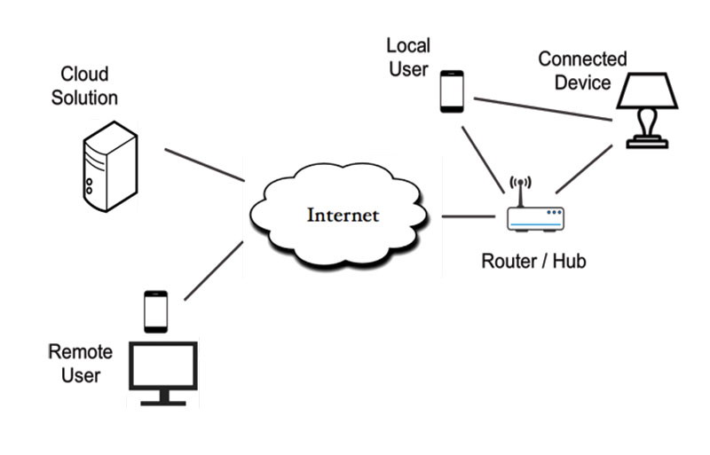devices and their intention of pervasive presence.

Figure1.8 Internet of things

The IoT can realize the seamless integration of various manufacturing devices equipped with sensing, identification, processing, communication, actuation, and networking capabilities. Based on such a highly integrated smart cyber-physical space, it opens the door to create a whole new business and market opportunities for manufacturing. Network control and management of [manufacturing equipment](https://en.wikipedia.org/wiki/Reconfigurable_Manufacturing_System), [asset](https://en.wikipedia.org/wiki/Asset_management) and situation management, or manufacturing [process control](https://en.wikipedia.org/wiki/Process_control) bring the IoT within the realm of industrial applications and smart manufacturing as well. The IoT intelligent systems enable rapid manufacturing of new products, dynamic response to product demands, and real-time optimization of manufacturing production and [supply chain networks](https://en.wikipedia.org/wiki/Supply_chain_network), by networking machinery, sensors and control systems together.

[Digital control systems](https://en.wikipedia.org/wiki/Digital_control) to automate process controls, operator tools and service information systems to optimize plant safety and security are within the purview of the IoT.But it also extends itself to asset management via [predictive maintenance](https://en.wikipedia.org/wiki/Predictive_maintenance), [statistical evaluation](https://en.wikipedia.org/wiki/Statistical_model), and measurements to maximize reliability.[[63]](https://en.wikipedia.org/wiki/Internet_of_things#cite_note-Future-IoT-63) Smart industrial management systems can also be integrated with the [Smart Grid](https://en.wikipedia.org/wiki/Smart_Grid), thereby enabling real-time energy optimization. Measurements, automated controls, plant optimization, health and safety management, and other functions are provided by a large number of networked sensors.

The term industrial Internet of things (IoT) is often encountered in the manufacturing industries, referring to the industrial subset of the IoT. [IIoT](https://www.researchnreports.com/semiconductor-electronics/Global-Industrial-IoT-Market-Professional-Survey-Report-2017-71402) in manufacturing could generate so much business value that it will eventually lead to the [Fourth Industrial Revolution](https://en.wikipedia.org/wiki/Fourth_Industrial_Revolution), so the so-called [Industry 4.0](https://en.wikipedia.org/wiki/Industry_4.0). It is estimated that in the future, successful companies will be able to increase their revenue through the Internet of things by creating new business models and improve productivity, exploit analytics for innovation, and transform the workforce.

Design architecture of cyber-physical systems-enabled manufacturing system. [Industrial big data](https://en.wikipedia.org/wiki/Industrial_big_data) analytics will play a vital role in manufacturing asset predictive maintenance, although that is not the only capability of industrial big data. [Cyber-Physical Systems](https://en.wikipedia.org/wiki/Cyber-physical_system) (CPS) is the core technology of industrial big data and it will be an interface between human and the cyber world. Cyber-physical systems can be designed by following the *5C* (connection, conversion, cyber, cognition, and configuration) architectureand it will transform the collected data into actionable information, and eventually interfere with the physical assets to optimize processes.

Band saw machines are not necessarily expensive, but the band saw belt expenses are enormous since they degrade much faster. However, without sensing and intelligent analytics, it can be only determined by experience when the band saw belt will actually break. The developed [prognostics](https://en.wikipedia.org/wiki/Prognostics) system will be able to recognize and [monitor the degradation](https://en.wikipedia.org/wiki/Intelligent_maintenance_system) of the band saw belts even if the condition is changing, advising users when is the best time to replace the belt. This will significantly improve user experience and operator safety and ultimately save on costs.

**1.9 WEBSITE**

A website or Web site is a collection of related network web resources, such as web pages, multimedia content, which are typically identified with a commondomain name, and published on at least one web server. Notable examples are wikipedia.org, google.com, and amazon.com.

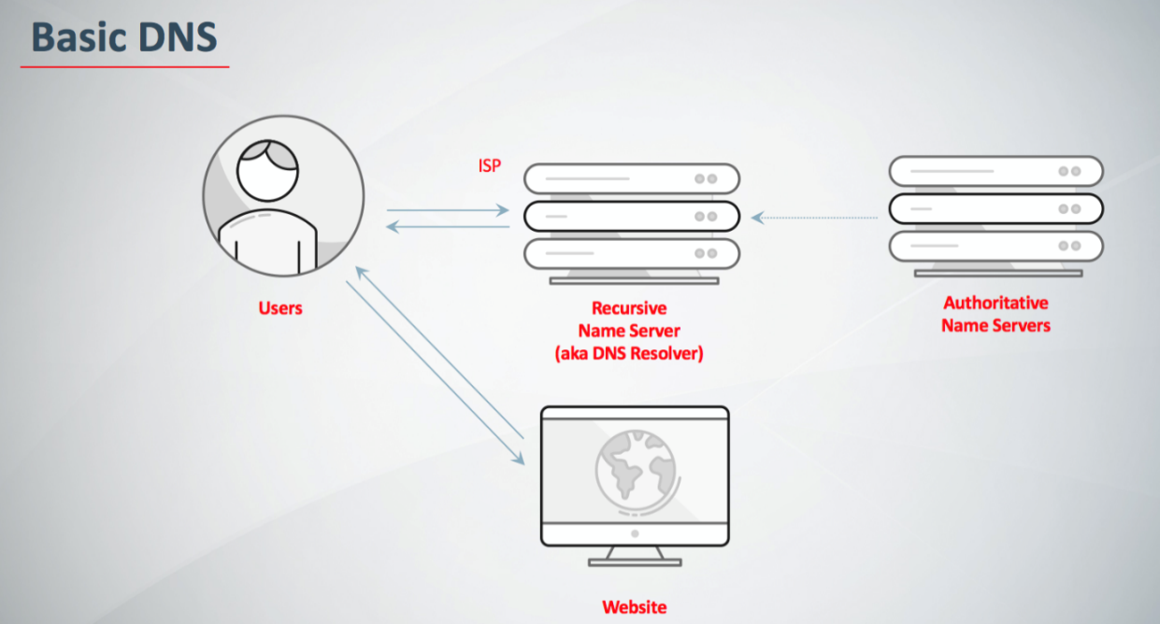Websites can be accessed via a public Internet Protocol (IP) network, such as the Internet, or a private Local Area Network (LAN), by a Uniform .

Figure1.9 Website block diagram

Websites can have many functions and can be used in various fashions; a website can be a personal website, a corporate website for a company, a government website, an organization website, etc. Websites are typically dedicated to a particular topic or purpose, ranging from entertainment and social networking to providing news and education. All publicly accessible websites collectively constitute the World Wide Web, while private websites, such as a company's website for its employees, and are typically part of an intranet.

Web pages, which are the building blocks of websites, are documents, typically composed in plain text interspersed with formatting instructions of Hypertext Mark-up Language (HTML, XHTML). They may incorporate elements from other websites with suitable mark-up anchors. Web pages are accessed and transported with the Hypertext Transfer Protocol (HTTP), which may optionally employ encryption (HTTP Secure, HTTPS) to provide security and privacy for the user. The user's application, often a web browser, renders the page content according to its HTML mark-up instructions onto a display terminal.

Hyperlinking between web pages conveys to the reader the site structure and guides the navigation of the site, which often starts with a home page containing a directory of the site web content. Some websites require user registration or subscription to access content. Examples of subscription websites include many business sites, news websites, academic journal websites, gaming websites, file-sharing websites, message boards, web-based email, social networking websites, websites providing real-time stock market data, as well as sites providing various other services. End users can access websites on a range of devices, including desktop and laptop computers, tablet computers, smartphones and smart TVs WEBSITE

**CHAPTER 2**

**PROPOSED VOICE CONTROLLED HOME AUTOMATION**

**2.1 PROPOSED BLOCK DIAGRAM**

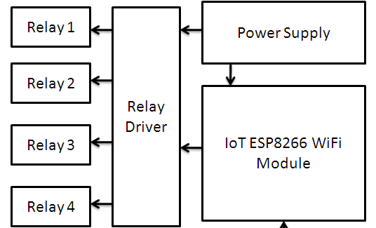

Figure2.1Block diagram

**2.2 BLOCK DIAGRAM DISCRIPTION**

The ESP8266 wifi module is connected with power supply and relay driver. The power supply is also connected with relay driver. In the relay home appliances are connected.

**2.2.1 POWER SUPPLY**

Mobile phones generally charge with **5v regulated DC supply,** so basically to build a 5v regulated DC supply from 220 AC. This DC supply can be used to charge mobiles as well as the power source for digital circuits, breadboard circuits, ICs, microcontrollers etc.

This system build 6V DC, 9V, 12V, 15V etc by using proper transformer, capacitor and voltage regulator. The basic concept remains the same, you just need to arrange a heat sink for higher voltage and current.

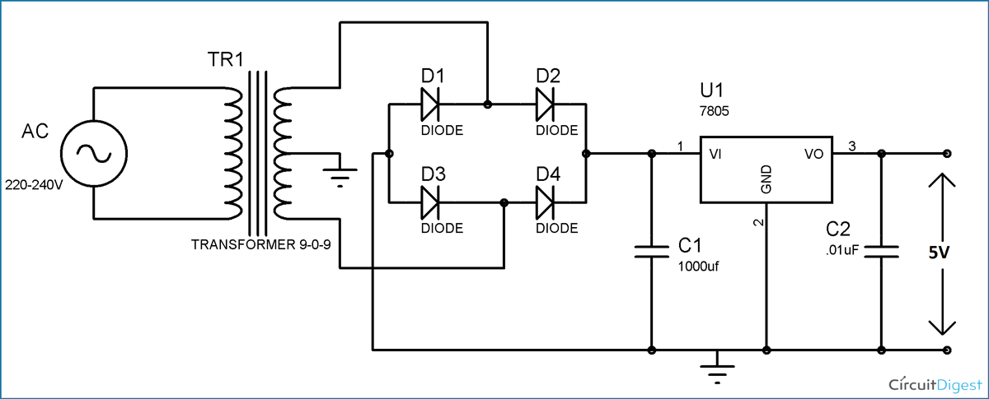Figure 2.2 Schematic Diagram of Power Supply

This circuit mainly consists a step down Transformer, a Full wave bridge rectifier and a 5V voltage regulator IC (7805). We can divide this circuit into four parts: (1) Step down AC voltage (2) Rectification (3) Filtration (4) Voltage Regulation.

**2.2.2 STEP DOWN AC VOLTAGE**

As converting 220V AC into a 5V DC, first to need a step-down transformer to reduce such high voltage. Here we have used 9-0-9 1A step-down transformer, which convert 220V AC to 9V AC. In transformer there are primary and secondary coils which step up or step down the voltage according to the no of turn in the coils.

  Selection of proper transformer is very important. Current rating depends upon the Current requirement of Load circuit (circuit which will use the generate DC). The voltage rating should be more than the required voltage. Means if we need 5V DC, transformer should at least have a rating of 7V, because voltage regulator IC 7805 at least need 2V more i.e. 7V to provide a 5V voltage.

### ****2.2.3 RECTIFICATION****

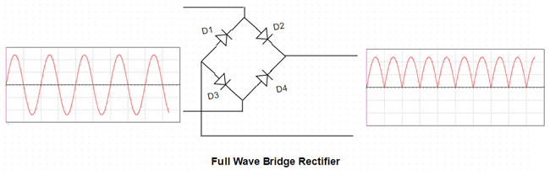Rectification is the process of removing the negative part of the Alternate Current (AC), hence producing the partial DC. This can be achieved by using 4 diodes. Diodes only allow current to flow in one direction. In first half cycle of AC diode D2 & D3 are forward biased and D1 and D4 are reversed biased, and in the second

Figure 2.3 Rectifier circuit

Half cycle (negative half) Diode D1 and D4 are forward biased and D2 and D3 are reversed biased. This Combination converts the negative half cycle into positive.A full wave bridge rectifier component is available in the market, which consist that combination of 4 diode internally. Here we have used this component.

### ****2.2.4 FILTRATION****

The output after the Rectification is not a proper DC, it is oscillation output and has a very high ripple factor. We don’t need that pulsating output, for this we use Capacitor. Capacitor charge till the waveform goes to its peak and discharge into Load circuit when waveform goes low. So when output is going low, capacitor maintains the proper voltage supply into the Load circuit, hence creating the DC. Now how the value of this filter capacitor should be calculated.

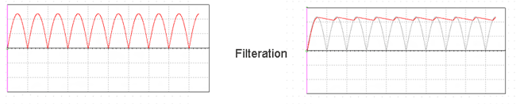Figure 2.4 Filtration

**2.3 ESP8266 NODE MCU**

# **2.3.1 Description**

NodeMCU is an open-source firmware and development kit that helps you to prototype or build IoT product. It includes firmware which runs on the ESP8266 Wi-Fi SoC from Espressif Systems, and hardware which is based on the ESP-12 module. The firmware uses the Lua scripting language.

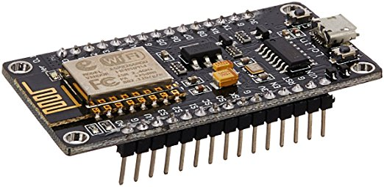

Figure2.5 Esp8266 NodeMcu

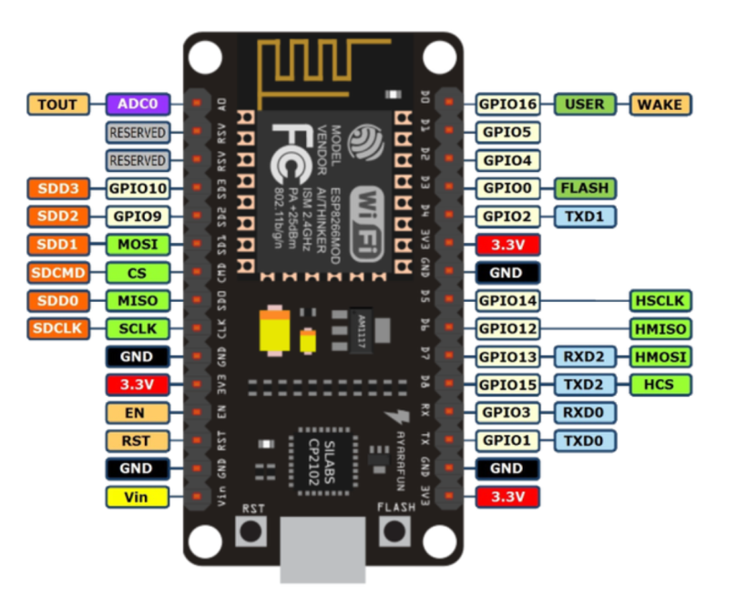Based on the eLua project, and built on the Espressif Non-OS SDK for ESP8266. NodeMCU is an open source Lua based firmware for the ESP8266 Wi-Fi SOC from Espressif and uses an on-module flash-based SPIFFS file system. NodeMCU is implemented in C and is layered on the Espressif NON-OS SDK.

Figure2.6 NodeMcu pin diagram

The firmware was initially developed as is a companion project to the popular ESP8266-based NodeMCU development modules, but the project is now community-supported, and the firmware can now be run on any ESP module.

**2.3.2 PROGRAMMING OF NODE MCU**

**ESP8266 Arduino Core**

As Arduino.cc began developing new MCU boards based on non-AVR processors like the ARM/SAM MCU and used in the Arduino Due, they needed to modify the Arduino IDE so that it would be relatively easy to change the IDE to support alternate tool chains to allow Arduino C/C++ to be compiled down to these new processors. Some creative ESP8266 enthusiasts have developed an Arduino core for the ESP8266 Wi-Fi SoC that is available at the GitHub ESP8266 Core webpage. This is what is popularly called the “ESP8266 Core for the Arduino IDE” and it has become one of the leading software development platforms for the various ESP8266 based modules.

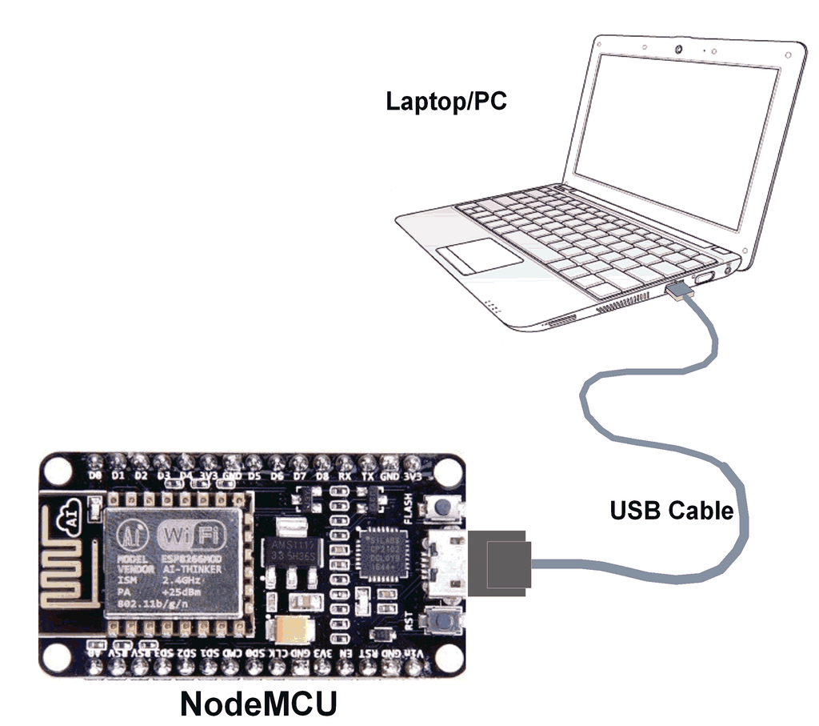

Figure2.7 NodeMCU programming

**Advantages of NodeMCU platform relative to the Arduino**

* Low cost
* Integrated support for WIFI network
* Reduced size of the board
* Low energy consumption

**Disadvantages**

* Need to learn a new language and IDE
* Reduced pinout
* Scarce documentation

The NodeMCU programming can be as easy as in Arduino.

**2.3 ARDUINO IDE**

**2.3.1 IDE**

The Arduino integrated development environment (IDE) is a cross-platform application (for Windows, macOS, Linux) that is written in the programming language Java. It is used to write and upload programs to Arduino board. The source code for the IDE is released under the GNU General Public License, version 2. The Arduino IDE supports the languages C and C++ using special rules of code structuring. The Arduino IDE supplies a software library from the Wiring project, which provides many common input and output procedures. User-written code only requires two basic functions, for starting the sketch and the main program loop, that are compiled and linked with a program stub main() into an executable cyclic executive program with the GNU toolchain, also included with the IDE distribution. The Arduino IDE employs the program argued to convert the executable code into a text file in hexadecimal encoding that is loaded into the Arduino board by a loader program in the board’s firmware.

**2.3.2 SKETCH**

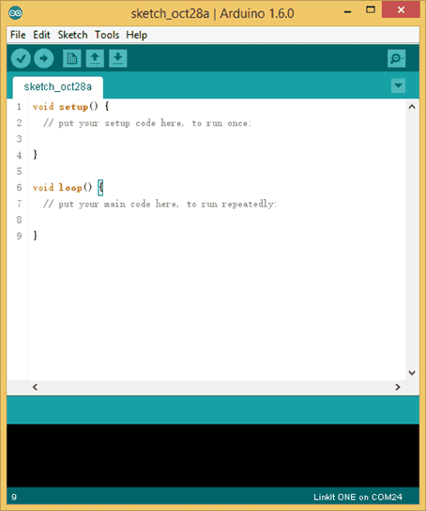A sketch is a program written with the Arduino IDE. Sketches are saved on the development computer as text files with the file extension .ion. Arduino Software (IDE) pre-1.0 saved sketches with the extension .pde.A minimal Arduino C/C++ program consist of only two functions.

**Setup():** This function is called once when a sketch starts after power-up or reset. It is used to initialize variables, input and output pin modes, and other libraries needed in the sketch.

**Loop():** After setup() function exits (ends), the loop() function is executed repeatedly in the main program. It controls the board until the board is powered off or is reset.

**2.4 CLOUD**

Cloud computing makes computer system resources, especially storage and computing power, available on demand without direct active management by the user. The term is generally used to describe data centres available to many users over the Internet. Large clouds, predominant today, often have functions distributed over multiple locations from central servers. If the connection to the user is relatively close, it may be designated an Edge server.

Advocates of public and hybrid clouds note that cloud computing allow companies to avoid or minimize up-front IT infrastructure costs. Proponents also claim that cloud computing allows enterprises to get their applications up and running faster, with improved manageability and less maintenance, and

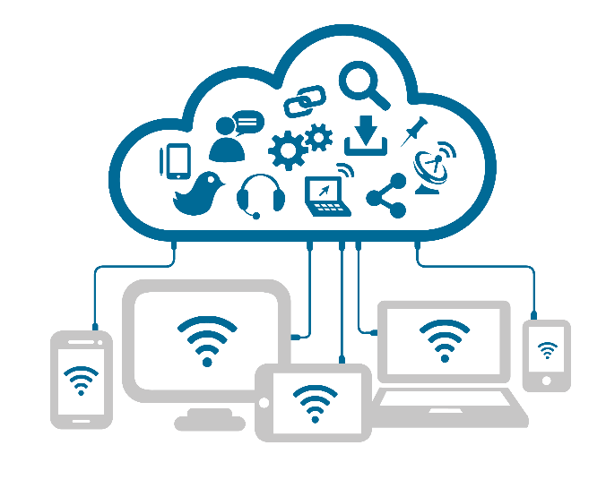

Figure2.8

That it enables IT teams to more rapidly adjust resources to meet fluctuating and unpredictable demand. Cloud providers typically use a "pay-as-you-go" model, which can lead to unexpected operating expenses if administrators are not familiarized with cloud-pricing models.

The availability of high-capacity networks, low-cost computers and storage devices as well as the widespread adoption of hardware virtualization, service-oriented architecture, and autonomic and utility computing has led to growth in cloud computing.

**2.4.1 ADAFRUIT**

Adafruit is an open data platform for the Internet of Things. Your device or application can communicate with Adafruit using a restful API, and you can either keep your data private, or make it public. In addition, use Adafruit to analyse and act on your data. Adafruit which is a online web server uses to act in such way that it store the feed from the google assistant and it send to the respective subscriber.

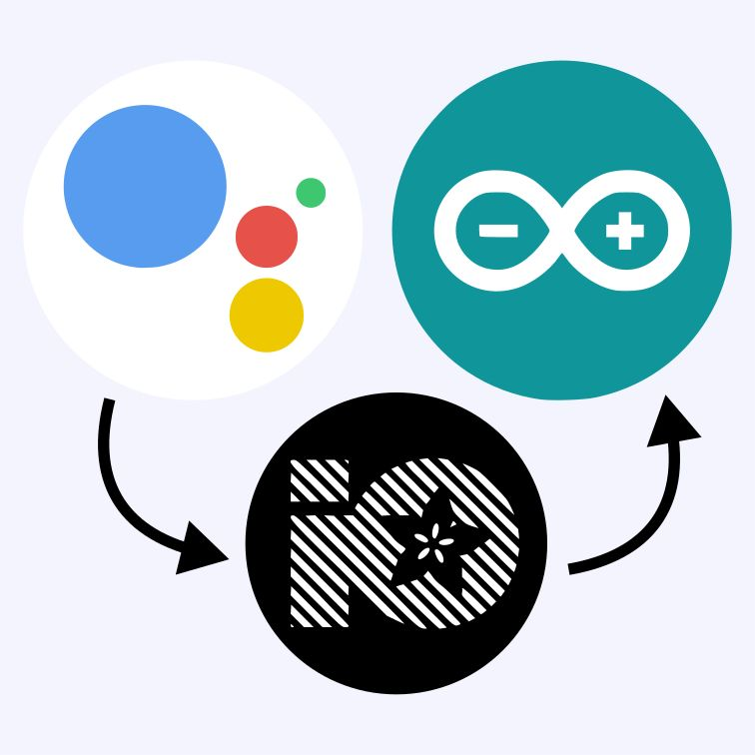

Figure2.9 Adafruit

**2.4.2 API**

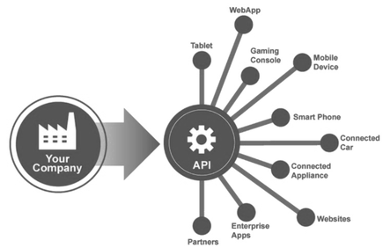In computer programming, an application programming interface (API) is a set of subroutine definitions, communication protocols, and tools for building software. In general terms, it is a set of clearly defined methods of communication among various components. A good API makes it easier to develop a computer program by providing all the building blocks, which are then put together by the programmer.

Figure2.10 API

An API may be for a web-based system, operating system, database system, computer hardware, or software library. An API specification can take many forms, but often includes specifications for routines, data structures, object classes, variables, or remote calls. POSIX, Windows API and ASPI are examples of different forms of APIs. Documentation for the API usually is provided to facilitate usage and implementation.

**2.4.3 PURPOSE**

In building applications. An API simplifies programming by abstracting the underlying implementation and only exposing objects or actions the developer needs. While a graphical interface for an email client might provide a user with a button that performs all the steps for fetching and highlighting new emails, an API for file input/output might give the developer a function that copies a file from one location to another without requiring that the developer understand the file system operations occurring behind the scenes.

**2.4.4 WEB API**

Web APIs are the defined interfaces through which interactions happen between an enterprise and applications that use its assets, which also is a Service Level Agreement (SLA) to specify the functional provider and expose the service path or URL for its API users.

When used in the context of web development, an API is typically defined as a set of specifications, such as Hypertext Transfer Protocol (HTTP) request messages, along with a definition of the structure of response messages, usually in an Extensible Mark-up Language (XML) or JavaScript Object Notation (JSON) format. An example might be a shipping company API that can be added to an e-commerce-focused website to facilitate ordering shipping services and automatically include current shipping rates, without the site developer having to enter the shipper's rate table into a web database. Web APIs allow the combination of multiple APIs into new applications known as mashups. In the social media space, web APIs have allowed web communities to facilitate sharing content and data between communities and applications. For example, Twitter's REST API allows developers to access core twitter data and the Search API provides methods for developers to interact with Twitter Search and trends data.

**2.5 CIRCUIT DIAGRAM** 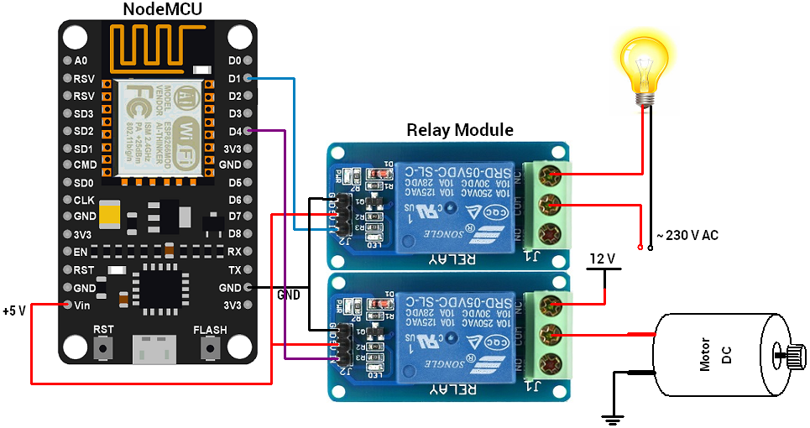

Figure2.11 Circuit Diagram

**2.6 CIRCUIT DIAGRAM DESCRIPTION**

The NodeMcu is supplied by 230V AC to 5V 2A DC power adapter. And NodeMCU is programmed to connect with the local Wi-Fi hotspot. D1 pin and D4 pine of NodeMCU is connected to input pin of the relay a 5V pin or Vin pin is connected Vin pin of the relay. The gnd of the NODEMCU is connected with gnd of the relay. The relay is connect with home appliance like light, fan, etc,.

**2.7 PROGRAM**

#include <ESP8266WiFi.h>

#include "Adafruit_MQTT.h"

#define Relay1 2

#define Relay2 13

#define Relay3 16

#define WLAN_SSID "......"

#define WLAN_PASS "......."

#define AIO_SERVER ......

#define AIO_SERVERPORT .....

#define AIO_USERNAME "......"

#define AIO_KEY "......."

WiFiClient client;

Adafruit_MQTT_Client mqtt(&client, AIO_SERVER, AIO_SERVERPORT, AIO_USERNAME, AIO_KEY);

Adafruit_MQTT_Subscribe Light1 = Adafruit_MQTT_Subscribe(&mqtt, AIO_USERNAME"/feeds/relay1");

Adafruit_MQTT_Subscribe Light2 = Adafruit_MQTT_Subscribe(&mqtt, AIO_USERNAME "/feeds/relay2");

Adafruit_MQTT_Subscribe Light3 = Adafruit_MQTT_Subscribe(&mqtt, AIO_USERNAME "/feeds/relay3");

void MQTT_connect();

void setup() {

Serial.begin(115200);

pinMode(Relay1, OUTPUT);

pinMode(Relay2, OUTPUT);

pinMode(Relay3, OUTPUT);

// Connect to WiFi access point.

Serial.println(); Serial.println();

Serial.print("Connecting to ");

Serial.println(WLAN_SSID);

WiFi.begin(WLAN_SSID, WLAN_PASS);

while (WiFi.status() != WL_CONNECTED) {

delay(500);

Serial.print(".");

}

Serial.println();

Serial.println("WiFi connected");

Serial.println("IP address: ");

Serial.println(WiFi.localIP());

mqtt.subscribe(&Light1);

mqtt.subscribe(&Light3);

mqtt.subscribe(&Light2);

}

void loop() {

MQTT_connect();

Adafruit_MQTT_Subscribe *subscription;

while ((subscription = mqtt.readSubscription(20000))) {

if (subscription == &Light1) {

Serial.print(F("Got: "));

Serial.println((char *)Light1.lastread);

int Light1_State = atoi((char *)Light1.lastread);

digitalWrite(Relay1, Light1_State);

}

if (subscription == &Light2) {

Serial.print(F("Got: "));

Serial.println((char *)Light2.lastread);

int Light2_State = atoi((char *)Light2.lastread);

digitalWrite(Relay2, Light2_State);

}

if (subscription == &Light3) {

Serial.print(F("Got: "));

Serial.println((char *)Light3.lastread);

int Light3_State = atoi((char *)Light3.lastread);

digitalWrite(Relay3, Light3_State);

}

}}

void MQTT_connect() {

int8_t ret;

if (mqtt.connected()) {

return;

}

Serial.print("Connecting to MQTT... ");

uint8_t retries = 3;

while ((ret = mqtt.connect()) != 0) {

Serial.println(mqtt.connectErrorString(ret));

Serial.println("Retrying MQTT connection in 5 seconds...");

mqtt.disconnect();

delay(5000);

retries--;

if (retries == 0) {

while (1);

}

}

Serial.println("MQTT Connected!");

}

**CHAPTER 3**

**CONCLUSION AND FUTURE DEVELOPMENT**

**3.1 CONCLUSION**

Our work focus is mainly to develop the device which controls the home appliance via voice. Today, Android is the world’s powerful mobile platform open source operating system to fit easily whatever the functionality we had in our mind. This article is about wireless home automation using google assistant helps you to implement such a fantastic system in our home at a very reasonable price using cost-effective devices. Thus, it overcomes many problems like costs, inflexibility, security etc. In addition, will provide greater advantages like it decrease our energy costs, it improves home security. In addition, it is very convenient to use and will improve the comfort of our home.

**3.2 FUTURE SCOPE**

Future scope for the home automation systems involves making homes even smarter. Homes can be interfaced with sensors including motion sensors, light sensors and temperature sensors and provide automated toggling of devices based on conditions. More energy can be conserved by ensuring occupation of the house before turning on devices and checking brightness and turning off lights if not necessary. The system can be integrated closely with home security solutions to allow greater control and safety for home owners. The next step would be to extend this system to automate a large scale environment, such as offices and factories. Home Automation offers a global standard for interoperable products. Standardization enables smart homes that can control appliances, lighting, environment, energy management and security as well as the expandability to connect with other network

**REFERENCES**

[1] Internet Society; Internet of Things Overview; [online] Available: [www.internetsociety.org](http://www.internetsociety.org)

[2] The Intel IoT Platform reference architecture specification white paper.[online] Available: <http://www.intel.in>

[3] Twinkle Gondaliya ,”A Survey on an Efficient IOT Based Smart Home”, International Journal of Review in Electronics and Communication Engineering Volume 4, No 1 February 2016.

[4] Gaurav Tripathi, Dhananjay Singh, and Antonio J. Jara, "A survey of Internet-of-Things: Future Vision, Architecture, Challenges and Service", IEEE World Forum on Internet of Things (WF-IoT), 2014, pp. 287-292

[5] Sarita Agrawal, and Manik Lal Das, "Internet of Things – A Paradigm Shift of Future Internet Applications", International Conference on Current Trends in Technology, December, 2011.

[6] Pooja N.Pawar1, Shruti Ramachandran2, Nisha P.Singh3, Varsha V.Wagh4, “A Survey on Internet of Things Based Home Automation System”,International Journal of Innovative Research in Computer and Communication Engineering, Vol. 4, Issue 1, January 2016.

[7] Dhakad Kunal1, Dhake Tushar2, Undegaonkar Pooja3, Zope Vaibhav4, Vinay Lodha5,” Smart Home Automation using IOT”, International Journal of Advanced Research in Computer and Communication Engineering Vol. 5, Issue 2, February 2016.