EXPERIMENT – 1 CODES

AMPLITUDE MODULATION AND DEMODULATION

**B Siddharth Sekhar - EC22B1064**

**DSBFC (Double Sideband Full Carrier) Modulation and Demodulation Code:**

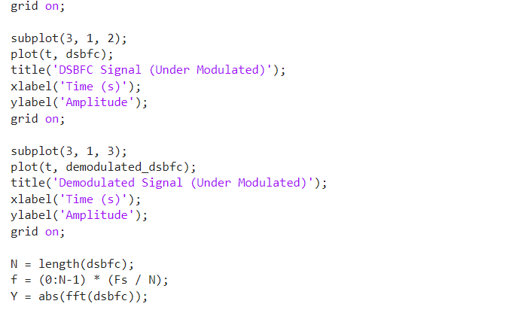****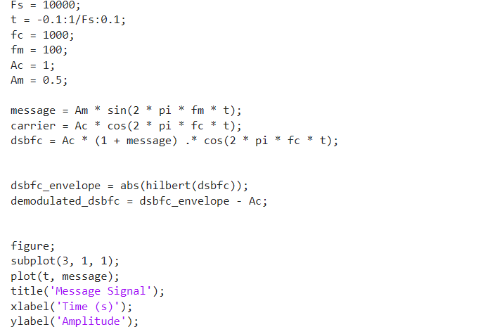

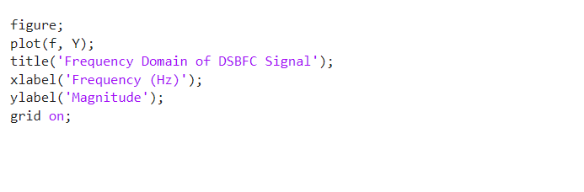

**DSBSC (Double Sideband Suppressed Carrier) Modulation and Demodulation Code:**



