EXPERIMENT – 10

**DESIGN OF MICROSTRIP LINE USING ANSYS HFSS**

April 8 - 2025

B Siddharth Sekhar - EC22B1064

**Aim:**

Design and Simulation of Microstrip Line using ANSYSS HFSS

1. Generate plots for S11 and S21

2. Calculate the Power reflected and transmitted through the line.

**Theory:**

A microstrip line

is a type of planar transmission line used in RF and microwave circuits. It consists of:

* A conductive strip (signal line) on top,
* A dielectric substrate (like FR4),
* And a ground plane at the bottom.

It is commonly used for signal routing and RF component integration (e.g., antennas, filters, couplers).

Characteristic Impedance (Z₀)

• The characteristic impedance (Z₀) depends on:

* Width (W) of the conductor
* Substrate height (h)
* Dielectric constant (εᵣ)

• For FR4 (εᵣ = 4.4, h = 1.6 mm), to achieve Z₀ = 50 Ω, the conductor width W ≈ 3.06 mm.

• Z₀ is independent of length (L).

S-Parameters (Scattering Parameters)

* S-parameters describe how RF signals behave in a network:
* S11 (Return Loss): Amount of signal reflected back from port 1.

Ideally S11 < -10 dB (less reflection, better matching).

* S21 (Insertion Loss / Transmission Gain): Amount of signal transmitted from port 1 to port 2 Ideally close to 0 dB (minimum loss).

Choosen Design Parameters

|  |  |
| --- | --- |
| **W-Width of the top conductor** | 3.06mm |
| **L – Length of the top conductor** | 25mm |
| **h – Height of the substrate** | 1.6mm |
| **ɛr – Relative permittivity of**  **substrate** | ɛr = 4.4 |
| **Thickness (Ground,conductor)** | 0.035mm |
| **substrate** | 25mmx25mm |

**Simulation Results and Observations :**

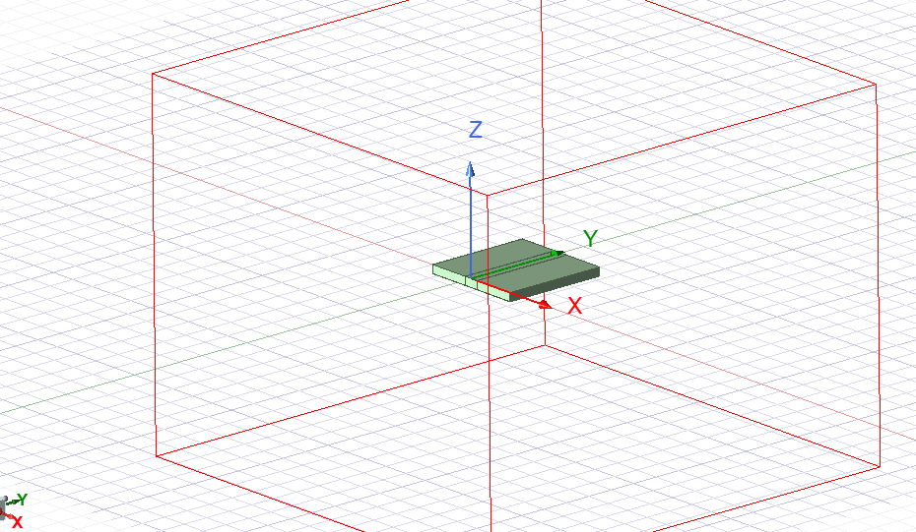

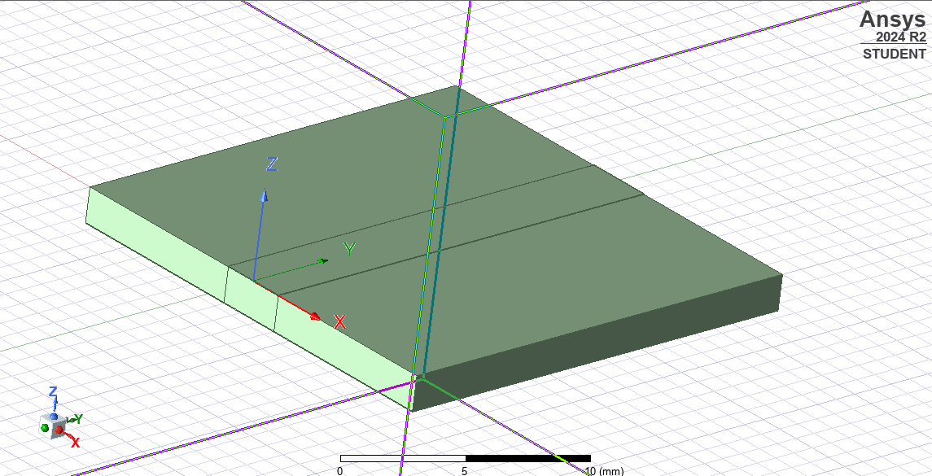

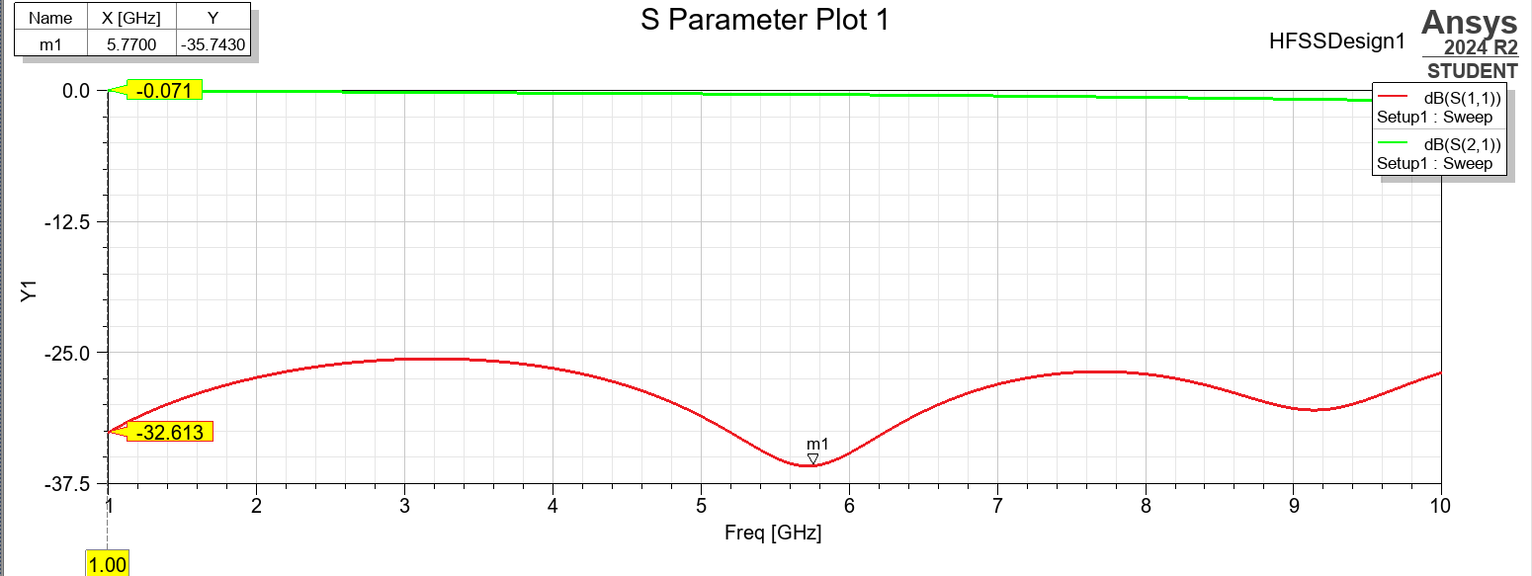

**From the Plot the following dB values:**

* S11 @ 3 GHz = -26.75 dB
* S21 @ 3 GHz = -0.22 dB

Let’s convert these to linear scale to calculate power.

**Calculations:**

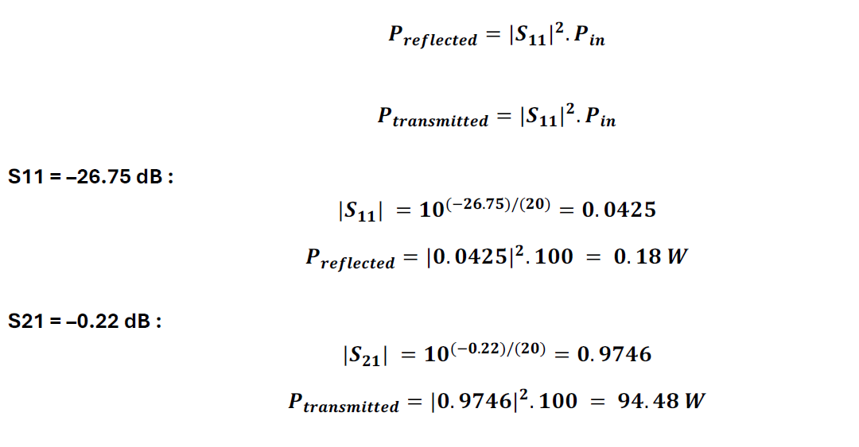

**Inference:**

From the simulation results, the microstrip line designed with a characteristic impedance of 50 ohms

shows excellent performance at 3 GHz. The S-parameter plot indicates:

• S11 = -26.75 dB, meaning very low signal reflection (good impedance matching).

• S21 = -0.22 dB, indicating minimal transmission loss.

This confirms that the line is well-matched and eeiciently transmits power with negligible reflection.

**Conclusion:**

The microstrip line was successfully designed and simulated using ANSYS HFSS. The analysis of S11 and S21 parameters shows that the structure achieves proper impedance matching and low signal loss at the operating frequency. This validates the effectiveness of the design and suitability of the microstrip line for high-frequency applications.

**References:**  [1] Simon Haykins, Communication systems, 2nd ed. (New York John Wiley and Sons, 2005).