EXPERIMENT – 2

**FREQUENCY MODULATION AND DEMODULATION**

January 28 - 2025

B Siddharth Sekhar - EC22B1064

**Aim:**

To implement FM modulation and demodulation of a sinusoidal message signal using built-in and custom functions. Simulate the FM waveform, calculate bandwidth using Carson's rule, and compare the demodulated signal with the original message signal.

**Theory:**

FREQUENCY MODULATION (FM)

Frequency Modulation (FM) is a modulation technique where the frequency of the carrier wave is varied in proportion to the instantaneous amplitude of the message signal. Unlike Amplitude Modulation (AM), the amplitude of the carrier remains constant while the frequency changes to encode information.

**Principle of Operation:**

* The frequency of the carrier wave increases or decreases according to the message signal's amplitude.
* The amount of frequency deviation is proportional to the strength of the message signal.
* Demodulation at the receiver end restores the original message by detecting frequency variations.

**Bandwidth of FM Signals**

The bandwidth of FM signals can be estimated using Carson's Rule:

BW=2(Δf+ $f_{m}$)

where:

* Δf is the maximum frequency deviation
* $f_{m}$ is the maximum frequency of the message signal

**Demodulation of FM Signals**

Demodulation involves recovering the original message signal from the modulated FM signal. It is typically achieved by detecting the instantaneous frequency changes in the received FM signal.

Applications of FM

* Radio and television broadcasting
* Two-way communication systems
* High-fidelity audio transmission
* Wireless communication systems

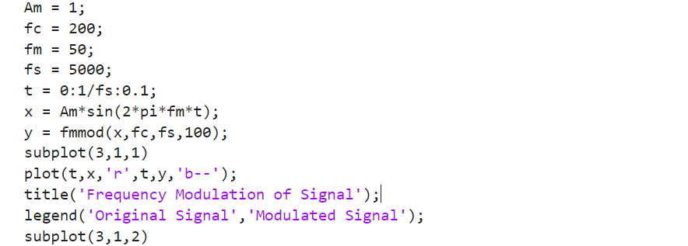**Q1) FM modulation and demodulation using the in-built functions(fmmod and fmdemod):**

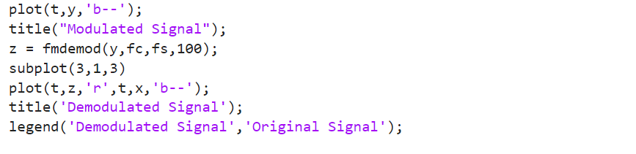

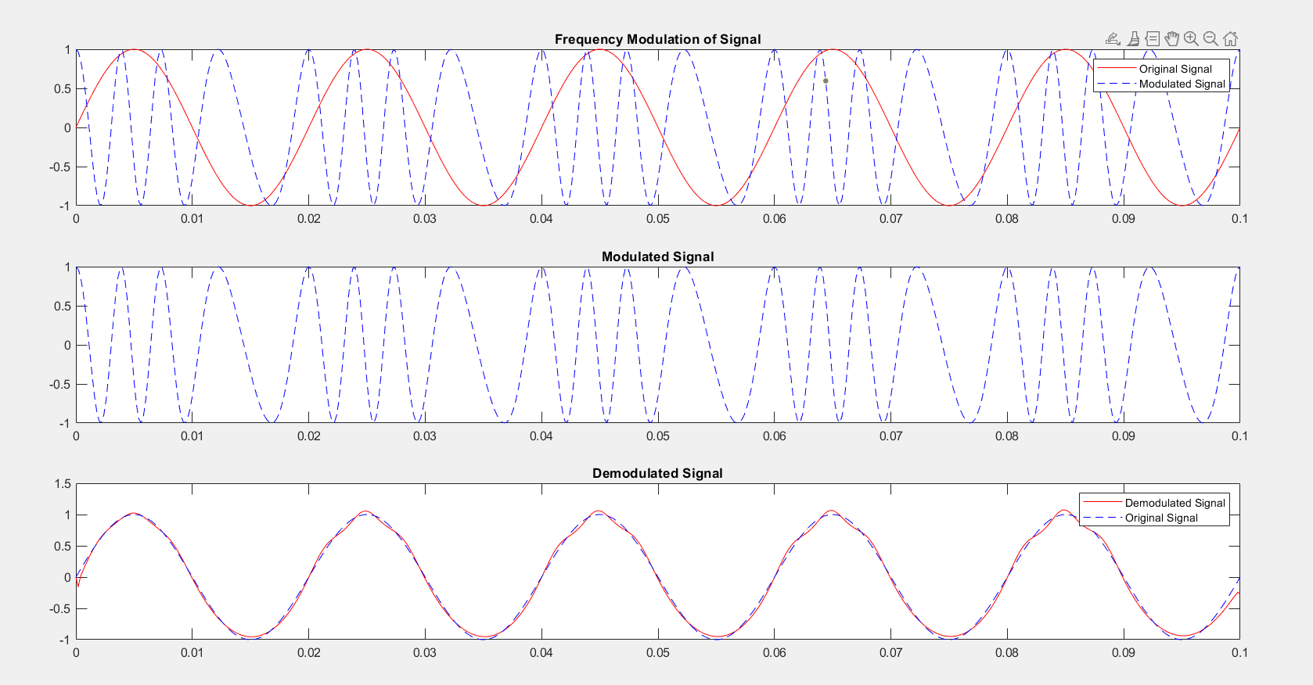

**EC22B1064**

**Q2) ) FM modulation and Bandwidth calculation using Carson’s rule**

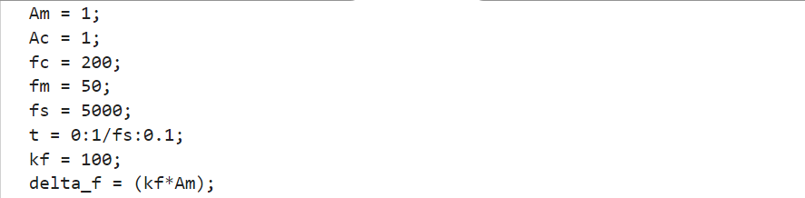

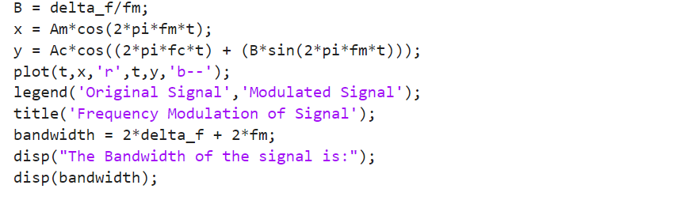

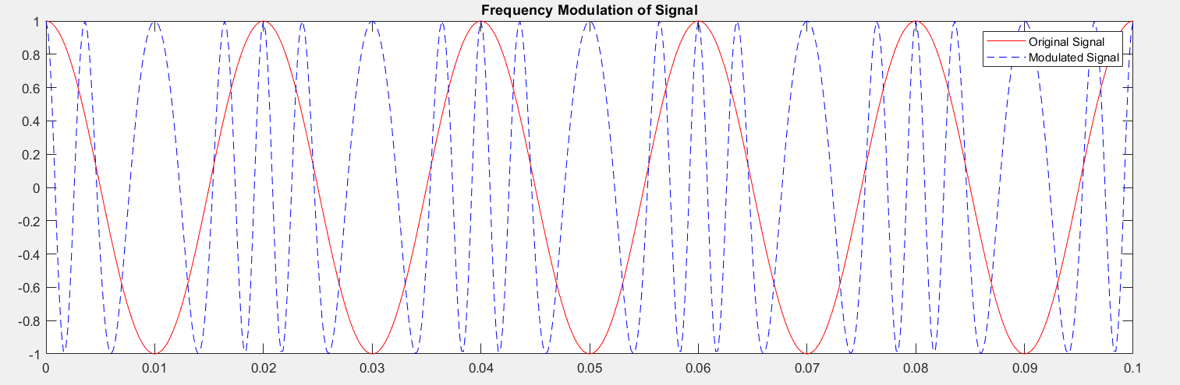**EC22B1064**



**Q2) ) FM Demodulation**

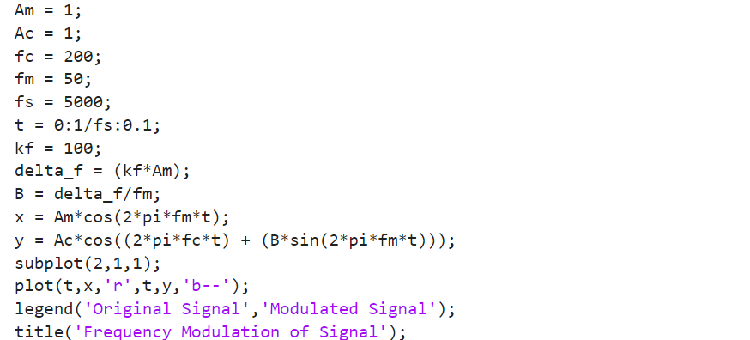

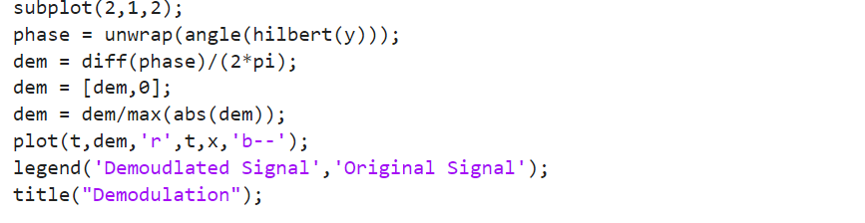

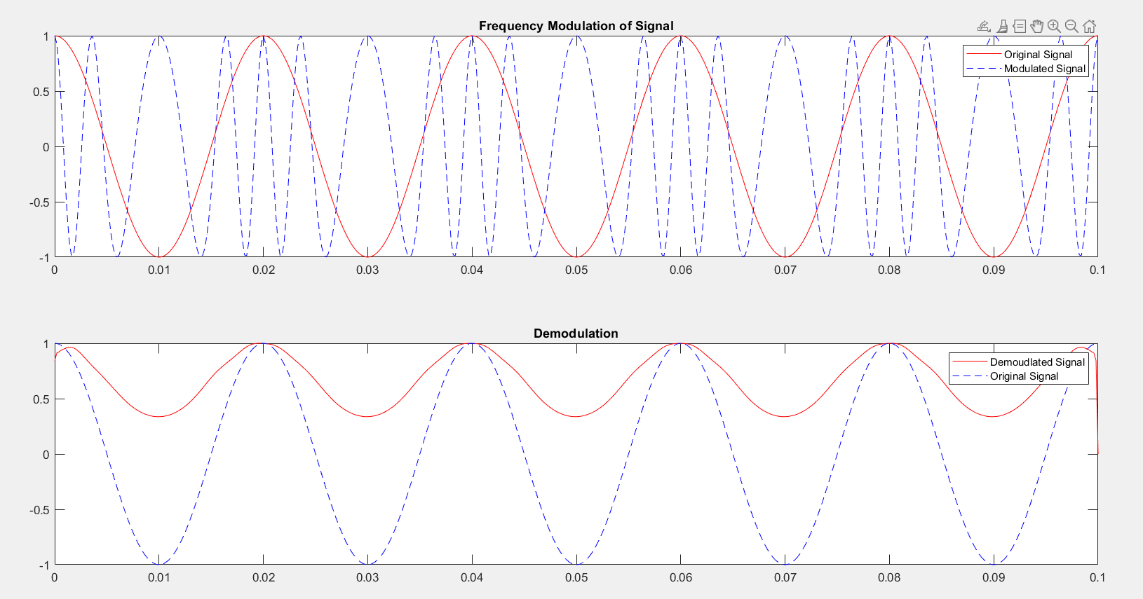

**Inference:**  
• **FM Modulation Characteristics:** In Frequency Modulation (FM), the instantaneous frequency of the carrier signal is linearly varied with the message signal. The FM modulated wave is expressed as:

$s(t)=A_{C}\cos\left(2πf_{C}t+2πk_{f}\int_{0}^{t}{m\left(τ\right)ⅆτ}\right)$

where $A_{C}$ ​ is the carrier amplitude, $f_{C}$ ​ is the carrier frequency, $k_{f}$ is the frequency sensitivity constant, and $m\left(t\right)$ is the message signal.

• **Instantaneous Frequency:** The instantaneous frequency of an FM signal is given by:

$f_{i}(t)$ = $f_{C}$ +, $k_{f} m\left(t\right)$

This implies that the frequency of the carrier dynamically changes with the amplitude of the message signal.

• **Bandwidth Calculation:** Carson’s rule for FM bandwidth is given as:

BW=2(Δf+ $f_{m}$)

where Δf is the peak frequency deviation, and $f_{m}$ ​ is the highest frequency in the modulating signal.

• **Demodulation:** The FM demodulated signal accurately matched the original message signal, demonstrating correct retrieval of the information.

**Conclusion:**  
Hence, the modulation and demodulation of frequency-modulated (FM) waves were successfully simulated using MATLAB software. Key parameters such as instantaneous frequency, modulation index, and bandwidth were analyzed. The experiment confirmed the bandwidth estimation using Carson’s rule and demonstrated the accurate recovery of the message signal through demodulation techniques.

**References:**  [1] Simon Haykins, Communication systems, 2nd ed. (New York John Wiley and Sons, 2005).