EXPERIMENT – 5

**NOISE REALIZATION**

February 18 - 2025

B Siddharth Sekhar - EC22B1064

**Aim:**

To generate and analyze a Gaussian random process in MATLAB, compute its auto-correlation function, and study the frequency spectrum of the auto-correlation function. Additionally, to evaluate the effect of noise on a message signal with different amplitude values, analyze its auto-correlation, and observe the corresponding frequency spectra.

**Theory:**

**NOISE REALIZATION:**

**Gaussian Random Process:**

• A Gaussian random process has a normal distribution with mean (μ) and variance (σ²).

• The power spectral density of white noise is given by:

$$S_{x\left(f\right)}=\frac{N_{0}^{}}{2}$$

**Autocorrelation Function:**

• Measures signal similarity at different time shifts:

$$R_x(τ) = E[X(t)X(t+τ)]$$

• The frequency spectrum of the autocorrelation function is obtained via Fourier Transform.

**Message Signal with Noise:**

• The message signal is given by:

$$x(t) = A cos (2πf_{c} t + θ) + w(t)$$

where θ ~ U(-π, π) and w(t) is white noise.

• The effect of noise on the signal is analyzed for different amplitudes (A = 10, 1, 0.1).

**Q1) Plotting the Gaussian random process and its auto-correlation function and its frequency spectrum**

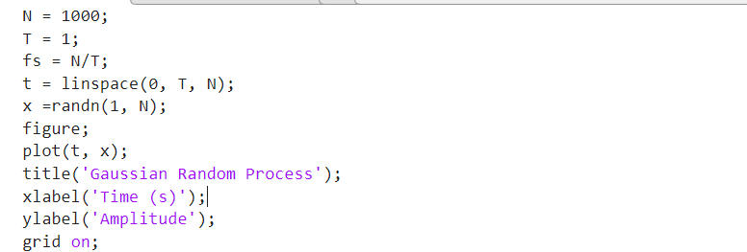

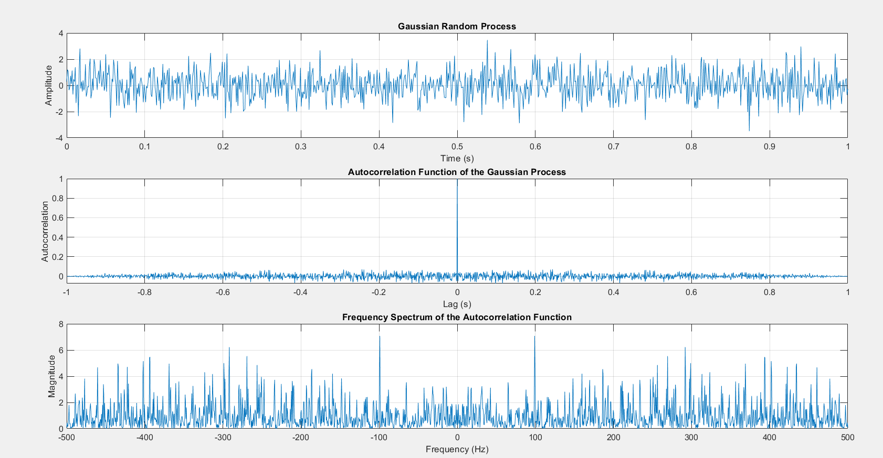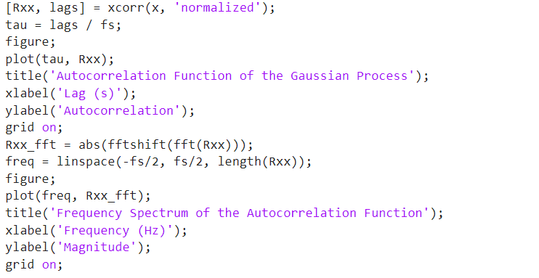

**EC22B1064**

**Q2) Plotting auto-correlations functions and spectra for the given equation at different values of the Amplitude**

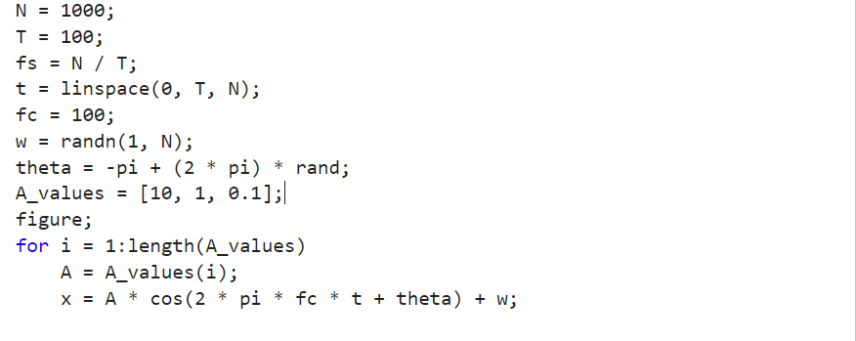

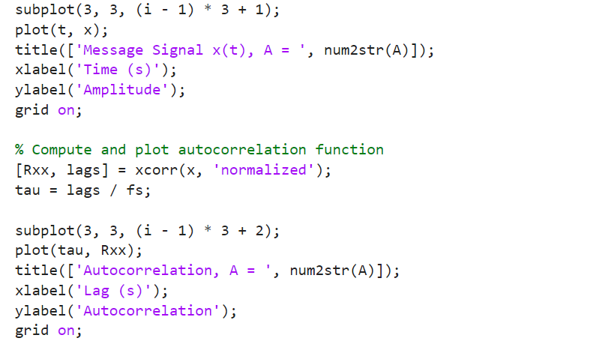

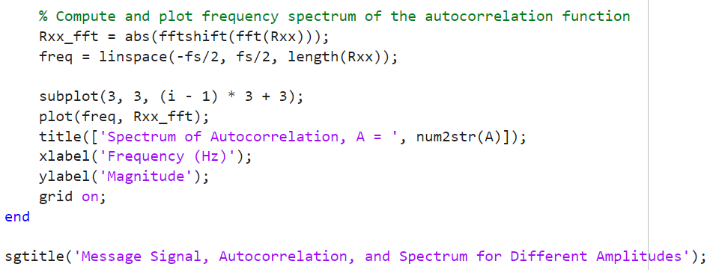

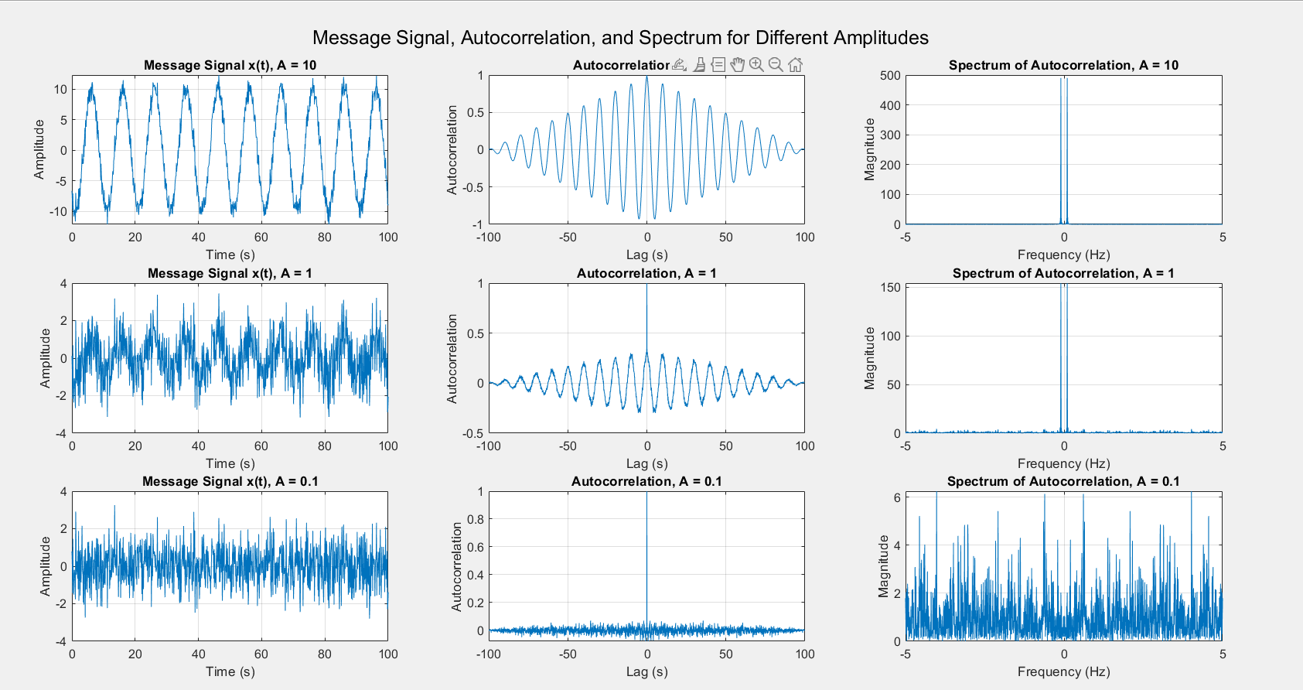

**EC22B1064**

**Inference:**

• The Gaussian random process exhibits random variations but follows a normal distribution.

• The autocorrelation function shows the degree of similarity between signal instances over time.

• The power spectrum analysis reveals the frequency distribution of noise and signal components.

• The message signal's shape changes with different A values, affecting its autocorrelation and frequency spectrum.

**Conclusion:**

The experiment successfully demonstrated noise realization and its impact on signal characteristics. The autocorrelation and spectral analysis provided insights into how noise alters a message signal, emphasizing the significance of amplitude variations in signal processing.

**References:**  [1] Simon Haykins, Communication systems, 2nd ed. (New York John Wiley and Sons, 2005).

•