EXPERIMENT – 6

**Binary-ASK And M-ary ASK**

March 10 - 2025

B Siddharth Sekhar - EC22B1064

**Aim:**

To implement Binary Amplitude Shift Keying (BASK) and M-ary ASK (M = 4, 8) for a given binary message sequence. Verify the decoded bits at the receiving end and plot the corresponding waveforms.

**Theory:**

Amplitude Shift Keying (ASK)

is a digital modulation technique where the amplitude of a carrier signal varies according to the digital data. The frequency and phase of the carrier remain constant while the amplitude changes to represent binary data.

1. **Binary ASK (BASK):**

* Also known as On-Off Keying (OOK), BASK uses two distinct amplitude levels to represent binary '1' and '0'.
* The modulated BASK signal is given by: $s\left(t\right)=b\left(t\right).A_{c}cos⁡(2πf_{c}t)$

where is the carrier amplitude, is the carrier frequency, and is the binary data signal.

1. **M-ary ASK:**

* Extends BASK by allowing M different amplitude levels, where $M=2^{k}$ and k is the number of bits per symbol.
* The modulated M-ASK signal is expressed as: $s\left(t\right)=A_{m}cos⁡(2πf_{c}t)$

where takes one of M discrete amplitude values.

* Example:

4-ASK: Uses 4 amplitude levels to represent 2 bits per symbol.

8-ASK: Uses 8 amplitude levels to represent 3 bits per symbol.

**Advantages of M-ASK:**

Higher data rates as multiple bits are transmitted per symbol.

Improved bandwidth efficiency compared to BASK.

**Disadvantages of M-ASK**:

Increased complexity in modulation and demodulation.

Higher noise susceptibility as M increases, leading to greater chances of symbol errors.

**Q1)Perform Binary Amplitude Shift Keying (BFSK) and decode the signal.**

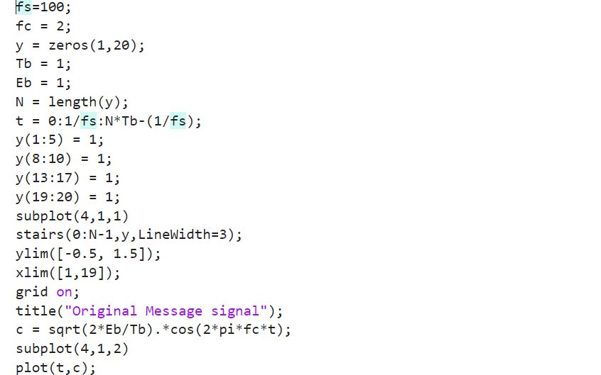

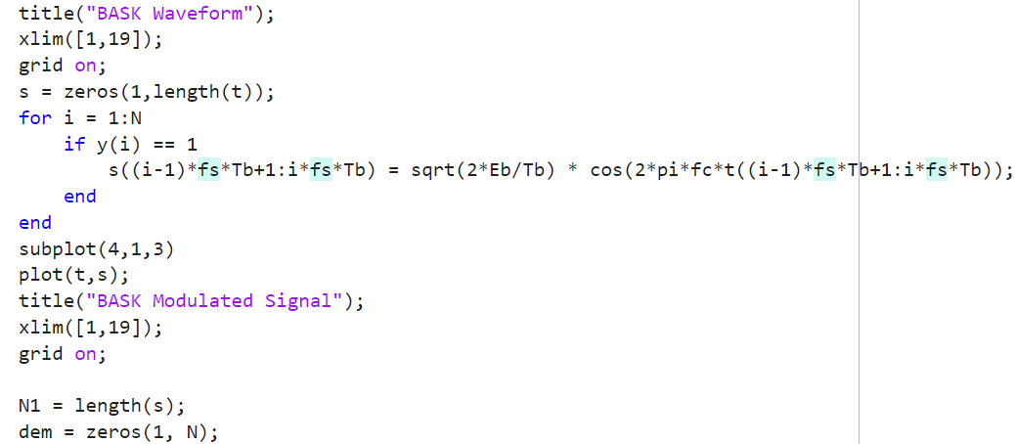

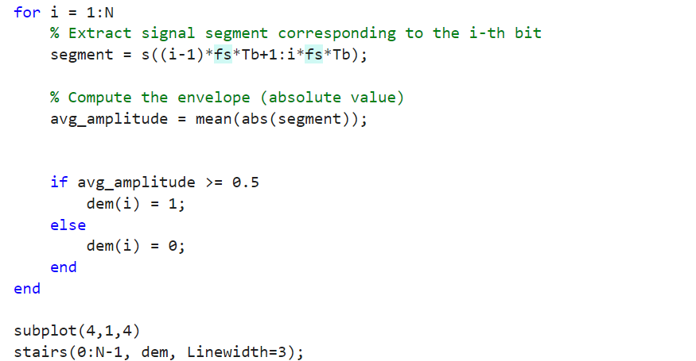

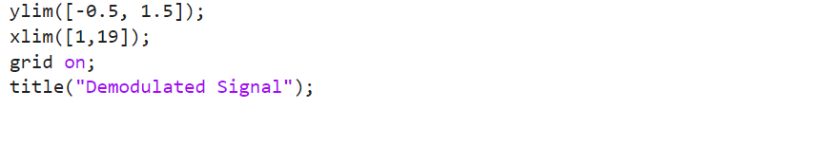

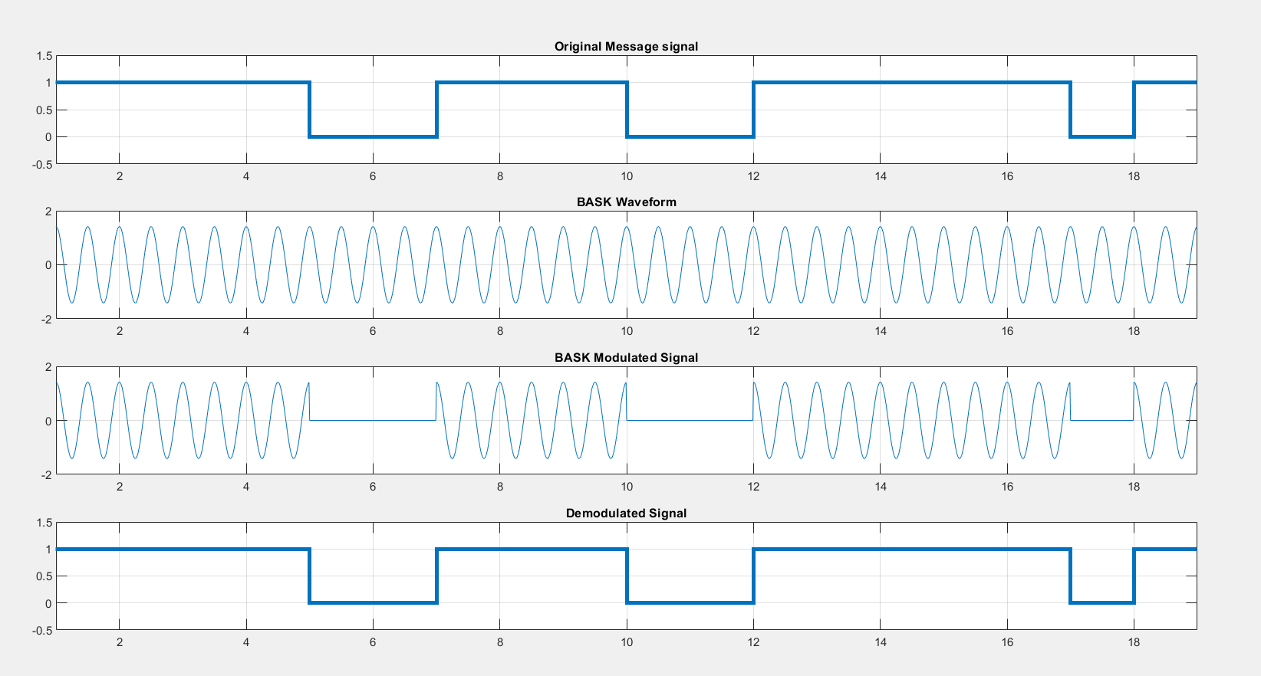

**EC22B1064**

**Q2) Perform M-ary Amplitude Shift Keying (M=4, M=8) and decode the signal.**

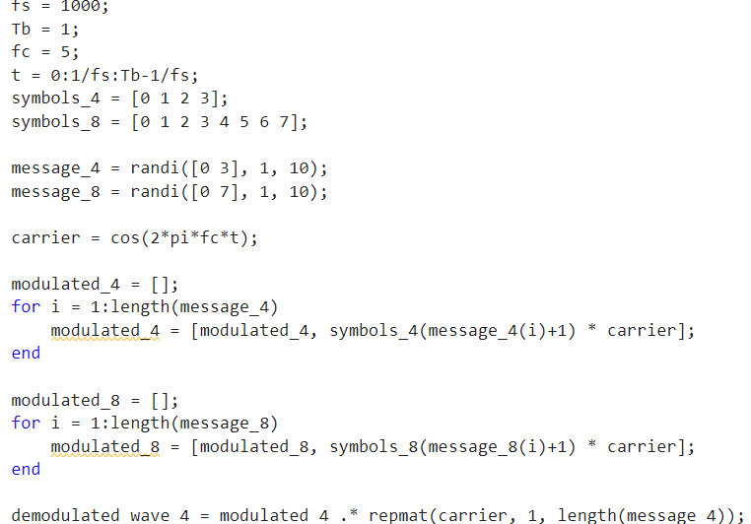

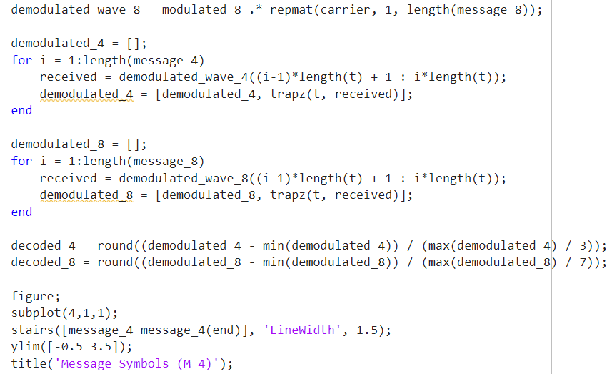

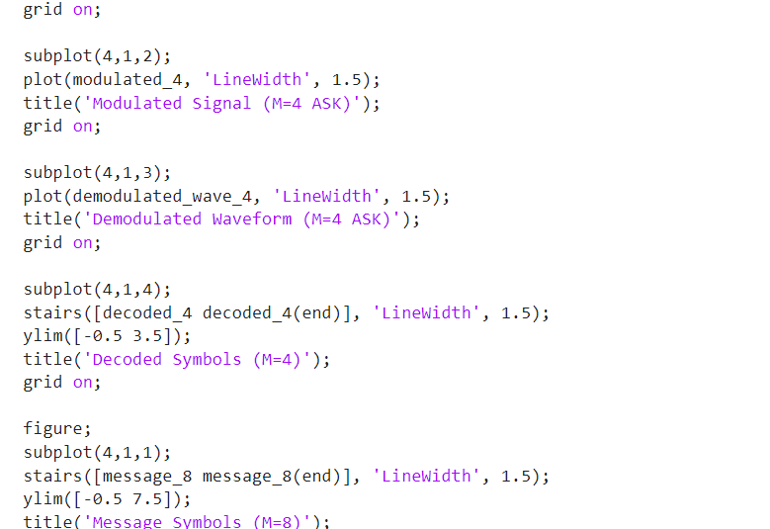

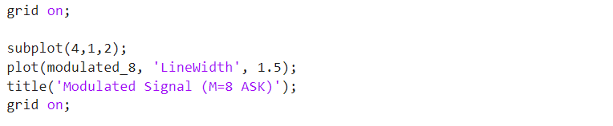

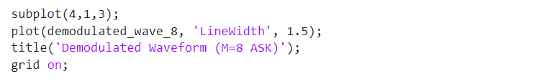

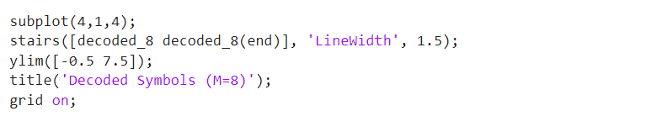

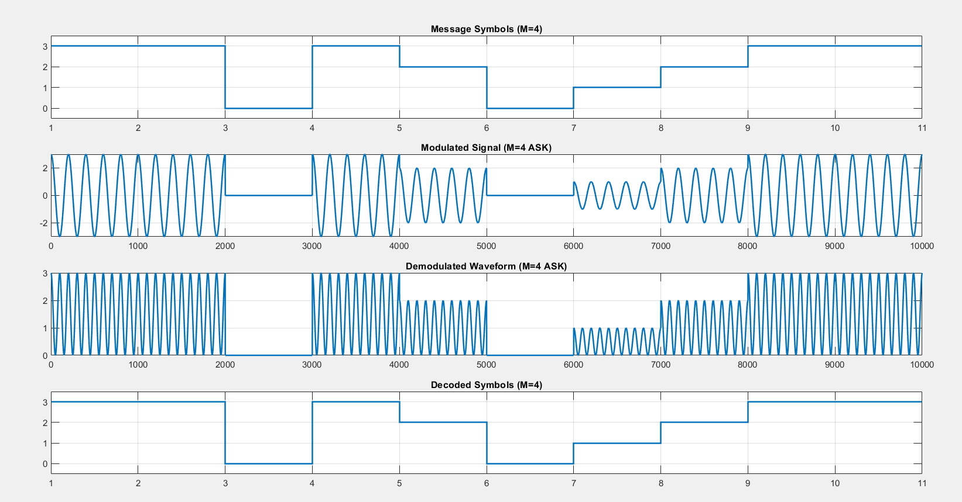**EC22B1064**

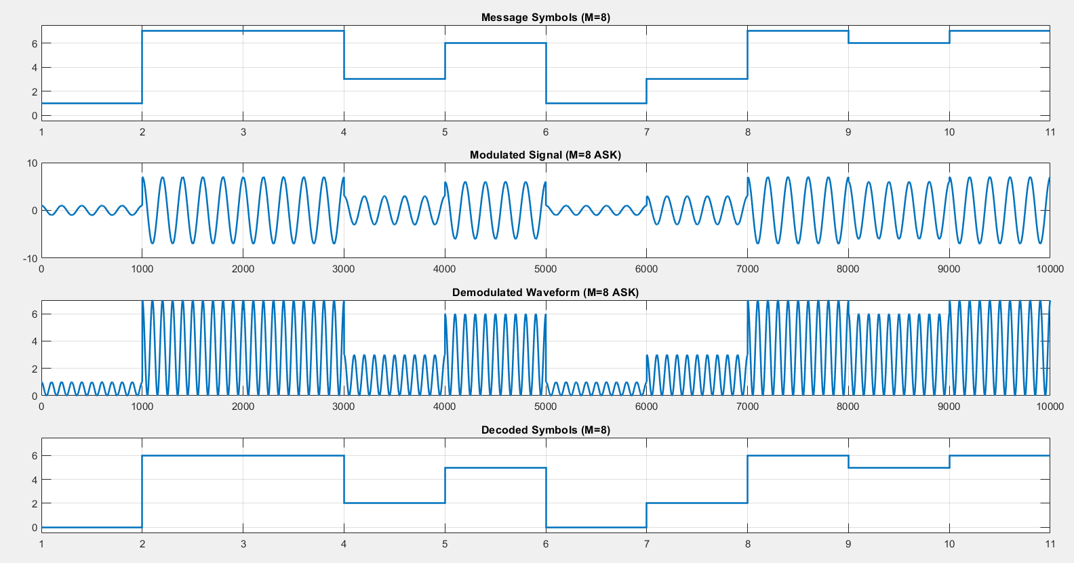**EC22B1064**

**Inference:**

* In BASK, the carrier is switched on and off, making it simple but prone to noise.
* In M-ASK, multiple amplitude levels allow transmission of more data per symbol, increasing efficiency but requiring better signal processing.
* As M increases, the system becomes more complex and susceptible to noise

**Conclusion:**

* ASK is an efficient modulation technique for digital communication, widely used in optical fiber and wireless communication.
* M-ASK improves data transmission rates but requires better signal-to-noise ratio and more complex demodulation techniques.
* The experiment successfully demonstrates BASK and M-ASK, verifying the transmitted and received signals.

**References:**  [1] Simon Haykins, Communication systems, 2nd ed. (New York John Wiley and Sons, 2005).

•