EXPERIMENT – 8

**BINARY PHASE SHIFT KEYING BPSK**

March 25 - 2025

B Siddharth Sekhar - EC22B1064

**Aim:**

To implement Binary Phase Shift Keying (BPSK) on aspecified binary message sequence, decode the signal, and compare it with the original message. Additionally, analyze the effect of noise on the BPSK demodulation process and plot the corresponding waveforms.

**Theory:**

Binary Phase Shift Keying (BFSK):

Binary Phase Shift Keying (BPSK) is a digital modulation technique where the phase of the carrier signal changes based on the binary data. The carrier frequency remains constant, while the phase shifts by 180 degrees depending on whether the bit is '1' or '0'.

**Mathematical Representation**

The BPSK modulated signal is given by:

$s\left(t\right)=Acos\left(2πf_{c}t\right) if b\left(t\right)=1$

$$s\left(t\right)=-Acos\left(2πf_{c}t\right) if b\left(t\right)=0$$

where: A is the carrier amplitude, $f_{c}$ is the carrier frequency, b(t) is the binary message signal.

**Advantages of BPSK:**

High noise immunity compared to ASK and BFSK. Simple coherent detection using matched filtering. Disadvantages of BPSK: Requires coherent detection for demodulation. More complex circuitry compared to ASK.

**Q1)Perform Binary Phase Shift Keying (BFSK) and decode the signal.**

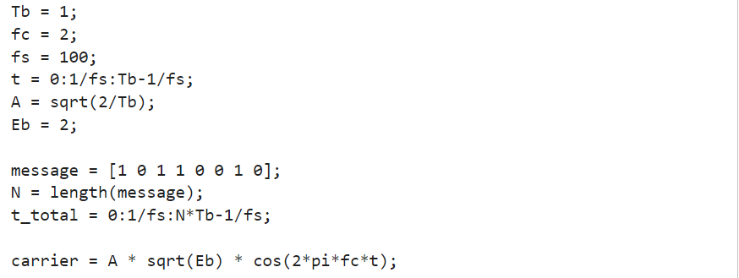



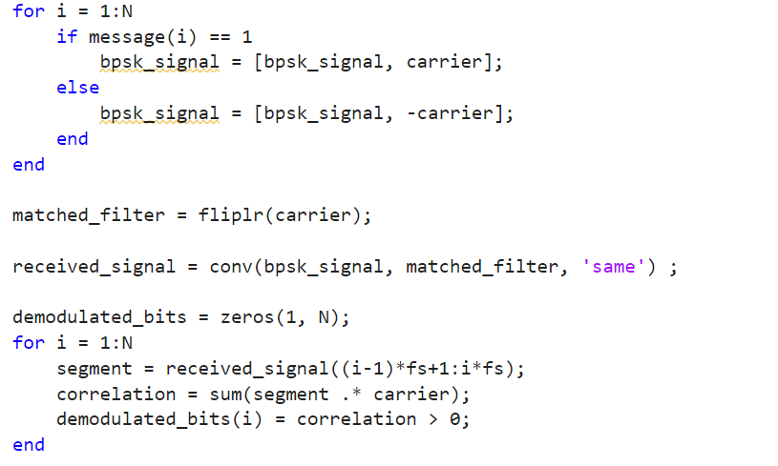

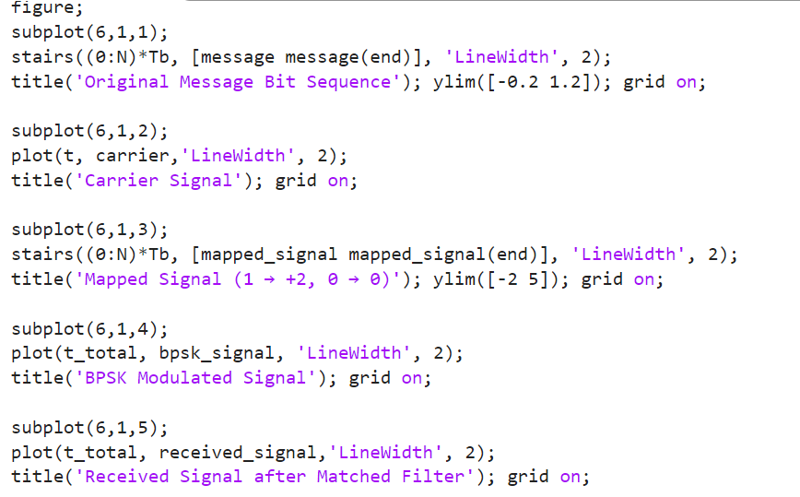

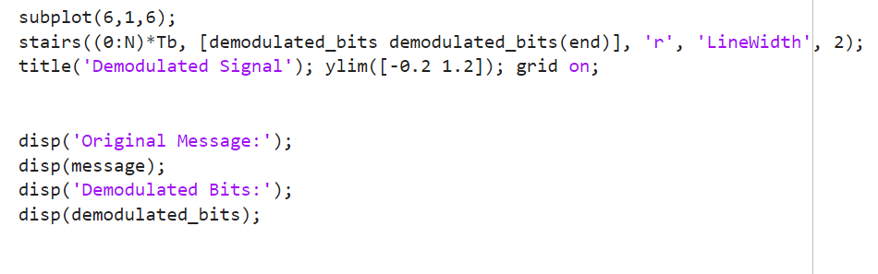

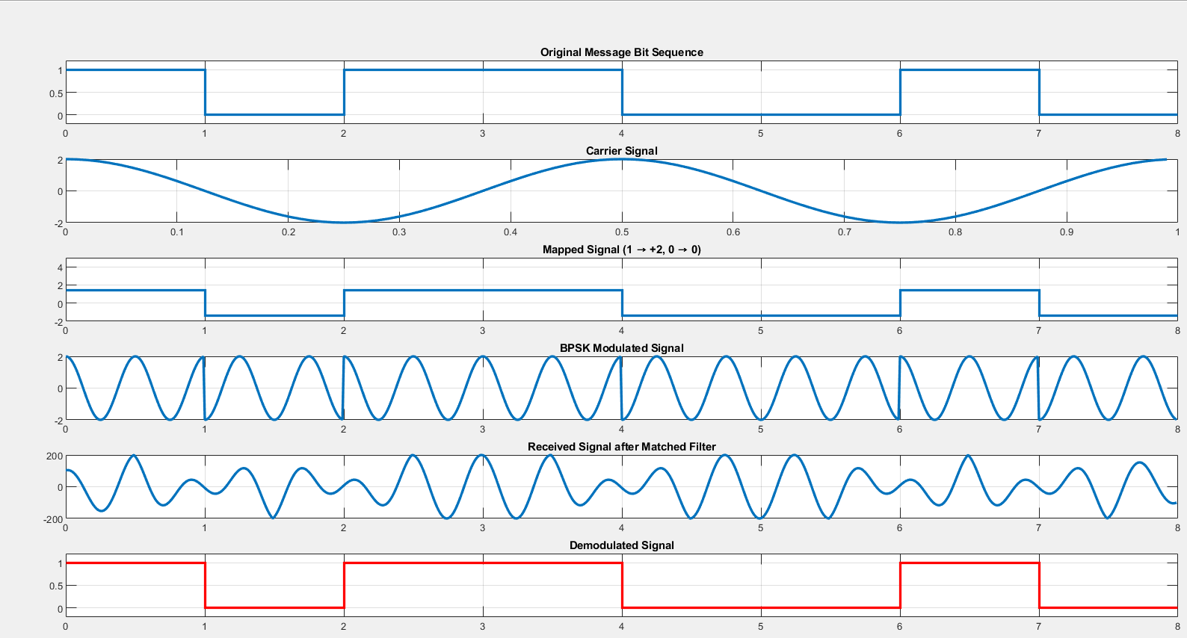 **EC22B1064**

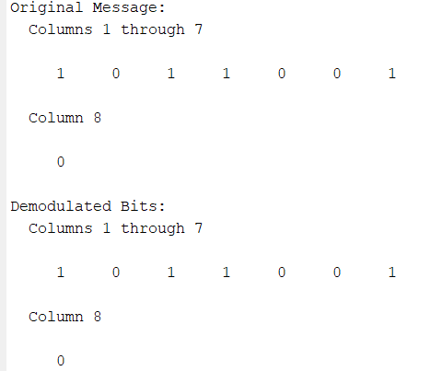 **EC22B1064**

**Q2) Analyze the effect of noise on BPSK demodulation process by adding AWGN to the BPSK Modulated signal**

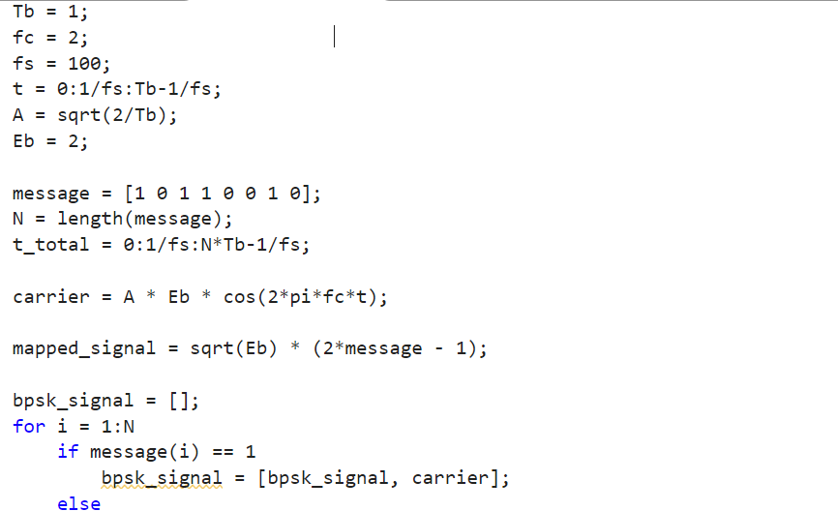

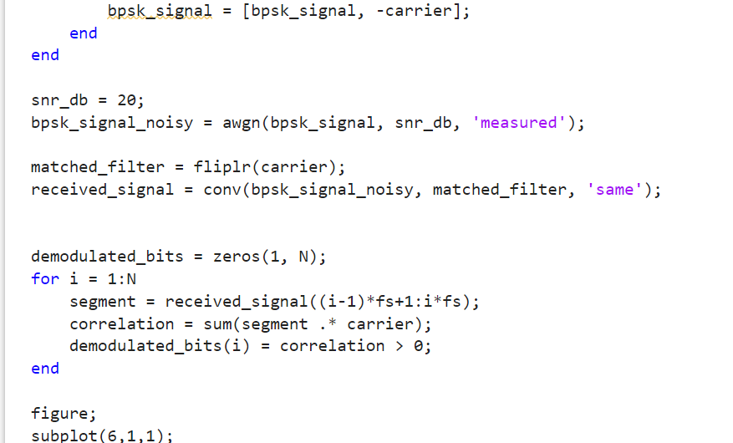

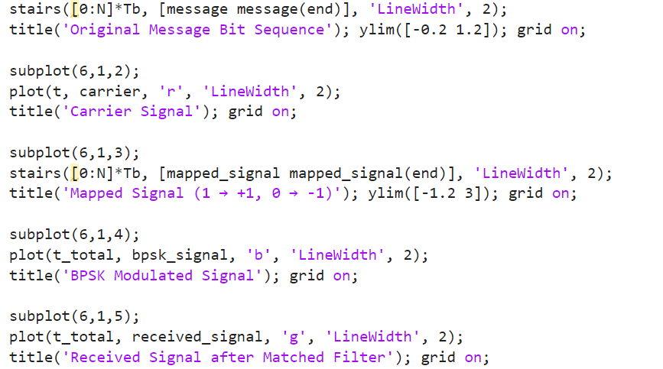

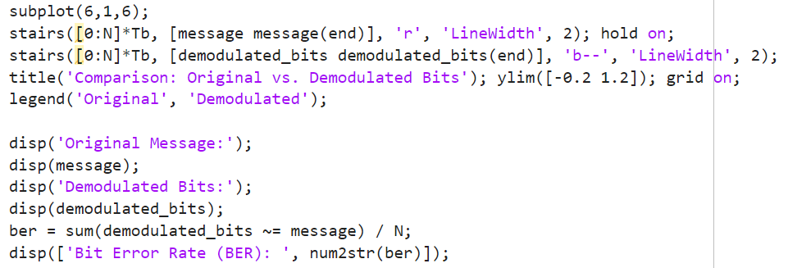

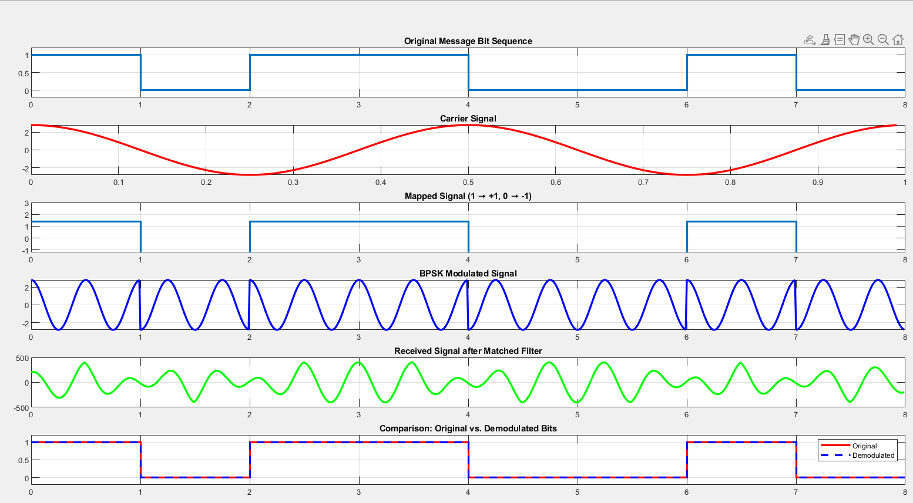

**EC22B1064**

**Inference:**

In BPSK, binary symbols are represented by phase shifts, making it highly robust against noise. The presence of noise (AWGN) affects the demodulation process, leading to potential bit errors. Trade-off: BPSK offers better noise performance but requires phase-coherent detection.

**Conclusion:**

Binary Phase Shift Keying (BPSK) is an efficient modulation technique widely used in digital communication. BPSK provides better noise immunity than BFSK but requires coherent demodulation. The experiment successfully demonstrates BPSK modulation and demodulation, verifying the transmitted and received signals.

**References:**  [1] Simon Haykins, Communication systems, 2nd ed. (New York John Wiley and Sons, 2005).

•