EXPERIMENT – 9

**DIFFERENTIAL PHASE SHIFT KEYING (DPSK)**

April 1 - 2025

B Siddharth Sekhar - EC22B1064

**Aim:**

To implement Binary Differential Phase Shift Keying (B-DPSK) on a randomly generated binary message sequence, demodulate the noisy modulated signal, and compare it with the original message. Additionally, generate plots for various stages of the modulation and demodulation process.

**Theory:**

Phase Shift Keying (PSK):  
PSK is a digital modulation technique where the phase of the carrier signal is varied in accordance with the message signal.

Differential Phase Shift Keying (DPSK):  
In DPSK, instead of transmitting the absolute phase of the carrier, the information is conveyed by the phase difference between consecutive bits.

* **No reference signal** is required for demodulation.
* Reduces the complexity of the receiver design.
* However, **error propagation** may occur during demodulation.

Binary DPSK (B-DPSK):

* Consecutive bits with the same value → No phase change.
* Opposite bits → Phase shift of π (180°).
* The first bit is treated as a reference.

**Modulation and Demodulation Logic:**

* A differential encoder encodes the input message sequence.
* At the receiver, the decoder compares the current phase with the previous phase to decode the original message.

**Q)Performing Binary Differential Phase Shift Keying(B-DPSK) on random message singal, demodulating the signal, performing the same operations on a noisy signal and showing the plots**

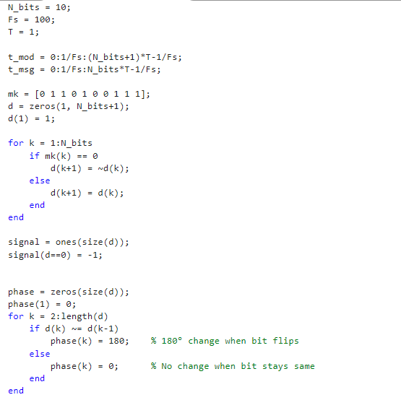

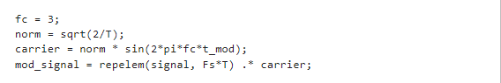

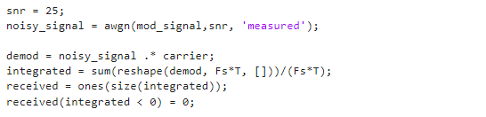

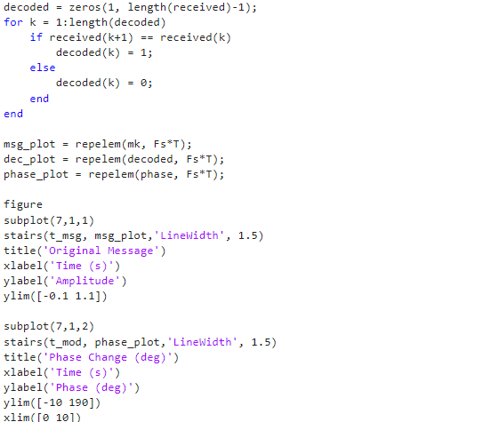

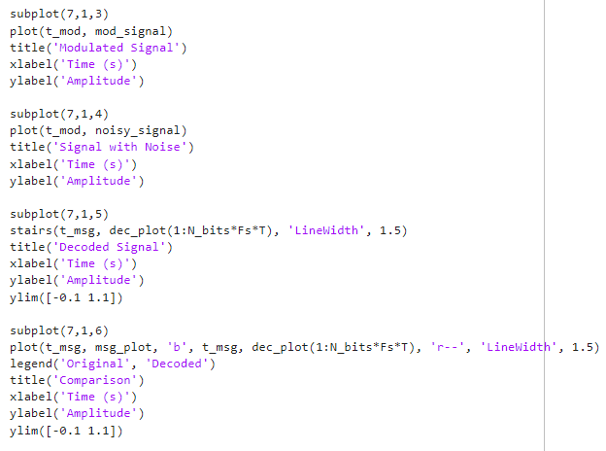

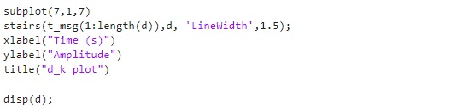

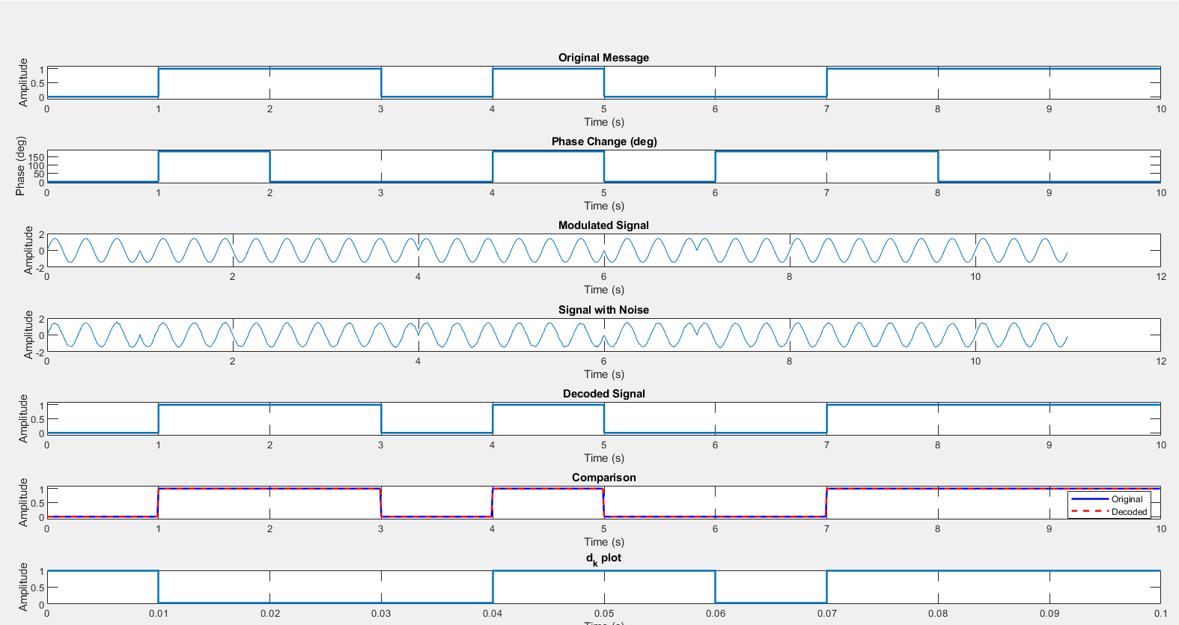**EC22B1064**

**Inference:**

Differential encoding in B-DPSK allows demodulation without a reference phase, which simplifies receiver circuitry. Noise can still impact phase differences between bits, potentially causing bit errors due to error propagation, especially at very low SNRs. However, it provides a robust alternative to conventional PSK for systems where carrier phase synchronization is difficult.

**Conclusion:**

The experiment successfully demonstrates B-DPSK modulation and demodulation. The decoded output matches the original message with slight variations in the presence of noise. B-DPSK is particularly useful in scenarios where coherent detection is not feasible, offering simplified receiver design at the cost of occasional error propagation.

**References:**  [1] Simon Haykins, Communication systems, 2nd ed. (New York John Wiley and Sons, 2005).