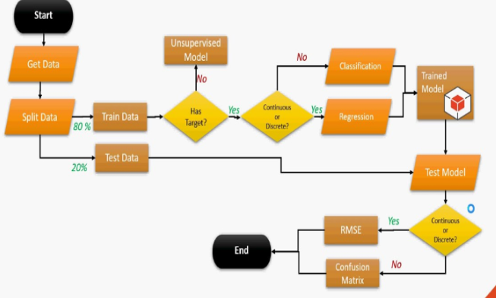
OVERVIEW

Good health is essential to human welfare and to sustained economic and social development. WHO's Member States have set themselves the target of developing their health financing systems to ensure that all people can use health services, while being protected against financial hardship associated with paying for them.

In this report, the World Health Organization maps out what countries can do to modify their financing systems so they can move more quickly towards this goal - universal coverage - and sustain the gains that have been achieved The report builds on new research and lessons learnt from country experience. It provides an action agenda for countries at all stages of development and proposes ways that the international community can better support efforts in low income countries to achieve universal coverage and improve health outcomes.

PURPOSE

A major concern raised by WHO about the life expectancies of humans. As the world expand day to day ,some factor is also generated which affect the life cycle and decrease the lifespan to study of these factors , WHO collect the data (from 2015-2022) of various factors such as Life expectancy , Adult Mortality, infant deaths, Alcohol, percentage expenditure, Hepatitis B,Measles , BMI ,under-five deaths ,Polio,Total expenditure and more . With study of these data any one can predict the average life span ,but it is a difficult task to overcome it. We use MACHINE LEARNING algorithms which give us the ability to review large volumes of data and discover specific trends and patterns that would not be easily apparent to humans .

The purpose of this project is the major concern of WHO predicting the life expectancies of humans. The development of the industrial sector and expansion of the various sectors at their own level is somehow affecting the factors that gradually influence the life span of the humans.
A study of these was undertaken by WHO through surveys resulting in collection of some useful data that could help drawing relevant predictions.

The collection of data by WHO was categorized so as to have a better overview of the data visualisation. The categories were as follows:-
- Life expectancy
- Adult Mortality
- infant deaths
- Alcohol
- percentage expenditure
- Hepatitis B
- Measles
- BMI
- under-five deaths
- Polio
- Total expenditure

With this collected data , the predictions can be accurate and precise by implementing machine learning algorithms so as to develop models that predict the life span of humans based on the input feeded to the model.
It helps to review large volumes of data and discover specific trends and patterns that could not be easy for humans to predict.
The existing problem is thus visualising such a big collection of data manually by humans which becomes very painful sometimes .
Thus the proposed solution is to get these visualisations done by implementing machine learning models to avoid human labour.

PROPOSED SOLUTION

The proposed solution is to develop the machine learning model that could precisely predict the outputs of as the life expectancy of humans. The model is developed using regression technique of machine learning that gives the prediction of dependent variable taking independent variables as input.

BLOCK DIAGRAM OF MACHINE LEARNING MODEL

FLOWCHART
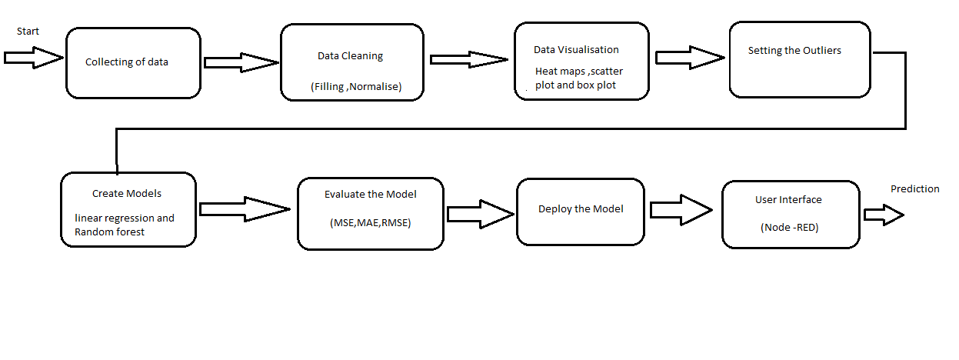

ADVANTAGES AND DISADVANTAGES

The advantage of this machine learning model is to reduce human labour.

The disadvantage is that it would require highly experienced data scientists , developers and market experts for implementation of the model and handling the relevant business tactics.

EXPERIMENT INVESTIGATION
- Life Expectancy of human is decreasing .
- Overview of vast data to study and experiment will be provided .
- In developed country have more Life Expectancy ,then developing country.
- Life Expectancy is depend on locality we live ,we expence , health .

APPLICATIONS
It will be applied in predicting the life expectancy of humans with minimal human labour.

RESULTS
It will result in a developed software that would precisely predict the life expectancy of humans.

CONCLUSION
We conclude that life expectancy is degrade every year , human have to aware about it and contribute on future over come . By this study ,open the scope of ecologist, medical scientists not to depend on expert and try to contribute with this data .

FUTURE SCOPE
It has a great future scope as the world is leaning towards more technical and precised solutions with minimal user labour which will be easily accessible to the users.

BIBILOGRAPHY
- IBM account-https://www.youtube.com/watch?v=HBkY-Fs1d6E .
- Watson Machine Learning-https://www.youtube.com/watch?v=My9Hr7EDy4g
- Node red-https://www.youtube.com/watch?v=PfGpCPRPHws
- Linear Regression- https://towardsdatascience.com/linear-regression-detailed-view-ea73175f6e86 .
- Random Forest-https://scikit-learn.org/stable/modules/generated/sklearn.ensemble.RandomForestRegressor.html .
APPENDIX
link=https://github.com/SmartPracticeschool/llSPS-INT-1661-Predicting-Life-Expectancy-using-Machine-Learning

