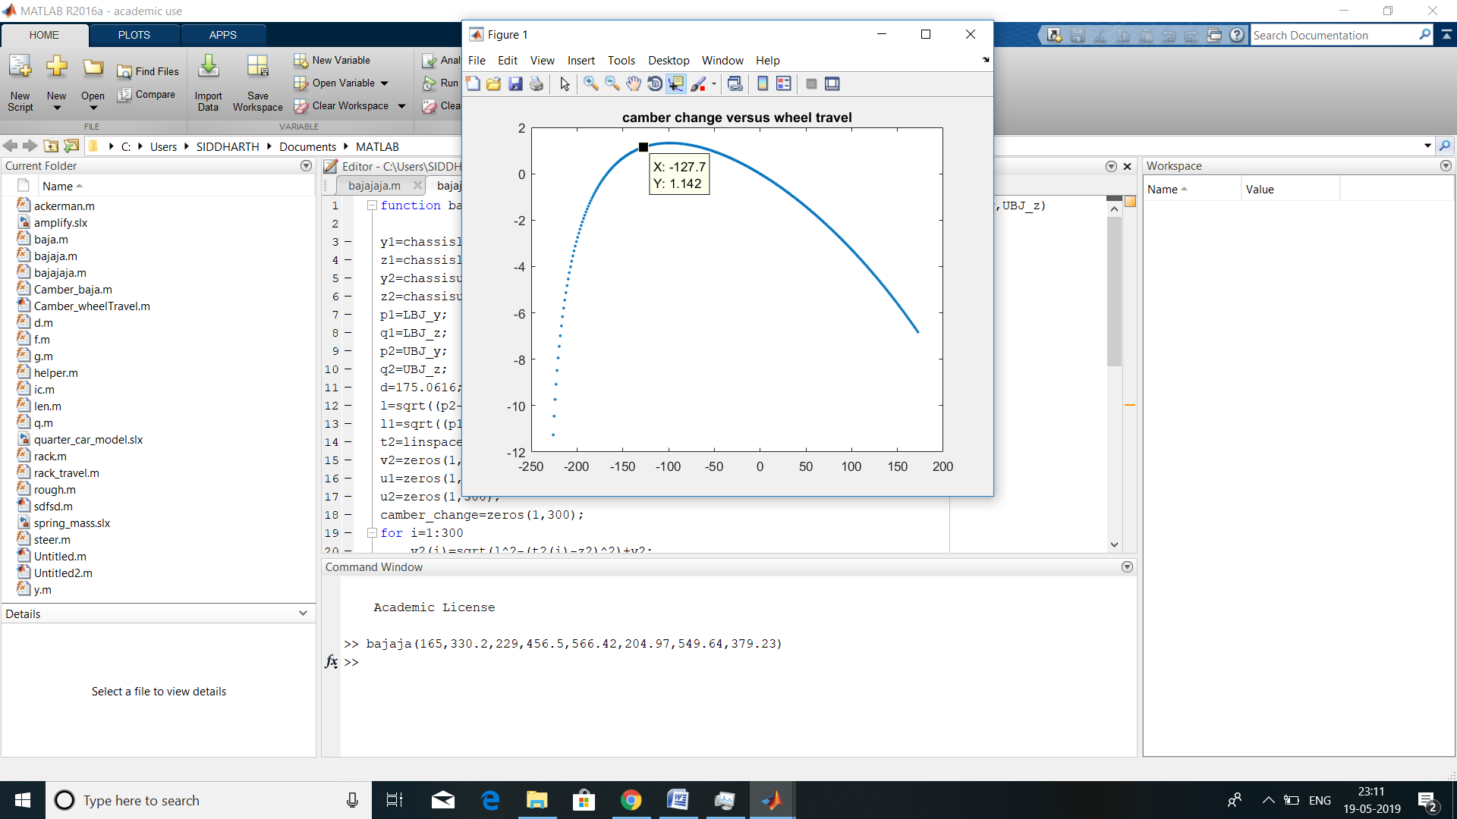

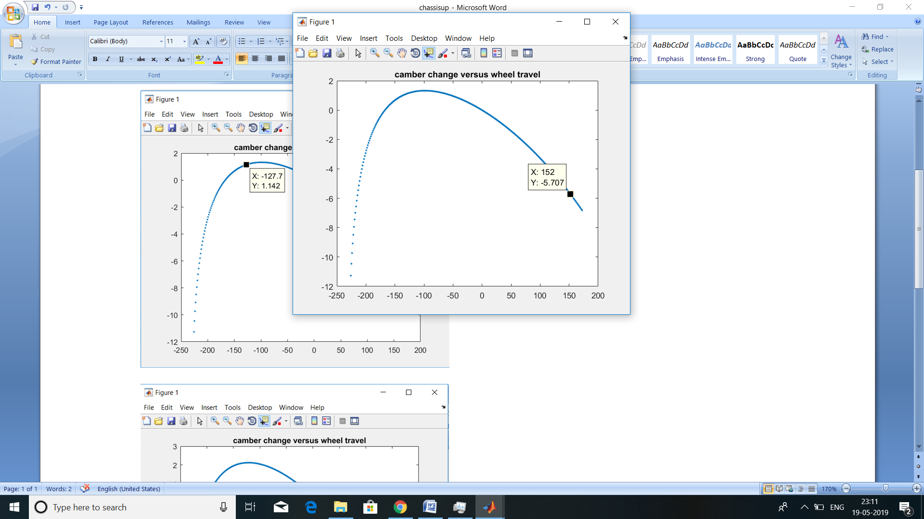

(chassislp_y,chassislp_z,chassisup_y,chassisup_z,LBJ_y,LBJ_z,UBJ_y,UBJ_z)

=(165,330.2,229,456.5,566.42,204.97,549.64,379.23)