KAFKA INSTALLATION GUIDE FOR LINUX

Table of Contents
Overview 2
Basic Linux commands 3
Prerequisites 4
Kafka Installation Methods 5
Method 1: Download and Run Kafka Files 5
Method 2: Install and Run Kafka using Docker 6
Additional Tips and Suggestions 8
Finding and Stopping Kafka Processes on Port 9092 8
Listing All Kafka Topics 8
Check Running Docker Containers 8
Create a topic to store your events 8
Write some events into the topic 9
Read the events 9
Delete topic in Kafka 10

Overview
Apache Kafka is a distributed event streaming platform used to build real-time data pipelines and applications. This guide will help you install Kafka on a Linux system (Ubuntu/Debian) from scratch, assuming you have minimal Linux experience.

Basic Linux commands
- sudo: Runs commands with superuser (admin) privileges
- apt update: Updates your package list to get the latest software versions
- apt install <package>: Installs a software package
- java -version: Checks installed Java version

Prerequisites
Install OpenJDK 17 or higher
Kafka requires Java to run. You can install OpenJDK 17 using the package manager:
sudo apt update
sudo apt install default-jdk
Check Java is installed correctly:
java -version

Kafka Installation Methods
There are two common ways to install Kafka on your system:
- Download Kafka files, extract, and run from the local directory.
- Use a Docker image (requires Docker Desktop) to run Kafka in containers.

Method 1: Download and Run Kafka Files
Step 1: Download Kafka
Visit the official Kafka quickstart page:
https://kafka.apache.org/quickstart
Download the latest Kafka release tarball (file ending in .tgz).
Step 2: Extract Kafka Files
Open a terminal and navigate to the directory where you downloaded the Kafka tarball. Run:
tar -xzf kafka_2.13-4.1.0.tgz
Replace kafka_2.13-4.1.0.tgz with your downloaded Kafka file name.
Step 3: Navigate to Kafka Directory
Change into the extracted Kafka directory:
cd kafka_2.13-4.1.0
Step 4: Generate a Cluster UUID
Kafka requires a unique cluster ID. Generate one with:
KAFKA_CLUSTER_ID="$(bin/kafka-storage.sh random-uuid)"
Step 5: Format the Kafka Log Directories
Use the generated cluster ID to format Kafka's log directories:
bin/kafka-storage.sh format --standalone -t $KAFKA_CLUSTER_ID -c config/server.properties
Step 6: Start Kafka Server
Launch the Kafka broker with:
bin/kafka-server-start.sh config/server.properties
Once the server successfully starts, your Kafka environment will be running and ready for use.
Step 7: Verify Kafka Server is Running
Check if Kafka is listening on its default port 9092 using either:
netstat -tlnp | grep 9092
OR
ss -tlnp | grep 9092
If you see output showing port 9092 in a listening state, Kafka has started successfully.
Step 8: Add Kafka to Your PATH
To avoid having to navigate to the Kafka directory for every command, you can add Kafka’s bin path to your system’s PATH environment variable.
Instructions:
- Open your .bashrc file (from your home directory):
nano .bashrc
This opens the file in a text editor.
Go to the end of the file and add this line (replace the path with your actual Kafka install location):
PATH="$PATH:/home/yourusername/kafka_2.13-4.1.0/bin"
For example, if your user is siddharth and Kafka is in your home directory:
PATH="$PATH:/home/siddharth/kafka_2.13-4.1.0/bin"
- Save and exit nano:
Press Ctrl + O to save.
Press Enter to confirm the filename.
Press Ctrl + X to exit.
- Reload your shell configuration so the new PATH takes effect:
Now you can run Kafka commands like kafka-server-start.sh and kafka-topics.sh from any directory, without needing to cd into the Kafka directory each time.

Method 2: Install and Run Kafka using Docker
This method requires Docker Desktop installed on your system.
Step 1: Pull the Kafka Docker Image
Download the official Kafka Docker image by running:
docker pull apache/kafka:4.1.0
This fetches the Kafka version 4.1.0 container image.
Step 2: Run Kafka Container
Start a Kafka container and map container port 9092 to your host’s port 9092:
docker run -p 9092:9092 apache/kafka:4.1.0
This command runs Kafka inside a Docker container and makes it accessible on your host machine.
Step 3: Verify the Running Container
Check if the Kafka container is running:
docker ps
You should see a listing with your Kafka container and ports mapped, for example:
CONTAINER ID IMAGE COMMAND CREATED STATUS PORTS NAMES
535bee3bdb4d apache/kafka:4.1.0 "/..." 9 hours ago Up 8 hours 0.0.0.0:9092->9092/tcp elastic_black
Step 4: Verify Kafka Server is Running
Confirm Kafka is listening on port 9092 inside Docker using:
netstat -tlnp | grep 9092
OR
ss -tlnp | grep 9092
If port 9092 is listening, your Kafka server within Docker is active.

Additional Tips and Suggestions

Finding and Stopping Kafka Processes on Port 9092
If you want to find the process ID (PID) that is using Kafka’s default port (9092), run:
sudo lsof -t -i:9092
This command will show the PID of the process occupying port 9092.
To stop/kill that process, run:
sudo kill -9 <PID>
Replace <PID> with the actual process ID from the previous command.

Listing All Kafka Topics
Kafka topics are streams/categories where messages are published and consumed.
  - If running Kafka locally (installed from files):
Navigate to your Kafka installation directory, then run:
bin/kafka-topics.sh --list --bootstrap-server <broker_address:port>
  - If running Kafka in Docker:
Use the following command to list topics inside the Kafka Docker container:
docker exec -it <container_name> /opt/kafka/bin/kafka-topics.sh --list --bootstrap-server <broker_address:port>
Example
docker exec -it elastic_black /opt/kafka/bin/kafka-topics.sh --list --bootstrap-server localhost:9092
Note: Replace elastic_black with your actual Docker container name.

Check Running Docker Containers
To see which Docker containers are running on your system, use:
docker ps
This will list all active containers with their IDs, image names, and status.

Create a topic to store your events
  - If running Kafka locally (installed from files):
bin/kafka-topics.sh --create --topic <topic_name> --bootstrap-server <broker_address:port>
Example
bin/kafka-topics.sh --create --topic test_topic_local_1_Nov --bootstrap-server localhost:9092
  - If running Kafka in Docker:
Use the following command to create a topic -
docker exec -it <container_name> /opt/kafka/bin/kafka-topics.sh --create --topic <topic_name> --bootstrap-server <broker_address:port>
Example
docker exec -it elastic_black /opt/kafka/bin/kafka-topics.sh --create --topic test_topic_elastic_black_1_Nov_2025 --bootstrap-server localhost:9092

Write some events into the topic
  - If running Kafka locally (installed from files):
bin/kafka-console-producer.sh --topic <topic_name> --bootstrap-server <broker_address:port>
Example
bin/kafka-console-producer.sh --topic test_topic_elastic_black_1_Nov_2025 --bootstrap-server localhost:9092
  - If running Kafka in Docker:
Use the following command to create a topic -
docker exec -it <container_name> /opt/kafka/bin/kafka-console-producer.sh --topic <topic_name> --bootstrap-server <broker_address:port>
Example
docker exec -it elastic_black /opt/kafka/bin/kafka-console-producer.sh --topic test_topic_elastic_black_1_Nov_2025 --bootstrap-server localhost:9092
By default, each line you enter will result in a separate event being written to the topic.
You can stop the producer client with Ctrl-C at any time.

Read the events
  - If running Kafka locally (installed from files):
bin/kafka-console-consumer.sh --topic <topic_name> --from-beginning --bootstrap-server <broker_address:port>
Example
bin/kafka-console-consumer.sh --topic test_topic_elastic_black_1_Nov_2025 --from-beginning --bootstrap-server localhost:9092
  - If running Kafka in Docker:
Use the following command to create a topic -
docker exec -it <container_name> /opt/kafka/bin/kafka-console-consumer.sh --topic <topic_name> --from-beginning --bootstrap-server <broker_address:port>
Example
docker exec -it elastic_black /opt/kafka/bin/kafka-console-consumer.sh --topic test_topic_elastic_black_1_Nov_2025 --from-beginning --bootstrap-server localhost:9092
By default, each line you enter will result in a separate event being written to the topic.
You can stop the producer client with Ctrl-C at any time.

Delete topic in Kafka
To delete a topic in Apache Kafka, follow these steps:
Enable Topic Deletion: Ensure that topic deletion is enabled on all Kafka brokers. This is controlled by the delete.topic.enable property in the broker's server.properties file. Set it to true.
delete.topic.enable=true
  - If running Kafka locally (installed from files):
You can check the Kafka broker configuration for delete.topic.enable in the Kafka server properties file:
      - This file is usually located at:
/path/to/kafka/config/server.properties
      - Open the file (for example, using nano or any text editor):
nano /path/to/kafka/config/server.properties
      - Search for the property delete.topic.enable.
      - If the line is not present, the default is true in recent Kafka versions. If you want to ensure it’s enabled, add or update the line to:
delete.topic.enable=true
      - After making changes to the configuration, restart the Kafka broker for the changes to take effect.
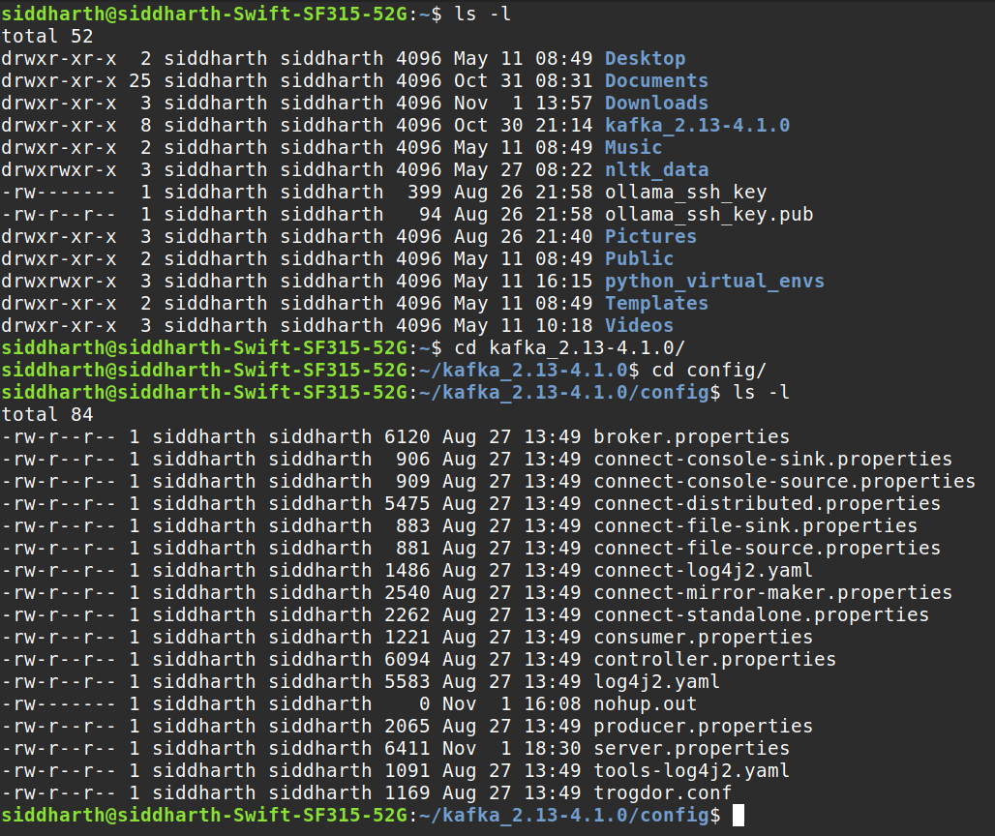
      - Execute the Deletion Command: Use the kafka-topics.sh command-line utility to initiate the topic deletion.
bin/kafka-topics.sh --bootstrap-server <broker_address:port> --delete --topic <topic_name>
Replace <broker_address:port> with the address and port of one of your Kafka brokers (e.g., localhost:9092).
Replace <topic_name> with the actual name of the topic you wish to delete.
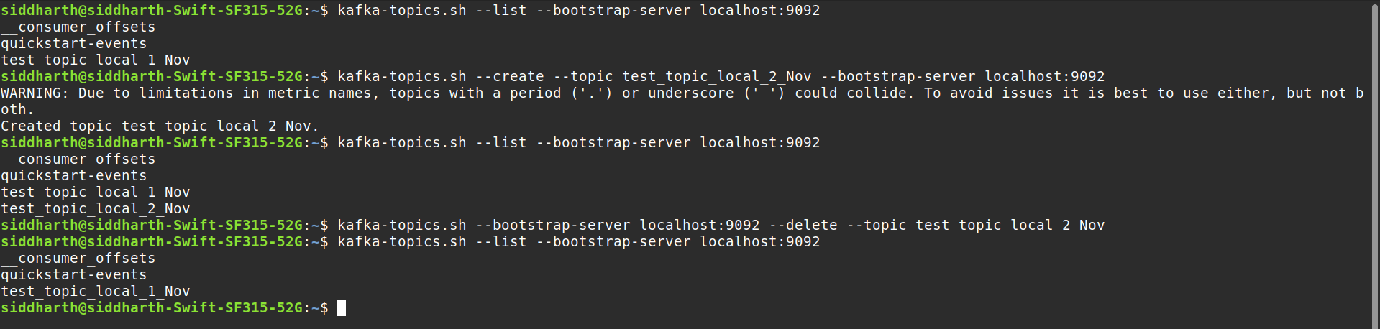
  - If running Kafka in Docker:
How to access it:
- Find your running Kafka container name or ID:
docker ps
- Access the container's shell:
docker exec -it <container_name_or_id> /bin/bash
- Navigate to the config directory:
cd /opt/kafka/config
- You can view or edit server.properties using a command-line editor like vi or cat to view:
cat server.properties
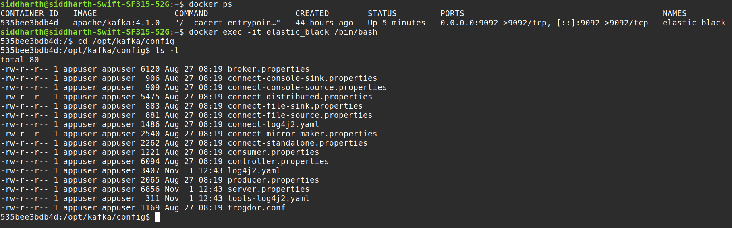
- To exit ot of the container type – Ctrl + D.
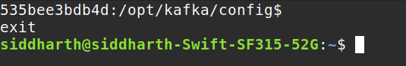
- Execute the Deletion Command: Use the kafka-topics.sh command-line utility to initiate the topic deletion.
docker exec -it <container_name> /opt/kafka/bin/kafka-topics.sh --bootstrap-server <broker_address:port> --delete --topic <topic_name>
Replace <broker_address:port> with the address and port of one of your Kafka brokers (e.g., localhost:9092).
Replace <topic_name> with the actual name of the topic you wish to delete.
