**OLLAMA INSTALLATION ON LINUX**

# Install with one command : curl -fsSL https://ollama.com/install.sh | sh

To check Ollama version : ollama -v

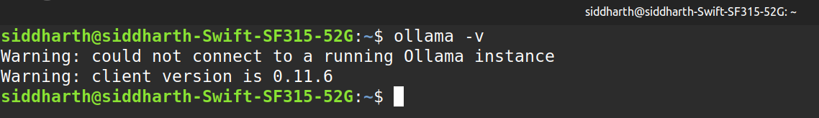

Starts the Ollama server, which is necessary for running models : ollama serve

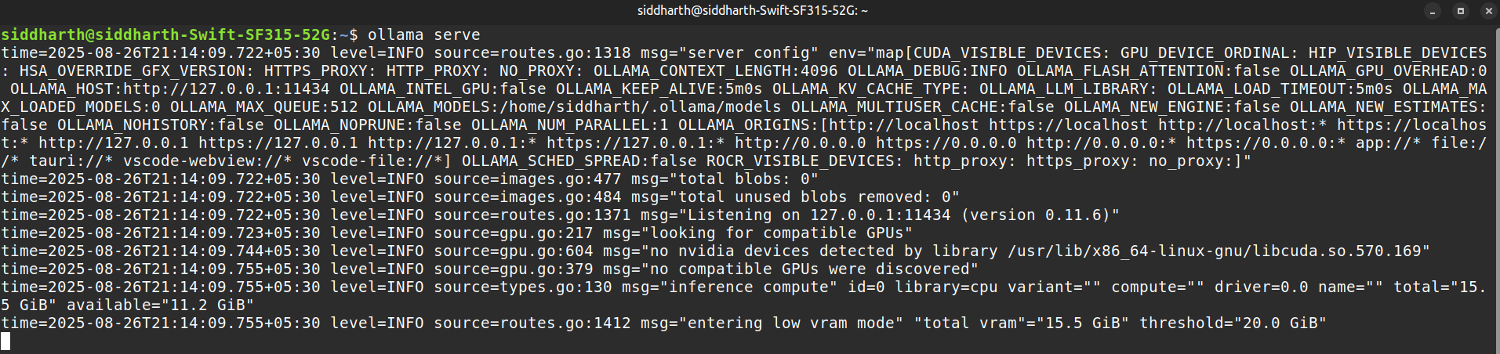

Browser or cURL: Visit http://localhost:11434/ in a browser, or use the command: curl http://localhost:11434

  
For systemd-based systems: 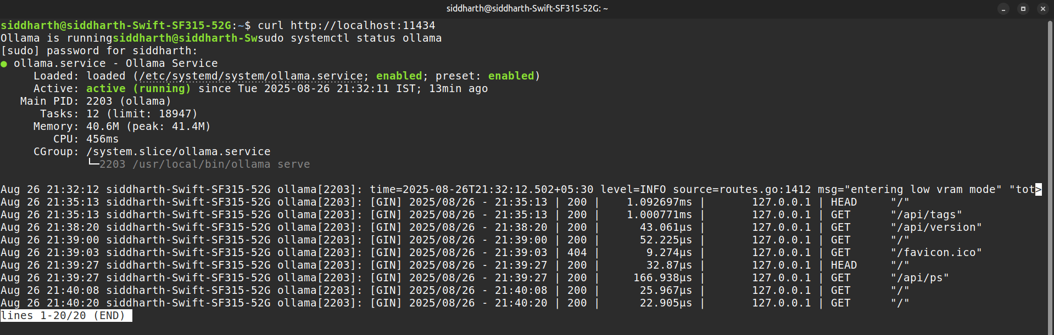sudo systemctl status ollama

Run this command to see all the current process running - ps aux | grep ollama

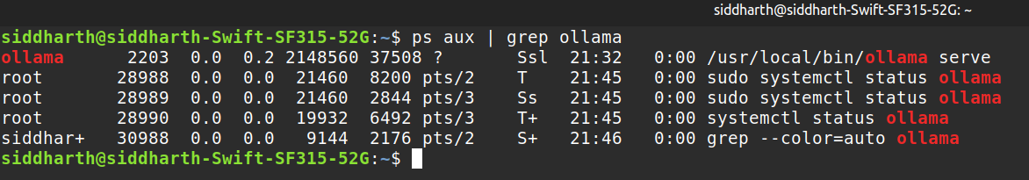

To generate SSH Key for local usage - ssh-keygen -t ed25519 -C "ollama_local"

