**US Healthcare analysis**

**Project Objective**

**VIRAJ N. BHUTADA**

* **Utilization of Business Intelligence (BI) Tools**: Employ advanced analytics using Microsoft Power BI to conduct a comprehensive examination of healthcare industry data spanning a year.
* **Focus on Insights for Policy Decisions**: Emphasize the identification of pivotal trends and insights crucial for guiding policy decisions within the scope of the US government.
* **Creation of Comprehensive Dashboards**: Develop meticulously crafted dashboards to offer a multifaceted perspective on the healthcare landscape.
* **Executive Summary and Key Performance Indicators (KPIs)**: Curate an Executive Summary integrating essential KPIs and overarching trends to furnish government officials with a strategic overview of the healthcare industry's performance and evolution.
* **Tailored Views for Stakeholders**: Customize separate views within the dashboards to cater to the diverse needs of stakeholders within the healthcare ecosystem, including Hospitals, Payers, Providers, and Patients.
* **Specialized Dashboards**: Design specialized dashboards for distinct stakeholder groups to ensure relevance, actionability, and applicability to the specific challenges and opportunities encountered by each constituency.
* **Focus on COVID-19 Impact**: Illuminate the profound impact of the COVID-19 pandemic on the healthcare industry through rigorous data analysis and visualization
* **Understanding Pandemic Dynamics**: Elucidate the various ways in which the pandemic has influenced healthcare delivery, utilization patterns, financial dynamics, and patient outcomes.
* **Informed Decision-Making**: Equip government officials with nuanced insights to facilitate informed decision-making and the formulation of effective strategies for addressing ongoing pandemic challenges.

**DATA DICTIONARY**

**FACT TABLE:**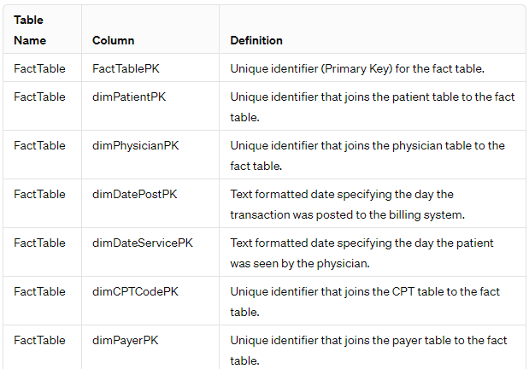

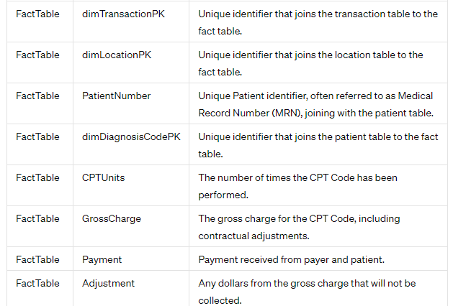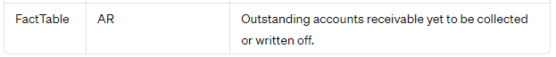

**Patient Table:**

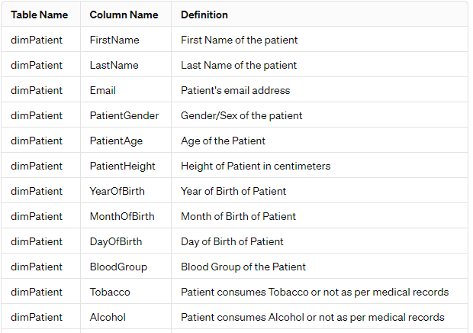

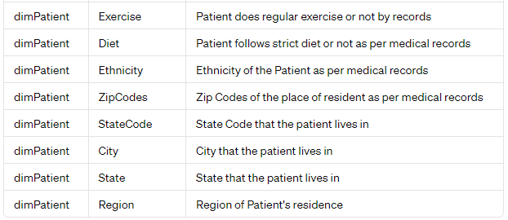

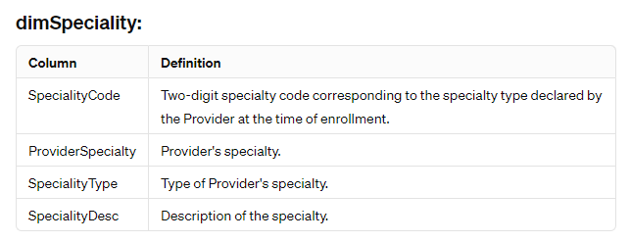

**Transaction Table:**

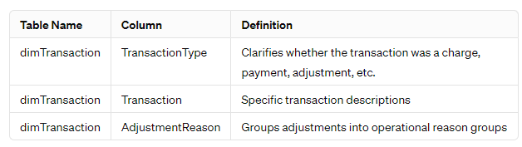

**Physician Table:**

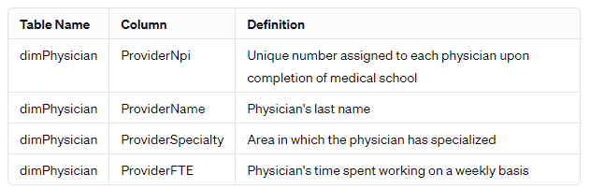

**Payer Table:**

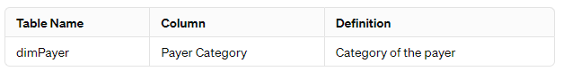

**Diagnosis code Table:**

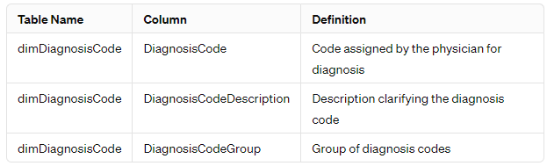

**CPT code Table:**

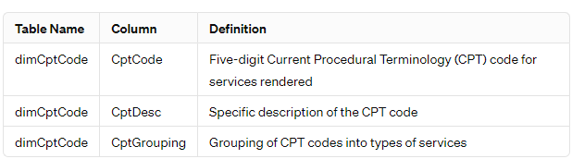

**Date Table:**

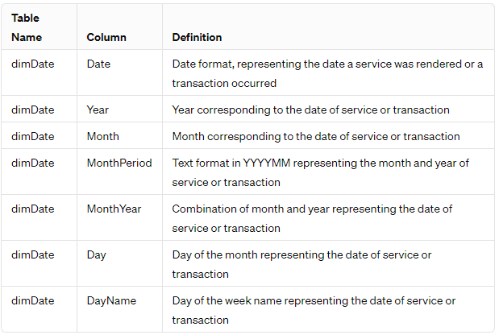

**Hospital Table:**

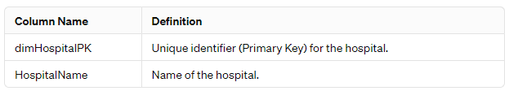

**Project Overview: Healthcare Industry Analysis with Power BI**

**OBJECTIVE**

## **Overview**

The project aims to conduct a comprehensive analysis of one year's worth of healthcare industry data utilizing Power BI. The analysis will focus on presenting crucial trends and insights to the United States government, aiding in informed decision-making and strategic planning.

## **Key Deliverables**

**1. Executive Summary Dashboard:**

* Develop an Executive Summary dashboard highlighting essential Key Performance Indicators (KPIs) pertinent to the healthcare industry.
* Provide succinct summaries of critical findings and trends.

**2. Stakeholder-Specific Views:**

* Create distinct dashboard views tailored to various stakeholders including Hospitals, Payers, Providers, and Patients.
* Customize insights and metrics relevant to each stakeholder group, ensuring actionable information.

## **Highlights**

**1. COVID-19 Impact Analysis:**

* Conduct a thorough examination of the COVID-19 pandemic's impact on the healthcare sector.
* Informed Decision-Making:
* Equip government officials with actionable insights to facilitate informed decision-making.

**2. Strategic Planning Support:**

* Provide data-driven inputs essential for strategic planning initiatives within the healthcare domain.

## **Professional Presentation**

* Ensure the presentation of insights adheres to professional standards, facilitating clear comprehension and effective communication.
* Utilize appropriate data visualization techniques to enhance understanding and engagement.
* Employ professional narrative structures to convey findings cohesively and persuasively.

## **Collaborative Approach**

* Foster collaboration with relevant stakeholders to validate insights and ensure alignment with governmental objectives.

## **Continuous Improvement**

* Implement mechanisms for feedback and iteration, allowing for continuous improvement of analytical outputs and dashboards.

By accomplishing these objectives, the project endeavors to provide the United States government with actionable insights into the healthcare industry's dynamics, thereby supporting proactive decision-making and strategic planning in response to ongoing challenges, particularly those posed by the COVID-19 pandemic.

**CORE CAPABILITIES / KEY FEATURES**

## **Comprehensive Data Analysis**

* Conducts an exhaustive examination of healthcare industry data, delivering in-depth insights into patient demographics, expenditures, and treatment patterns.

## **Interactive Data Visualization**

* Utilizes a diverse array of visual aids, including bar charts, pie charts, line graphs, and area charts, to effectively communicate data and enhance comprehension.

## **Dynamic Data Exploration**

* Empowers users to dynamically explore data through customizable filters based on parameters such as geographical region, healthcare facility, insurance provider, healthcare service provider, and patient demographics.

## **Hospital Performance Assessment**

* Explores various dimensions of hospital performance, encompassing accounts receivable, procedure volumes, and financial metrics. Identifies hospitals with notable accounts receivable and insurance payment ratios to inform financial management strategies and resource allocation decisions.

## **Analysis of Patient Demographics and Treatment Patterns**

* Provides insights into patient demographics, behaviors, and treatment trends. Analyzes patterns in-patient admissions, demographics, and treatment modalities, enabling healthcare providers to tailor services effectively.

## **Concise Executive Summary**

* Presents a succinct overview of critical metrics and trends in the healthcare industry, incorporating regional impact assessments, hospital performance evaluations, trend analyses, payer contributions assessments, and procedure dominance recognition.

## **Evaluation of Payer-Provider Performance**

* + Assesses the performance and trends of healthcare payers and providers, analyzing expenditures, reimbursement rates, and service utilization patterns. Offers insights to optimize financial performance and enhance patient care delivery.

## **Customized Stakeholder-Specific Perspectives**

* + Tailor perspectives for hospitals, payers, providers, and patients, enabling stakeholders to focus on insights relevant to their specific roles and responsibilities.

## **Bookmark Functionality**

* + Implements bookmarking functionality to streamline user experience and usability. Enables users to bookmark essential insights within the dashboard for easy access to critical information.

**STRATEGIC INSIGHTS**

**1. Regional Impact Assessment:**

* + Identifies regions significantly affected by the pandemic in terms of patient volume and expenditure.
  + Supports informed resource allocation and strategic decision-making for effective pandemic response.

**2. Hospital Performance Review:**

* Evaluate hospitals exhibiting notable accounts receivable and insurance payment ratios.
* Enables targeted interventions to address financial challenges and optimize operational effectiveness.

**3. Trend Analysis:**

* Examines longitudinal trends in healthcare expenditure and patient admissions.
* Provides insights into evolving patterns, empowering stakeholders to adapt and plan strategically.

**4. Payer Contribution Analysis:**

* Assesses key contributors to the dispersion of medical expenses among payers.
* Guides the formulation of strategies to manage cost-sharing agreements and optimize financial outcomes.

**5. Procedure Dominance Identification:**

* Recognizes hospitals with significant involvement in specific procedures during the pandemic.
* Facilitates resource optimization and enhances patient care delivery based on procedural demands.

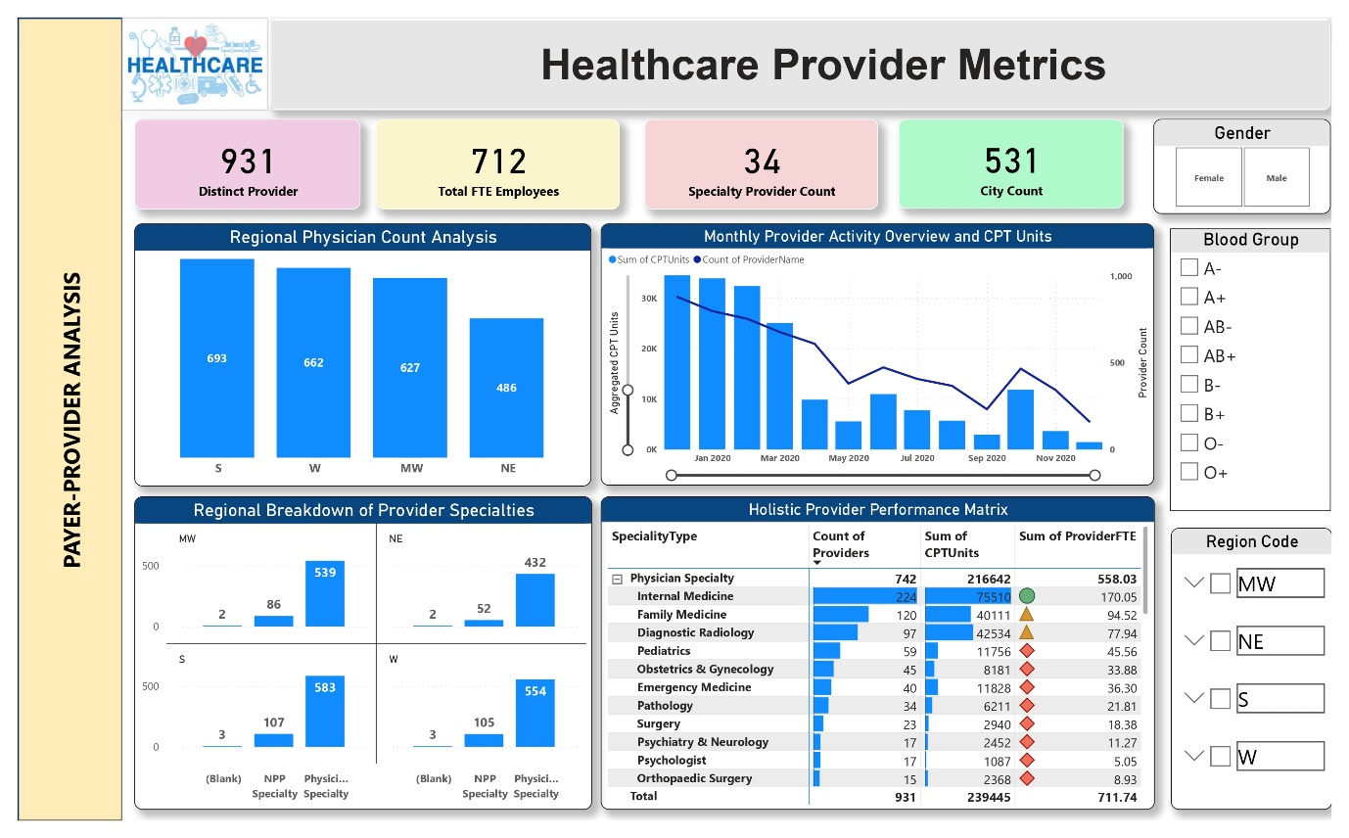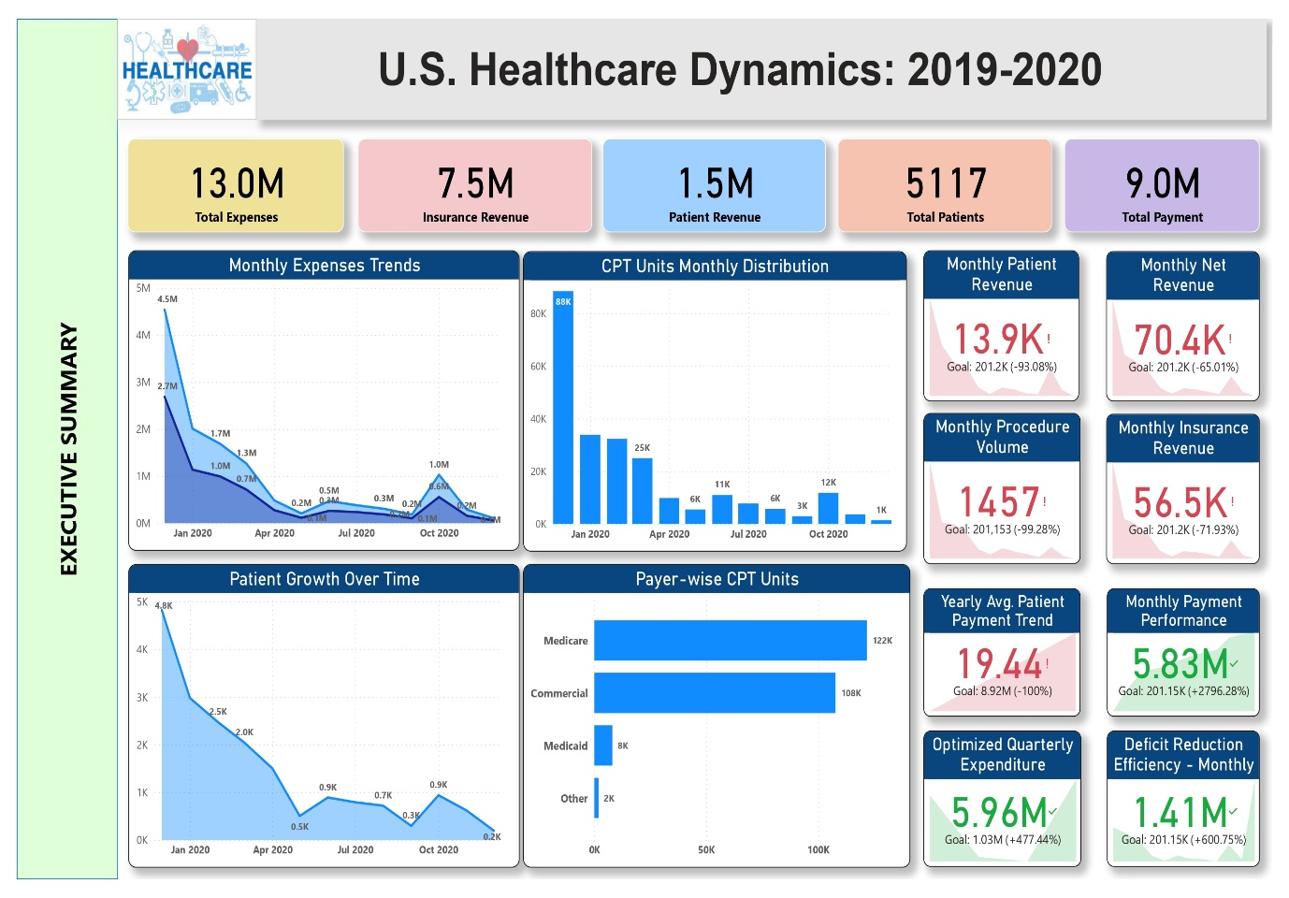

**DASHBOARDS**

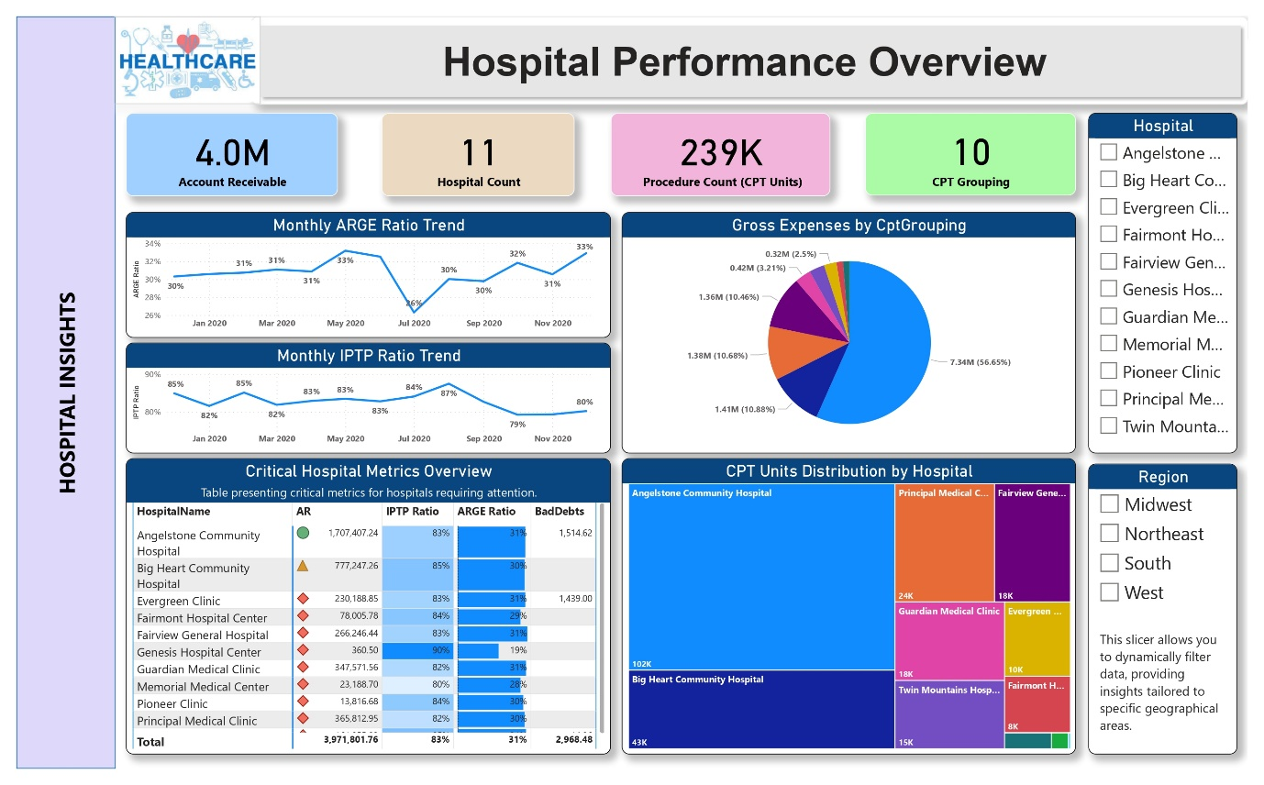

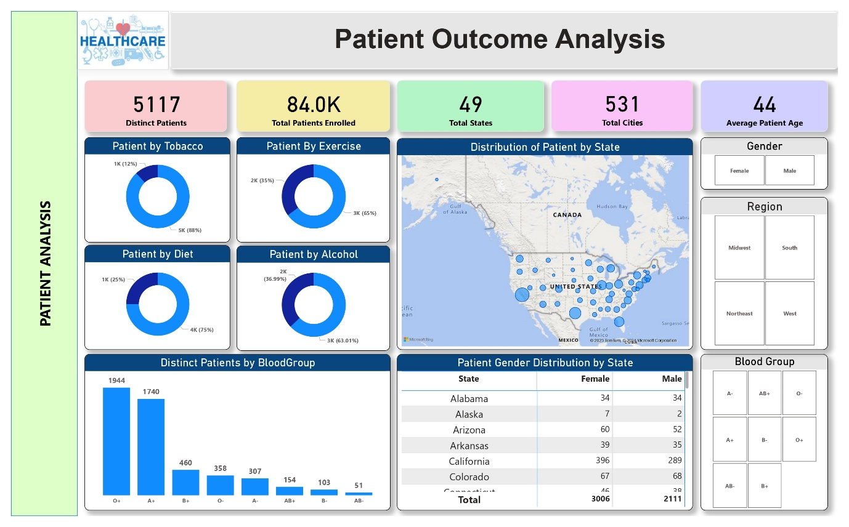

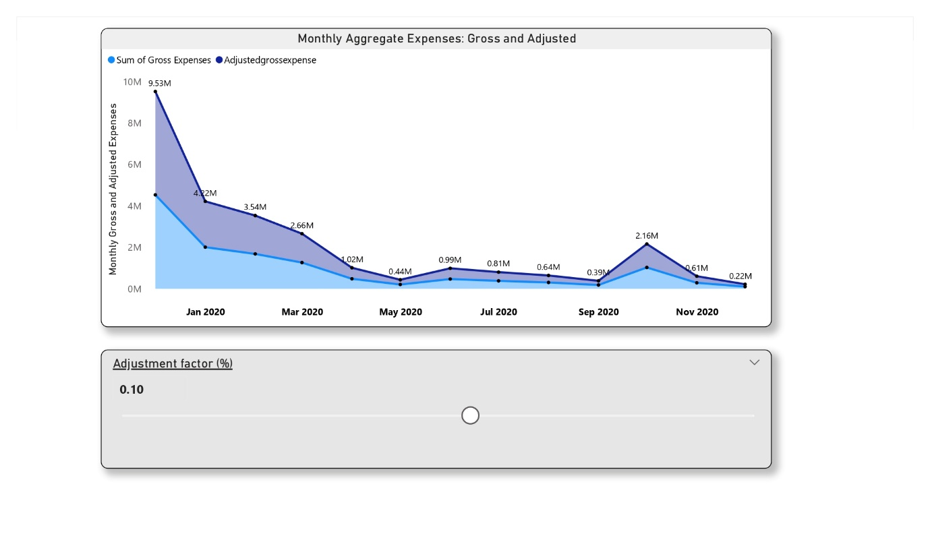

# **Entity – Relationship Diagram**

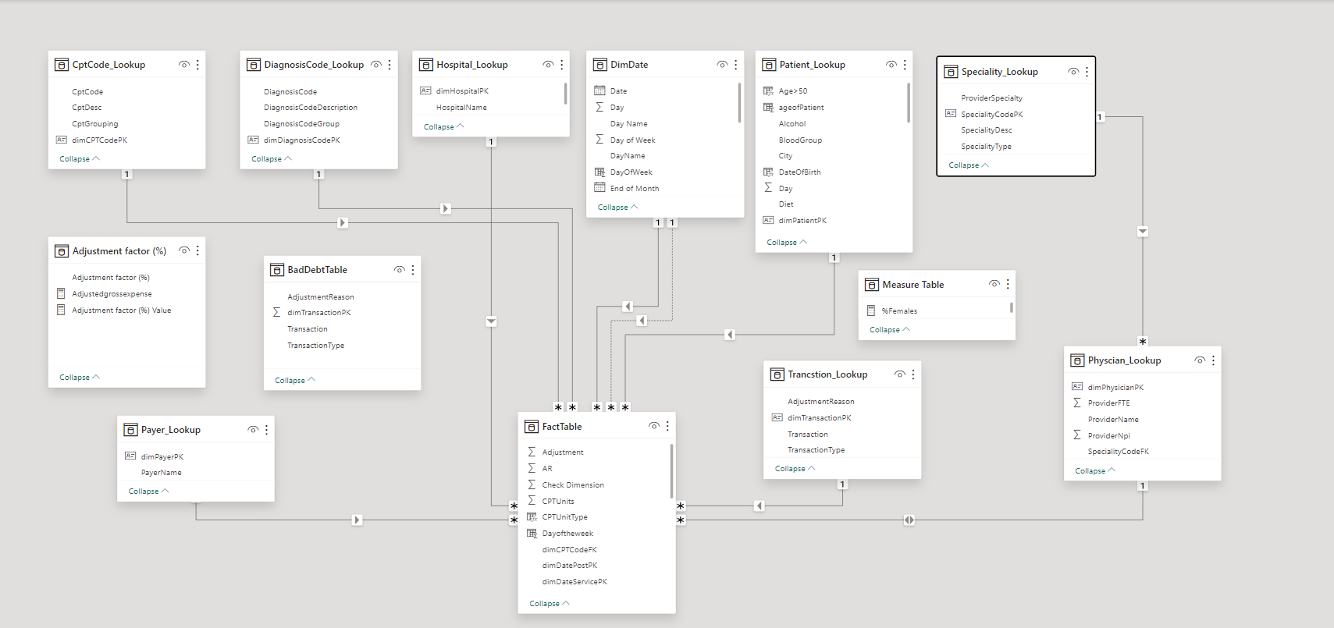

**PROJECT CONCLUSION**

* **Comprehensive Analysis:**
  + Conducted a thorough examination of the healthcare industry, analyzing patient demographics, hospital performance, and payer-provider dynamics.
* **Interactive Insights**
  + Provided stakeholders with intuitive interactive visualizations and dynamic filtering mechanisms, enabling deep insights into the complex healthcare landscape.
* **Actionable Findings:**
  + Derived actionable insights from meticulous data analysis, facilitating informed decision-making and strategic planning.
* **Regional Impact Assessment:**
  + Identified areas of concern through regional impact assessment, guiding efficient resource allocation and targeted interventions.
* **Hospital Performance Evaluation:**
  + Evaluated hospital performance metrics to optimize resource allocation and enhance operational efficiency.
* **Trend Analysis:**
  + Analyzed longitudinal trends to identify evolving patterns and inform strategic initiatives.
* **Payer Contribution Assessment:**
  + Examined payer contributions to guide cost management strategies and resource optimization efforts.
* **Procedure Dominance Identification:**
  + Identified procedures dominating healthcare delivery to facilitate resource optimization and enhance patient care.
* **Vital Tool for Stakeholders:**
  + Serves as a crucial tool for healthcare stakeholders, offering invaluable insights and driving positive outcomes.
* **Advanced Analytics and Visualization:**
  + Leveraged advanced analytics and visualization techniques to support informed decision-making and proactive management of challenges.
* **Continued Impact:**
  + Will continue to play a vital role in driving positive outcomes, improving patient care, and enhancing operational efficiency within the healthcare ecosystem.