**COA-LAB**

**LAB-11**

**Name: Aditya Pratap Singh Chauhan**

**Enroll: 9920103027**

**Batch: F1**

**1.Write a MIPS program which takes an array from user and count negative numbers which are at odd index of array.**

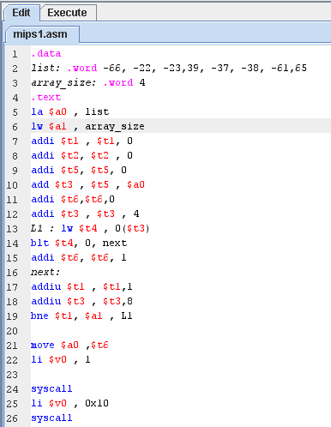

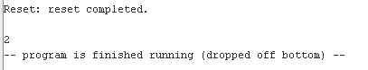

**2.Write a MIPS program which takes an array from the user and counts positive numbers which are at the index of the array.**

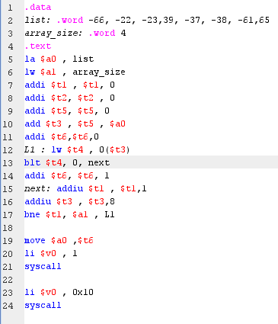

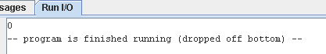

**3.Write an MIPS program that multiplies the number in $t0 by 46.**

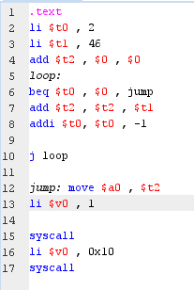



**4.Write an MIPS program that divides the number in $t0 by 28.**

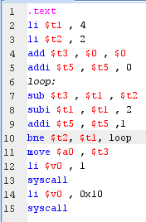



**5.Write MIPS program that finds a number in an array using linear search.**

**6.Write MIPS program that finds a number in an array using binary search.**

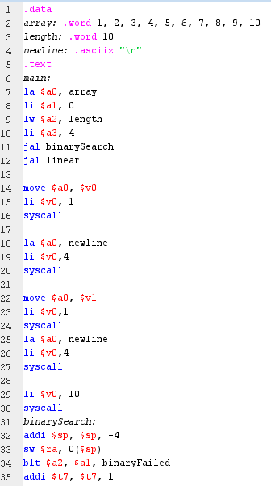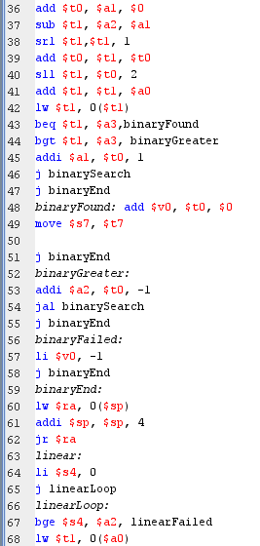

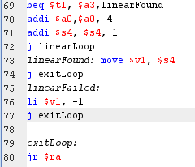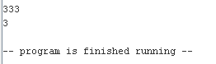

**7.Write MIPS program that finds and prints the smallest number in the integer array.**



