**COA-LAB**

**LAB-9**

**Name: Aditya Pratap Singh Chauhan**

**Enroll: 9920103027**

**Batch: F1**

**1.Write a program in 8086 microprocessor to sort numbers in ascending order in an array of n numbers, where size “n” is stored at memory address 2000 : 500 and the numbers are stored from memory address 2000 : 501.**

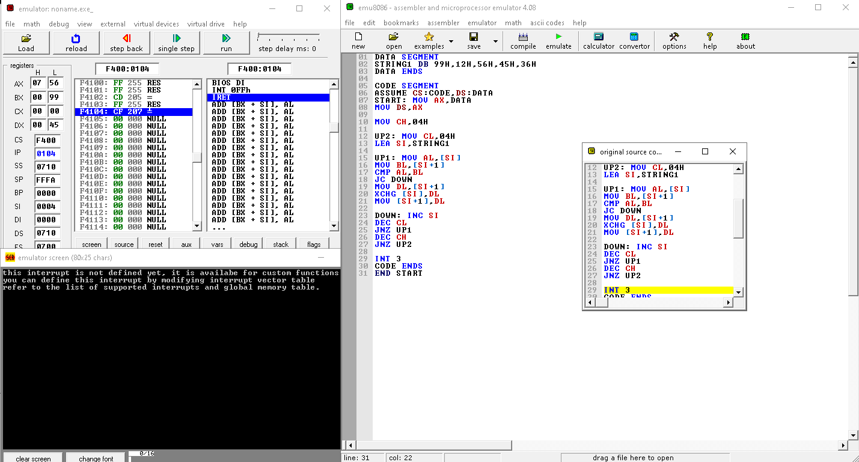

**2. Write a program in 8086 microprocessor to sort numbers in descending order in an**

**array of n numbers, where size “n” is stored at memory address 2000 : 500 and the**

**numbers are stored from memory address 2000 : 501.**

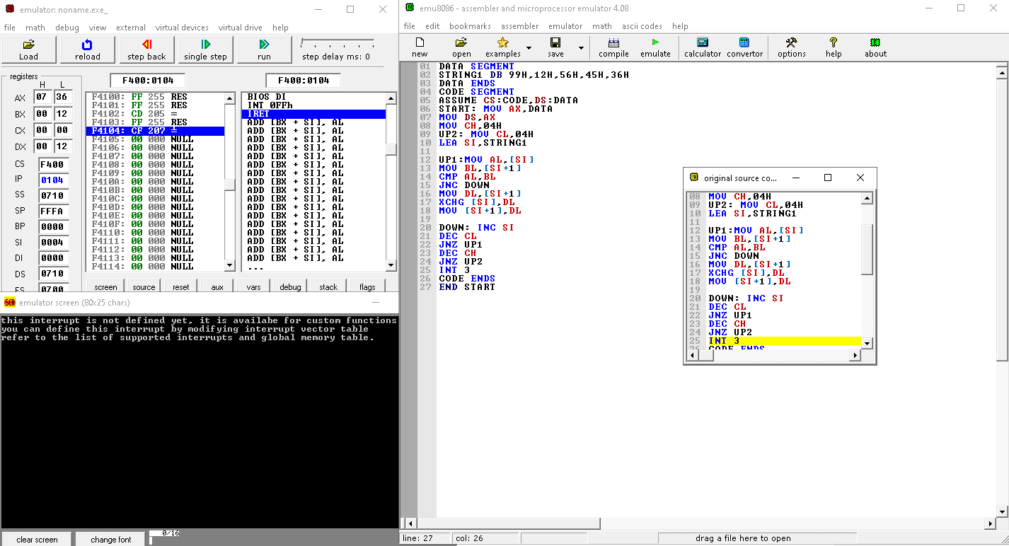

**3.8086 program to find the min value in a given array.**

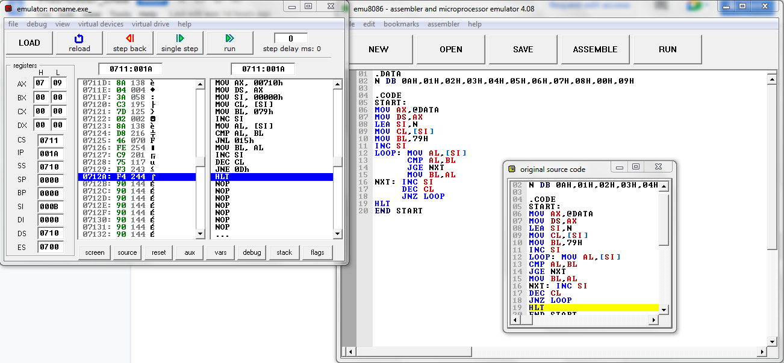

**4.8086 program to determine largest number in an array of n numbers.**



**5.8086-assembly-program-to-count-number-of-0s-and-1s-from-a-string.**

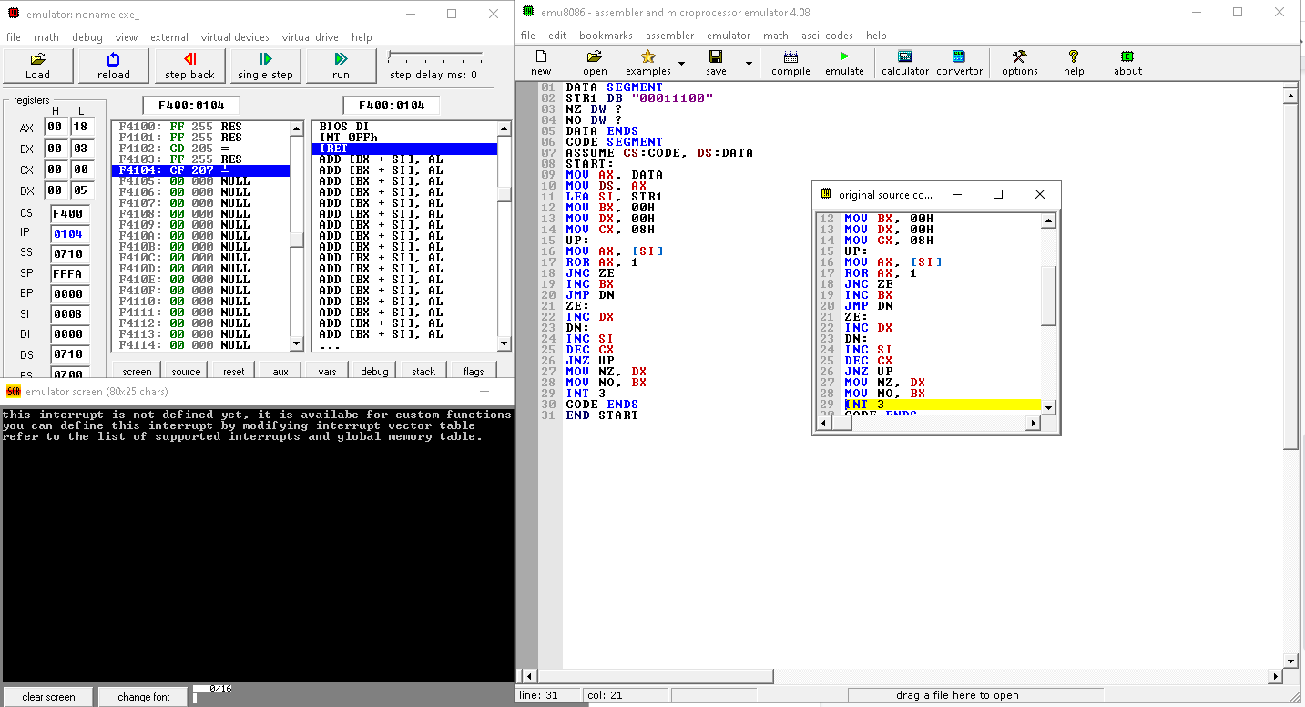

**6.8086-assembly-program-to-count-number-of-0s-and-1s-from-a-number.**

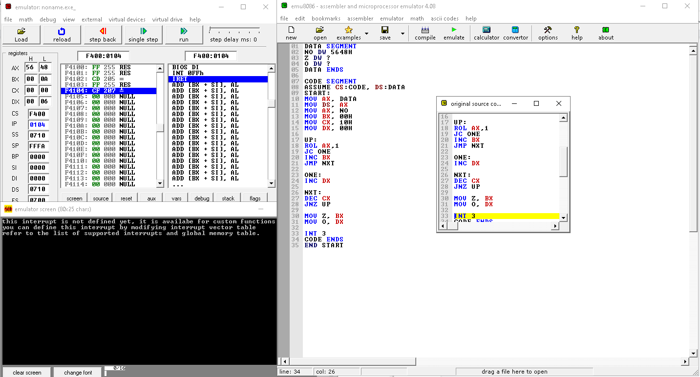

**7.8086-assembly-program-to-find-reverse-of-an-array.**

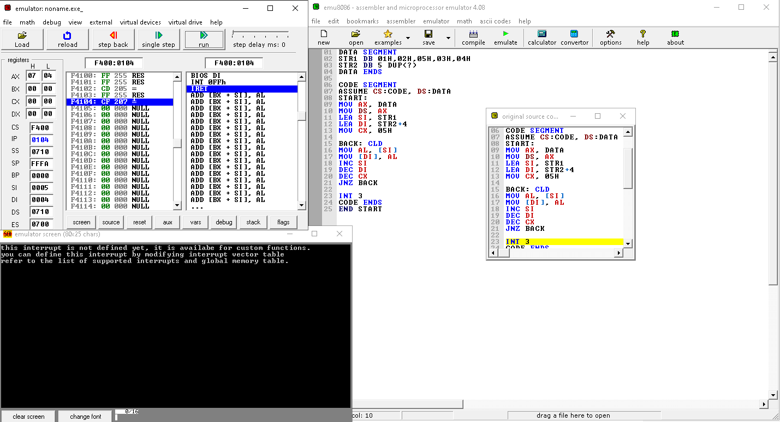

**8.8086-assembly-program-to-check-if-string-is-palindrome-or-not.**

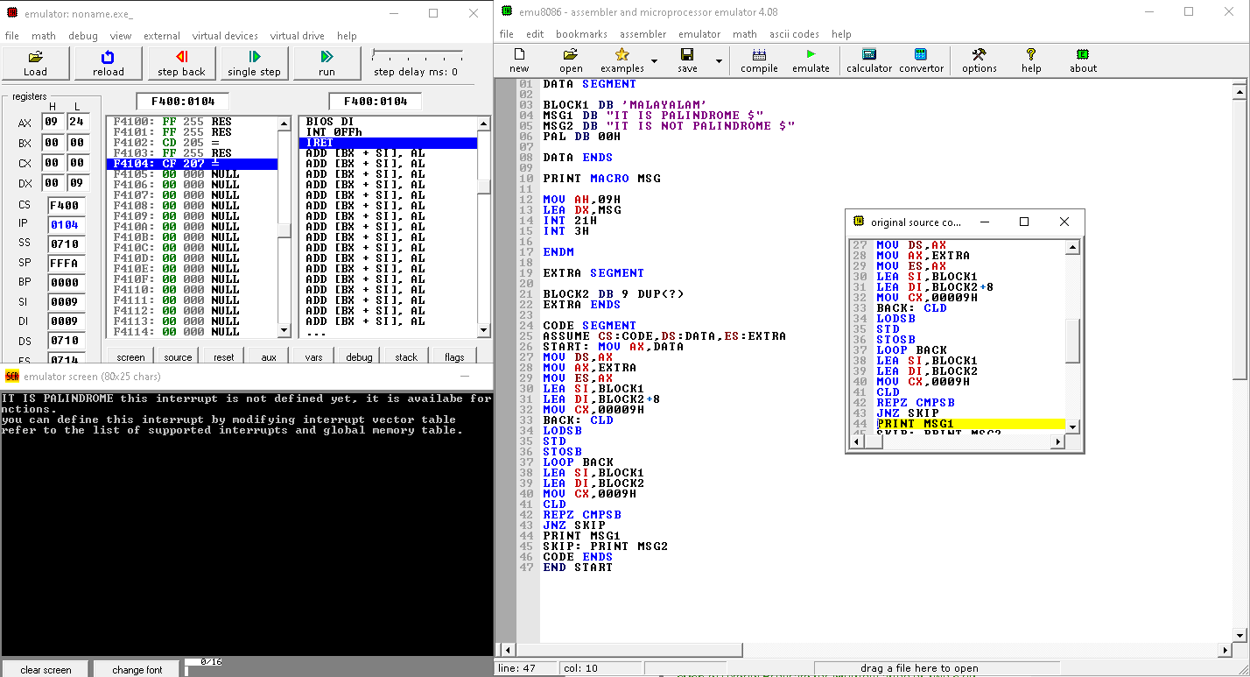

**9.8086-assembly-program-to-search-an-element-in-an-array.**

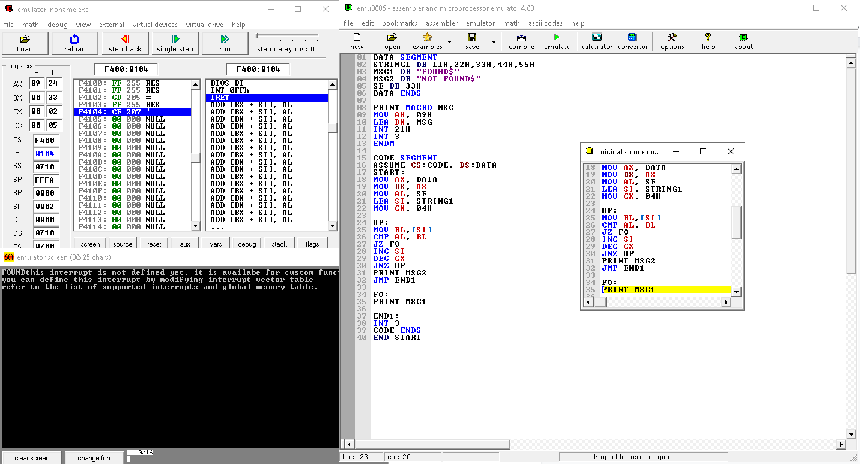

**10.The 8 data bytes are stored from memory location E000H to E007H. Write 8086 ALP to transfer the block of data to new location B001H to B008H.**

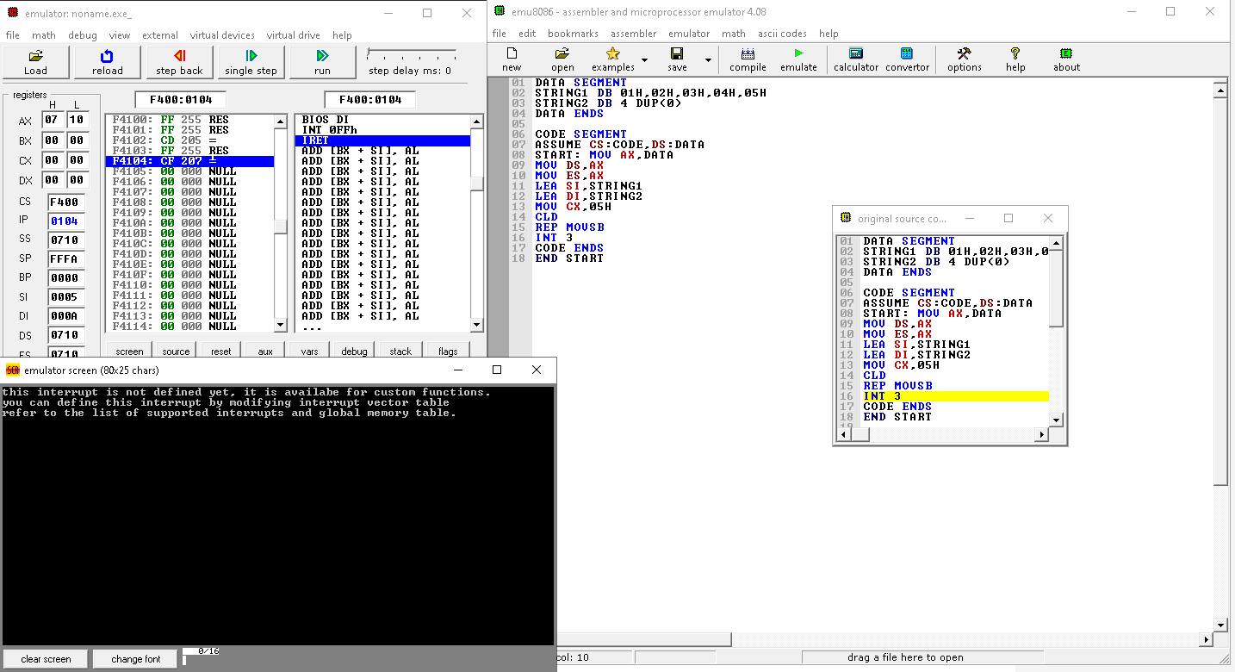

**11.Write a program to display string “JIIT” for 8086**

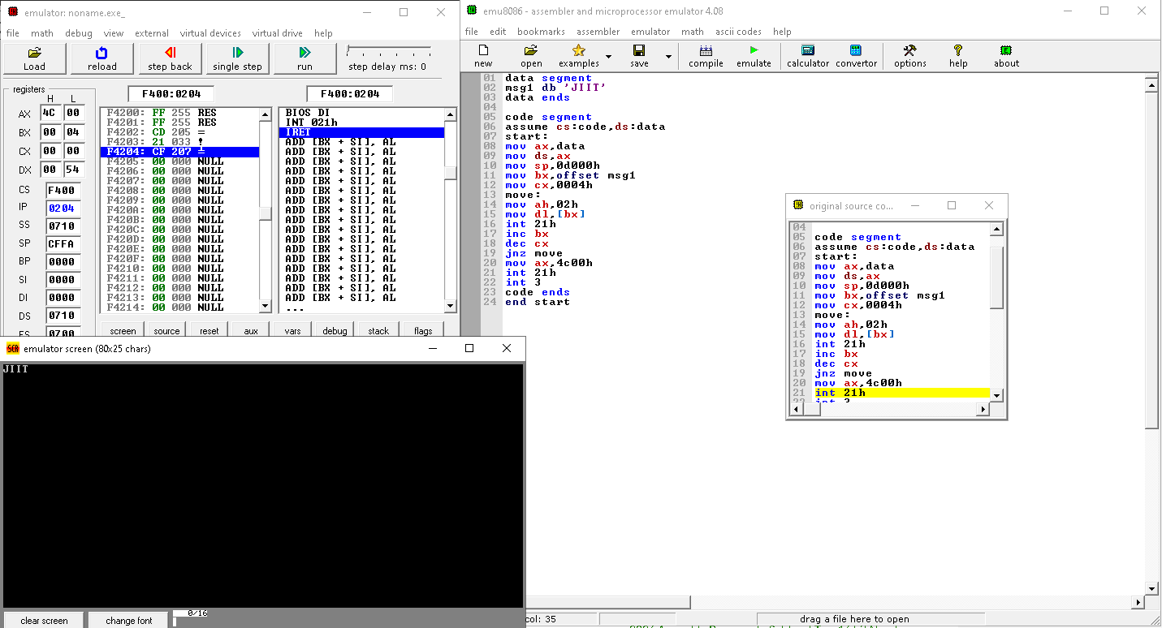

**12.Write a program to reverse the given string for 8086.**

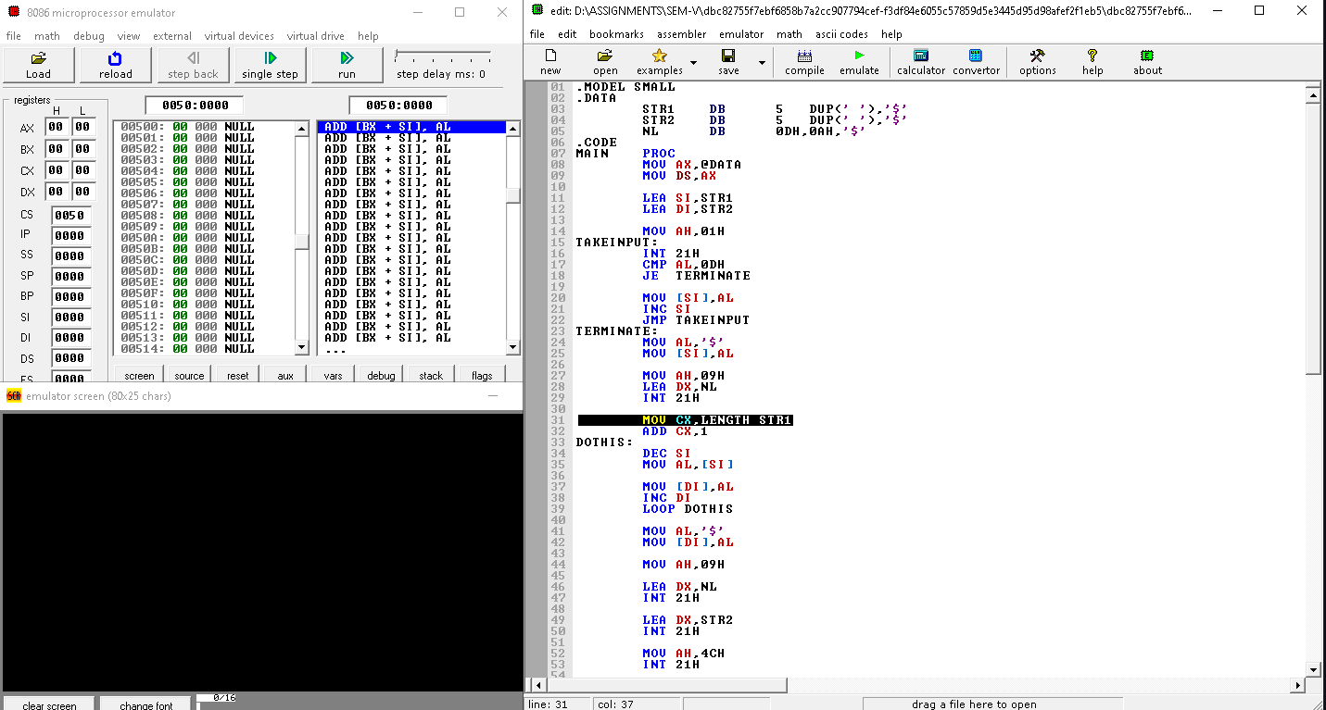

**13.Find number of times letter I exist in the string JIIT, Store the count at memory**

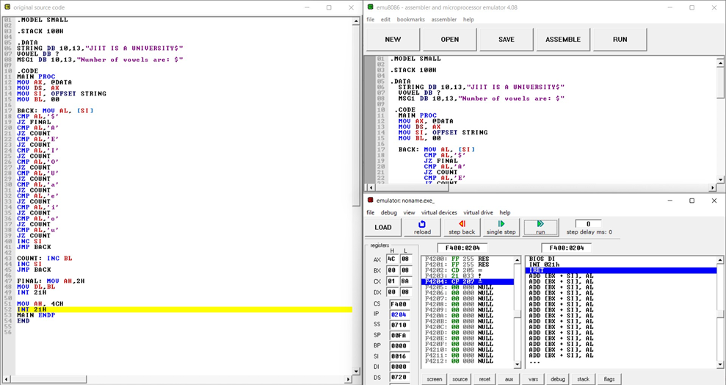

**14.Write an assembly language program to count number of vowels in a given string**

