OneStream Testcase Document Generator
User Navigation Guide, Prompt Engineering Templates, and System Walkthrough
Application Portal: https://tc-document-generator.onrender.com
Target Audience: OneStream Developers, Financial Systems Analysts, QA Engineers, and Release Managers

1. Purpose of this Guide
This document is a comprehensive user manual designed to help team members quickly navigate the Testcase Document Generator web portal. Whether you are releasing an updated Cube View, deploying a revised Dashboard interface, modifying system Parameters, or packaging financial Books, this guide explains how to construct clear, effective prompts and download production-ready Microsoft Word testcase review documents in seconds.

2. User Interface Overview and Navigation
When you navigate to https://tc-document-generator.onrender.com, you are presented with a clean, focused single-page interface designed for rapid entry without unnecessary menus.
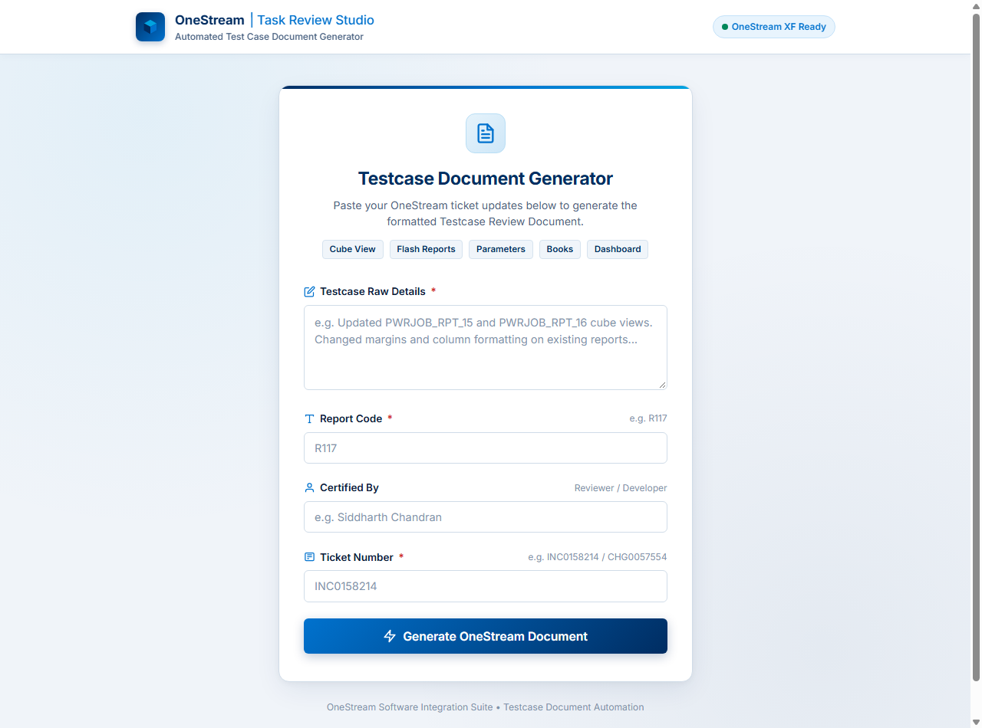
Figure 1: Main Landing Screen of the OneStream Task Review Studio

Key Visual Elements on the Main Screen
• Top Enterprise Navigation Header: Displays the active environment indicator ('OneStream XF Ready') and confirms you are connected to the live generator service.
• Supported Artifact Category Pills: Clearly highlights the five core OneStream change categories supported by the engine: Cube View, Flash Reports, Parameters, Books, and Dashboard.
• Testcase Raw Details Input Area: A multi-line text input field where you paste ServiceNow change descriptions, JIRA tickets, or email handover notes.
• Metadata Fields: Three concise input controls for Report Code (e.g. R117, R168), Certified By (your full name for the sign-off record), and Ticket Number (e.g. CHG0058275, INC0158214).
• Generate OneStream Document Button: The primary action button that triggers validation, AI classification, template rendering, and automatic document delivery.

3. Crafting a Neat Prompt: The Secret to Perfect Documents
The Testcase Document Generator uses artificial intelligence (Google Gemini) to analyze your ticket notes and match them to official corporate compliance checklists. While the engine is intelligent enough to understand unstructured text, writing a 'neat prompt' ensures the AI classifies your ticket correctly on the very first try and populates all 8 to 12 checklist verification items accurately.

The 4 Core Ingredients of a Neat Prompt
1. Ticket Identifier & Action Verb: Always start with the ticket number and what was done (e.g. 'CHG0058275 - Updated Planning Dashboard' or 'INC0158214 - Modified margins on PWRJOB_RPT_15').
2. Exact Artifact Name: State the exact OneStream report or dashboard name. For Cube Views, include prefixes like PWRJOB_RPT_, FLH_, or CV_. For Dashboards, mention the dashboard name or maintenance unit.
3. Workflow or Application Context: Specify where the artifact lives (e.g. 'workflow group (RptgGrp_Dashboard)' or 'Finance application workspace').
4. Specific Changes Implemented: List the concrete modifications made (such as margins, columns, SQL adapter queries, parameter bindings, or creating backup files like _ORG).

Ready-to-Use Neat Prompt Templates
Copy and adapt the following templates for your daily ticket submissions:

Template A: Dashboard Updation Prompt (12 Checklist Items)
Use this template when changing dashboard components, layout grids, or maintenance units:
Ticket: CHG0058275 Forecast reports in workflow (RptgGrp_Dashboard)

Requirement: Updated Planning Dashboard - RPO Jobs under workflow group RptgGrp_Dashboard.
Changes Implemented:
1. Re-aligned dashboard layout components and validated SQL data adapter queries.
2. Verified that parameter drop-down selections update all embedded forecast reports dynamically.
3. Created a verified backup of the original dashboard named Planning Dashboard_ORG.
4. Confirmed security profile access so unauthorized user groups cannot access the dashboard.
5. Verified zero broken links or missing components across all reporting periods.

Template B: Existing Cube View Review Prompt (8 Checklist Items)
Use this template when updating margins, column formats, or data on existing reports:
Ticket: INC0158214 - Formatting update on Power Job reports

Requirement: Update page layout and column formatting for monthly review reports.
Changes Implemented:
1. Updated Cube Views PWRJOB_RPT_15 and PWRJOB_RPT_16.
2. Adjusted left and right page margins to standard 0.5 inches for clean PDF export.
3. Fixed column widths and verified header alignment across Entity 991.
4. Created backups of existing cube views named PWRJOB_RPT_15_ORG and PWRJOB_RPT_16_ORG.

Template C: Flash Report Cube View Prompt (Flash Checklist)
Use this template when modifying OneStream Flash reports:
Ticket: CHG0057890 - Flash Income Statement Update

Requirement: Update FLH_Income_Statement flash cube view for executive review.
Changes Implemented:
1. Updated row suppression rules on FLH_Income_Statement report.
2. Ensured single-page PDF print fit constraints are satisfied.
3. Verified Entity and Region names in the report header and footer.
4. Created backup copy FLH_Income_Statement_ORG.

Template D: Parameter Change Prompt
Use this template when modifying workflow parameters or rule variables:
Ticket: CHG0059120 - Update Parameter Default Value

Requirement: Update parameter Param_CurrentPeriod for Q4 financial close workflow.
Changes Implemented:
1. Updated business rule parameter Param_CurrentPeriod default selection to 2026M10.
2. Verified parameter binding across associated Cube Views and workflow validation steps.

4. Step-by-Step Navigation Walkthrough

Step 1: Open the Application
Navigate to https://tc-document-generator.onrender.com in Google Chrome, Microsoft Edge, or any modern web browser. The application is cloud-hosted and requires no installation.

Step 2: Enter Your Neat Prompt
Paste your prepared prompt into the 'Testcase Raw Details' textarea. The field expands automatically to accommodate multi-line bulleted descriptions.

Step 3: Fill in Document Metadata
Complete the three short metadata fields beneath the prompt textarea:
• Report Code (Required): Enter the internal reference code, such as R117, R168, or R197. This code is used as the official prefix in the generated filename.
• Certified By (Recommended): Enter your full name (e.g. 'Siddharth Chandran'). This name is stamped onto the title page and certification blocks of the Word document.
• Ticket Number (Required): Enter the ServiceNow Change or Incident number (e.g. 'CHG0058275').
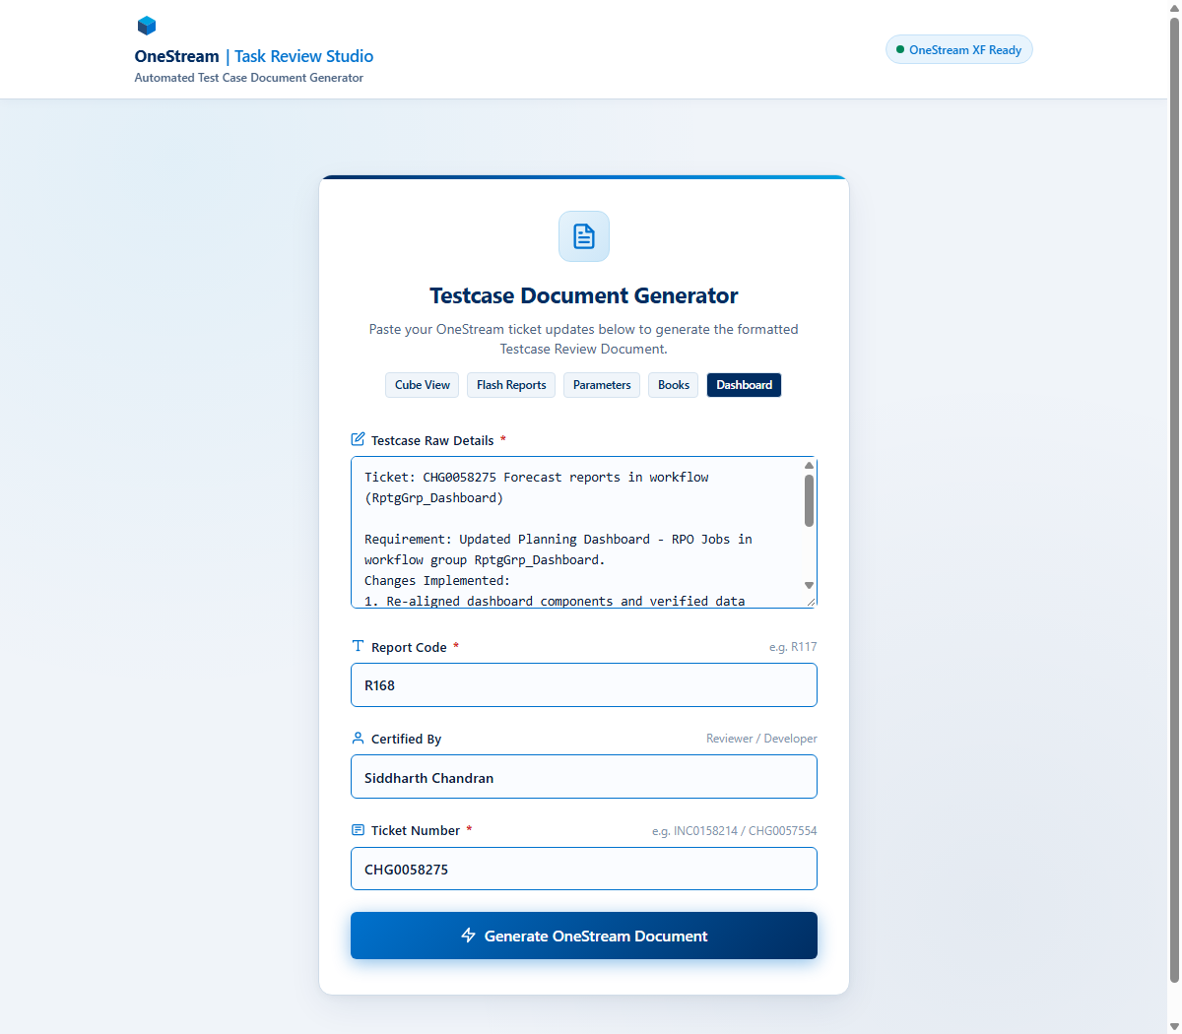
Figure 2: Form populated with a structured neat prompt and metadata

Step 4: Click 'Generate OneStream Document'
Click the blue 'Generate OneStream Document' button at the bottom of the card. The portal switches to an animated progress screen that tracks each stage of document compilation:
1. Parsing Ticket Scope: Validates inputs and prepares the context payload.
2. AI Analysis & Checklist Mapping: Google Gemini classifies the ticket type and selects the corporate verification items.
3. Assembling Word Document: Docxtemplater populates the OpenXML template, inserts checkboxes, computes summary totals, and creates the binary file.

Step 5: Download the Generated Word Document
Once compilation finishes (typically within 2 to 3 seconds), the success card appears displaying the exact generated filename. Your browser will automatically trigger the download, saving the file directly to your Downloads folder.
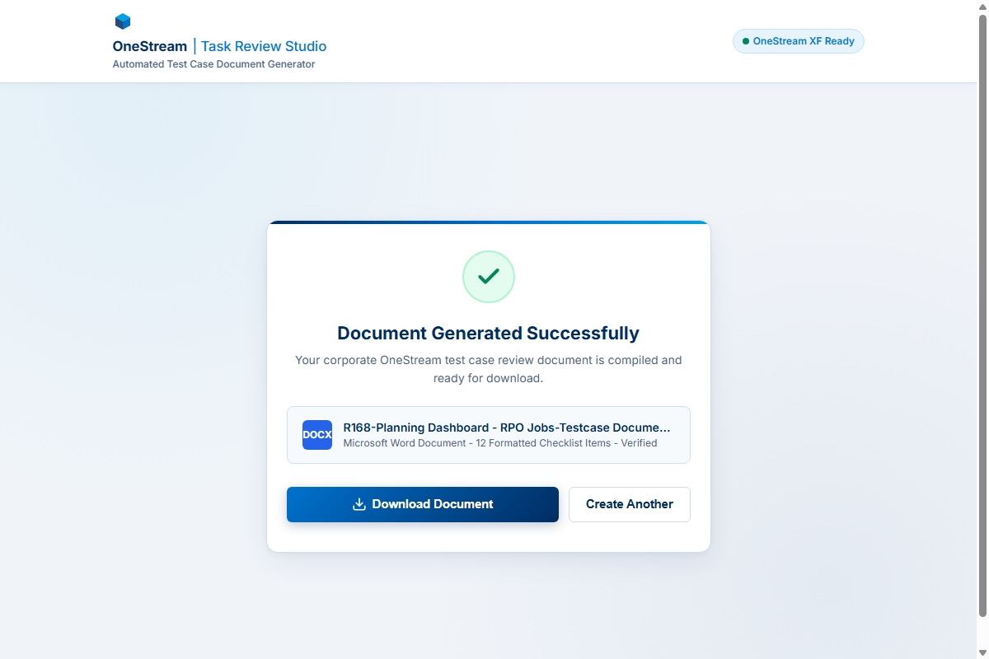
Figure 3: Document generated successfully with instant download button
If your browser blocked the automatic download popup, simply click the blue 'Download Document' button to save the file. To process another ticket, click 'Create Another' to return to a clean form.

5. Verifying Your Downloaded Document
When you open the downloaded '.docx' file in Microsoft Word, take a moment to review the following sections:
• Header Title: Confirm the title matches your artifact type (e.g. 'ONESTREAM DASHBOARD TASK REVIEW CHECKLIST' for Dashboards, or 'ONESTREAM CUBEVIEW TASK REVIEW CHECKLIST' for Cube Views).
• Summary Table (Table 1): Verify that the summary counts are pre-calculated. For Dashboards, it should display 'Total Dashboards: 1 | Testcases per dashboard: 12 | Total Testcase: 12'. For Cube Views, it will display 'Total Reports: 1 | Testcases per Report: 8'.
• Checklist Verification Items (Table 2): Review the table rows. The Yes checkbox (checked symbol) is pre-marked for compliance. The yellow category banner displays the review type.
• Remediation Workbook Link: At the bottom of the document, verify the hyperlinked remediation workbook name. It follows the standard pattern: '<ReportName>_Remediation_MM-DD-YYYY.xlsx'.

6. Troubleshooting and Frequently Asked Questions

Q1: What if Google Gemini returns '503 Service Unavailable / High Demand'?
Answer: The system has built-in resilience. If Google experiences a traffic surge, the server automatically pauses for 1.5 seconds and retries the request. If the primary model remains busy, it automatically falls back to secondary models (gemini-flash-latest, gemini-2.5-flash-lite, and gemini-2.5-pro). You do not need to do anything—the system handles failovers automatically behind the scenes.

Q2: Why did my ticket generate an 8-item Cube View review instead of a 12-item Dashboard review?
Answer: The AI classifies tickets based on the keywords in your prompt. If you are modifying a dashboard, make sure to explicitly include the word 'Dashboard', 'dashboard updation', or the workflow group name '(RptgGrp_Dashboard)'. Refer to Template A above for an exact prompt example that guarantees Dashboard classification.

Q3: Does the website store or save my company's ticket data?
Answer: No. The platform adheres to a strict zero-persistence policy. All notes, report names, and documents are processed entirely in temporary server memory (RAM) and streamed directly to your browser. Nothing is saved to permanent databases or logs.

Q4: Can I edit the downloaded Word document after generating it?
Answer: Yes. The generated file is a standard Microsoft Word (.docx) document with native tables, text, and checkboxes. You can open it in Word, make additional notes, attach screenshots, or export it to PDF for official release sign-off.

