OneStream Testcase Document Generator
User Navigation Guide & Form Reference Manual
Application Portal: https://tc-document-generator.onrender.com
Target Audience: OneStream Developers, Financial Systems Analysts, QA Engineers, and Release Managers

1. Purpose of this Guide
This document is a comprehensive user manual designed to help team members quickly navigate the Testcase Document Generator web portal. Whether you are releasing an updated Cube View, deploying a revised Dashboard interface, modifying system Parameters, or packaging financial Books, this guide explains how to construct clear, effective inputs and download production-ready Microsoft Word testcase review documents in seconds.

2. User Interface Overview and Navigation
When you navigate to https://tc-document-generator.onrender.com, you are presented with a clean, focused single-page interface designed for rapid entry without unnecessary menus.
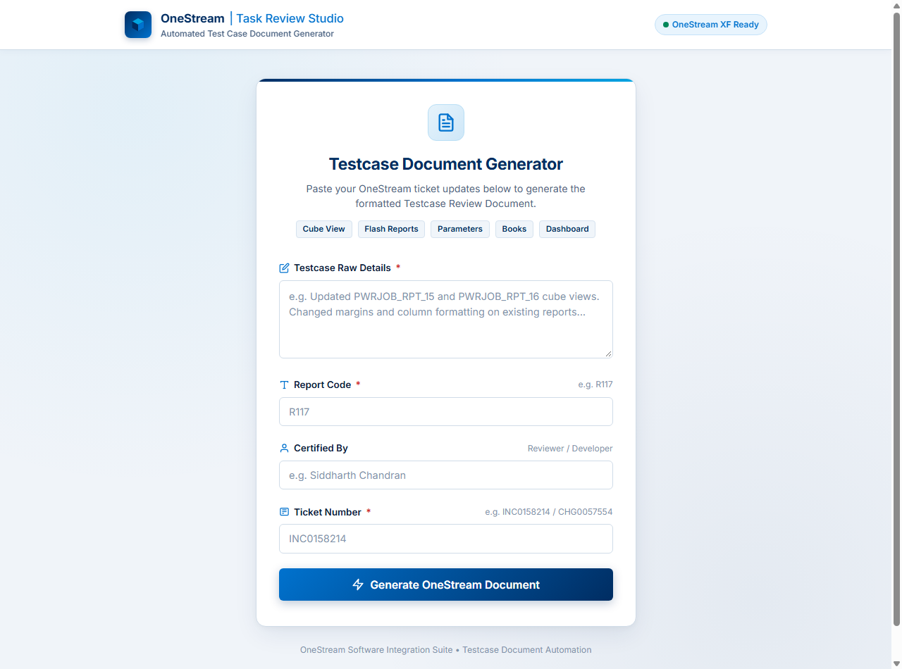
Figure 1: Main Landing Screen of the OneStream Task Review Studio

Field Descriptions:
• Testcase Raw Details (Required): Paste the complete ServiceNow change/incident description, developer notes, or prompt detailing modified OneStream artifacts and workflow changes. Minimum 10 characters.
• Report Code (Required): Enter the primary report or artifact code (e.g. R117, PWRJOB_RPT_15, or RPT_FORECAST).
• Certified By (Required): Developer name (e.g. Siddharth Chandran). Mandatory – stamped on the certification block of the generated document.
• Ticket Number (Required): ServiceNow tracking ticket (e.g. CHG0058275, INC0158214, or RITM0098421).
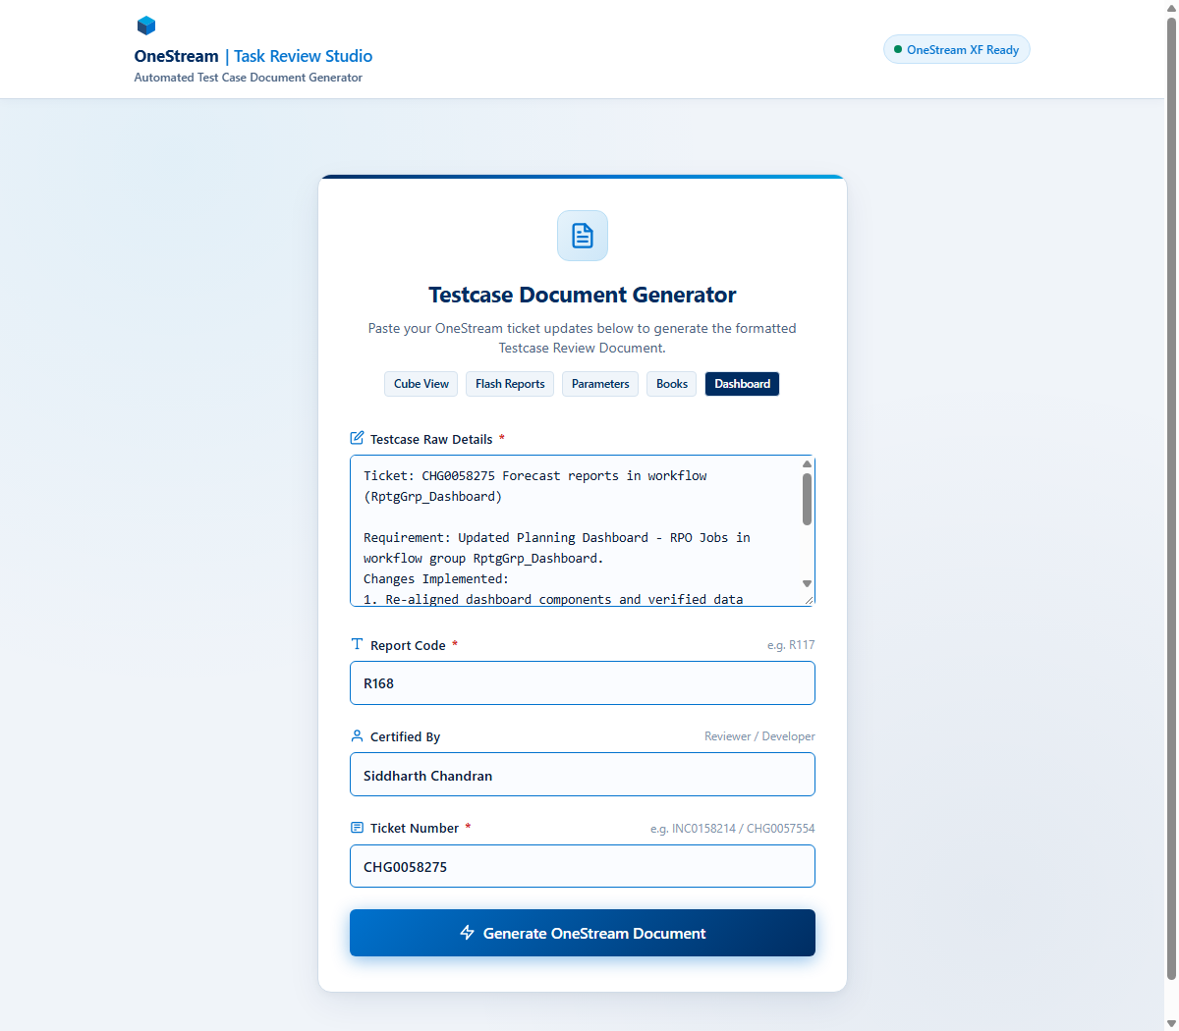
Figure 2: Form populated with ticket details and certified reviewer information

5. Generating & Downloading
Once all required metadata and ticket details are supplied, follow these steps to generate and download the review document:
1. Click Generate OneStream Document: Click the blue action button to begin AI-powered verification item assembly.
2. Processing & Synthesis: Wait 3-5 seconds while the system parses the scope and binds checklist items.
3. Download Word Document: Click 'Download Document' to obtain the standardized .docx file.
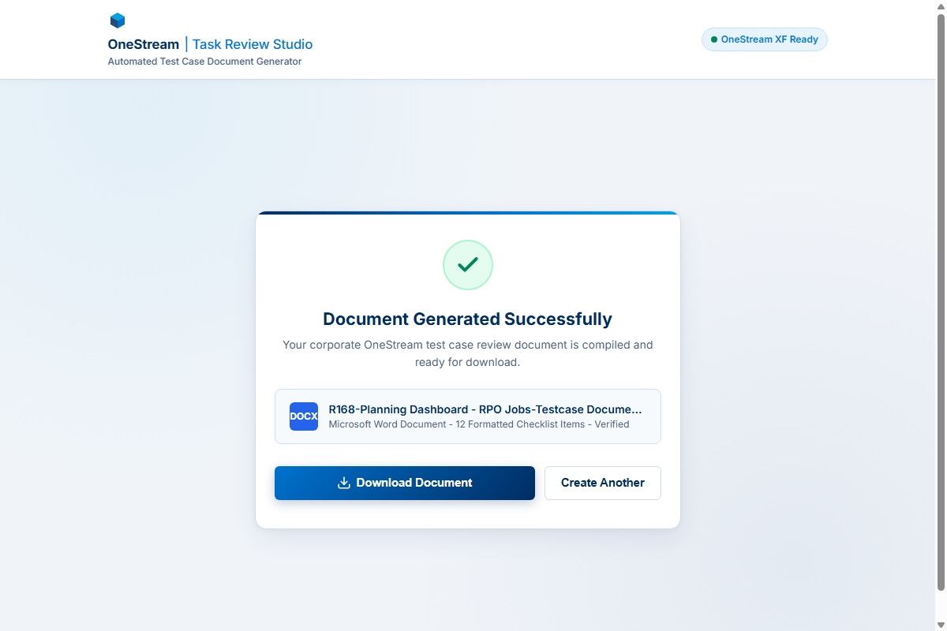
Figure 3: Document generated successfully with instant download button

