Assignment – 2

Solution – Siddharth Kumar

1. Get the tallest buildings across globe from Wikipedia.

**Sol:** Used the link <https://en.wikipedia.org/wiki/List_of_tallest_buildings_and_structures> to download the data set.

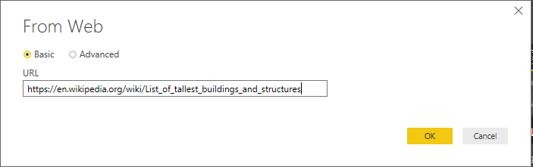

2. Get CO2(carbon-di-Oxide) level of countries/ cites across globe from Wikipedia.

**Sol:** Used the link <https://en.wikipedia.org/wiki/List_of_countries_by_carbon_dioxide_emissions> to download the data set.

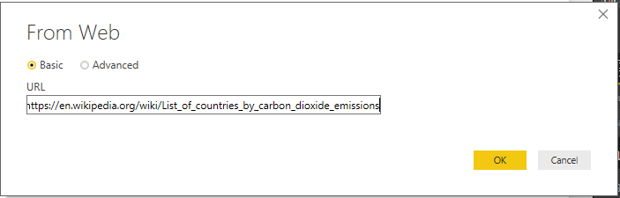

3. Create a model and define the relationship between the cities of tallest buildings to their CO2 levels.

**Sol:**

