Concurrent Data Processing System in Java and Go
Siddharth Malhotra
Data Processing System Assignment
October 8, 2026

Concurrent Data Processing System in Java and Go
This project compares equivalent three-worker systems in Java and Go. Each processes 10 queued integer tasks, records nine successes and one intentional input failure, and sorts the saved results for verification.

Java Concurrency and Exception Handling
The Java TaskQueue wraps an ArrayDeque with addTask and getTask methods. A ReentrantLock protects queue state, while a Condition suspends workers when no task is available. Unlock runs in finally blocks, so an exception cannot leave the queue locked. When the producer closes the queue, signalAll wakes waiting workers; getTask returns null only after the closed queue is drained. This creates a termination condition without polling or poison-pill tasks.
A fixed ExecutorService owns the workers. Main calls shutdown after submission and awaits termination with a timeout. Oracle (2026a) states that orderly shutdown rejects new work while allowing submitted work to finish. A synchronized list protects results. Worker try-catch blocks convert invalid inputs into ERROR records, preserve InterruptedException status, and continue processing when possible. Try-with-resources closes the output writer, and IOException is logged.

Go Concurrency and Error Handling
Go uses a buffered channel as its TaskQueue. AddTask sends a value, GetTask exposes a receive-only channel, and Close closes the channel after submission. A goroutine ranges over the channel and stops after it is closed and drained. Closing a channel indicates that no more values will be sent (The Go Authors, 2026a). A sync.WaitGroup prevents output from being written before every worker returns.
Go functions return errors rather than throwing exceptions. processTask returns a Result and an error; a bad value becomes a logged ERROR record without stopping other goroutines. A mutex protects the result slice, and deferred Unlock calls limit the critical section to slice operations. The output function wraps create, write, flush, and close errors. Deferred cleanup runs on every return path.

Comparison of the Concurrency Models
Java coordinates shared state with locks and a condition; ExecutorService separately manages thread lifecycle. ReentrantLock provides monitor-like exclusion, but lock release remains the programmer's responsibility, which is why Oracle (2026b) recommends try-finally. Go moves task ownership through a channel. Closing the channel communicates completion, while WaitGroup provides the join operation. A mutex is still required for the shared result slice.
Go needs less queue synchronization code because send, receive, and close express the handoff directly. Its pipeline guidance recommends closing outbound channels and draining receive loops (The Go Authors, 2014). Java gives more explicit control over waiting and interruption but requires stricter lock discipline.

Deadlock Prevention and Verification
Neither implementation nests locks or performs work while holding one. Java unlocks in finally blocks and wakes all waiters at closure; Go closes the task channel once after all sends. Both saved 10 records with nine OK and one ERROR status. The Go race-enabled test produced no race report.

References
Oracle. (2026a). ExecutorService (Java SE 25 & JDK 25). https://docs.oracle.com/en/java/javase/25/docs/api/java.base/java/util/concurrent/ExecutorService.html
Oracle. (2026b). ReentrantLock (Java SE 25 & JDK 25). https://docs.oracle.com/en/java/javase/25/docs/api/java.base/java/util/concurrent/locks/ReentrantLock.html
The Go Authors. (2014, March 13). Go concurrency patterns: Pipelines and cancellation. https://go.dev/blog/pipelines
The Go Authors. (2026a). The Go programming language specification: Channel types. https://go.dev/ref/spec#Channel_types

Repository
The complete source code, execution instructions, and report are available at https://github.com/siddharth2170/data-processing-system

Appendix A
Java Source Code and Sample Output
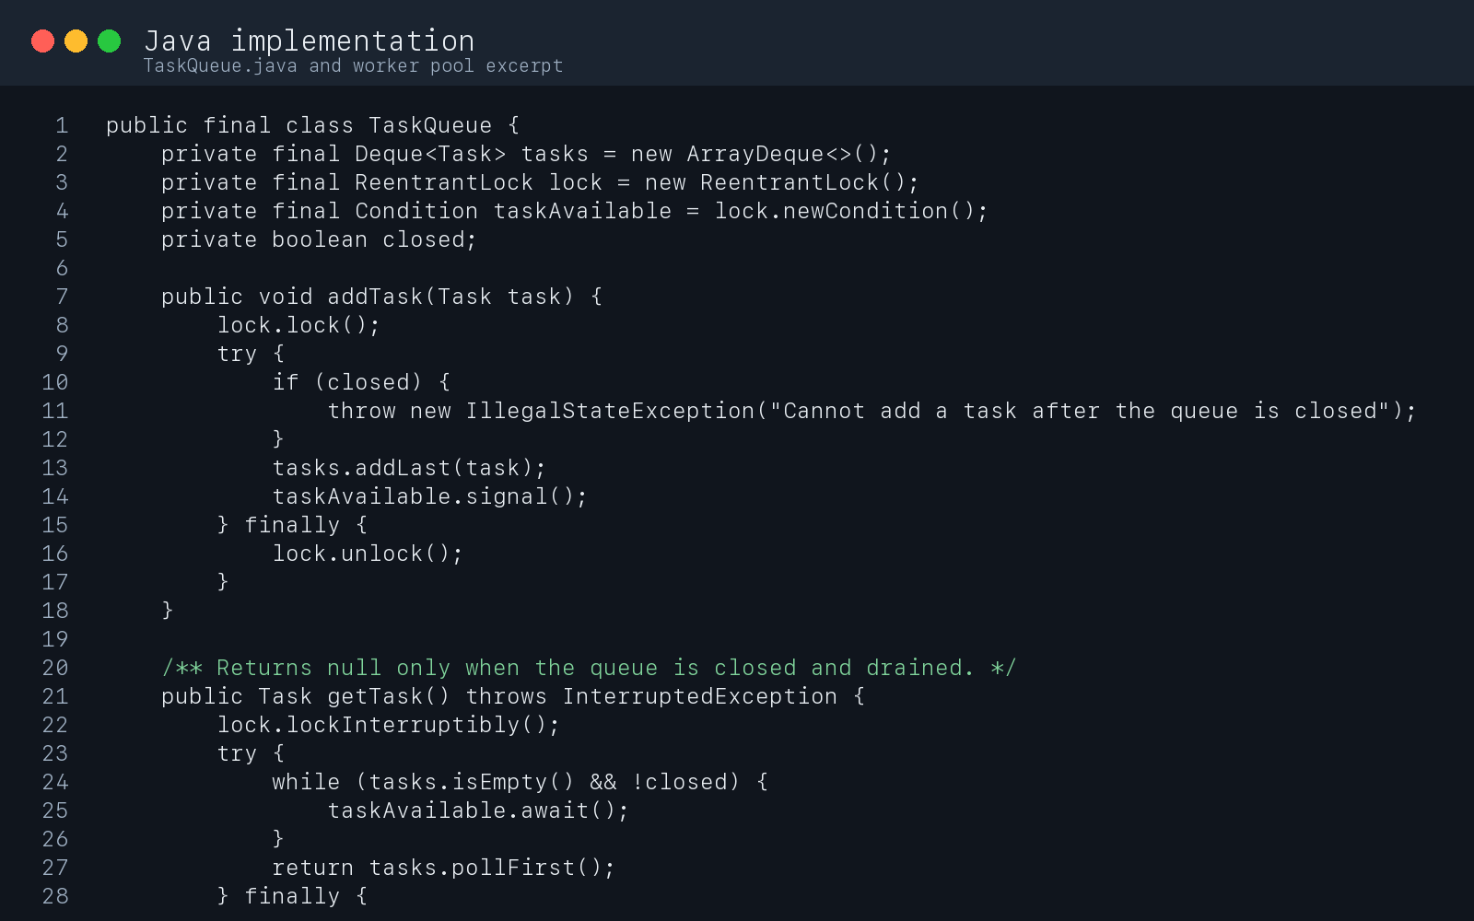
Figure A1. Java synchronized queue and worker-pool code excerpt

Appendix A Continued
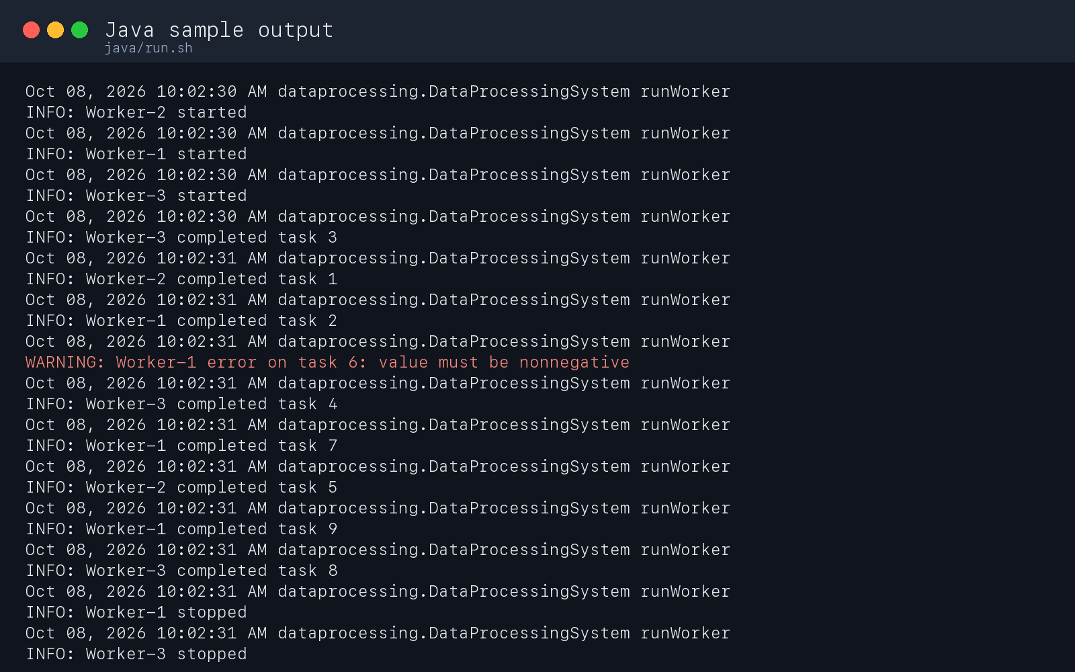
Figure A2. Java execution log showing worker lifecycle and final counts

Appendix B
Go Source Code and Sample Output
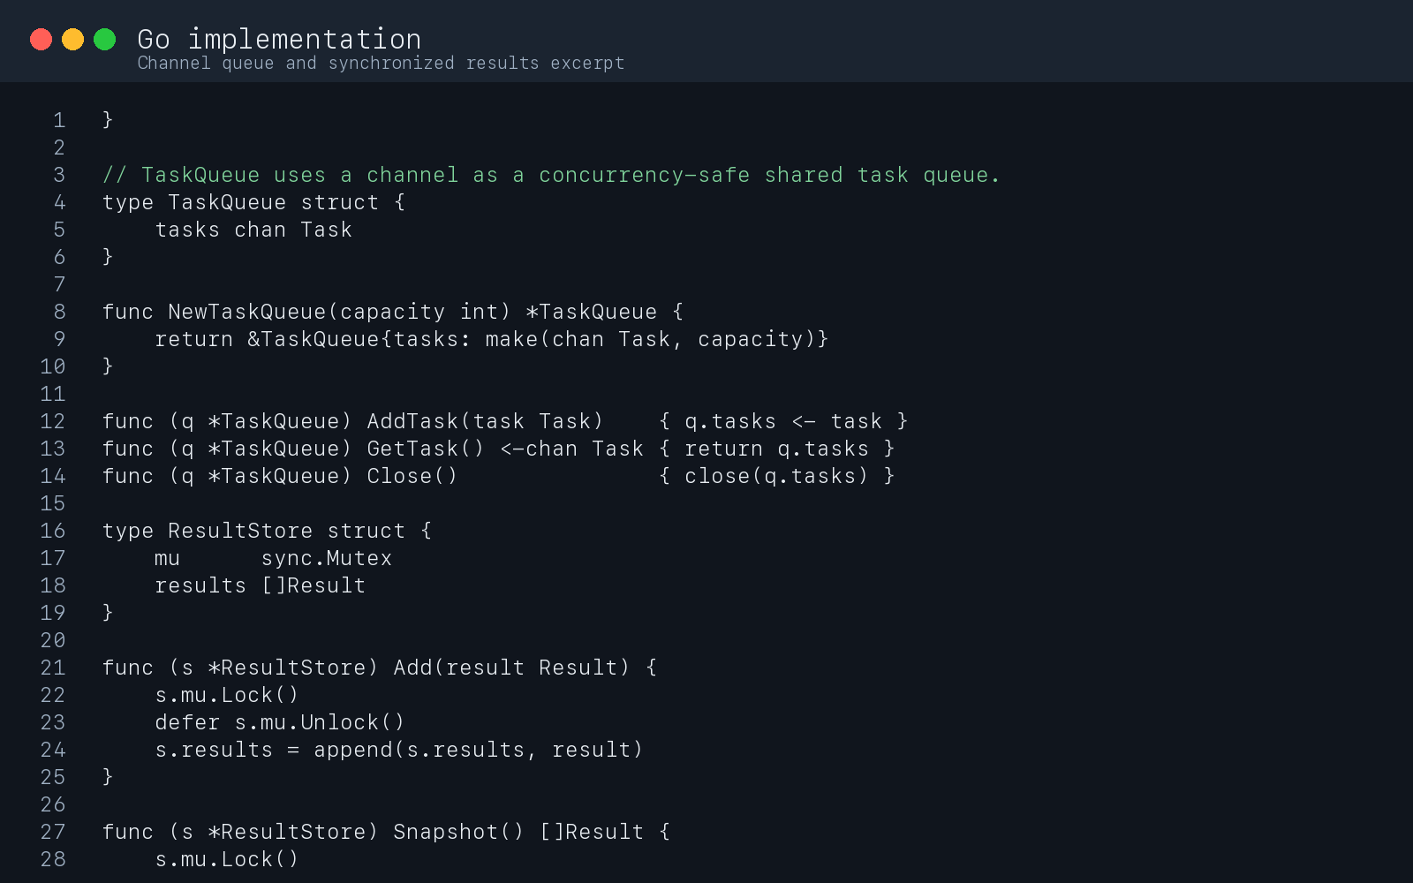
Figure B1. Go channel queue and synchronized result-store code excerpt

Appendix B Continued
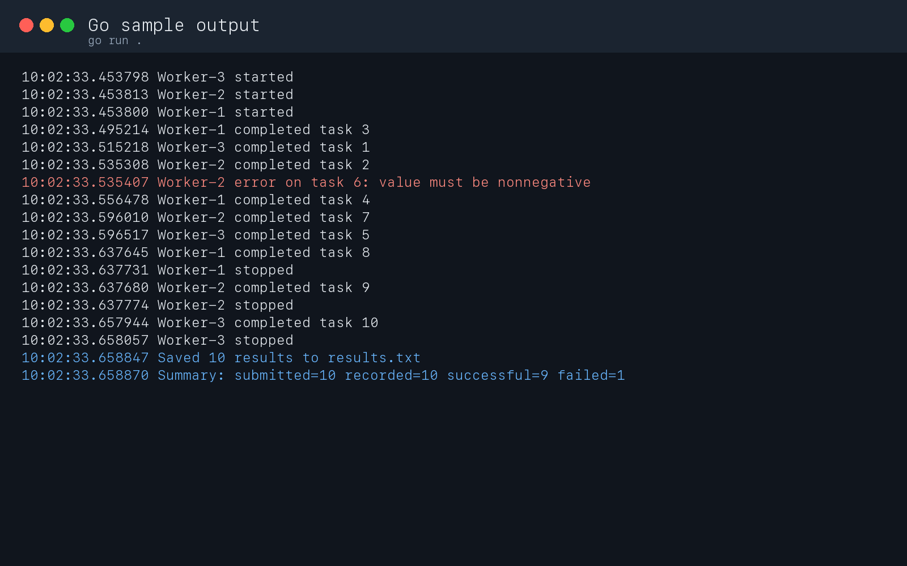
Figure B2. Go execution log showing worker lifecycle and final counts

