Calculating Basic Statistics Across Programming Paradigms
Siddharth Malhotra
[Institution Name]
[Course Number and Name]
[Instructor Name]
October 8, 2026

Calculating Basic Statistics Across Programming Paradigms
This project calculates the mean, median, and mode of an integer list in C, OCaml, and Python. The shared sample returns a mean of 3.12, median of 3.50, and mode of 4.

Procedural Implementation
The C version uses a procedure for each statistic and sorts a dynamically allocated array copy. Memory ownership is explicit, but bounds, tied modes, allocation failure, and cleanup require logic that built-in collections handle elsewhere.

Functional Implementation
The OCaml version maps each list to a result without updating variables. List.fold_left computes sums and frequencies; filter, map, and sorting produce tied modes. The data flow is clear, although composing the association-list frequency table takes care.

Object Oriented Implementation
The Python StatisticsCalculator validates and copies its input. Separate methods encapsulate each statistic, and a dictionary counts frequencies. Built-in collections made this version shortest, while the class supplies one reusable interface.

Comparison
C emphasizes control, OCaml immutable transformations, and Python encapsulation. The algorithm stays the same while responsibility moves among procedures, functions, and an object.
Repository: https://github.com/siddharth2170/ride-sharing-system

Appendix A

C Code and Sample Output
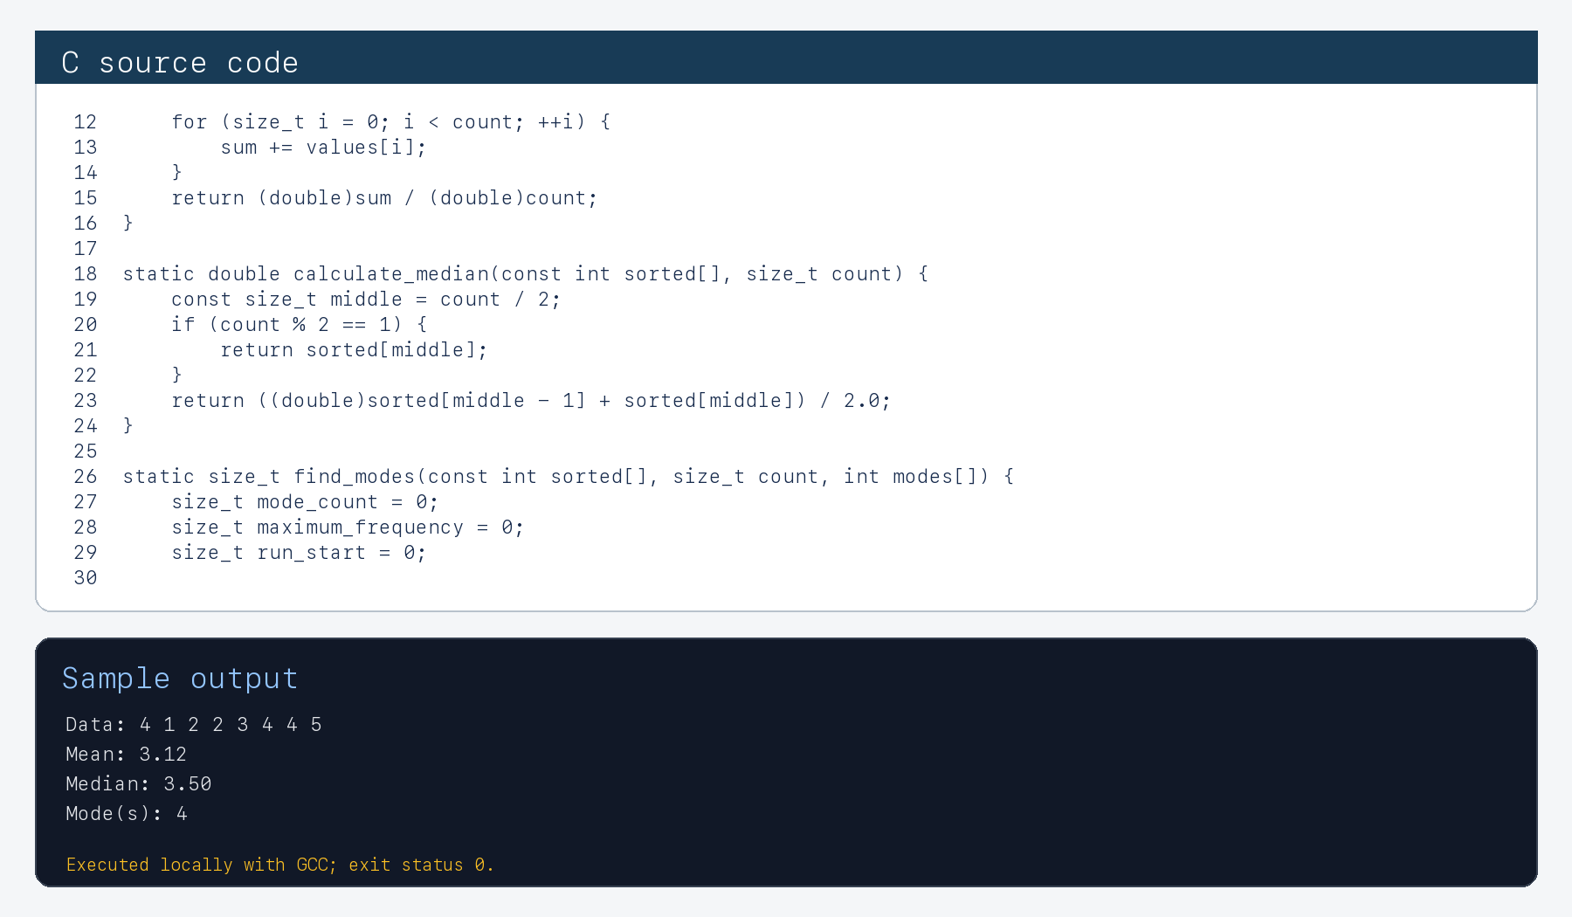
Figure A1. Procedural C implementation and locally executed sample output.

Appendix B

OCaml Code and Sample Output
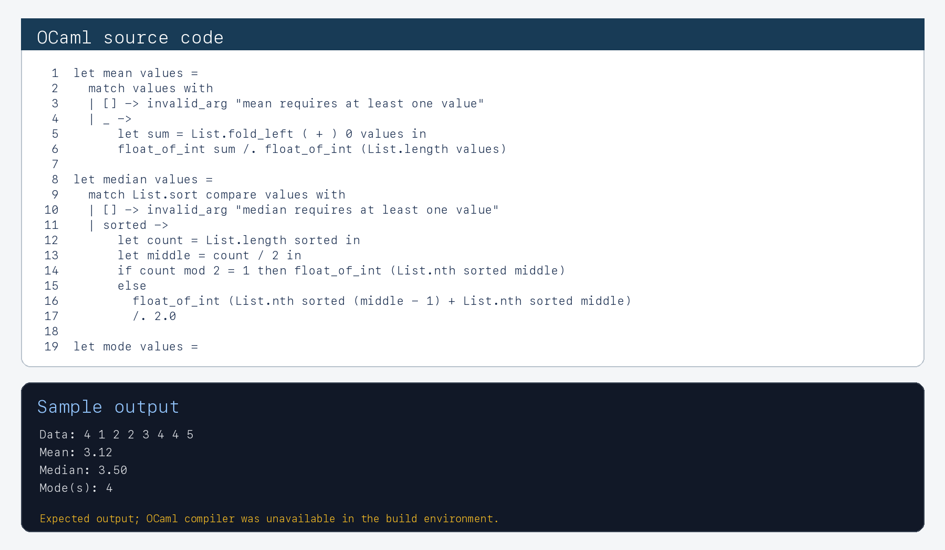
Figure B1. Functional OCaml implementation and expected sample output. The source was reviewed, but OCaml was not installed in the document build environment.

Appendix C

Python Code and Sample Output
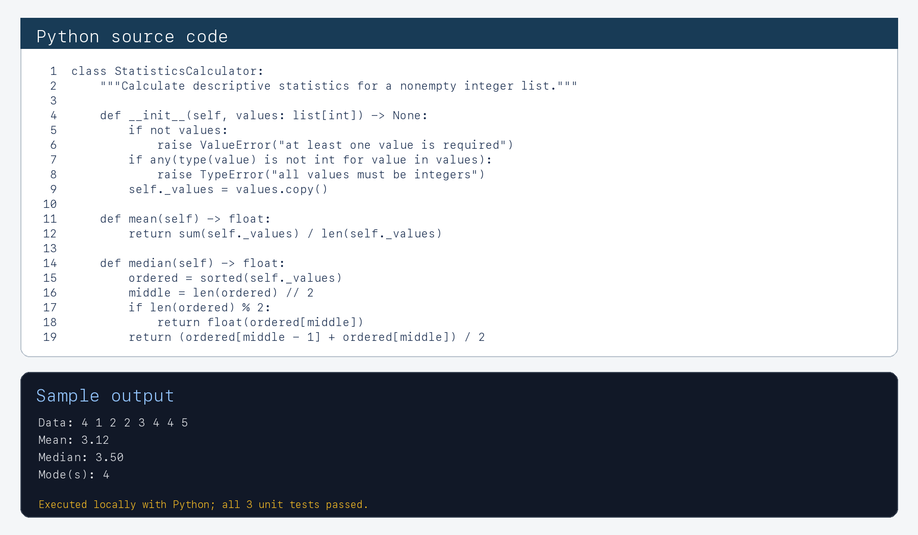
Figure C1. Object-oriented Python implementation and locally executed sample output.

