Object Oriented Ride Sharing System in Smalltalk and C++
Student Name
Institution
Course Number and Name
Instructor Name
October 4, 2026

Object Oriented Ride Sharing System in Smalltalk and C++
This project implements the same ride sharing domain in C++ and Smalltalk to demonstrate encapsulation, inheritance, and polymorphism. Both programs model standard and premium rides, a driver’s completed rides, and a rider’s request history. Mixed ride objects are processed through one interface, while each subtype calculates its own fare.

System Design
Ride stores an identifier, pickup and drop-off locations, and distance. StandardRide charges a $3.00 booking fee plus $2.00 per mile; PremiumRide charges $7.50 plus $3.50 per mile. Driver and Rider record completed and requested rides through methods. Validation rejects negative distance and invalid ratings.

Encapsulation
In C++, fields are private, including Driver::assignedRides_ and Rider::requestedRides_. Clients add rides only through public methods, leaving each class in control of its collection. In Smalltalk, instance variables are scoped to the class and its methods; clients send addRide: or viewRides rather than manipulating collections. Both versions therefore hide representation details behind a focused public protocol.

Inheritance
StandardRide and PremiumRide inherit identity, route, distance, and display behavior from Ride. Each supplies only rideType and fare. C++ declares these as pure virtual functions and shares a protected helper. Smalltalk uses subclassResponsibility and shares baseFareAt:bookingFee:. The hierarchy removes duplicated state and supports additional ride categories (Black et al., 2009; Stroustrup, 2013).

Polymorphism
Each demonstration places standard and premium objects in one collection. C++ stores shared pointers to Ride and dispatches virtual calls at runtime. Smalltalk sends identical messages to heterogeneous objects, and dynamic lookup selects the subtype method. A six-mile premium trip produces $28.50; a 12.5-mile standard trip produces $28.00. No type test is needed.

Language Comparison
C++ makes the boundary explicit with access specifiers, const methods, pure virtual functions, override, and smart pointers; the compiler checks much of the interface. Smalltalk uses fewer declarations because objects respond dynamically to messages. Despite different type systems, both versions bind data to behavior, specialize Ride through inheritance, and permit substitutable ride objects.

Verification and Repository
The C++ program compiled with C++17, -Wall, -Wextra, and -pedantic and executed successfully (Appendix B). The Smalltalk source uses Pharo/Squeak file-in syntax and includes a Transcript demonstration (Appendix D). The complete source and documentation are available in the public repository below.
GitHub repository: https://github.com/siddharth2170/ride-sharing-system

Conclusion
Both implementations meet the required functionality. Encapsulation protects ride histories, inheritance centralizes shared behavior, and polymorphism selects subtype-specific fares through a common Ride interface. The result is compact and extensible in both languages.

References
Black, A. P., Ducasse, S., Nierstrasz, O., Pollet, D., Cassou, D., & Denker, M. (2009). Pharo by example. Square Bracket Associates.
Stroustrup, B. (2013). The C++ programming language (4th ed.). Addison-Wesley Professional.

Appendix A C++ Code
Figure 1
Ride hierarchy and overridden fare methods in C++
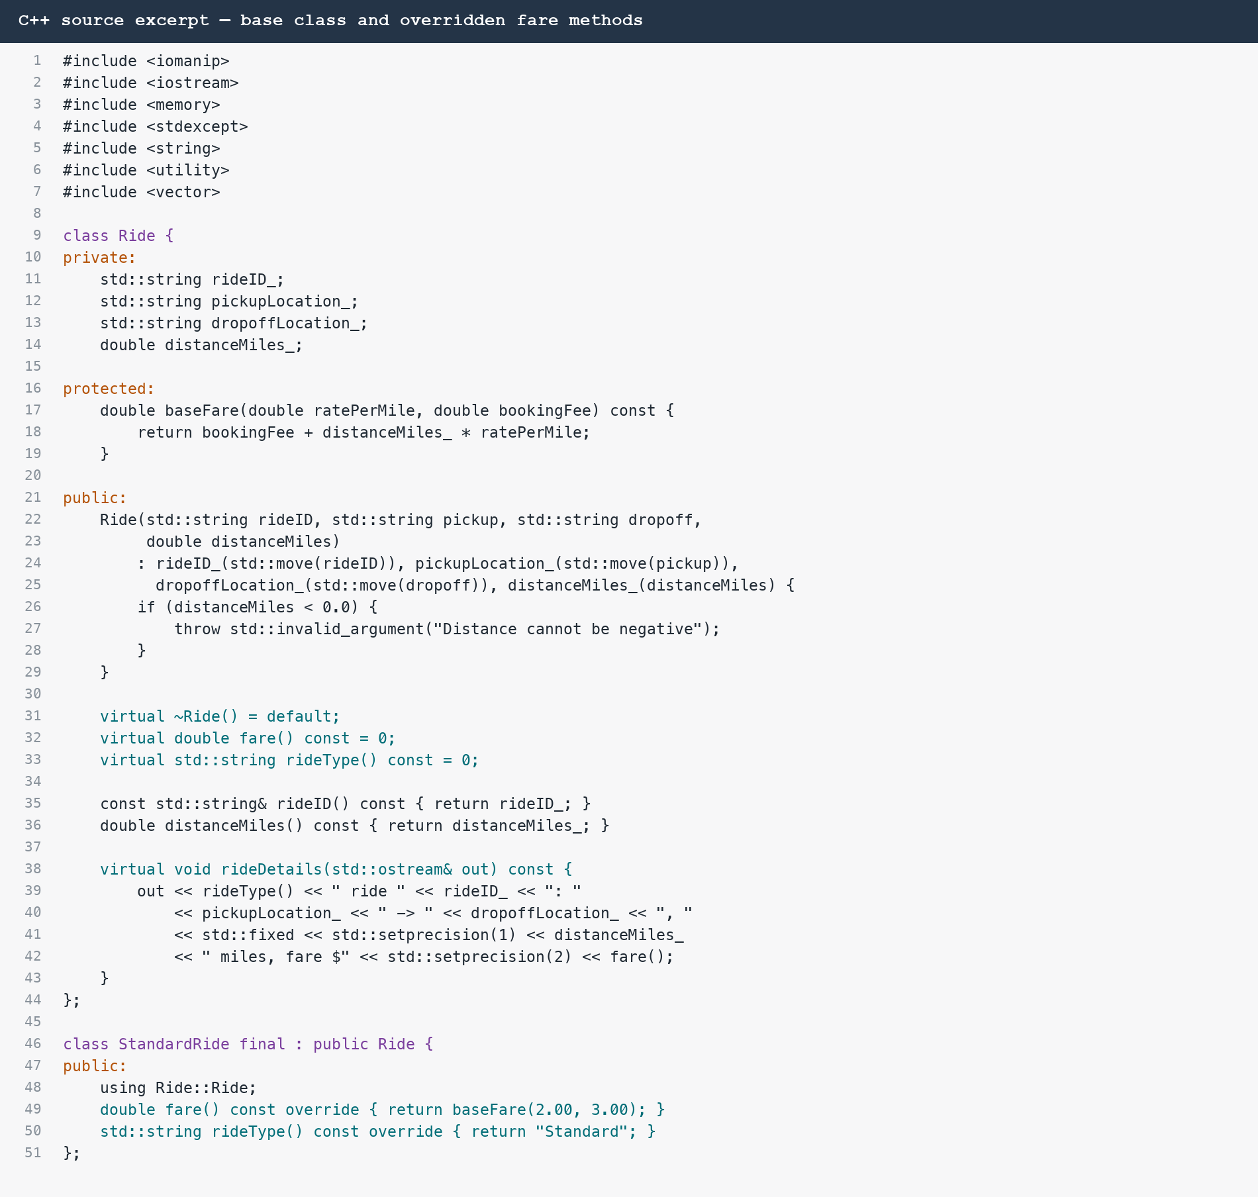

Appendix B C++ Sample Output
Figure 2
Compiled C++ program output
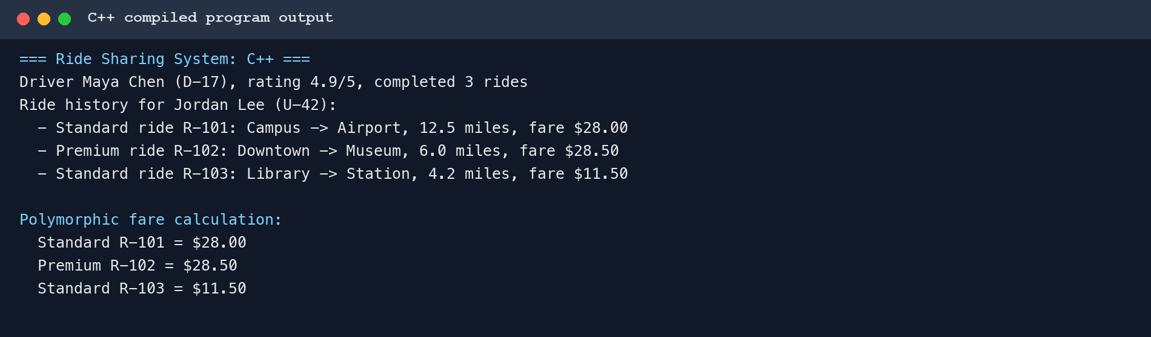

Appendix C Smalltalk Code
Figure 3
Ride hierarchy and overridden fare methods in Smalltalk
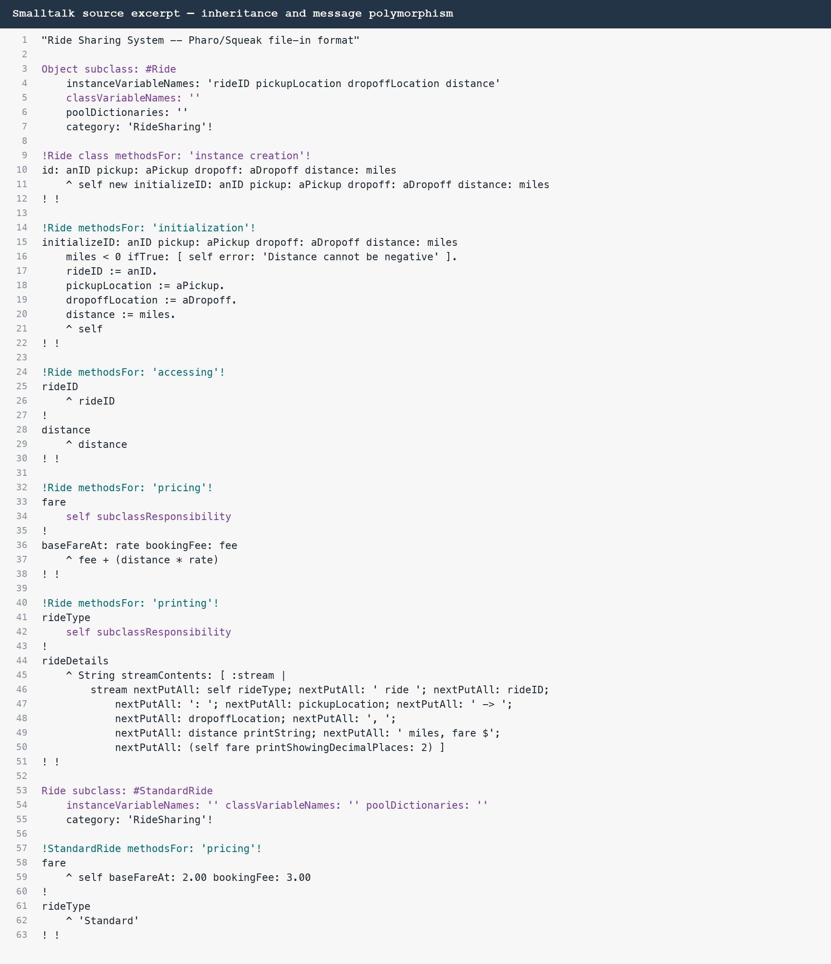

Appendix D Smalltalk Sample Output
Figure 4
Smalltalk Transcript output for the demonstration
