PRACTICAL: 02
Aim: To Implement Linear search and binary search and Time analysis their algorithms.

LINEAR SEARCH
Algorithm:

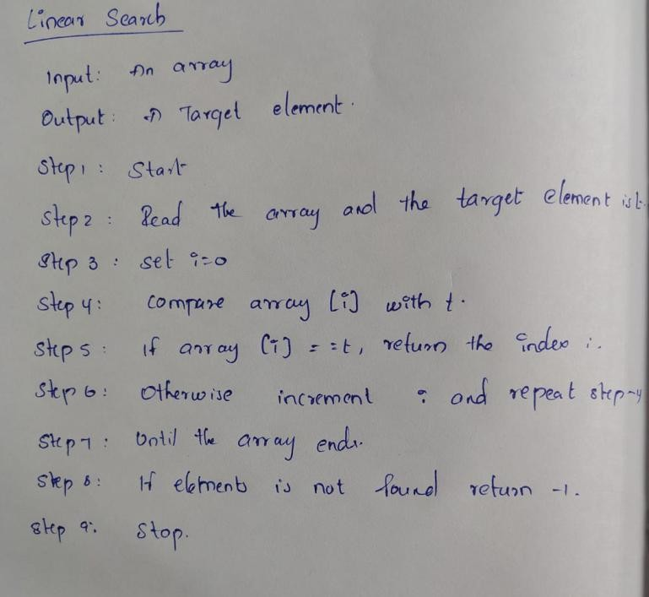

Program:
#include <iostream> using namespace std;

int linearSearch(int arr[], int n, int key) { for (int i = 0; i < n; i++) {
if (arr[i] == key)
return i;

} return -1;
}

int main() {
int arr[] = {10, 20, 30, 40, 50}; int n = 5; int key = 30;

int result = linearSearch(arr, n, key);

if (result != -1)
cout << "Element found at index " << result; else
cout << "Element not found";

return 0;
}
Output:

Time Complexity:

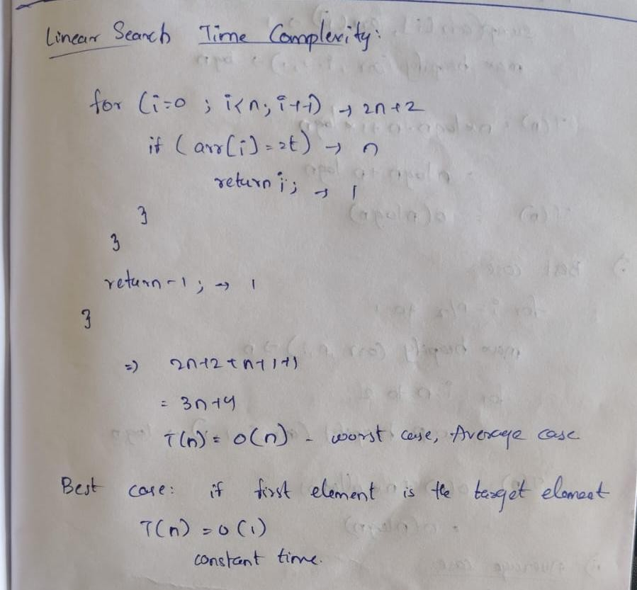

Conclusion:
Linear Search is a simple searching technique that checks each element one by one until the target element is found. It can be used on both sorted and unsorted arrays, but its time complexity is O(n).

BINARY SEARCH
Algorithm:
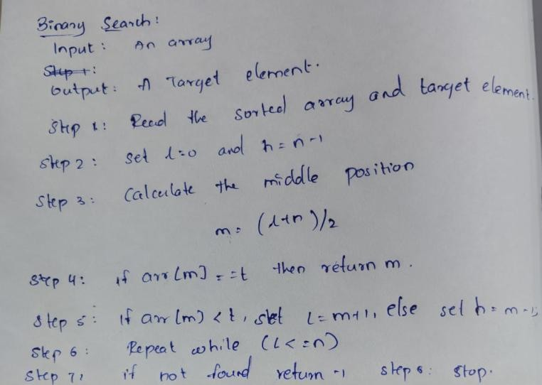
Program: #include <iostream> using namespace std;

int binarySearch(int arr[], int n, int key) { int low = 0, high = n - 1;

while (low <= high) { int mid = (low + high) / 2;

if (arr[mid] == key) return mid;
else if (arr[mid] < key) low = mid + 1;
else
high = mid - 1;
}

return -1;
}

int main() {
int arr[] = {10, 20, 30, 40, 50}; int n = 5; int key = 40;

int result = binarySearch(arr, n, key);

if (result != -1)
cout << "Element found at index " << result;
else
cout << "Element not found";

return 0;
}

Output:

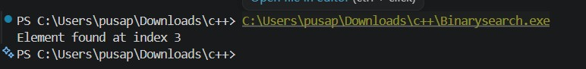

Time complexity:
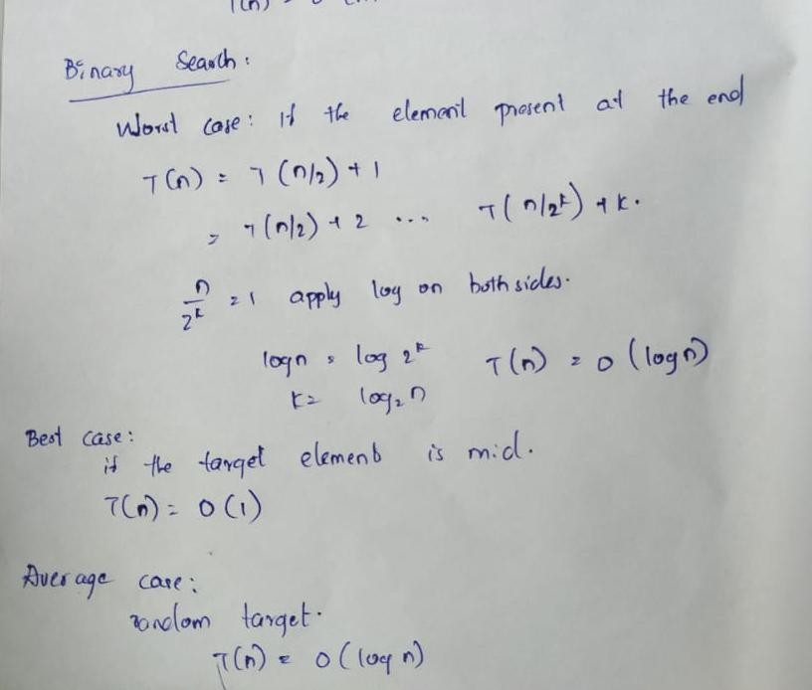

Conclusion:
Binary Search is a faster searching technique that repeatedly divides a sorted array into two halves to find the target element. Its time complexity is O(log n), making it more efficient than Linear Search for large sorted arrays.

