Practical – 3

Aim : To Implementation of Max-Heap sort algorithm

Algorithm :
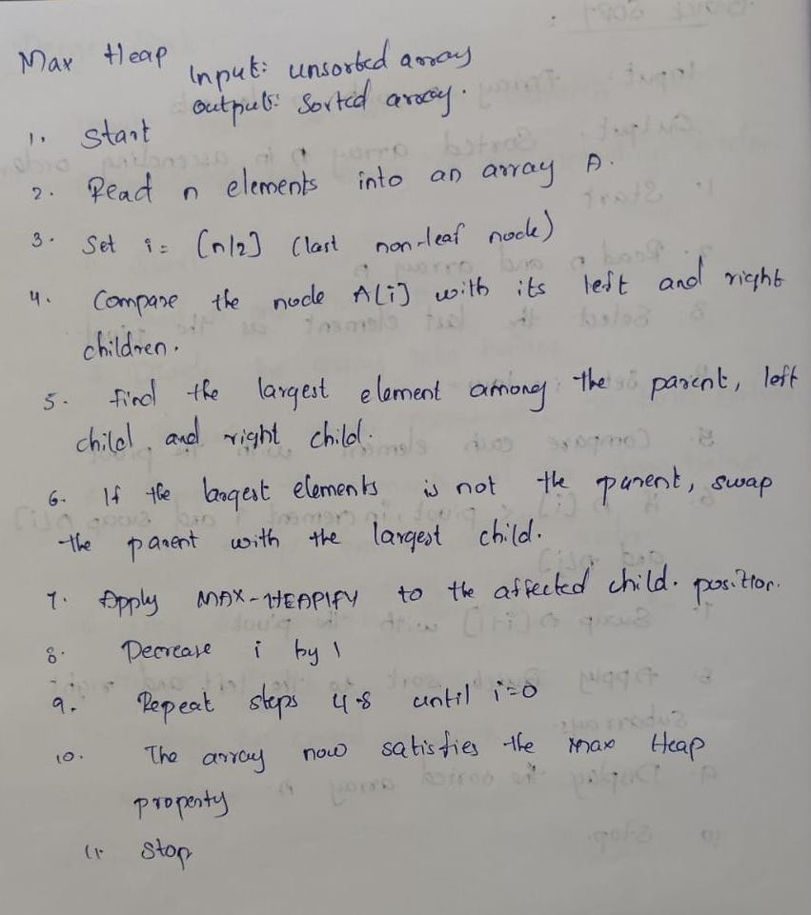

Program / Code :
#include <iostream> #include <vector> using namespace std;

void heapify(vector<int> &arr, int n, int i)
{ int largest = i; int left = 2 * i + 1; int right = 2 * i + 2;

if (left < n && arr[left] > arr[largest])
largest = left;

if (right < n && arr[right] > arr[largest]) largest = right;

if (largest != i) { swap(arr[i], arr[largest]); heapify(arr, n, largest);
}
}

void heapsort(vector<int> &arr)
{ int n = static_cast<int>(arr.size());

for (int i = n / 2 - 1; i >= 0; i--) heapify(arr, n, i);

for (int i = n - 1; i > 0; i--)
{ swap(arr[0],arr[i]); heapify(arr, i, 0);
}
}

int main() {
vector<int> arr = {64, 34, 25, 12, 22, 11, 90};

heapsort(arr);

cout << "Sorted array using heap sort:\n"; for (int value : arr)
cout << value << ' ';

cout << '\n'; return 0;
}

OUTPUT:
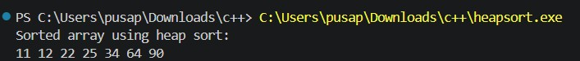

Time Complexity :
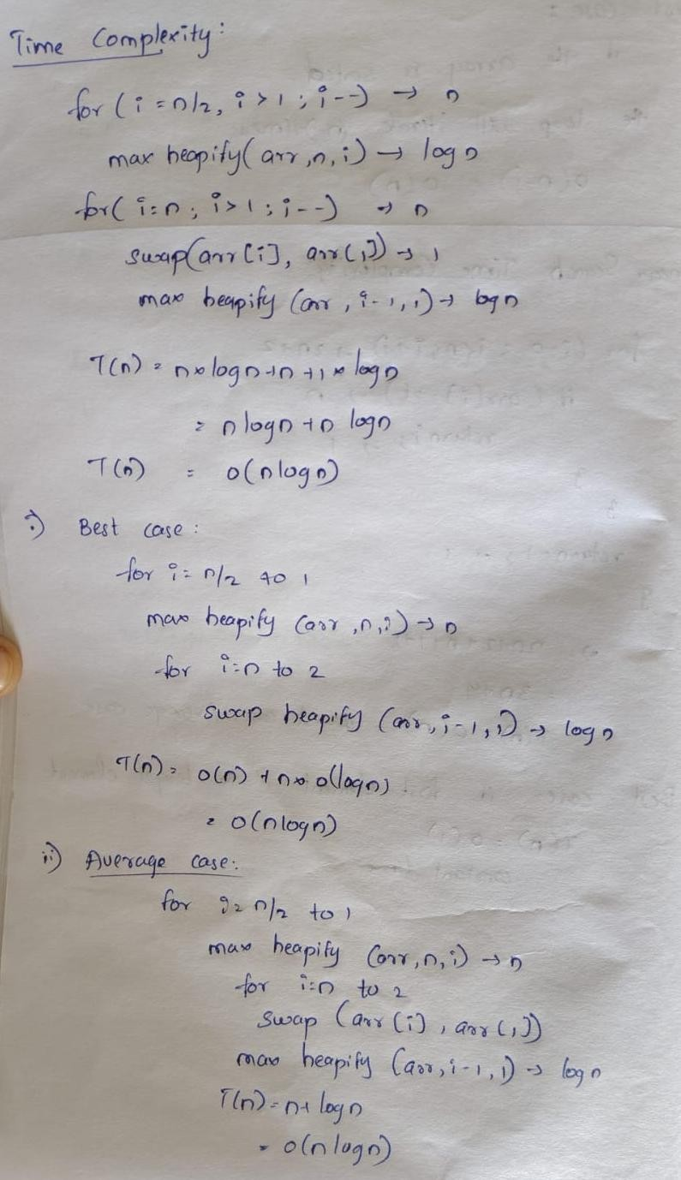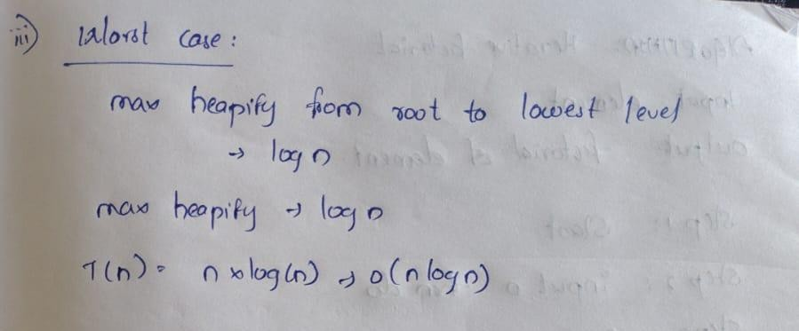

Conclusion :
The Max-Heap Sort algorithm was successfully implemented and executed to sort the elements in ascending order. The program verified a consistent time complexity of \(O(n \log n)\) across the best, average, and worst cases using an in-place binary heap structure

