PRACTICAL: 04
Aim: Implementation and Time analysis of factorial program using iterative and recursive method.
Algorithm:
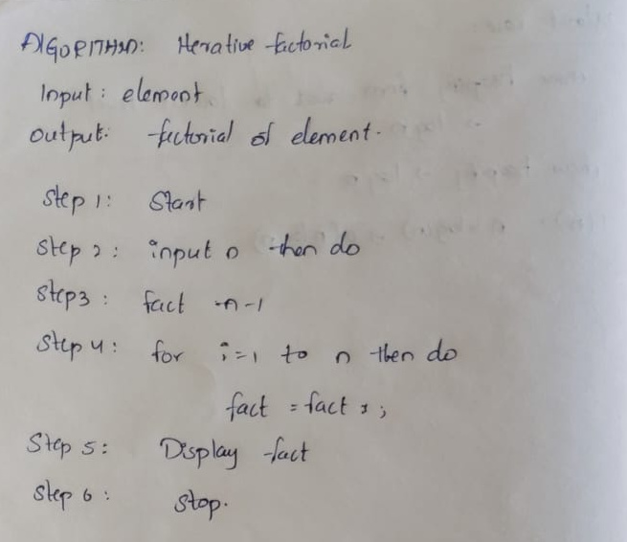

Program / Code: #include <iostream> using namespace std; class Factorial
{
public:
int fact(int n)
{
int result = 1;
for (int i = 1; i <= n; i++)
{
result = result * i;
}
return result;
}
};
int main()
{
int n, result;
Factorial obj;
cout << "Enter the value to find its factorial: ";
cin >> n;
result = obj.fact(n);
cout << "Factorial of " << n << " is " << result << endl; return 0;
}
Output:

Time Complexity:
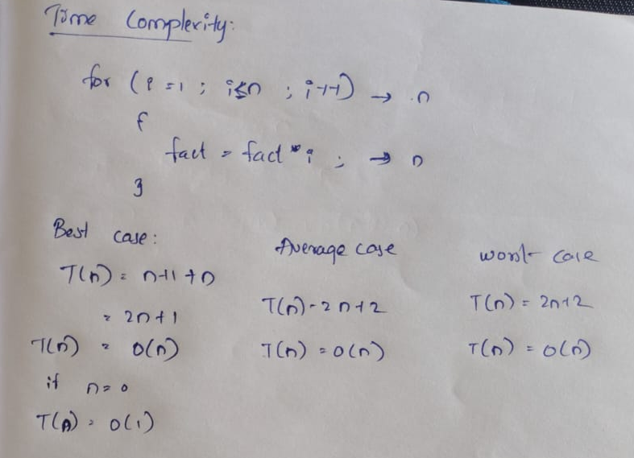

RECURSIVE METHOD:
Algorithm:
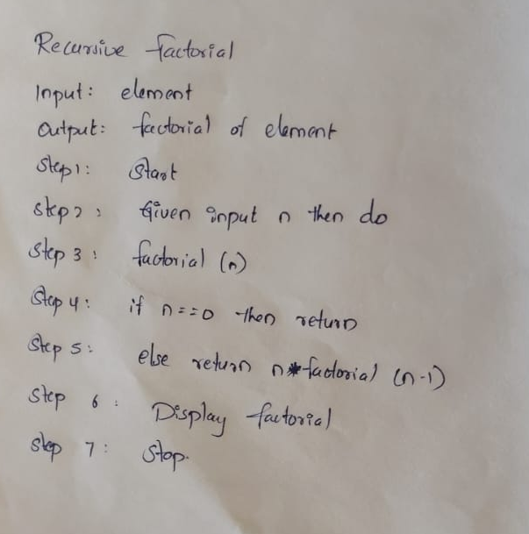
Program:
#include<iostream>
using namespace std;

int factorial(int n) {
if (n == 0 || n == 1)
return 1;
else
return n * factorial(n - 1);
}

int main() {
int num;
cout << "Enter a number: ";
cin >> num;

int result = factorial(num);
cout << "Factorial of " << num << " is " << result << endl;

return 0;
}

Output:

Time complexity:
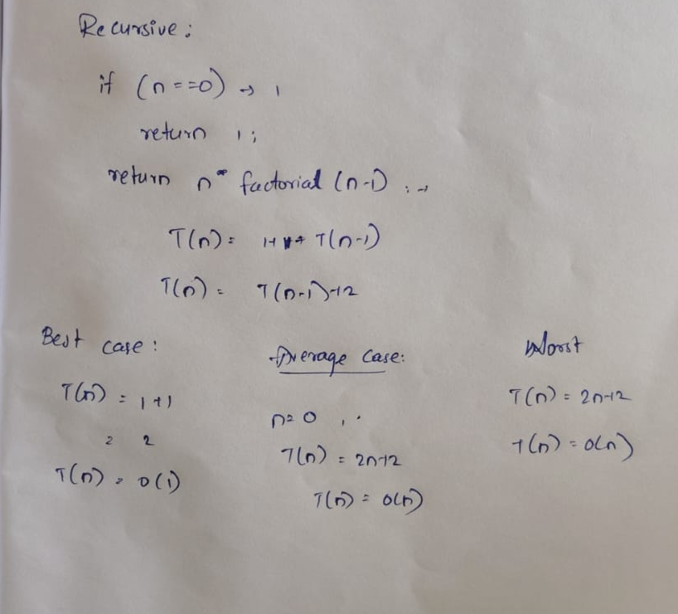

Conclusion:
The factorial program was implemented using both iterative and recursive methods. The iterative method uses a loop, while the recursive method uses function calls. Both methods have O(n) time complexity in the general case. The iterative method uses O(1) space, whereas the recursive method uses O(n) space due to the recursive call stack.

