De novo peptide binders against human RBP4
Design campaign, orthogonal validation, and candidate shortlist
24 September 2026 · BindCraft 2 + Protenix-v2 · AIMecoSPECS

Summary
Two BindCraft 2 (BC2) campaigns produced 21 accepted peptide binders against the retinol portal of human RBP4 — 10 head-to-tail macrocycles and 11 linear peptides. Twenty of these were re-predicted with Protenix-v2, an independent structure-prediction architecture, across five random seeds (500 structures total). The twenty are all 10 macrocycles and 10 of the 11 linears; linear rank 5 was excluded at input generation, having already bound off-epitope in BC2's own output.
The central finding is that BC2's own confidence score does not predict independent agreement: r(BC2 i_pTM, Protenix ipTM) = +0.06, and r(BC2 i_pTM, epitope agreement) = −0.19. Candidates are therefore ranked on cross-model consensus, not on BC2 score. Ten designs survive; four are recommended for synthesis.
Nothing here is experimental. These are two structure predictors agreeing with one another, which raises confidence but does not demonstrate binding.

1. Target and epitope
Human retinol-binding protein 4 (RBP4), PDB 5NU7 at 1.50 Å — chosen over 1RBP (2.00 Å) and 3FMZ (2.90 Å) on resolution, single chain, and native retinol ligand. Prepared as chain A only, residues 1–174, with retinol, chloride and waters stripped and disordered Asp175 dropped. All three disulfides intact (Cys4–Cys160, Cys70–Cys174, Cys120–Cys129); no free cysteines.
RBP4 is a lipocalin: an eight-stranded β-barrel holding retinol in a cup. The targeted site is the mouth of that cup — the portal — which overlaps the transthyretin binding surface and is the pharmacologically meaningful site.
The epitope was selected in two steps: residues within 5 Å of retinol, then filtered by solvent accessibility, since barrel-interior residues contact retinol but are unreachable by a peptide. The resulting hotspot set is 35, 62, 64, 67, 93, 95, 96, 98, 99 — a hydrophobic groove framed by charges, with Trp67 and Phe96 at the core.
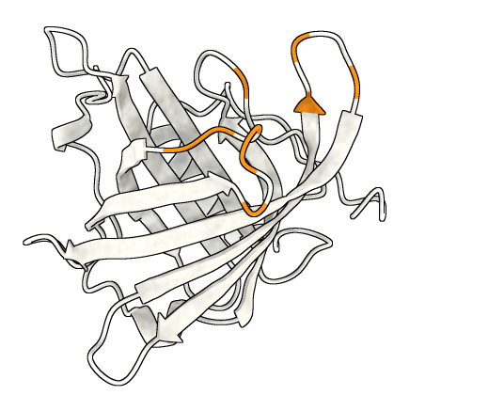
Figure 1. RBP4 (PDB 5NU7, chain A) in grey, with the nine targeted portal residues in orange. The retinol calyx opens toward the upper right. All figures share one orientation and one superposition frame (target Cα RMSD 0.22–0.31 Å).

2. Design
BC2 was run in peptide modality with soft hotspot targeting, binder lengths 12–25, on three RTX 3070-class GPUs. Two campaigns:
Campaign | Trajectories | Accepted | Accept rate | Runtime
Cyclic (macrocycle) | 815 | 10 | 1.2 % | 10 h 56 m
Linear | 347 | 11 | 3.2 % | —
Active filters: Backbone_Clashes ≤ 0, Interface_Residues ≥ 7, i_pAE ≤ 0.33, i_pTM ≥ 0.7. Stage gates from core defaults (min_plddt_screen 0.6, min_plddt_refine 0.6, min_iptm_anneal 0.5).

3. Orthogonal validation
BC2 designs with AlphaFold2 and validates with held-out AlphaFold2 models, so its own scores cannot serve as an independent check. The 20 validated designs were re-predicted with Protenix-v2 (464 M parameters, bf16), a different architecture. Macrocycles were cyclised explicitly through a covalent_bonds record joining the N of residue 1 to the C of residue L.
Two quantities are reported per design:
ipTM — Protenix's own confidence that the two chains form the predicted interface. A self-assessment, not a measurement.
Jaccard — geometric overlap between the RBP4 residues BC2 says the peptide touches and those Protenix independently places it against (any target residue within 4.5 Å of any peptide atom). 1.0 means identical residue sets; 0.0 means the two models dock the peptide in different places.
These come apart, which is why both are reported. One design scored ipTM 0.878 — high confidence — at Jaccard 0.23: confident about the wrong site.

3.1 Seed replication
An initial pass used a single seed. Repeating all 20 validated designs at five seeds (101, 202, 303, 404, 505) changed two verdicts, both on designs where one draw was deciding:
Design | 1 seed (Jaccard) | 5 seeds (mean ± sd) | Verdict change
rbp4cyc_r03_l17 | 0.69 | 0.14 ± 0.31 | kept → rejected
rbp4cyc_r04_l15 | 0.23 | 0.75 ± 0.29 | rejected → kept*
* r04 is rejected on stability regardless: a Jaccard sd of 0.29 means the peptide moves between seeds. Notably, rbp4cyc_r03_l17 carried the highest BC2 i_pTM in the entire set (0.79) and binds off-epitope in four of five seeds.
Two practical notes. The five samples Protenix emits per seed are near-duplicates (ipTM spread ~0.005); between seeds the shift is roughly five times larger, so replication requires more seeds, not more samples. And with cached MSAs the full five-seed sweep costs about 29 s of GPU per design-seed — 18 minutes wall for all 80 additional runs.

4. Shortlist
Gates: mean Jaccard ≥ 0.55, minimum Jaccard ≥ 0.4 (agreement in every seed, not merely on average), mean ipTM ≥ 0.60, ipTM sd < 0.10. Ten of the 20 pass, ordered by the product of mean ipTM and mean Jaccard.
Design | Len | Sequence | ipTM | Jaccard | Jac min | Hotspots
lin_r09_l19 | 19 | MPEVVKMRSPEGKWEEHTF | 0.787 ± 0.021 | 0.90 ± 0.15 | 0.67 | 3.8
lin_r06_l24 | 24 | EKPKVKLTPGMTMEEFKEEYEKKL | 0.827 ± 0.014 | 0.80 ± 0.07 | 0.71 | 5.2
lin_r10_l21 | 21 | LTDEQIVEEFEKHNMKVVHRE | 0.730 ± 0.086 | 0.88 ± 0.04 | 0.83 | 5.6
lin_r01_l25 | 25 | APVPKMPEEIKKEAEKWGMKMTYRP | 0.810 ± 0.015 | 0.78 ± 0.07 | 0.72 | 6.2
cyc_r08_l14 | 14 | TFHRPGQTMVLDGL | 0.875 ± 0.036 | 0.72 ± 0.04 | 0.67 | 2.0
lin_r03_l21 | 21 | SKTKMPEEMKEEMDKHGIKYT | 0.822 ± 0.007 | 0.71 ± 0.04 | 0.65 | 5.0
cyc_r07_l16 | 16 | RHPDKTVTLPEMNVTM | 0.704 ± 0.032 | 0.82 ± 0.09 | 0.73 | 2.6
lin_r04_l21 | 21 | MIVPAKNDKGEEVPVHMRKRE | 0.790 ± 0.008 | 0.71 ± 0.06 | 0.65 | 6.0
lin_r08_l24 | 24 | EWKVWSREEVTEDMKKHGMPVPAP | 0.786 ± 0.031 | 0.60 ± 0.03 | 0.57 | 5.2
cyc_r02_l17 | 17 | IEEVNMRMRHPDGTEMV | 0.616 ± 0.045 | 0.69 ± 0.05 | 0.61 | 2.8
Rows shaded in cream are the four recommended below. “Hotspots” is the mean number of the nine targeted residues contacted per seed.

5. Recommended for synthesis
Four candidates, chosen for cross-model consensus and to span both modalities and a range of lengths.

5.1 rbp4lin_r09_l19 · linear, 19 aa
MPEVVKMRSPEGKWEEHTF
ipTM (5 seeds) | Jaccard (5 seeds) | Worst seed | Hotspots contacted
0.787 ± 0.021 | 0.90 ± 0.15 | 0.67 | 3.8
Strongest epitope agreement in the set: Protenix reproduces BC2's residue set exactly (Jaccard 1.00) in three of five seeds. The shortest linear candidate.
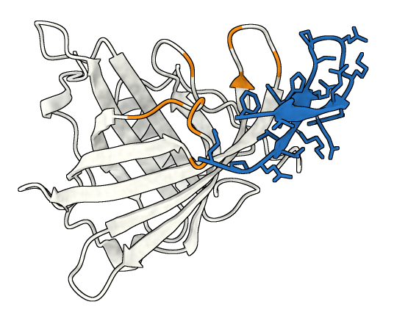
Figure 2. rbp4lin_r09_l19 (blue, sticks) on the RBP4 portal. Targeted hotspot residues in orange.

5.2 rbp4lin_r06_l24 · linear, 24 aa
EKPKVKLTPGMTMEEFKEEYEKKL
ipTM (5 seeds) | Jaccard (5 seeds) | Worst seed | Hotspots contacted
0.827 ± 0.014 | 0.80 ± 0.07 | 0.71 | 5.2
The most confident linear design, and tightly reproducible — ipTM varies by only ±0.014 across seeds.
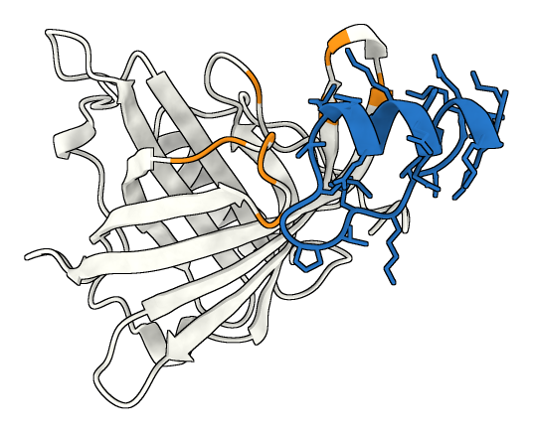
Figure 3. rbp4lin_r06_l24 (blue, sticks) on the RBP4 portal. Targeted hotspot residues in orange.

5.3 rbp4lin_r10_l21 · linear, 21 aa
LTDEQIVEEFEKHNMKVVHRE
ipTM (5 seeds) | Jaccard (5 seeds) | Worst seed | Hotspots contacted
0.730 ± 0.086 | 0.88 ± 0.04 | 0.83 | 5.6
Highest worst-case agreement of any candidate (0.83), meaning no seed places it appreciably off-epitope. Its ipTM is the loosest of the four (±0.086).
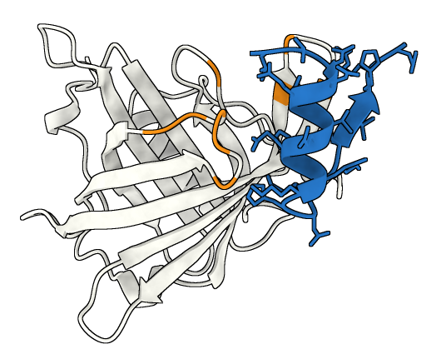
Figure 4. rbp4lin_r10_l21 (blue, sticks) on the RBP4 portal. Targeted hotspot residues in orange.

5.4 rbp4cyc_r08_l14 · macrocycle, 14 aa
TFHRPGQTMVLDGL
ipTM (5 seeds) | Jaccard (5 seeds) | Worst seed | Hotspots contacted
0.875 ± 0.036 | 0.72 ± 0.04 | 0.67 | 2.0
The macrocycle recommendation, and the most confident design overall at ipTM 0.875. At 14 aa it is the shortest candidate, but it contacts only ~2 of the nine hotspots — it grips a smaller piece of the portal than the linears, which reach 5–6.
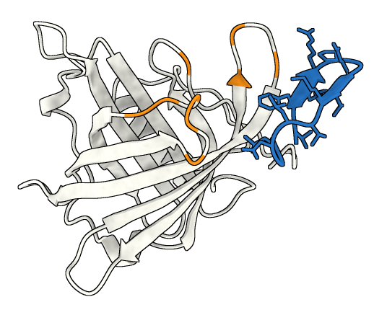
Figure 5. rbp4cyc_r08_l14 (blue, sticks) on the RBP4 portal. Targeted hotspot residues in orange.

6. What this does and does not establish
Agreement is not truth. Jaccard compares Protenix against BC2's claim, not against reality. Both models share training data and can be wrong together.
The gate thresholds are a judgement call. They are not a community standard. Two designs sat within 0.01 of a boundary.
Macrocycle synthesis is unconfirmed. The head-to-tail cyclisation route should be verified with the synthesis provider before any cyclic design is ordered; it may constrain sequence or length.
No dynamics. All predictions are static. An MD triage (50 ns per candidate, then 200 ns on survivors) is available and not yet run.
Licence. The Protenix-v2 weights used here came from an unofficial mirror of a gated checkpoint. This should be resolved before publication.

7. Reproducing this
All code, campaign definitions and the full session-by-session record are in the repository; prediction outputs (80 MB) are regenerated rather than stored.
bindcraft design campaigns/rbp4_peptide.json — run a campaign
./run_protenix.sh — first-pass validation (seed 101)
./run_protenix_seeds.sh — add seeds 202/303/404/505
python3 analysis/protenix/analyse.py — rebuild agreement.csv
chimerax --offscreen --script docs/figures/render.cxc — regenerate every figure
Per-design, per-seed numbers are in analysis/protenix/agreement_per_seed.csv; the aggregated table is agreement.csv. LOGBOOK.md carries the full narrative including negative results.

