**Name: Alok Sajwan**

**Roll no: PV-D1922004**

**Subject: Data Mining**

**Course: BSC(IT)**

**Ques 1. Write a program to find the mean, mode and median of the given range of numbers.**

**Code:**

num= [1,2,3,4,5,6,7,8,9,10,5]

print("mean is ", sum(num)/len(num))

print("median is ", sorted(num)[len(num)//2])

print("mode is", max(set(num), key=num.count))

**Output:**

**Ques 2. Write a program to calculate the standard deviation of a given set of numbers.**

**Code:**

num_set= [11,12,13,14,15,16,17,18,19,20,15]

def standard_deviation(num_set):

  mean = sum(num_set)/len(num_set)

  sum_of_squares = 0

  for i in num_set:

    sum_of_squares += (i - mean)**2

  return (sum_of_squares/len(num_set))**0.5

print( "standard deviation is ", standard_deviation(num_set))

**Output:**

**Ques 3. Write a Python to get a string made of the first 2 and the last 2 chars from a given string.**

**Code:**

def string_both_ends(str):

  if len(str) < 2:

    return ''

  return str[0:2] + str[-2:]

print(string_both_ends('harshit'))

print(string_both_ends('ha'))

print(string_both_ends('h'))

**Output:**

**Ques 4: Write a python program to get a string from a given string where all occurrences of its first char have been changed to ‘$’. #hint s1.replace(char,$)**

**Code:**

def change_char(str1):

  char = str1[0]

  str1 = str1.replace(char, '$')

  str1 = char + str1[1:]

  return str1

print(change_char('harshit'))

**Output:**

**Ques 5. Write a Python program to get a single string from two given strings, separated by a space and swap the first two characters of each string.**

**Code:**

str1="Sakshi"

str2="Bai"

print(str2[:2]+str1[2:]+" "+str1[:2]+str2[2:])

**Output:**

**Ques 6. Write a python function that takes a list of words and tell the length of the longest one.**

**Code:**

def find_longest_word(words_list):

    word_len = []

    for n in words_list:

        word_len.append((len(n), n))

    word_len.sort()

    return word_len[-1][0], word_len[-1][1]

result = find_longest_word(["Harshit", "Ronnie", "Rishab"])

print("\nLongest word: ",result[1])

print("Length of the longest word: ",result[0])

**Output:**

**Ques 7. Write a python program to remove the 4th index character from a nonempty string.**

**Code:**

def remove_char(str, n):

      first_part = str[:n]

      last_part = str[n+1:]

      return first_part + last_part

print(remove_char('Dehradun', 4))

**Output:**

**Ques 8.** **Write a python program to change a given string to a new string where the first and last chars have been exchanged.**

**Code:**

def change_sring(str1):

      return str1[-1:] + str1[1:-1] + str1[:1]

print(change_sring('Dehradun'))

**Output:**

**Ques 9.** **Write a python program to remove the characters which have odd index values of a given string.**

**Code:**

def odd_values_string(str):

  result = ""

  for i in range(len(str)):

    if i % 2 == 0:

      result = result + str[i]

  return result

print(odd_values_string('abcdef'))

print(odd_values_string('python'))

**Output:**

**Ques 10.** **Download iris dataset. Get Top 5 and bottom 5 rows. Drop Id and Species column from the Dataset. Drop Any two rows of your choice.**

**Ques 11. Write a Python program to sum all the items in a list.**

**Code:**

**Output:**

**Ques 12. Write a Python program to multiplies all the items in a list.**

**Code:**

**Output:**

**Ques 13. Write a Python program to get the largest number from a list.**

**Code:**

**Output:**

**Ques 14. Write a Python program to get the smallest number from a list.**

**Output:**

**Ques 15. Write a Python program to check a list is empty or not.**

**Code:**

**Output:**

**Ques 16. Write a Python program to find the list of words that are longer than n from a given list of words.**

**Code:**

**Output:**

**Ques 17. Write a Python program to print a specified list after removing the 0th, 4th and 5th elements using all the three methods of deletion. ['orange', 'kiwi', 'banana', 'apple', 'grapes', ’guava’, ’strawberry’]**

**Code:**

**Output:**

**Ques 18. Write a Python program to shuffle and print a specified list.**

**Code:**

**Output:**

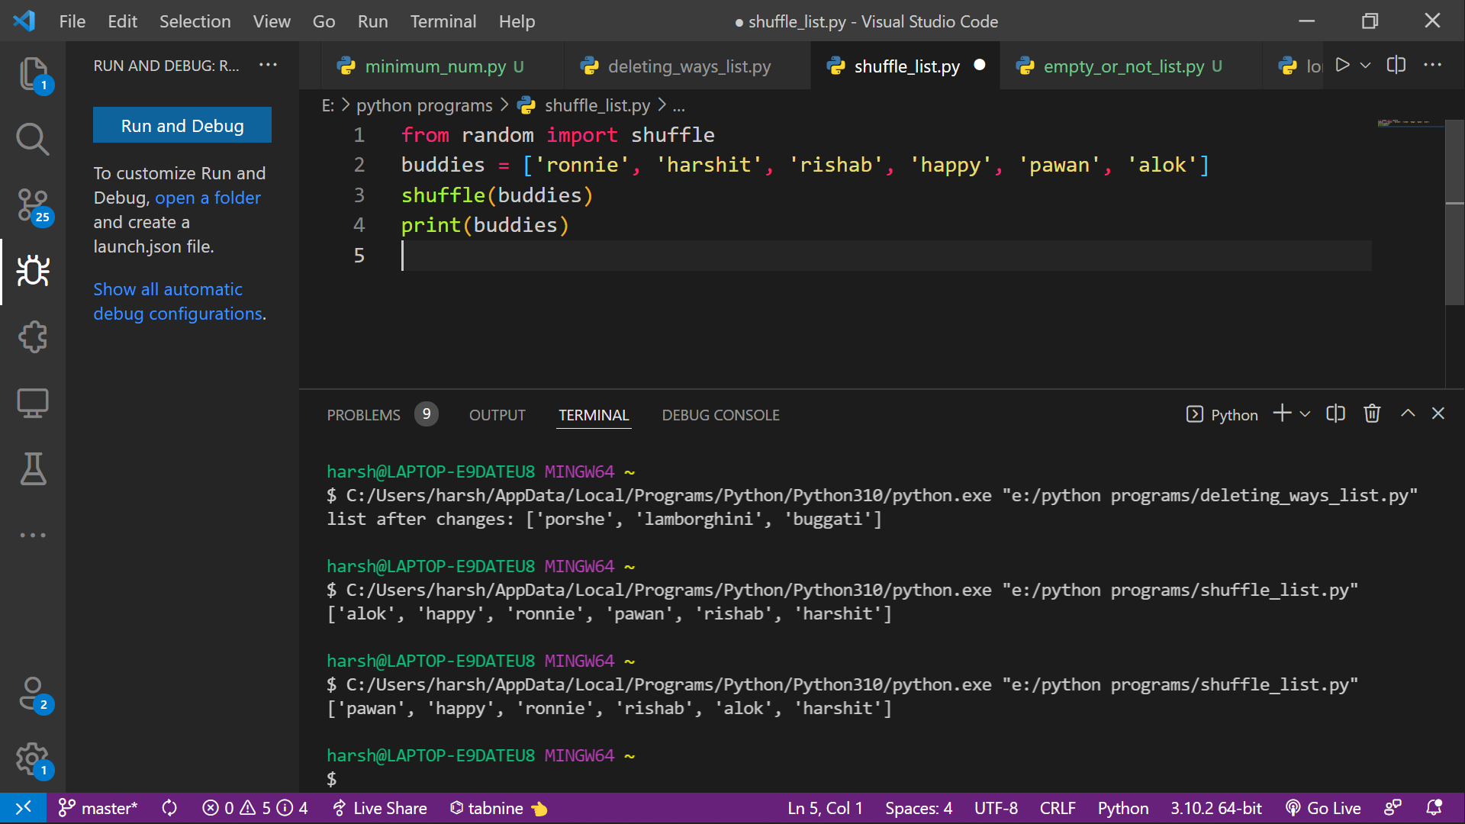

**Ques 19. Write a Python program to generate and print a list except for the first 5 elements, where the values are square of numbers between 1 and 20 (both included).**

**Code:**

**Output:**

**Ques 20. Write a Python program to convert a list of characters into a string.**

**Code:**

**Output:**

