**MOBILE WATCH**

**TABLE OF CONTENTS**

|  |  |  |
| --- | --- | --- |
| **Sl.No** | **Contents** | **Page No** |
| 1 | Abstract | 3 |
| 2 | Introduction | 3 |
| 3 | Technical Documentation | 4 |
| 4 | Software Architecture | 4 |
| 5 | UML Diagrams | 5 |
|  | a) Use case diagram | 5 |
|  | b) Class diagram | 6 |
|  | c) Sequence diagram | 6 |
| 6 | Screenshots | 7 |
| 7 | Results | 15 |

**1. Abstract or Project Description**

**Goal:** This app helps to handle emergency situations very quickly. The main concern is about informing or finding information at hard times to get help and handle the situation ideally. With the press of a button in your phone you can call, message, search and nearby resources you have.

Services provided by the proposed system

1) Calling: Call to the default numbers in emergency situations.

2) Message: A text message including the current location will be sent to the default numbers indicating that you are in danger.

3) Nearby locations: We can search all nearby Hospitals, Fire stations, Police stations and pharmacy.

4) Reporting: We can take a snapshot of the flaw, locate a particular location on google maps and report it to corresponding officials or departments. This can be used in a

society or a university to report various issues.

**2. Introduction**

**CALLING MODULE**

It is used to call the following persons with a click of a button during an emergency situation.

* Friend
* Police
* Ambulance
* Fire station
* Anti-poison
* Gas leak
* Report abuse

**SMS Module**

It is used to SMS the following persons with a click of a button during an emergency situation along with the location so that the person can be traced easily.

• Friend

• Ambulance

• Police

• Fire station

**MAPS Module**

It is used to view all the nearby emergency service locations during panic situations on google maps.

And also it can be used to know all the emergency service locations in the world.

 Police stations

 Hospitals

 Fire stations

 Pharmacy

**REPORT ISSUE MODULE**

This application is used to report to the following concerned departments regarding the issues faced by a person in his daily life through e-mail.

 Roads

 Electricity

 Water

 Sanitation

**3. Technical Documentation**

**Programming languages:** Java, XML

**Reused algorithms:** Google play services

**Tools & Environments:** Eclipse IDE, Java SDK, Android SDK

**Text files:** manifest.xml, .java, .xml

**End product:** Android application (apk)

**Methodology:** Agile model

**4. SOFTWARE ARCHITECTURE**

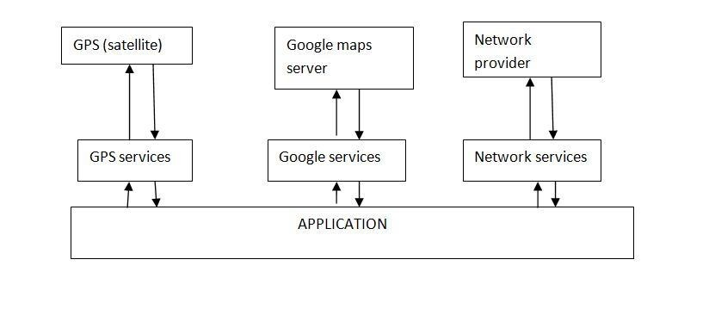

###### 5. UML DIAGRAMS DIAGRAMS

**5A. USE CASE DIAGRAM**

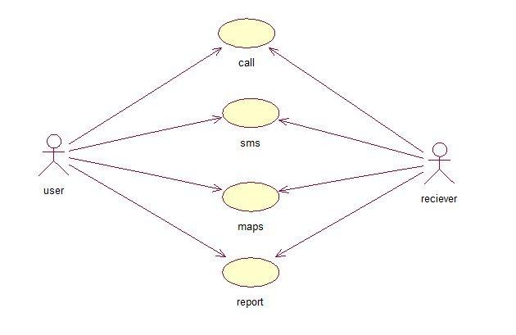

**5B. CLASS DIAGRAM**

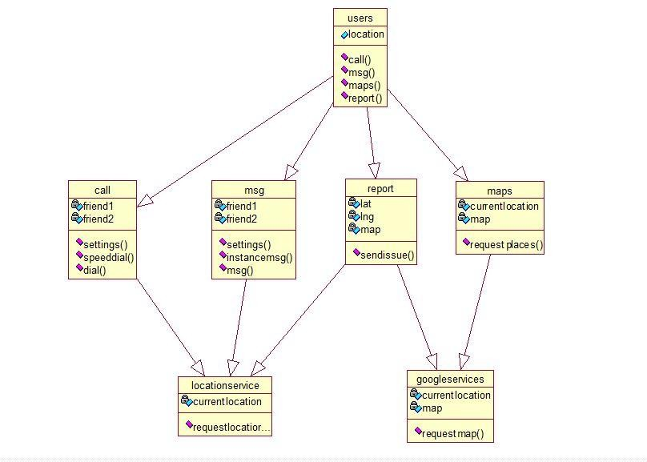

**5C. SEQUENCE DIAGRAM**

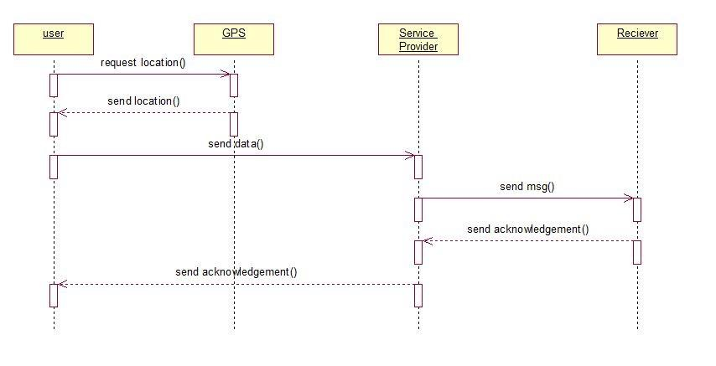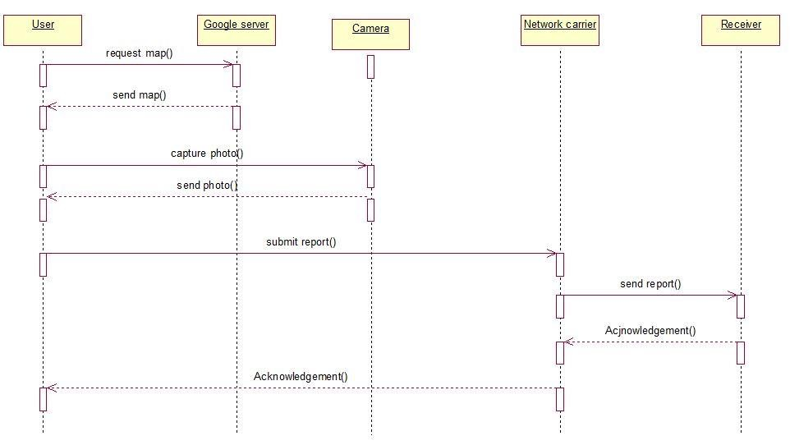

**6. SCREENSHOTS**

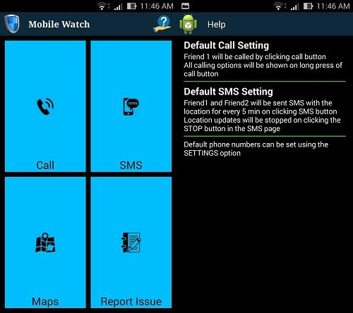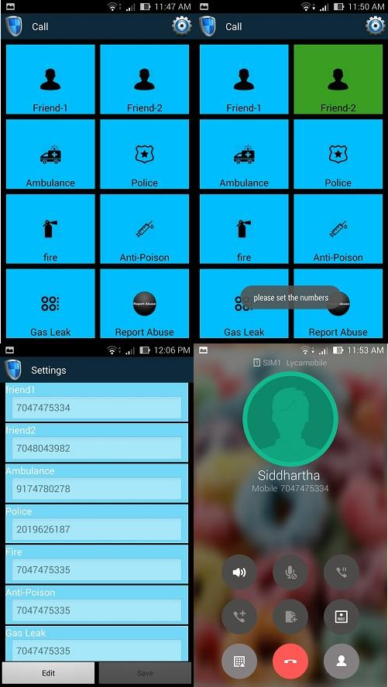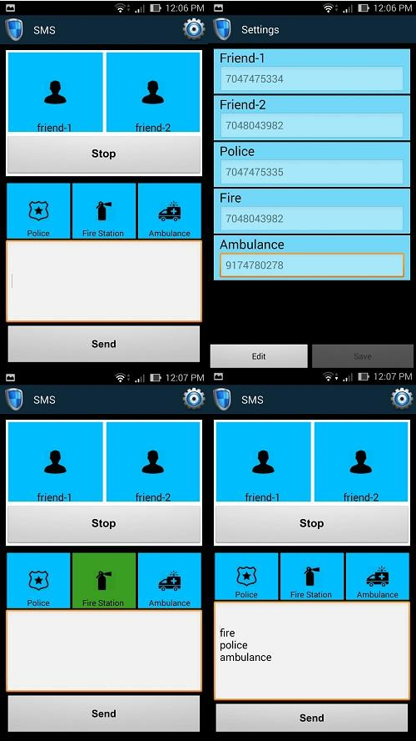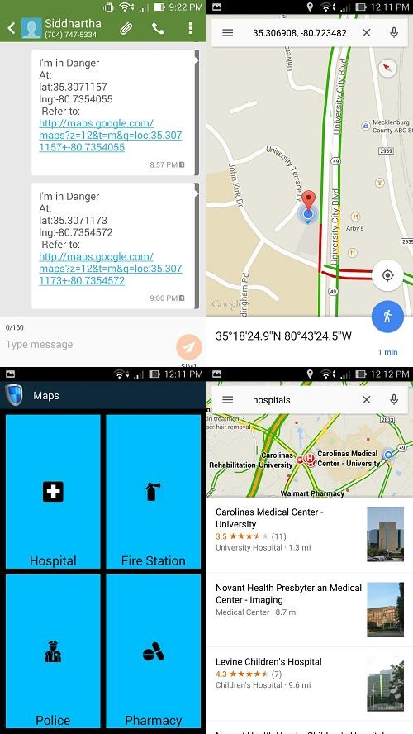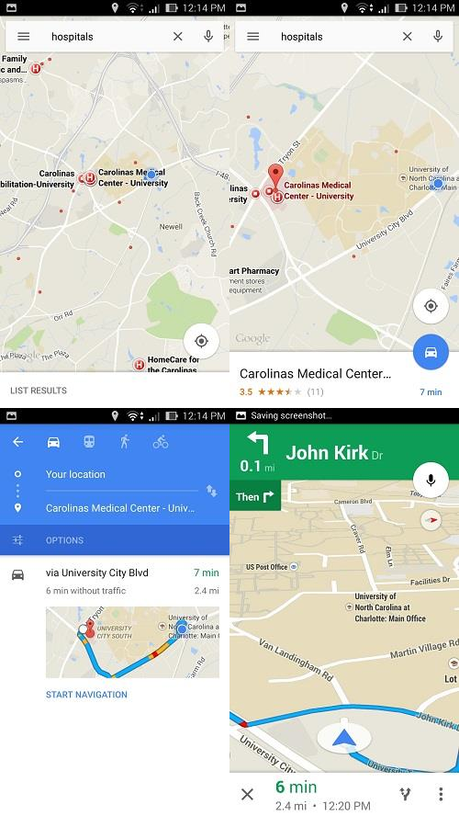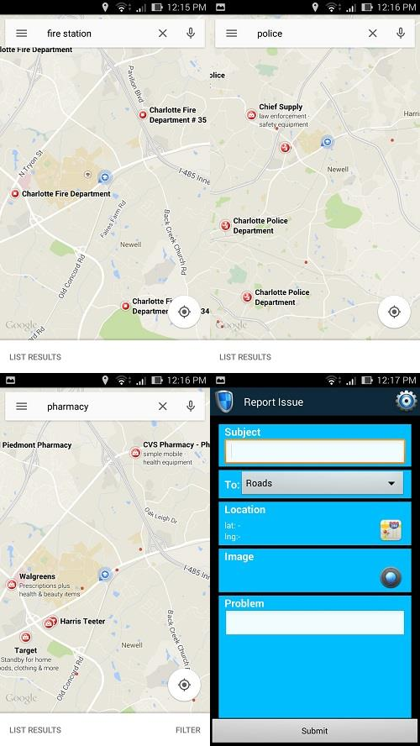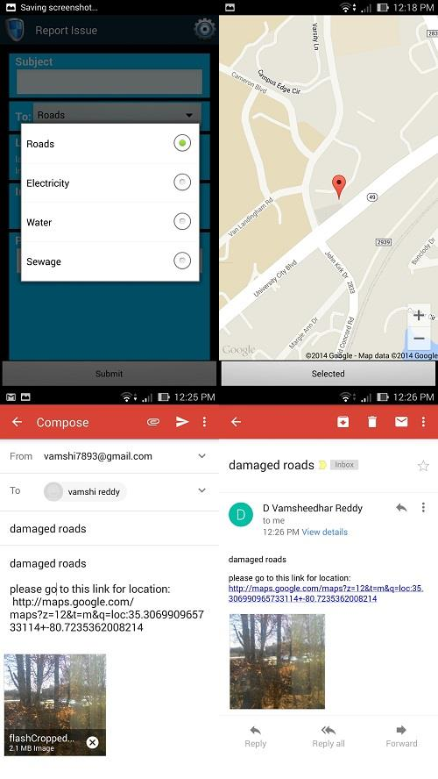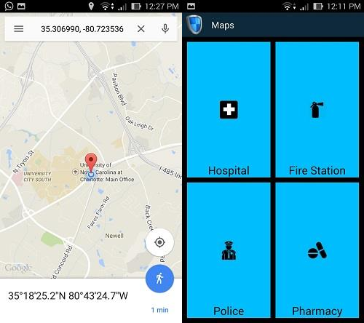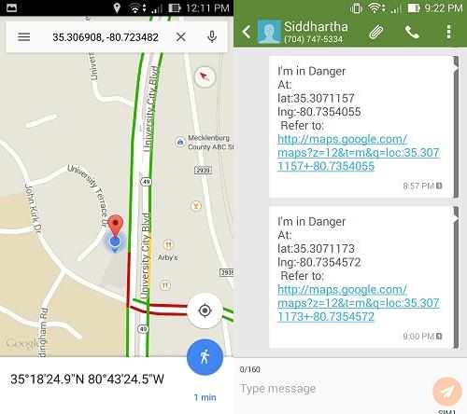

**7. Results**

 A light weighted application which makes use of the inbuilt applications present in any android device.

 Inbuilt applications such as Google maps, camera, GPS

 Basic services such as calling, SMS, E-mail are used

 Easy built user interface which allows a person to do the right thing at the wrong time

 Predefined values are provided to avoid searching and remembering the contact details during panic situations

 Maps allows a person to not only locate nearby locations but also any location on the google maps

 Report issue allows a person to choose the location irrespective of the location he is present in by selecting the co-ordinates on the google map

 Time saving application to report issues