Sporadic Phone Data Transfer

Open Soft

Inter IIT Tech Meet 2015

### Index

Overview 3

System Requirements 4

Architecture 5

Future Prospect 6

REPORT

Overview

Client End :

The interface has a search bar and a clickable search button at the top followed by a empty area where the search result is to be displayed . The search results can have either a red background (indicating that the file is present on the server but not on the device) or a green color (indicating that the file is present on the device) .The search algorithm uses editDistance function which is java inbuilt to match the query string with the name of the file available .

If a file present on the local server is clicked after displaying in the empty area two things happen , on the top the file gets opened with the default application for that file and and the number of hits get incremented for the file that gets opened .

If a file present on the server is clicked then a dialog box pops up asking for the priority of the file with which the file will get downloaded as the net connection gets restored .

The database is stored in database.json file . The number of hits are stored in hits.js file as a Hashmap.

Server End :  
 Server handles two kind of request i.e file download request and request to update list of files. To get updated list from database, server makes call to PHP code which in turns build and send updated list to server and then server send it back to client. For download request client passes the the file id to server then server gets the file location by calling the PHP module which takes the file id as parameter. After getting the file location server passes the file to client by converting it into byte stream.

In the backend we have developed a python script for saving the metadata about the files currently present in the system to the a MySQL Database. This python script is a very flexible script which can be attached to any kind of updates to the server. Every Time there is a change in files of the system you just need to run this script once and all the changes will be parsed and saved to the database in the form of incremental updates to the database which saves them in the log table and pushes them as when the client gets connected. There is PHP based Web API which interfaces between the JAVA-based file bundling system and the metadata saved in the MySQL server.

System Requirements

Server :

* Aptitude Packages  
   python-pip  
   python-dev  
   libmysqlclient-dev  
   ffmpeg  
   python-pyexiv2
* Python Modules  
   MySQL-python  
   sphinx  
   pymdeco  
   pyth
* Xampp Server
* JDK 7.0 +

Client :

JDK 7.0 +

OS: ubuntu10.4+

Architecture

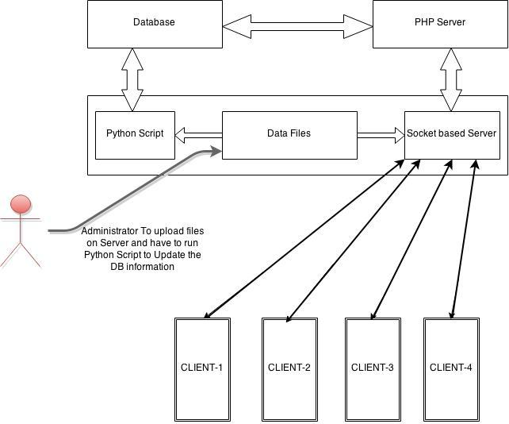

Future Prospect

* We can further add the option of searching the file(s) on the nearby active bluetooth devices
* We can add search with respect to category, tags and also enhance searching module by handling misspelling, autocomplete etc.
* We can resume the transfer of the intermediate file(s) that weren’t fully downloaded when the internet connection was lost