AQI Intelligence Dashboard & Predictor
Project Report — BharatCares / Data Decoded AI & ML Masterclass

1. Problem Statement
Air pollution is a major public health and environmental concern across Indian cities. This project analyzes historical air quality data to identify pollution trends, the key pollutants driving poor air quality, and the cities/seasons at greatest risk — and builds a machine learning model that predicts the Air Quality Index (AQI) from pollutant readings, so that stakeholders can anticipate hazardous conditions and act proactively.

2. Dataset
Air Quality Data in India (2015–2020) — Rohan Rao, Kaggle.
Link: https://www.kaggle.com/datasets/rohanrao/air-quality-data-in-india
File used: city_day.csv — daily pollutant readings and AQI across 26 Indian cities, 1 Jan 2015 to 1 Jul 2020 (29,531 rows).
Column | Description
City | Name of the monitoring city
Date | Date of the reading
PM2.5, PM10 | Particulate matter concentrations
NO2, SO2, CO, O3 | Gas pollutant concentrations
AQI | Computed Air Quality Index (target for regression)
AQI_Bucket | AQI category — Good/Satisfactory/Moderate/Poor/Very Poor/Severe (target for classification)

3. Business Intelligence Framework
This project follows the KPI → Trend → Driver → Risk → Action framework used throughout the masterclass series:
- KPIs: Average AQI, % of hazardous (Poor/Very Poor/Severe) days, best/worst performing cities
- Trends: AQI trajectory over time and seasonal (monthly) patterns
- Drivers: Correlation of each pollutant with AQI, to identify the strongest contributor
- Risks: Cities with the highest frequency of hazardous-AQI days
- Actions: Targeted recommendations based on the top driver pollutant and highest-risk cities

4. Methodology

4.1 Data Cleaning
- Parsed and standardized the Date column
- Removed rows with no AQI value — 4,681 of 29,531 rows (15.9%), leaving 24,850 city-days
- Filled missing pollutant readings using each city's own median (city-specific, since pollution levels vary widely by location). 8,840 rows (35.6%) needed at least one pollutant filled; PM10 was the most incomplete (37.7% missing in the raw file)
- Checked for exact duplicate records — none were found in this file

4.2 Exploratory Data Analysis
- City-wise and time-based AQI comparisons
- Correlation analysis between pollutants and AQI
- Seasonal/monthly pattern analysis

4.3 Modeling
- Regression: Random Forest Regressor (200 trees) predicting the exact AQI value from the six pollutant readings
- Classification: Random Forest Classifier (200 trees, stratified split) predicting the AQI_Bucket category
- Train/test split: 80/20 (19,880 training rows, 4,970 test rows), random_state = 42, evaluated on held-out data

5. Tech Stack
Layer | Tool
Language | Python
Data handling | pandas, numpy
Modeling | scikit-learn (RandomForestRegressor, RandomForestClassifier)
Frontend / Dashboard | Streamlit
Visualization | Plotly

6. Results
Model performance on held-out test data (the same figures the app shows in its Predict AQI tab; they may differ slightly with other library versions):
Model | Metric | Score
Regression (exact AQI) | R² | 0.905
 | MAE | 21.93 AQI points
Classification (AQI category) | Accuracy | 0.806
 | F1 (macro) | 0.782

The regression model explains about 90% of the variance in AQI, with a typical error of 22 points on a scale where categories are 50–100 points wide. The classifier gets the exact category right 80.6% of the time, and 99.4% of its predictions fall within one category of the true value — its errors are almost entirely between neighbouring bands. Per-category F1 is strongest for Severe (0.85), Satisfactory (0.83) and Moderate (0.83), and weakest for Good (0.69) and Poor (0.70). Section 9 discusses how far these scores can be trusted.
Note: the figures below were generated from the cleaned dataset using the same logic as each dashboard tab (all 26 cities, 2015–2020). The live app opens with the first five cities pre-selected, so its default numbers differ. Replace with live screenshots if your submission requires them.

6.1 Executive Overview
Average AQI | % Poor-or-worse days | Worst-average city | Best-average city
166.5 | 26.0% (6,456 of 24,850) | Ahmedabad (452.1) | Aizawl (34.8)

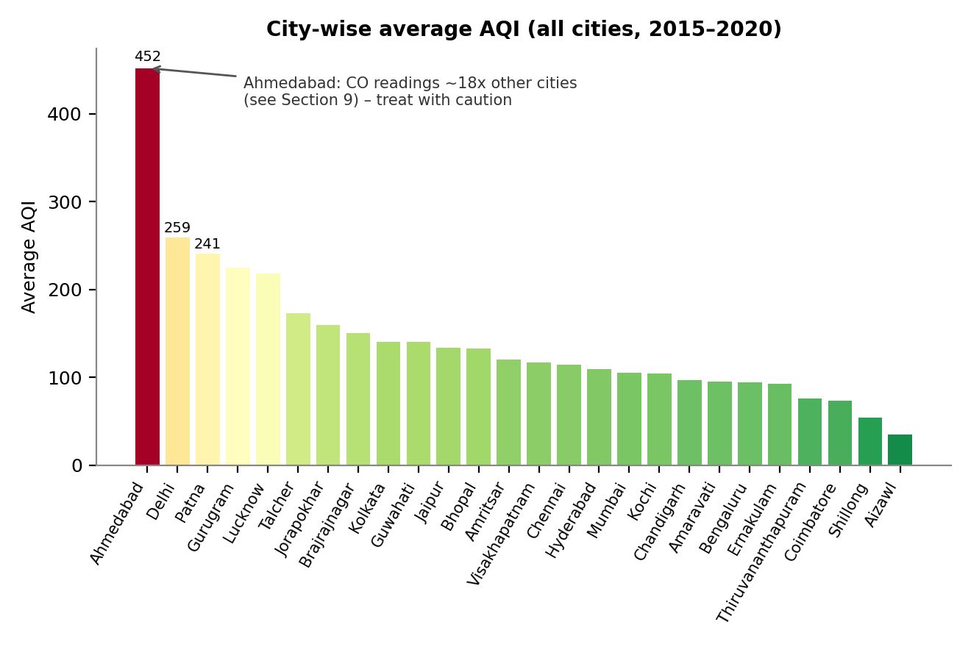
Figure 1. Executive Overview – city-wise average AQI.
Delhi (259.5), Patna (240.8), Gurugram (225.1) and Lucknow (218.0) follow Ahmedabad; the cleanest cities are Aizawl (34.8), Shillong (53.8) and Coimbatore (73.0). Ahmedabad's figure comes from unusual CO readings and should be read with caution (see Section 9).

6.2 Trends
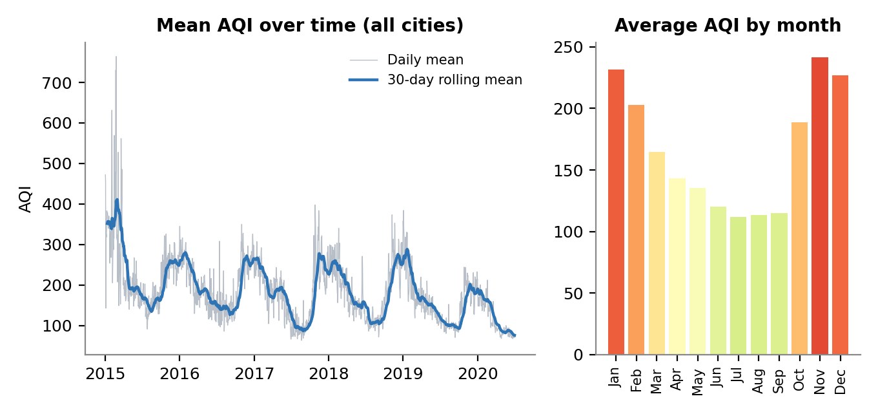
Figure 2. Trends – AQI over time and seasonal pattern.
AQI follows a strong annual cycle: November (241.7), January (231.7) and December (227.1) are the worst months, while July (111.9) is the best. Yearly average AQI across all cities fell from 212.5 in 2015 to 156.5 in 2019, and to 113.5 in the partial 2020 data (January–July, which includes the COVID-19 lockdown). Because the set of reporting cities grows over the period, this decline should not be read as a like-for-like improvement.

6.3 Drivers
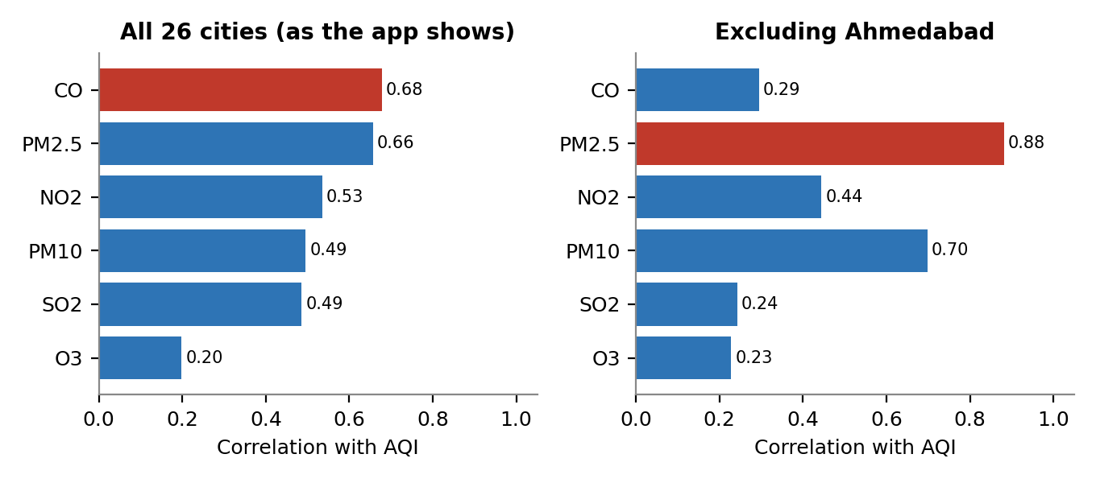
Figure 3. Drivers – correlation of each pollutant with AQI.
Across all cities the app reports CO as the strongest correlate of AQI (0.68), just ahead of PM2.5 (0.66). That ranking is produced almost entirely by Ahmedabad's CO readings: with that city removed, PM2.5 leads clearly (0.88), followed by PM10 (0.70) and NO2 (0.44). The Random Forest tells the same story, with PM2.5 (0.50) and CO (0.40) carrying 90% of the total feature importance.

6.4 Risk & Action
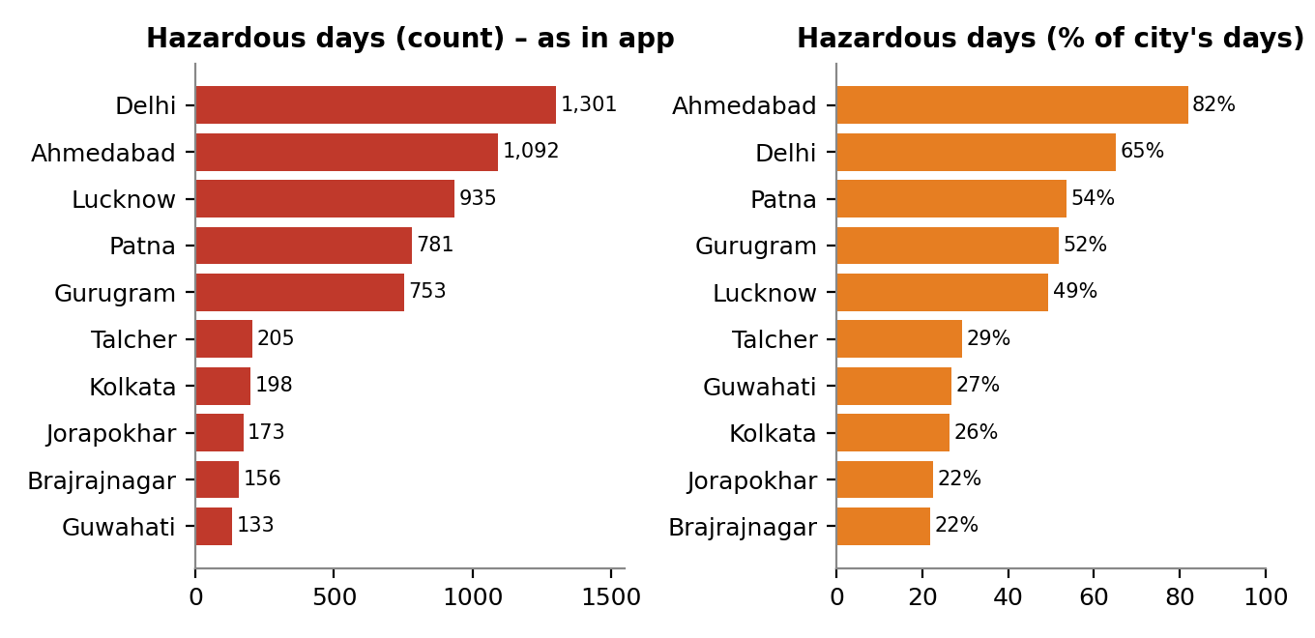
Figure 4. Risk – cities with the most hazardous (Poor/Very Poor/Severe) days.
Delhi has the most hazardous days in absolute terms (1,301), followed by Ahmedabad (1,092), Lucknow (935), Patna (781) and Gurugram (753). Together these five cities account for 4,862 of the 6,456 hazardous days (75.3%). Measured as a share of each city's own records, Ahmedabad (82%), Delhi (65%), Patna (54%), Gurugram (52%) and Lucknow (49%) lead.

6.5 Prediction
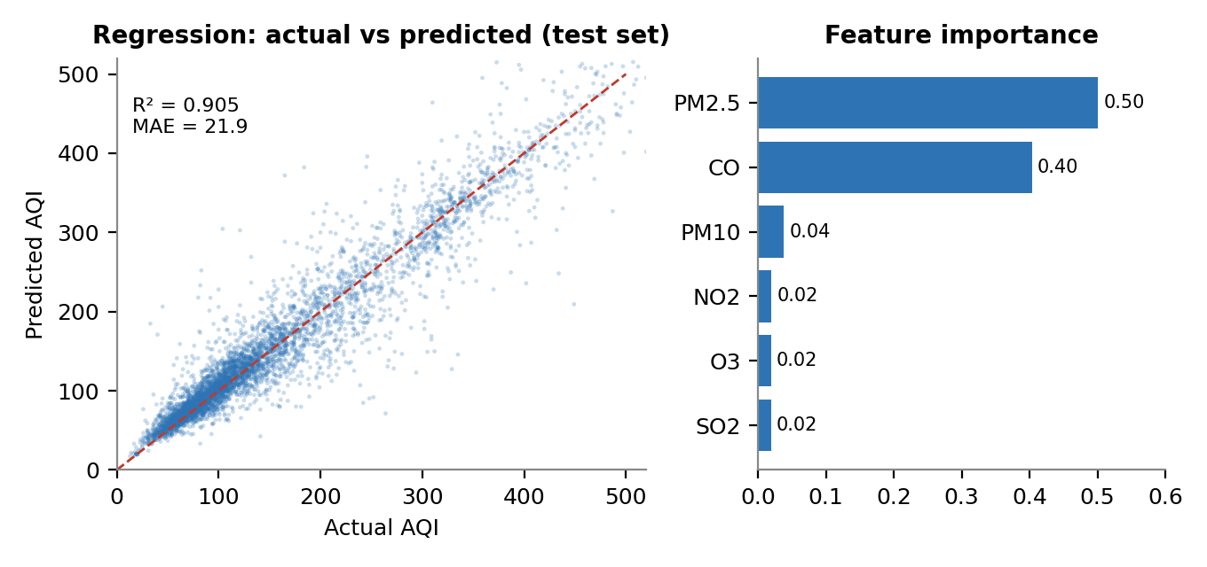
Figure 5. Predict AQI – model fit on the held-out test set and feature importance.
With the app's default inputs (dataset medians: PM2.5 49.2, PM10 100.1, NO2 21.8, SO2 9.3, CO 0.92, O3 31.2), the Predict button returns an AQI of 115.5 and the category Moderate, which is consistent with the dataset's typical day.

7. Key Insights
- Hazardous air is concentrated. 26.0% of all recorded city-days are Poor or worse, but five cities — Delhi, Ahmedabad, Lucknow, Patna and Gurugram — account for 75.3% of those days.
- Winter is the danger season. 65.5% of all hazardous days fall between October and February. In Delhi, 97.1% of days in November–January are Poor or worse, against 18.2% in July–August; its monthly average peaks at 402 in November.
- PM2.5 is the pollutant to target. Excluding the anomalous Ahmedabad readings, PM2.5 correlates 0.88 with AQI and is the single largest contributor in the model (0.50 importance). CO ranks first in the app only because of Ahmedabad.
- Ahmedabad's data needs validation. Its median CO is 16.3 against 0.89 in every other city combined, and it holds 47.7% of all records with AQI ≥ 401. Its top ranking may reflect a measurement or unit issue rather than the true air quality.
- Air quality is improving on paper, but with caveats. Average AQI fell from 212.5 (2015) to 156.5 (2019); 2020's 113.5 covers only seven months and coincides with the lockdown.
- AQI can be estimated accurately from pollutant readings. R² of 0.905 and MAE of 21.9, with the category correct 80.6% of the time (99.4% within one category).

8. Recommended Actions
- Focus emission control on PM2.5 first. Prioritise sources that generate fine particulates — vehicular and industrial emissions, construction dust and biomass/crop burning — since PM2.5 is the dominant driver once data issues are set aside.
- Prioritise Delhi, Lucknow, Patna and Gurugram for monitoring and public-health advisories, with Ahmedabad added once its readings are verified. These cities generate most of the hazardous days.
- Issue seasonal advisories from October to February, starting before the November peak, with school, outdoor-activity and vehicle-restriction guidance triggered by the predicted category.
- Audit data quality at the source. Confirm CO units and sensor calibration for Ahmedabad and add automated outlier checks (for example, flagging AQI above 500) before results are published.
- Use the predictor as a triage tool, not yet as a forecast. It estimates AQI from same-day readings; forecasting tomorrow's conditions needs lagged and weather features and city-level validation (Section 9).
- Learn from the cleanest cities. Aizawl, Shillong and Coimbatore consistently record low AQI; their practices and geography are worth studying for transferable measures.

9. Project Review
Overall assessment. This is a well-organised, runnable project: the KPI → Trend → Driver → Risk → Action framework maps cleanly onto the five dashboard tabs, the pipeline is compact and readable, and the repository includes the data, a requirements file and a README that matches the code. The main weakness is not the code but a few analytical claims that hold up less well than the headline metrics suggest. Most are quick to fix.

9.1 Strengths
- Clear structure: one tab per business question, with sidebar filters (city, year range) that apply throughout.
- Sound preprocessing choices: city-level median imputation, rows without a target dropped, and cached data loading and model training so the app stays responsive.
- Two complementary models with fixed random seeds, a stratified split for the classifier, and metrics displayed live in the app.
- Results agree with domain knowledge: winter peaks, monsoon relief, and Indo-Gangetic Plain cities (Delhi, Patna, Lucknow) at the top of the risk ranking.
- Easy to reproduce: two-command setup, dataset and dependency list included in the repository.

9.2 Issues Found
Each item was checked by re-running the app's pipeline on the included city_day.csv. Robustness checks used 100 trees for speed.
Finding | Evidence | Suggested fix
High — Ahmedabad data anomaly | Median CO is 16.3 in Ahmedabad vs 0.89 elsewhere; AQI reaches 2,049 although the Severe band is defined as 401–500; the city holds 47.7% of all AQI ≥ 401 records. It skews the worst-city ranking (452 vs Delhi 259), makes CO the top driver (0.68, vs PM2.5 at 0.88 without it), and the model fails on it (R² −0.32 when the city is held out). The cause cannot be confirmed from the data alone. | Verify CO units at the source; cap or exclude flagged rows; add an outlier check and show a data-quality warning in the app.
High — Prediction is mostly formula recovery | AQI is computed from pollutant concentrations, and AQI_Bucket matches fixed thresholds on AQI in 100% of rows, so an R² of 0.905 largely shows the model re-learning that calculation. The GitHub repository description promises "real-time" monitoring and "future trend prediction"; the app reads a static CSV and does no forecasting. | Reword the repository description, or add lagged/rolling features to predict next-day AQI. Optionally derive the category from the regression output using the standard thresholds.
Medium — Optimistic evaluation | A random row split puts neighbouring days from the same city in both train and test sets. A chronological split gives a similar R² (0.899), but on entirely unseen cities scores drop: Delhi 0.80, Mumbai 0.80, Ahmedabad −0.32. A 5-fold check on unshuffled data ranged from R² 0.34 to 0.91. | Report a time-based and a leave-city-out score alongside the random split; consider adding city and month as features.
Medium — Risk ranked by counts | Cities have very different record lengths (Delhi 1,999 days, Kochi 158), so raw counts favour long records. As a share of days, Ahmedabad (82%) tops Delhi (65%). | Show hazardous-day percentage next to the count.
Medium — Trend not like-for-like | Rows per year grow from 1,827 (2015) to 7,071 (2019), and 2020 covers January–July only. On the seven cities present in all six years the mean is 212, 201, 185, 232, 207, 140 — not a steady decline. | Plot a constant-city panel or per-city lines; annotate the 2020 lockdown period.
Medium — Imputation effects | 35.6% of rows had at least one pollutant filled with a city-wide median, which removes seasonality in those values and can dampen or distort correlations and model splits. | Fill by city-month median or time interpolation, add an "is_imputed" flag, and report metrics on fully observed rows.
Low — App defaults and small bugs | The city filter defaults to the first five cities alphabetically (Ahmedabad, Aizawl, Amaravati, Amritsar, Bengaluru), so the first view is unrepresentative (average AQI 188; CO the top driver at 0.88). Clearing the city selection resets to all cities and also ignores the year slider. The Drivers note implies causation from correlation. | Default to all cities; apply the year filter in every case; word the driver note as an association.
Low — Engineering polish | Dependencies are unpinned (>=), there are no tests, no saved model, no LICENSE and no screenshots in the README; models retrain on each server start. | Pin versions, add a few data/model tests, save the trained model, and add screenshots and a licence.

9.3 Suggested Next Steps (in priority order)
- Resolve the Ahmedabad CO/AQI anomaly and re-run every chart and metric.
- Reframe the predictor honestly (AQI estimation from readings) or build a real next-day forecast with lagged features and weather data.
- Add time-based and leave-city-out validation to the Predict tab.
- Show hazardous days as a percentage, and use a constant-city panel for trends.
- Change the sidebar defaults, fix the year-filter bug, and add screenshots to the README.

10. Conclusion
The project delivers a working Business Intelligence dashboard and prediction app for Indian air quality. It shows that hazardous air is concentrated in a handful of northern cities, peaks sharply from October to February, and is driven mainly by fine particulates, and it provides a Random Forest model that estimates AQI with an R² of 0.905 and MAE of about 22 points from pollutant readings. Its practical value is as a decision-support tool for prioritising cities, seasons and pollutants. Before its findings are used beyond a course setting, the Ahmedabad data anomaly should be resolved and the predictor validated on unseen cities and future dates, as outlined in Section 9.

11. Links
GitHub Repository:
https://github.com/siddharth9508kumar/IBM-PROJECT-AQI-Intelligence-Dashboard-Predictor
Dataset: https://www.kaggle.com/datasets/rohanrao/air-quality-data-in-india

