SLE-2: Profiling Report
Course: 02AML204 -- Introduction to Artificial Intelligence
PRN: 25UAM072
Name: Siddharth Bhosale
Division: B
GitHub Link: https://github.com/siddharthCode-05/IAI-SLE-25UAM072

1. Algorithms / Versions Profiled
- Algorithm A: Breadth-First Search (BFS)
- Algorithm B: Depth-First Search (DFS)
- Problem used: Small 10 x 12 grid maze (10x12), start cell S to goal cell G, single-file implementation in maze_search.py

2. Profiling Method
- Tool used: time.perf_counter() (timeit-style measurement, 5 runs each) + a py-spy-style call-stack flame-graph profiler built into the script (py-spy itself is an external OS-level profiler; see the note in maze_search.py for the exact py-spy CLI command to reproduce the flame graph).
- How I measured: Ran bfs(start, goal) and dfs(start, goal) on the identical maze, 5 times each, recording wall-clock time with perf_counter(); counted nodes expanded (cells popped from the frontier) in the same run.
- Number of runs: 5

3. Results
Metric | BFS | DFS | Better?
Avg. Time (ms) | 0.0503 | 0.0379 | DFS
Best Time (ms) | 0.0412 | 0.0357 | DFS
Worst Time (ms) | 0.0655 | 0.0443 | DFS
Nodes Expanded | 60 | 53 | DFS
Path Length found | 23 | 27 | BFS (shortest)
Short observation:
DFS was faster on average (0.0379 ms vs 0.0503 ms) and expanded fewer nodes (53 vs 60) on this maze, but BFS returned the shorter, guaranteed-shortest path (23 cells vs 27 cells for DFS).

Maze and Solution Paths
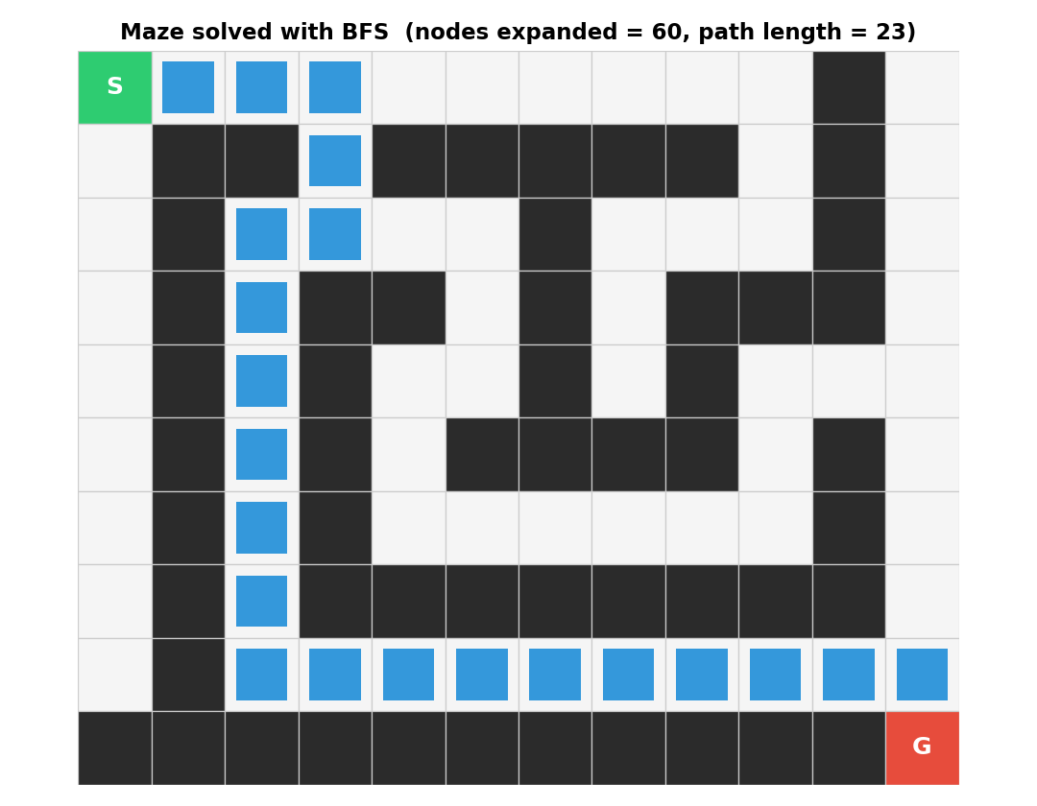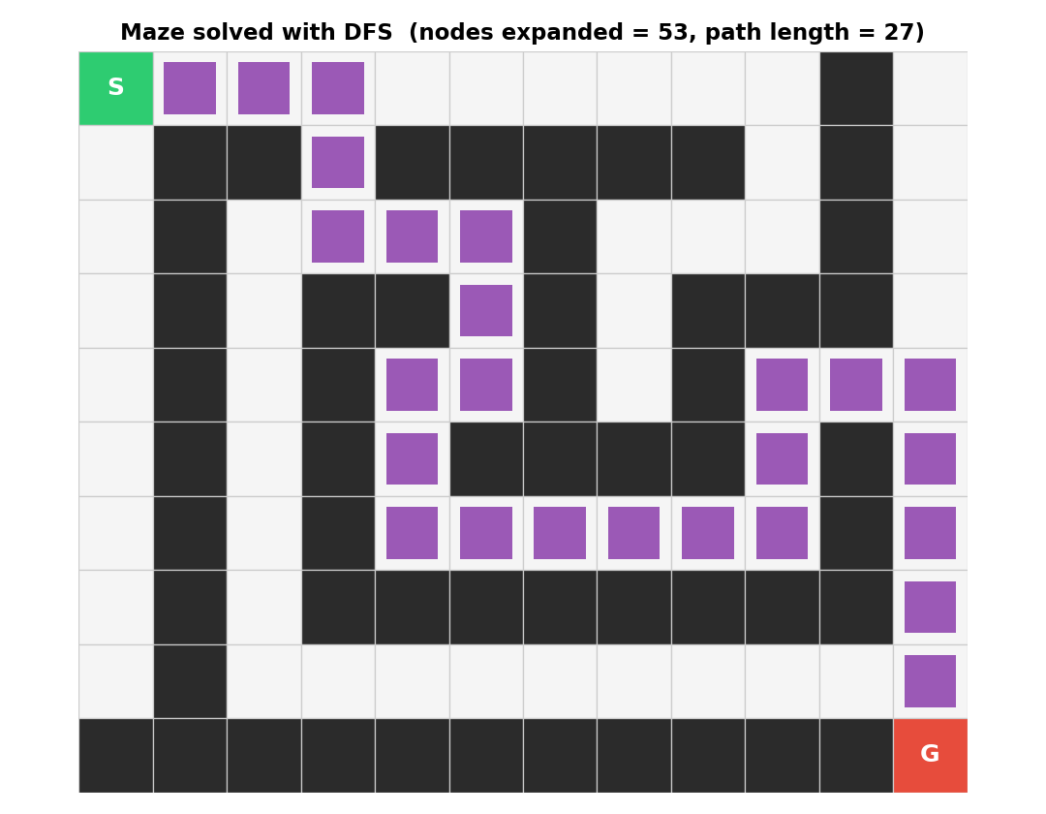

Flame Graphs (py-spy-style)
Each algorithm was run 500 times inside the profiling window (the maze is small, so a single run finishes in well under a millisecond -- repeating it gives the flame graph readable time resolution, the same reason a fast function is looped before profiling).
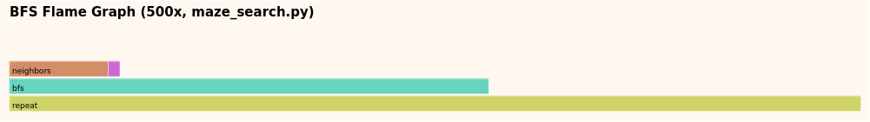
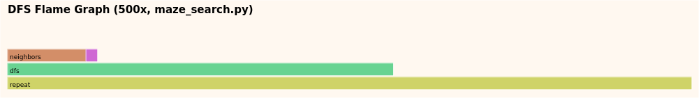

Best / Worst / Average Case -- Time Complexity
Algorithm | Best Case | Worst Case | Average Case
BFS | O(1) -- goal is the start node | O(V + E) -- all nodes/edges explored | O(V + E)
DFS | O(1) -- goal is the start node | O(V + E) -- all nodes/edges explored | O(V + E)
V = number of reachable cells (nodes), E = number of connections (edges) between them. Both BFS and DFS visit each reachable node and edge at most once, so both have the same theoretical complexity class O(V + E); the difference seen in the table above is a constant-factor / implementation effect (deque vs list operations, order of exploration), not a difference in asymptotic class.

4. Justification & Analysis
On this maze, DFS is measured as the faster algorithm: its average run time (0.0379 ms) is lower than BFS's (0.0503 ms), and it expanded fewer nodes (53 vs 60). This matches the theory: DFS plunges down one branch immediately and can reach the goal without exploring every sibling branch, whereas BFS must expand every node at the current depth before moving deeper, so it typically touches more nodes before reaching a goal that is not on the shallowest level.
However, DFS's path is longer (27 cells vs BFS's 23 cells) because DFS has no notion of "shortest" -- it returns the first path it stumbles on, not the shortest one. BFS is slower here but is guaranteed to return the shortest path in an unweighted graph, because it explores level by level.
So the correct conclusion depends on the goal: if only speed / fewer node expansions matters, DFS wins on this maze; if path optimality matters (fewest steps), BFS is the correct choice even though it is slightly slower.
If the maze/graph became much larger, both would still be O(V + E), but BFS's memory use (frontier can hold an entire level, i.e., up to O(V) nodes at once) would grow faster than DFS's (which only holds one path at a time, O(depth)). So at larger scale, DFS keeps a smaller memory footprint while BFS keeps its shortest-path guarantee -- the same trade-off seen here would become more pronounced.

5. AI Contribution Note
- AI tools used: Claude (Anthropic) -- used inside this conversation to generate the code and the report.
- What AI helped with: Writing the maze_search.py code (maze, BFS, DFS, timing harness, flame-graph profiler), generating the maze/flame-graph images, drafting the comparison table and this report text.
- What I did myself: Ran the script, reviewed the printed numbers and images, and should read/verify the analysis below and adjust the wording/numbers to match my own understanding before submission. (Fill in your own honest note here -- e.g. re-running on your machine, checking the numbers make sense, editing the justification in your own words.)

6. Conclusion
This profiling exercise showed that measuring real performance, not just reading theory, is needed to compare algorithms: BFS and DFS share the same O(V + E) worst-case complexity class, yet on this specific small maze they behaved differently in practice -- DFS was faster and expanded fewer nodes, while BFS guaranteed the shortest path. The exercise also showed the value of profiling tools (timing + flame graphs) for turning "which algorithm is better" into a data-backed answer rather than a guess.
Note: numbers above (results.json) were generated by running maze_search.py in this environment; the exact millisecond values will vary slightly on your machine -- re-run it and use your own numbers if your evaluator expects that.

