SLE-3: Architectural Design (Full C4 Model)
Course: 02AML204 – Introduction to Artificial Intelligence
PRN: | 25UAM072 | Name: | Siddharth
Division: | A / B (circle yours) | Date: | 04 October 2026
GitHub link (SLE-2 code): https://github.com/siddharthCode-05/IAI-SLE-2-profiling
1. System Title & Short Description
Maze Solver System – BFS vs DFS (continued from SLE-2, file maze_search.py).
This is a small Python program that solves a 10 × 12 grid maze ('#' = wall, 'S' = start, 'G' = goal). It finds a path from S to G using Breadth-First Search (BFS) and Depth-First Search (DFS), counts how many cells each algorithm expands, and measures run time (best / worst / average) with a timer and a flame-graph profiler. It solves the problem of finding a route through a maze and comparing two uninformed search strategies. As an agent, its percept is the current cell and its walkable neighbours; its actions are the four moves up, down, left and right.
2. Context Diagram (Level 1)
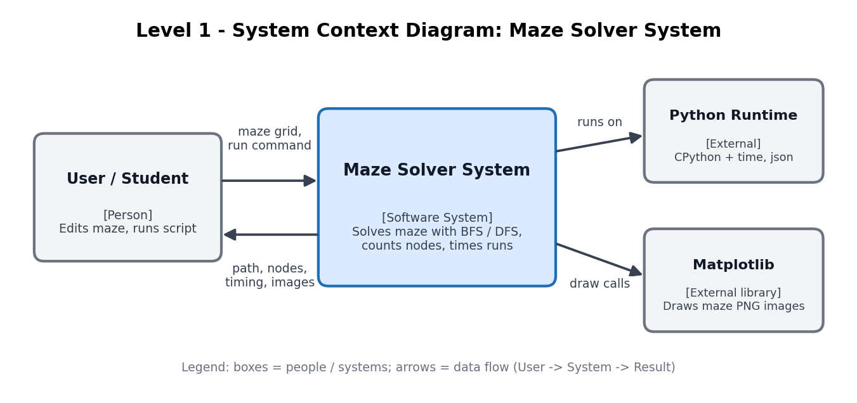
The User (student) edits the maze grid in the code and runs the program. The Maze Solver System returns the solved path, the number of nodes expanded, the timing table and picture files. It depends on only two outside things: the Python runtime (with its time and json modules) and the Matplotlib library, which draws the maze images. No network, database or other external service is used, so the context stays simple.
3. Container Diagram (Level 2)
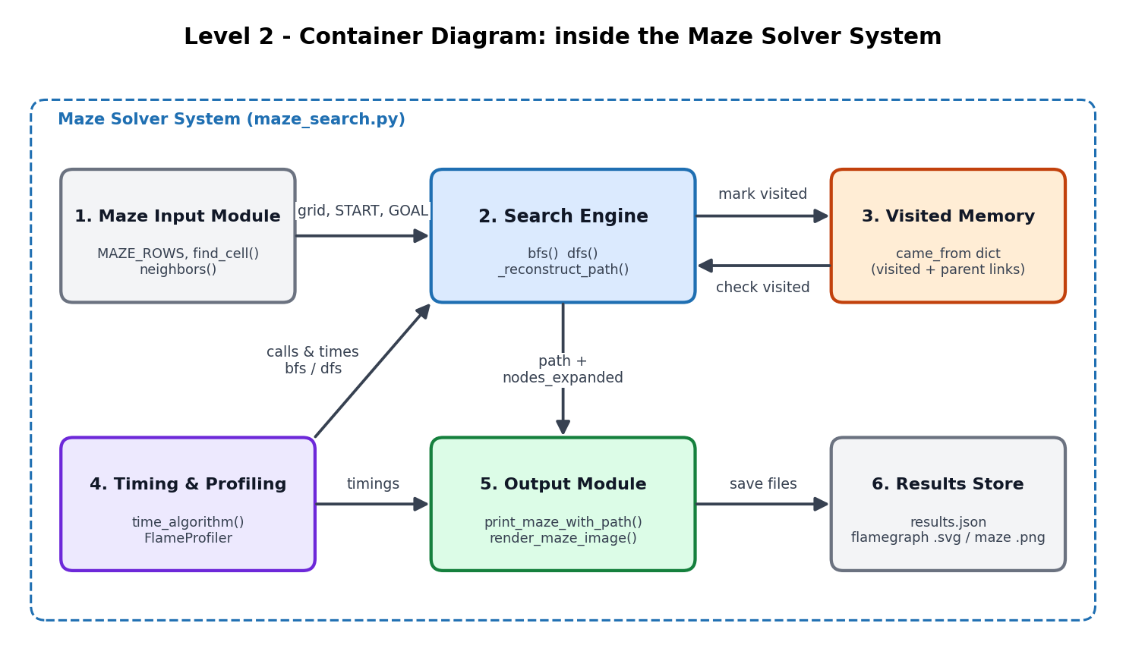
Explanation of each container:
- Maze Input Module: holds the grid (MAZE_ROWS), finds START and GOAL with find_cell(), and gives legal moves through neighbors().
- Search Engine: runs bfs() or dfs() from START to GOAL and returns the path with the nodes-expanded count.
- Visited Memory: the came_from dictionary; remembers visited cells (to avoid loops) and each cell's parent (to rebuild the path).
- Timing & Profiling: time_algorithm() runs each algorithm several times; FlameProfiler records the call stack for the flame graph.
- Output Module: prints the solved maze in the console and draws maze_bfs.png / maze_dfs.png with render_maze_image().
- Results Store: files written to disk: results.json, the flame-graph SVGs and the maze PNGs used in the SLE-2 report.
4. Component Diagram (Level 3) – Search Engine
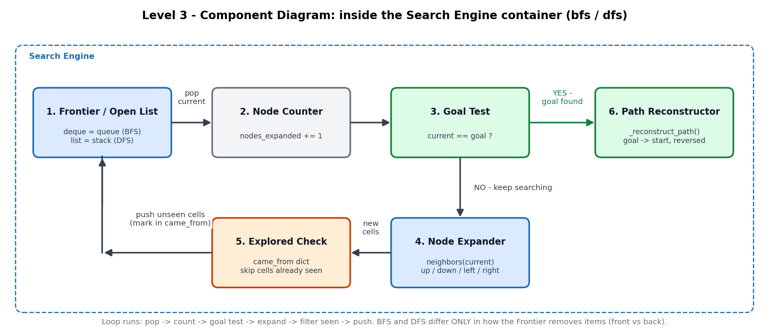
I chose the Search Engine because it is the heart of the system. Its loop starts by taking the next cell from the Frontier (a queue for BFS, a stack for DFS). The Node Counter adds 1, and the Goal Test checks whether the cell is the goal. If yes, the Path Reconstructor walks back through the parent links from goal to start and reverses the list. If no, the Node Expander gets the neighbours, the Explored Check drops cells already in came_from, and the new cells go into the Frontier.
5. Code Level Overview (Level 4)
Main classes / functions in maze_search.py (cells are plain (row, col) tuples, so there is no separate Node class):
- MAZE, START, GOAL : grid as a list of lists; start and goal found by find_cell('S' / 'G')
- def neighbors(cell) : yields walkable up / down / left / right cells inside the grid
- def bfs(start, goal) : queue (deque.popleft) search; returns (path, nodes_expanded)
- def dfs(start, goal) : stack (list.pop) search; returns (path, nodes_expanded)
- def _reconstruct_path() : follows came_from from goal back to start and reverses it
- class FlameProfiler : records call stacks with sys.setprofile; to_svg() draws the flame graph
- def time_algorithm() : repeats a search and returns best / worst / average time in ms
- print_maze_with_path() : console output; render_maze_image() draws the PNG pictures
6. Design Decisions
I put the maze rules in neighbors() and the search loops in bfs() / dfs() so that BFS and DFS differ in only one thing: how the Frontier removes cells (front of a queue vs. top of a stack). The single came_from dictionary does two jobs (visited set and parent links), which keeps memory small and makes path rebuilding easy. Timing and profiling are kept outside the search code, so measuring never changes the result. The containers are logical blocks inside one file, which keeps the project simple; a Heuristic Module could be added later for A* without changing the other parts.
7. AI Contribution Note
- AI tools used: Claude (Anthropic).
- What AI helped with: drafting the C4 diagrams (drawn by script) and the first version of the explanations, based on the SLE-3 guideline and my SLE-1 / SLE-2 repositories.
- What I did myself: chose to continue with my own SLE-2 Maze Solver, supplied the repositories and guideline, and checked that every box in the diagrams matches a function in my maze_search.py code.
8. Conclusion
In this SLE I learned that the C4 model explains the same system at four zoom levels: Context (who and what is around it), Container (the main blocks), Component (the parts of one block) and Code (the real classes and functions). Drawing the Maze Solver this way showed me which parts are search logic, which are data and which are only measurement. I also saw that BFS and DFS share almost the same structure, so good separation of parts makes it easy to change or extend one piece. SLE-1 gave me the code, SLE-2 the performance numbers, and SLE-3 the complete architecture.

