Siddharth Salunkhe

Dr. Mark Smith

ME 2016 / Section E

19 September 2017

Analysis of Taylor Approximation of Cosine

The goal of the assignment was to approximate the cosine function using a Taylor series. The approximation only works for small values of the argument x because there is a computer rounding error that occurs when dealing with larger values. To investigate this error, the approximation function is compared graphically with the relative and absolute errors given the exact cosine function built into MATLAB.

Based on the error results shown in figure 1 the rerr and the aerr for the smaller values of 1, 5, and 10, given 100 terms in the series, are negligible as they are on the order of 10 ^ -16. As the argument increases to 20 and 100, the rerr and aerr increase to the order of 10^-9 and unbounded respectively. Based on figures 2 – 6, there are oscillating errors with increasing magnitude to the point that when the argument is 100 in figure 6, the value of the function rises to the order of 10^ 41. The error itself stems from the summed term in the Taylor approximation. The formula is (x^2m)/(2m)!. with small values of x, the factorial term is higher magnitude than the exponential term, so the sum is convergent for more terms. As x becomes larger and larger, the exponential term has a higher magnitude as the terms increase. This leads to the sum’s cumulative value increasing greatly.

This is a form of rounding error because the large exponential base with a large exponential term after many iterations is on the order of 10 ^ 41 and the exponent carries the error forward. Only after many more iterations will the factorial term outweigh the exponent term, which is demonstrated in figures 5 and six where the oscillating errors and values finally settle and converge again.

This is rectified by the mycos2 function, which uses the periodicity and symmetry of the cosine function so that the input argument can be reduced to a small range between 0 to pi/2. This allows the number of terms to increase with less risk of an unbounded error propagating. In figure 7, the maximum number of terms that can be used before the error is less than machine precision is 18. This corresponds with the X value of pi/2 where cosine is 0.

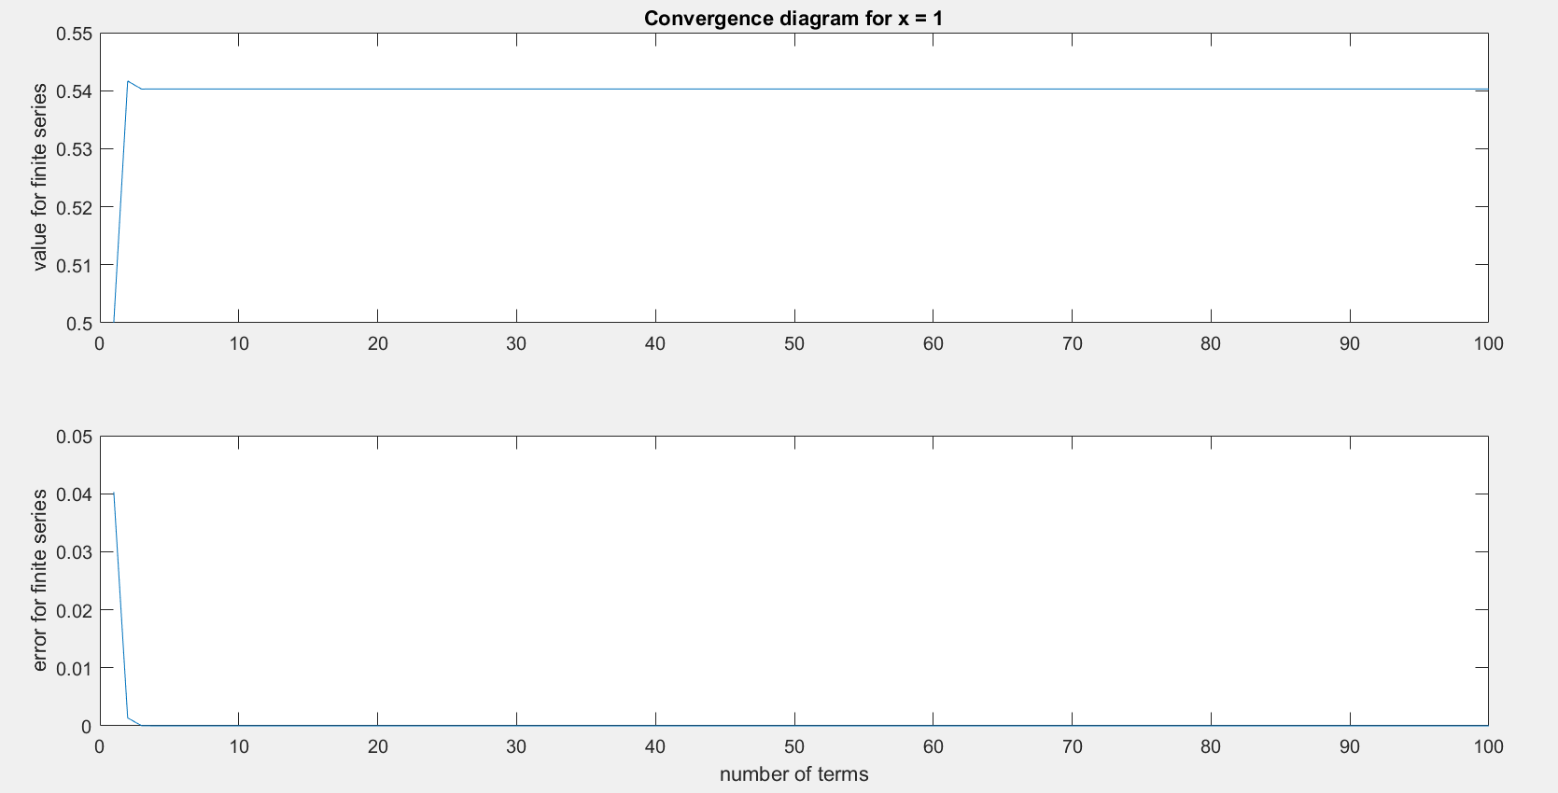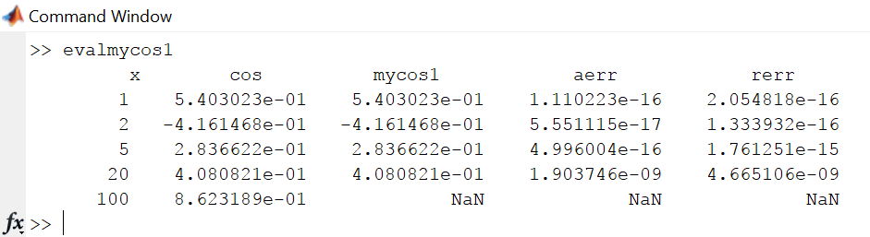Figure 1: evalmycos1 results show the error in using Taylor approximation

Figure 2: plotmycos1 error and function value vs number of terms for approximating cos(1)

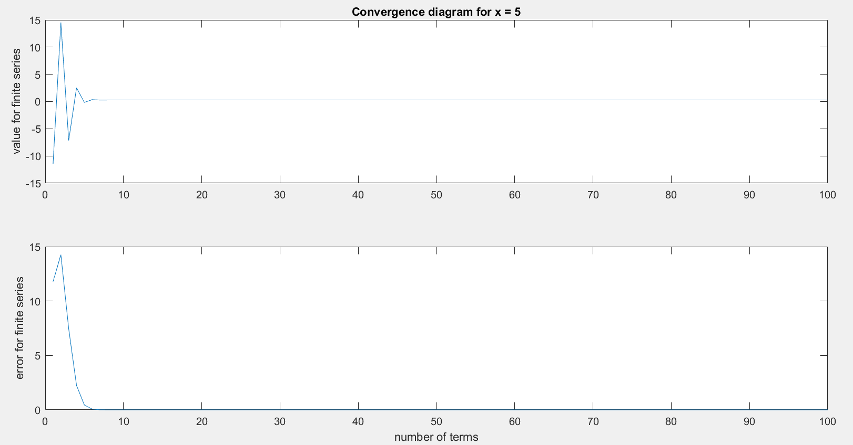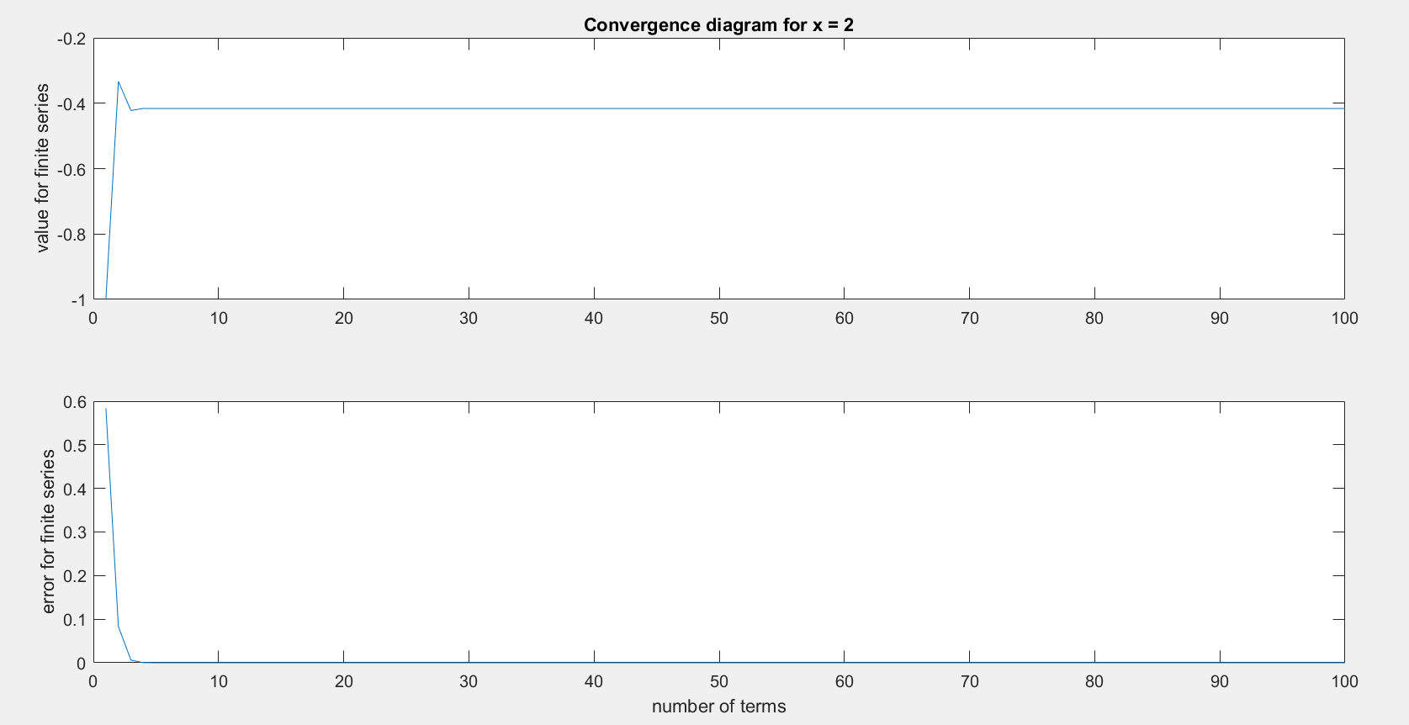

Figure 4: plotmycos1 error and function value vs number of terms for approximating cos(5)

Figure 3: plotmycos1 error and function value vs number of terms for approximating cos(2)

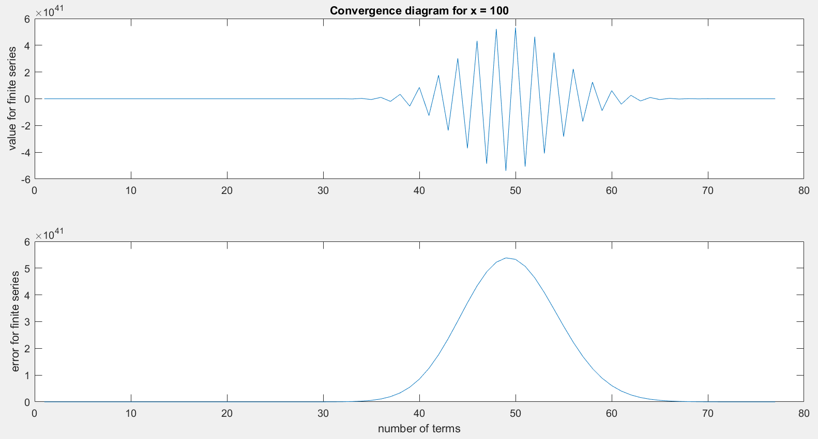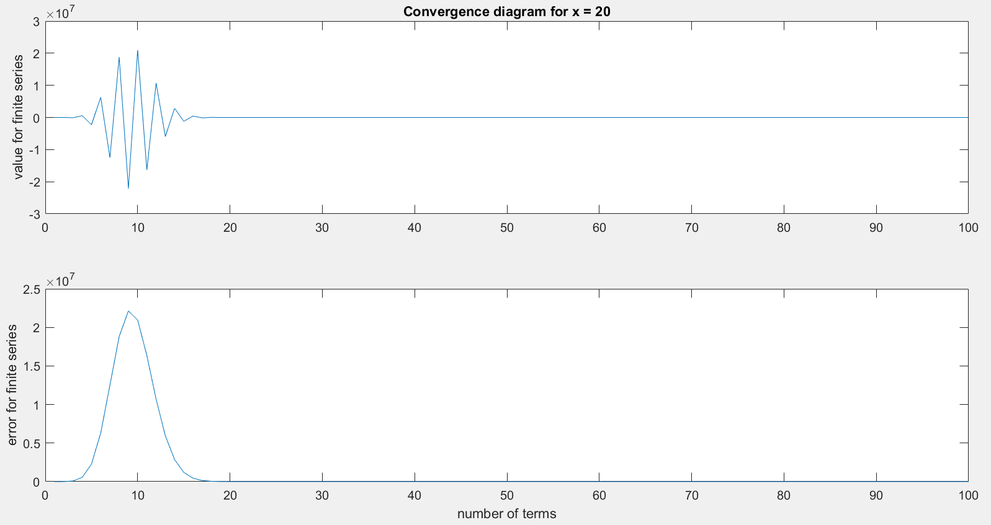

Figure 6: plotmycos1 error and function value vs number of terms for approximating cos(100)

Figure 5: plotmycos1 error and function value vs number of terms for approximating cos(20)

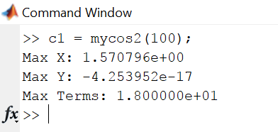

Figure 7: max number of terms that are within machine precision and the corresponding X and Y values

19