Name:-Siddhartha

Roll no:-2403A54122

Task – 01

Code With Error:-

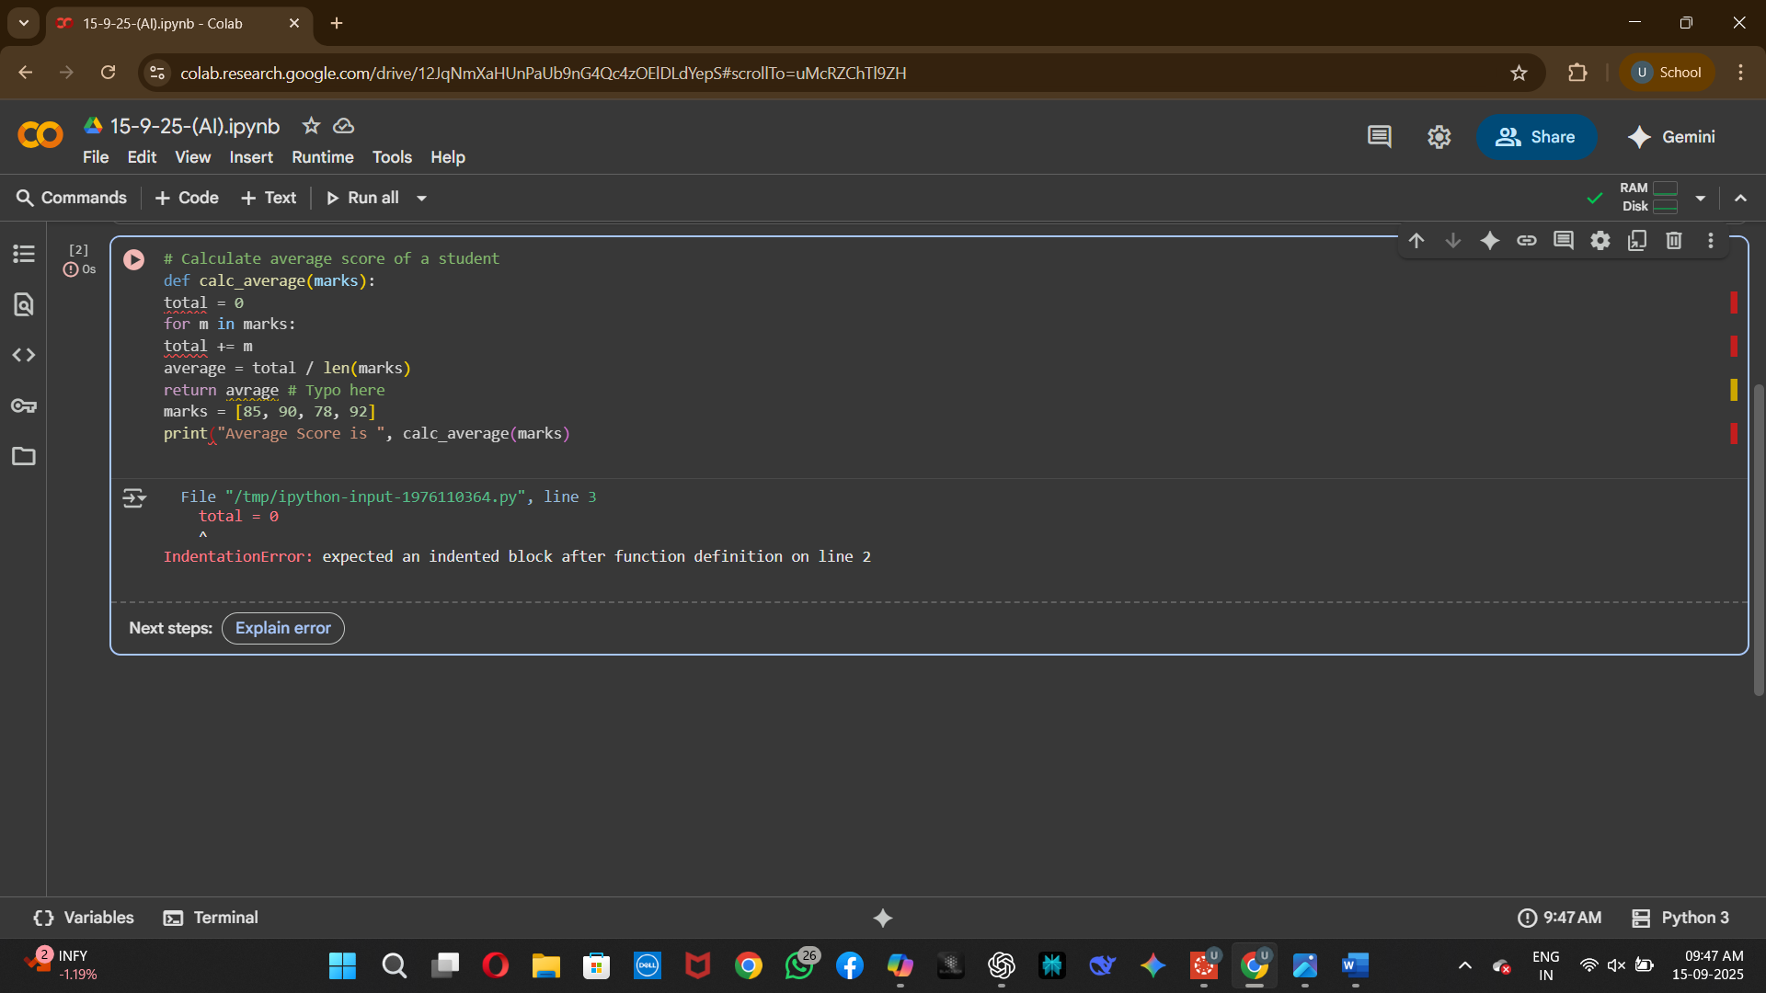

Code Without Error:-

Task:-2

Refactor Code:-

Task:-3

Readability Enhancement:-

Task:-4

Refactoring for Maintainability:-

Task:-5

Performance Optimization:-

Task:-6

Complexity Reduction:-

