Gas Price Time Series Modelling and 24-Month Forecasting
Student name: ____________________ Student ID: ____________________
Module: Statistical Modelling / Time Series Analysis Submission: Second Attempt

Abstract
This report investigates a daily gas price dataset containing 500 observations from 19 January 2025 to 2 June 2026. The analysis follows a full time-series workflow: initial exploration, stationarity testing, transformation, ARIMA modelling, diagnostic checking, 24-month forecasting and comparison with an alternative Prophet model. The raw series is clearly non-stationary, with prices increasing from a low of 25.44 to a maximum of 86.66. The Augmented Dickey-Fuller test on the raw data failed to reject the unit-root hypothesis, while first differencing produced a stationary series with an ADF statistic of -7.112 and a p-value close to zero. The final ARIMA model used in the notebook was ARIMA(8,1,8). On the held-out test period, ARIMA achieved an RMSE of 15.09 and MAE of 12.31. Prophet was then used as the alternative model because it can decompose a time series into trend and seasonal components while also producing uncertainty intervals. Prophet achieved a higher test RMSE of 19.13 and MAE of 16.28. Overall, ARIMA performed better on the test set, but both models struggled with the sharp upward movement at the end of the series. The forecasts should therefore be interpreted as exploratory model-based projections rather than precise market predictions.

1. Introduction and objective
The aim of this case study is to model daily gas prices and produce a 24-month forecast. The assignment requires a traditional autoregressive approach and one alternative modelling solution. ARIMA was used for the first part because it is a standard Box-Jenkins method for modelling autocorrelation in stationary time series after differencing (Box et al., 2015). For the alternative approach, Prophet was selected because it is designed for practical forecasting problems where trend and seasonality may be present, and it is commonly used for business and economic time-series forecasting (Taylor and Letham, 2018).
This work should be viewed as an exploratory forecasting exercise rather than a production-grade gas market model. Gas prices are affected by external factors such as storage levels, temperature, demand, supply disruptions, policy decisions and geopolitical events. None of these variables are included in the dataset. Because the models only use the historical price series, their long-range forecasts should be read cautiously. This limitation is important, especially because the requested forecast horizon of 24 months is longer than the amount of future data available for checking performance.

2. Dataset and exploratory data analysis
The dataset contains 500 daily observations with two variables: date and daily price. The dates run continuously from 19 January 2025 to 2 June 2026, and no missing dates or missing price values were found. The average gas price is 57.88, with a standard deviation of 16.40. The minimum value is 25.44 and the maximum is 86.66.
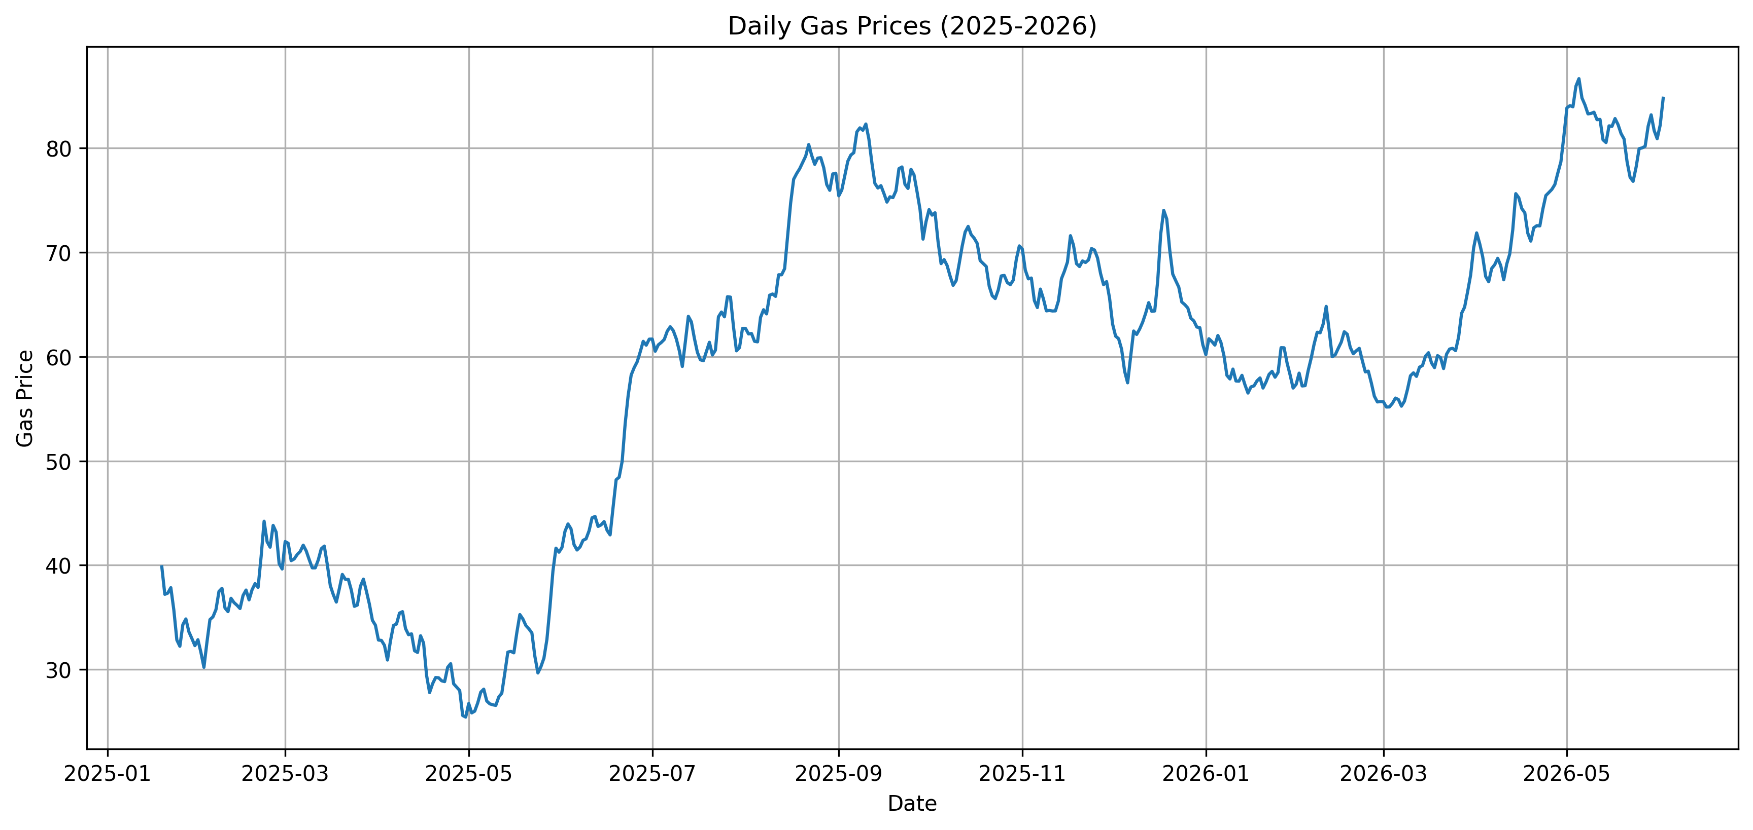
Figure 1. Daily gas price time series.
Figure 1 shows that the series is not moving around one stable long-term average. There is a visible fall in the early part of 2025, followed by a strong rise around the middle of 2025, a moderate decline during late 2025 and another sharp increase towards the end of the dataset. This shape matters because a model fitted to the earlier part of the sample may struggle to predict the final upward movement. Before any formal test is run, the plot already suggests that the raw price level is likely to be non-stationary.
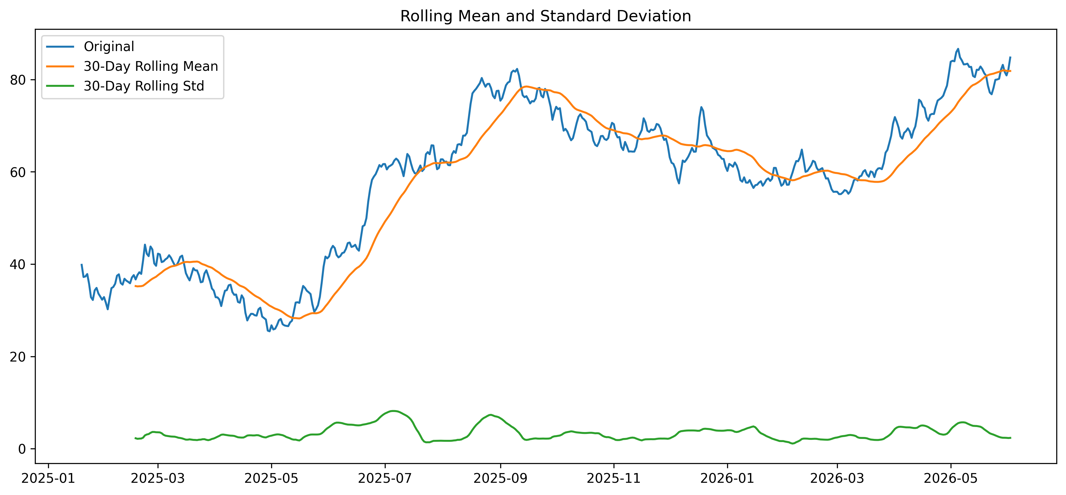
Figure 2. Rolling mean and rolling standard deviation.
The 30-day rolling mean in Figure 2 changes substantially over time, confirming that the average level of the series is not constant. The rolling standard deviation is also not completely stable, which suggests periods of higher and lower volatility. This is a warning sign for ARMA-type models because a pure ARMA model assumes stationarity. For this reason, differencing was considered before fitting the ARIMA model.

3. Stationarity testing and transformation
Stationarity was tested using the Augmented Dickey-Fuller test. The ADF test checks for a unit root, so a high p-value means there is not enough evidence to treat the series as stationary. On the raw gas price series, the ADF statistic was -0.964 and the p-value was 0.766. This is above the 5% significance level, so the null hypothesis of a unit root was not rejected. In plain terms, the raw series was not suitable for direct ARMA modelling.
Series | ADF statistic | ADF p-value
Raw series | -0.964 | 0.766
First difference | -7.112 | 3.907e-10
After applying first-order differencing, the ADF statistic became -7.112 and the p-value was 3.907e-10. This is far below 0.05, so the unit-root hypothesis was rejected. The differenced series can therefore be treated as stationary for the purpose of ARIMA modelling. This supports a differencing order of d = 1.
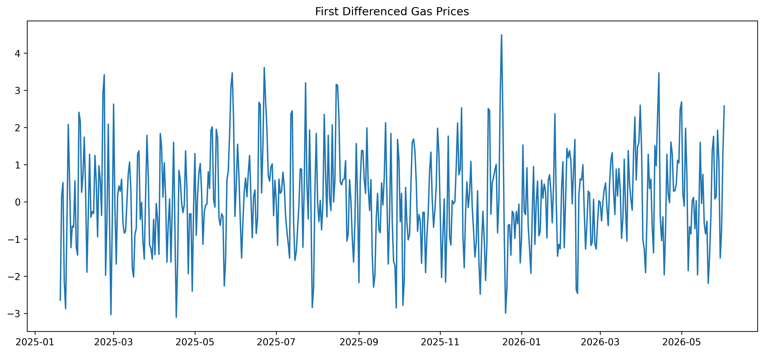
Figure 3. First-differenced gas price series.
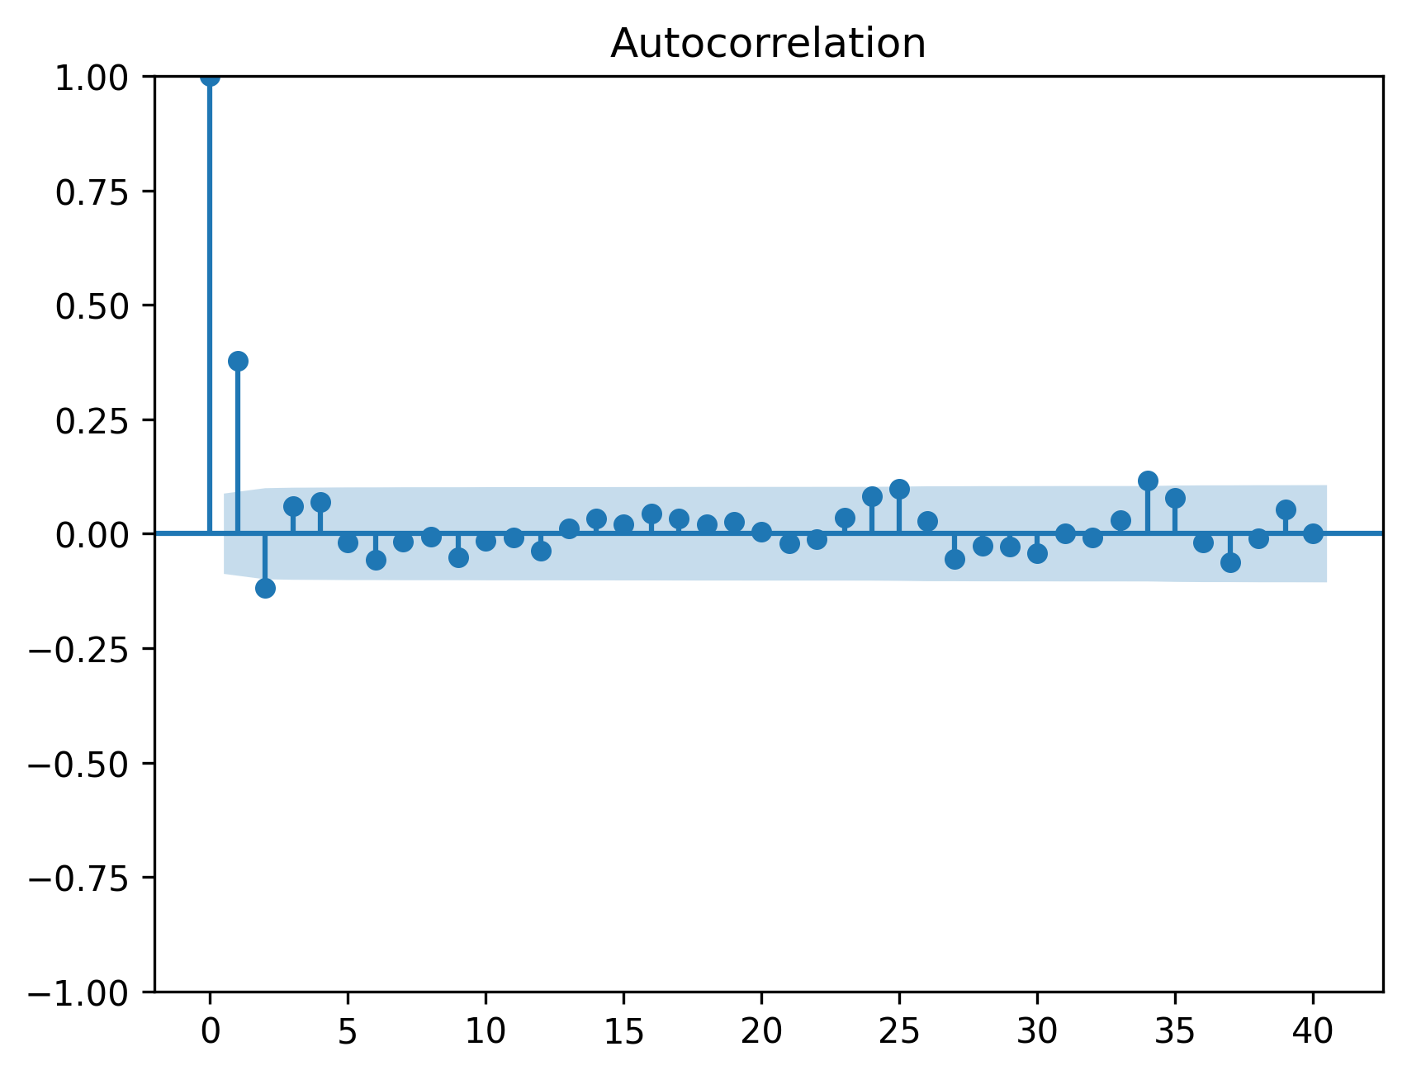
Figure 4. ACF plot after first differencing.
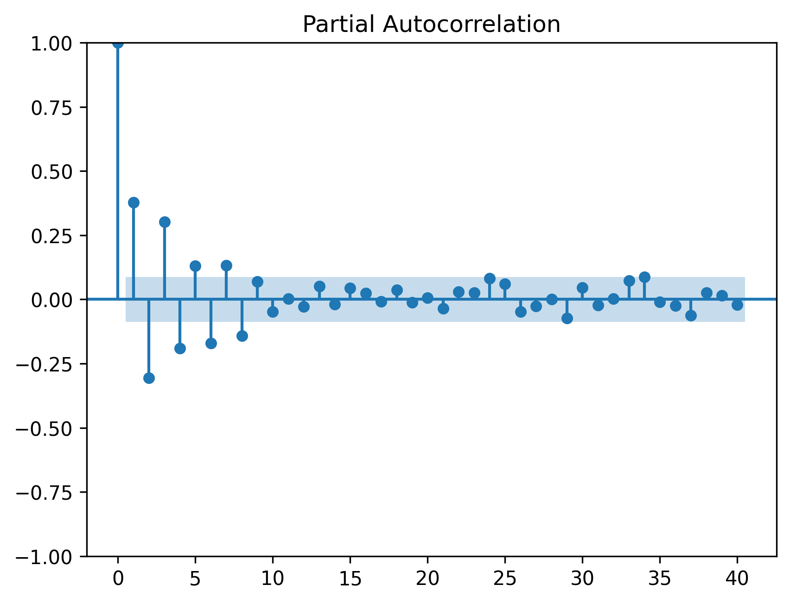
Figure 5. PACF plot after first differencing.
The differenced series in Figure 3 fluctuates around zero rather than following the same long upward movement seen in the raw data. The ACF and PACF plots were used to inspect remaining autocorrelation. The final model fitted in the notebook used a high-order ARIMA(8,1,8) specification. This is flexible enough to capture several short-lag dependencies, although it also increases the risk of overfitting. It was then assessed using residual diagnostics and test-set errors.

4. ARIMA modelling and diagnostics
The ARIMA model was fitted to the first 80% of the observations and evaluated on the final 20%. The final fitted model used in the submitted notebook was ARIMA(8,1,8), with AIC approximately 1155.08 on the training data. AIC is useful because it rewards goodness of fit while penalising model complexity (Akaike, 1974). However, a low AIC alone is not enough to prove that the model is good for forecasting. Residual checks are needed because a well-specified ARIMA model should leave residuals that behave roughly like white noise.
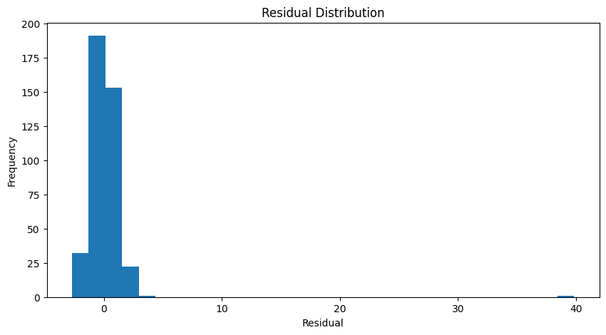
Figure 6. ARIMA residual distribution.
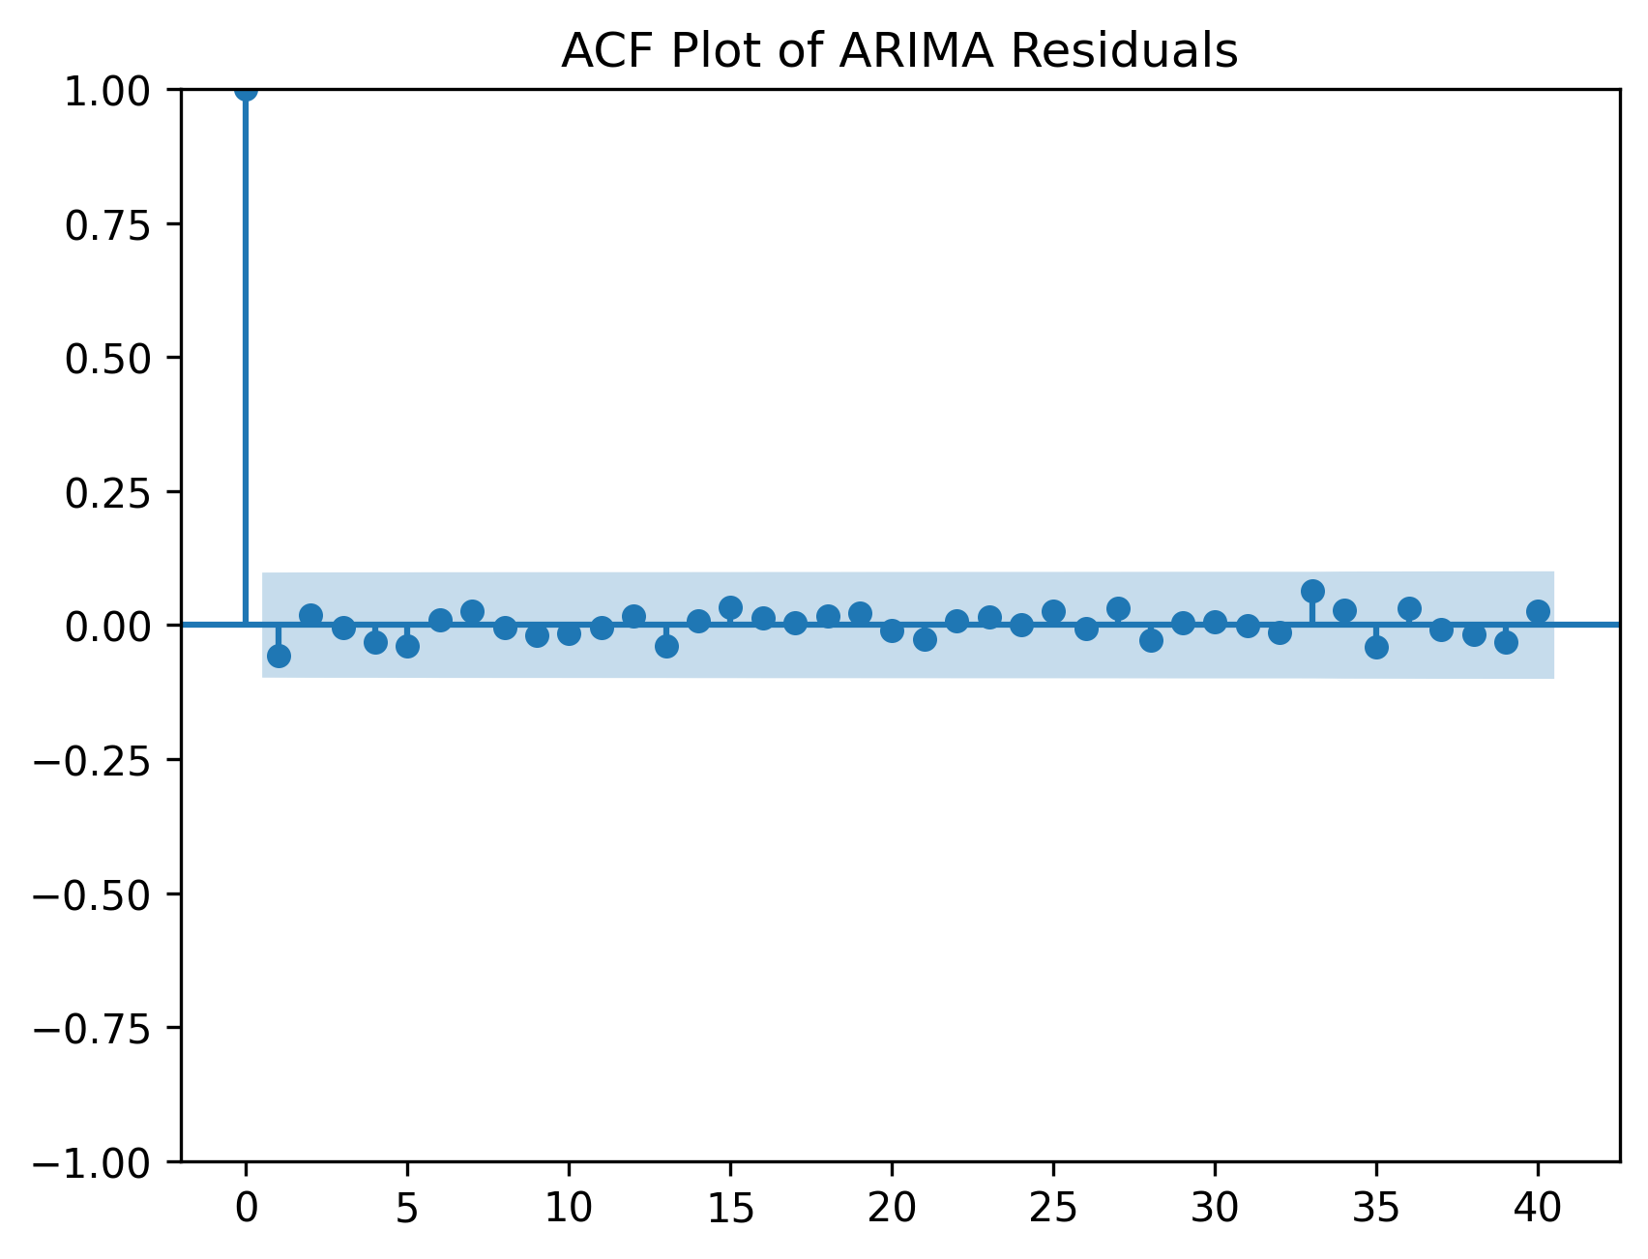
Figure 7. ACF plot of ARIMA residuals.
The residual distribution is centred fairly close to zero, but it is not perfectly normal and contains some heavier tails. The residual ACF is mostly within the confidence bands, suggesting that the model has removed much of the serial dependence. There are still small remaining spikes, which means the model is not perfect. This is realistic for a volatile economic series and is a useful point for critical reflection: the model captures internal autocorrelation, but it cannot observe the external causes of gas price changes.
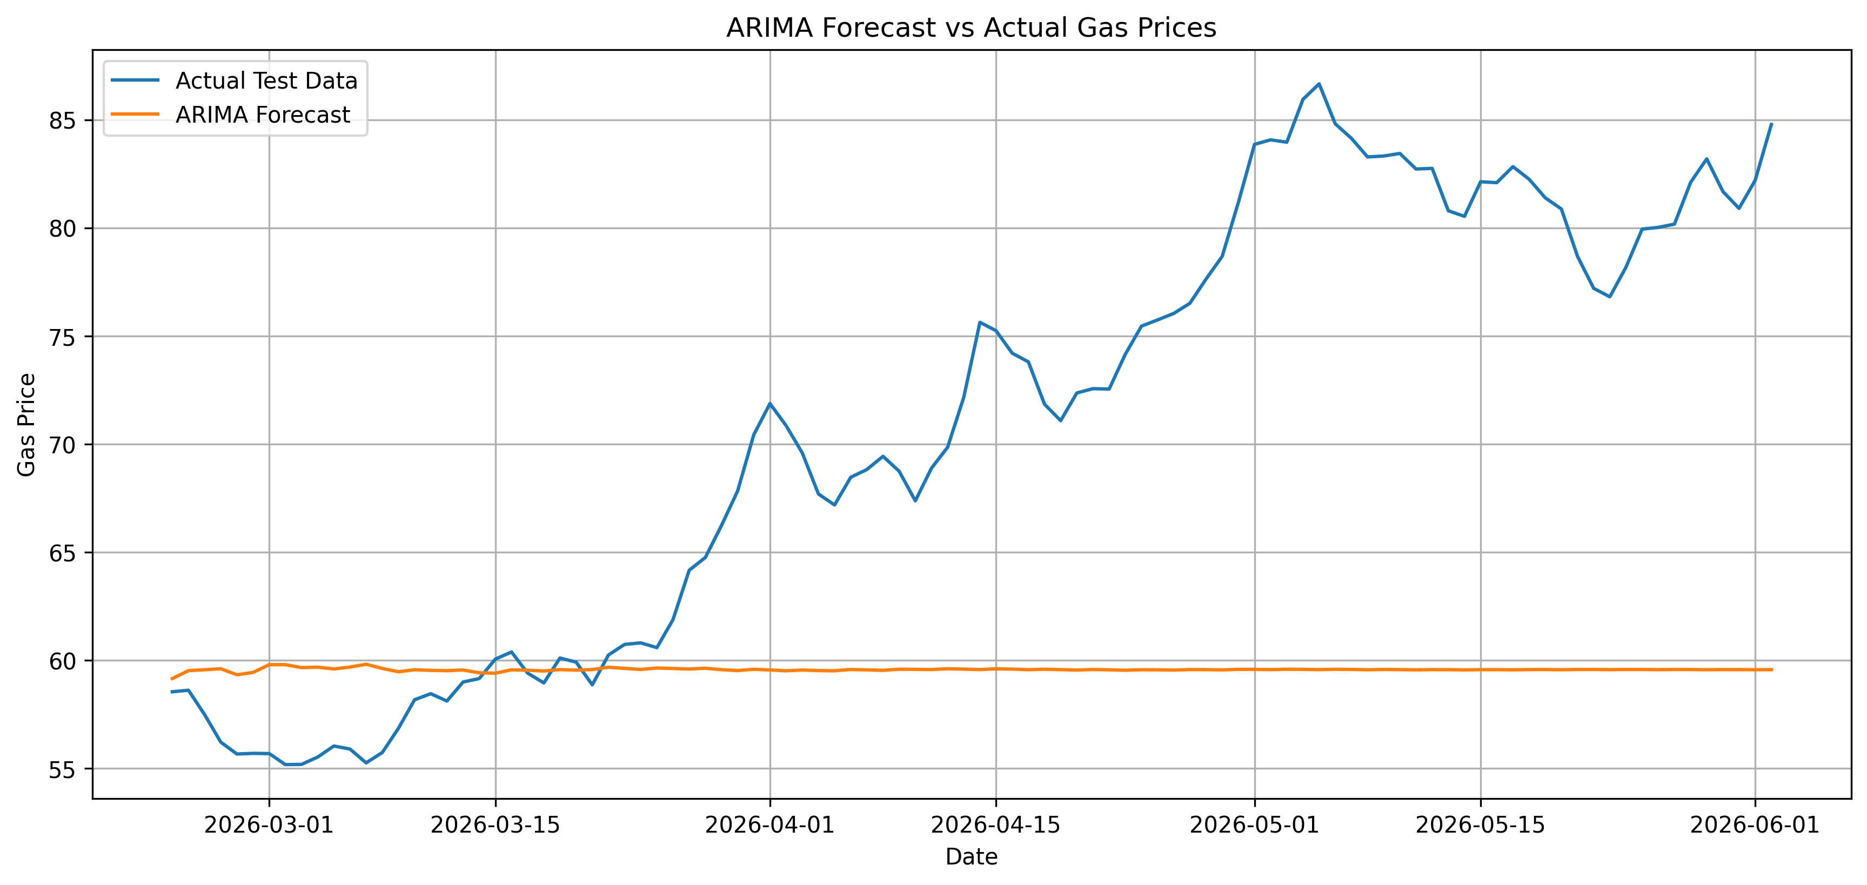
Figure 8. ARIMA forecast against actual test-period data.

5. Alternative model: Prophet
Prophet was used as the alternative model. Unlike ARIMA, which mainly works through differencing and autocorrelation, Prophet represents a time series as a combination of trend, seasonality and error terms (Taylor and Letham, 2018). This makes it attractive for business forecasting because the model can separate a broad trend from repeating calendar patterns. In this analysis, yearly and weekly seasonality were enabled, while daily seasonality was disabled because the data contains one observation per day rather than intraday observations.
The Prophet model was trained using the same 80/20 split as ARIMA. It was then refitted on the full dataset to produce the 24-month forecast. Prophet also provides uncertainty intervals. However, these intervals should not be treated as a guarantee. They depend on the assumptions of the fitted model and still do not include unobserved external shocks such as supply disruptions or sudden policy changes.
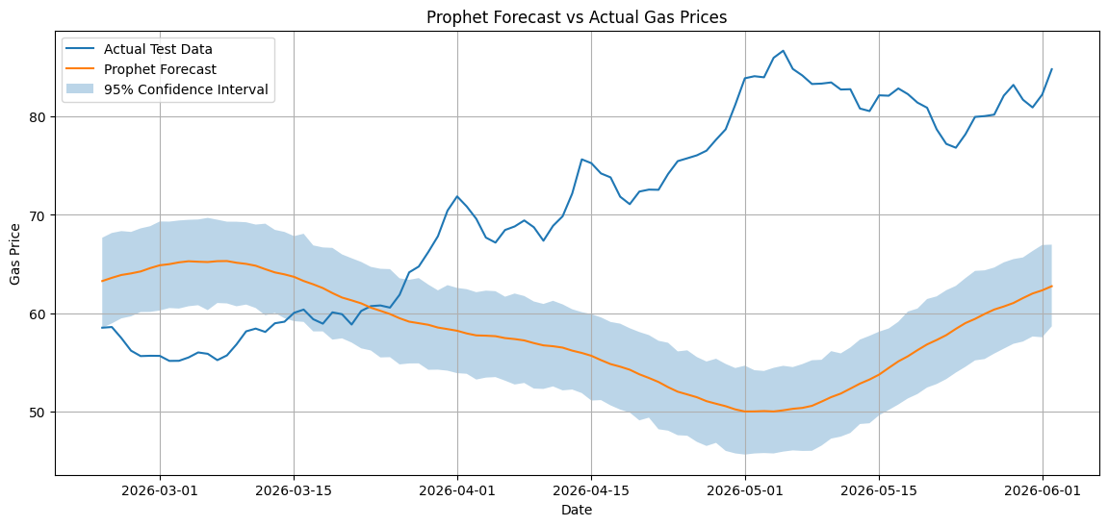
Figure 9. Prophet forecast against actual test-period data.
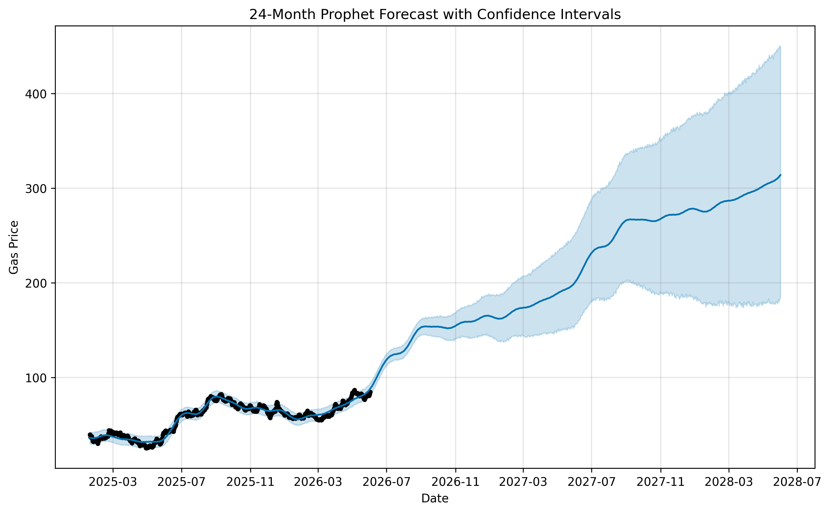
Figure 10. Prophet 24-month forecast with uncertainty intervals.

6. Results and model comparison
Model | MAE | RMSE | Comment
ARIMA(8,1,8) | 12.31 | 15.09 | Lower error on the test set, but underestimates sharp rises.
Prophet | 16.28 | 19.13 | More interpretable decomposition, but weaker test accuracy here.
The test-period results show that ARIMA performed better than Prophet for this particular dataset. ARIMA produced an RMSE of 15.09 and MAE of 12.31, compared with Prophet RMSE of 19.13 and MAE of 16.28. This does not mean ARIMA is universally better. It means that, for this sample and this train-test split, the ARIMA model tracked the test period more closely than Prophet.
The difference is partly explained by the shape of the data. The test period contains a strong upward movement. Prophet tends to smooth the underlying trend and seasonal structure, so it can lag behind sharp changes when they are not supported by a long historical pattern. ARIMA also struggled with the final increase, but its short-term dependence structure gave it slightly better test errors. Both models therefore show the same practical problem: a univariate model cannot fully explain a gas price series that is likely driven by market conditions outside the dataset.
The long-range forecasts should be interpreted even more carefully than the test-set metrics. The ARIMA forecast has widening confidence intervals, which is expected because uncertainty accumulates as the model projects further ahead. Prophet produces a trend-based projection with uncertainty intervals, but the same limitation remains: the forecast assumes that future behaviour is related to the past pattern captured by the model. For a 24-month horizon, this is a strong assumption.
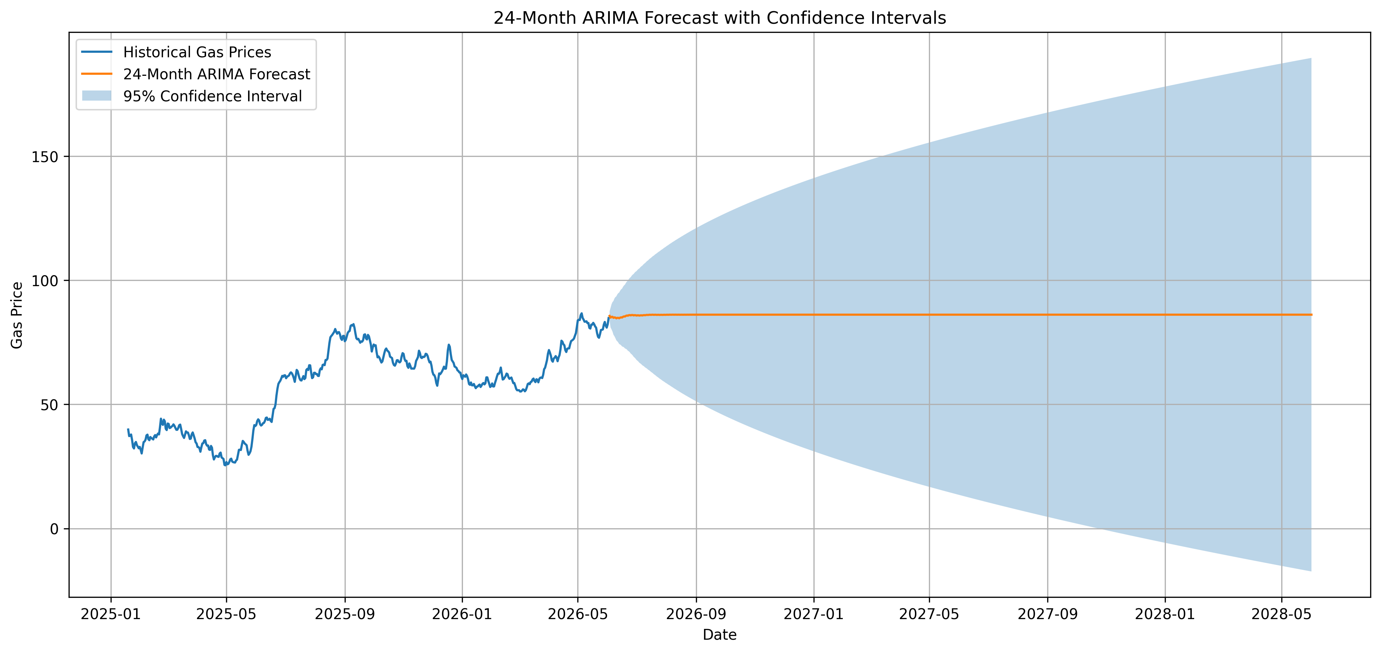
Figure 12. ARIMA 24-month forecast with 95% confidence intervals.

7. Critical reflection and future improvements
The strongest part of the analysis is that it follows a proper time-series workflow rather than fitting models blindly. The raw series was plotted, non-stationarity was tested, differencing was justified, ARIMA residuals were inspected, and a second model was used for comparison. This gives the analysis a clear structure and makes the results easier to defend.
The main weakness is that the dataset is short and univariate. There are only 500 observations, while the requested forecast horizon is 730 days. This means the model is being asked to forecast further into the future than the length of the test set and almost as long as the full sample itself. That is ambitious and naturally creates uncertainty. A second limitation is that no exogenous variables are included. Gas prices are unlikely to be driven only by their own past values, so a model without demand, supply, weather or macroeconomic variables can only give a partial explanation.
Future work should use external predictors such as gas demand, temperature, storage levels, crude oil prices, inflation, exchange rates and geopolitical event indicators. A SARIMAX model could then test whether exogenous variables improve the ARIMA forecast. For the alternative model, Prophet could be improved by tuning changepoint prior scale and seasonality prior scale, rather than using a single default configuration. If longer historical data were available, LSTM models could also be tested, although they would require careful validation to avoid overfitting. Rolling-origin evaluation would be stronger than a single train-test split because it would test whether the models are stable across several forecast starting points.

8. Conclusion
The analysis found clear evidence that the raw gas price series was non-stationary. First differencing successfully produced a stationary series, supporting the use of ARIMA with d = 1. The ARIMA(8,1,8) model achieved better test accuracy than Prophet, with RMSE 15.09 compared with 19.13. However, neither model should be treated as a fully reliable market forecasting system. The test period included a strong upward movement, and both approaches were limited by the absence of external explanatory variables. The main conclusion is therefore balanced: ARIMA was the stronger model in this implementation, while Prophet provided a useful alternative decomposition-based view of the data. For real decision-making, future analysis should include external drivers and stronger backtesting.

References
Akaike, H. (1974) "A new look at the statistical model identification", IEEE Transactions on Automatic Control, 19(6), pp. 716-723.
Box, G.E.P., Jenkins, G.M., Reinsel, G.C. and Ljung, G.M. (2015) Time Series Analysis: Forecasting and Control. 5th edn. Hoboken: Wiley.
Hyndman, R.J. and Athanasopoulos, G. (2021) Forecasting: Principles and Practice. 3rd edn. Melbourne: OTexts.
Taylor, S.J. and Letham, B. (2018) "Forecasting at scale", The American Statistician, 72(1), pp. 37-45.
Hyndman, R.J. and Khandakar, Y. (2008) "Automatic time series forecasting: the forecast package for R", Journal of Statistical Software, 27(3), pp. 1-22.
Hamilton, J.D. (1994) Time Series Analysis. Princeton: Princeton University Press.
Makridakis, S., Wheelwright, S.C. and Hyndman, R.J. (1998) Forecasting: Methods and Applications. 3rd edn. New York: Wiley.
Montgomery, D.C., Jennings, C.L. and Kulahci, M. (2015) Introduction to Time Series Analysis and Forecasting. 2nd edn. Hoboken: Wiley.

