**Intune Application Deployment Process**

To create a .intunewin file which is compatible with Intune, we will need to use the Microsoft Win32 Content Prep Tool. This tool converts various app installation files like .msi and .exe into the .intunewin format, which is then used for deploying applications to devices managed by Intune.

* **Process of deploying a Win32 application to Windows devices using Microsoft Intune Prep Tool:**

1. **Download the Win32 Content Prep Tool**

* We can download the tool from Microsoft's official documentation or Github.
* Link for Github-<https://github.com/microsoft/Microsoft-Win32-Content-Prep-Tool>
* In this repository we need to download the **IntuneWinAppUtil.exe** file.

1. **Prepare the App Package**

* The tool takes our original app installation files and processes them to create the .intunewin package.
* Using the **IntuneWinAppUtil.exe** file we need to convert our .msi or .exe file into .intunewin file which is uploadable in the Intune.
* **Steps:-**

**i)** We need to open the **IntuneWinAppUtil.exe** file.

**ii)** Next it asks for **Source Folder** so here we put the Path of our .exe file.

**iii)** Next it asks for **Setup File** so here we put our .msi or .exe file name.

**iv)** Next it asks for **Output Folder** so here we put the Path where we want our .intunewin file to be placed after getting converted.

**v)** Next it asks for **do we want a Catalog Folder** so here we have to put N as we don’t need it.

**vi)** Finally it starts converting our .msi or .exe file into .intunewin file.

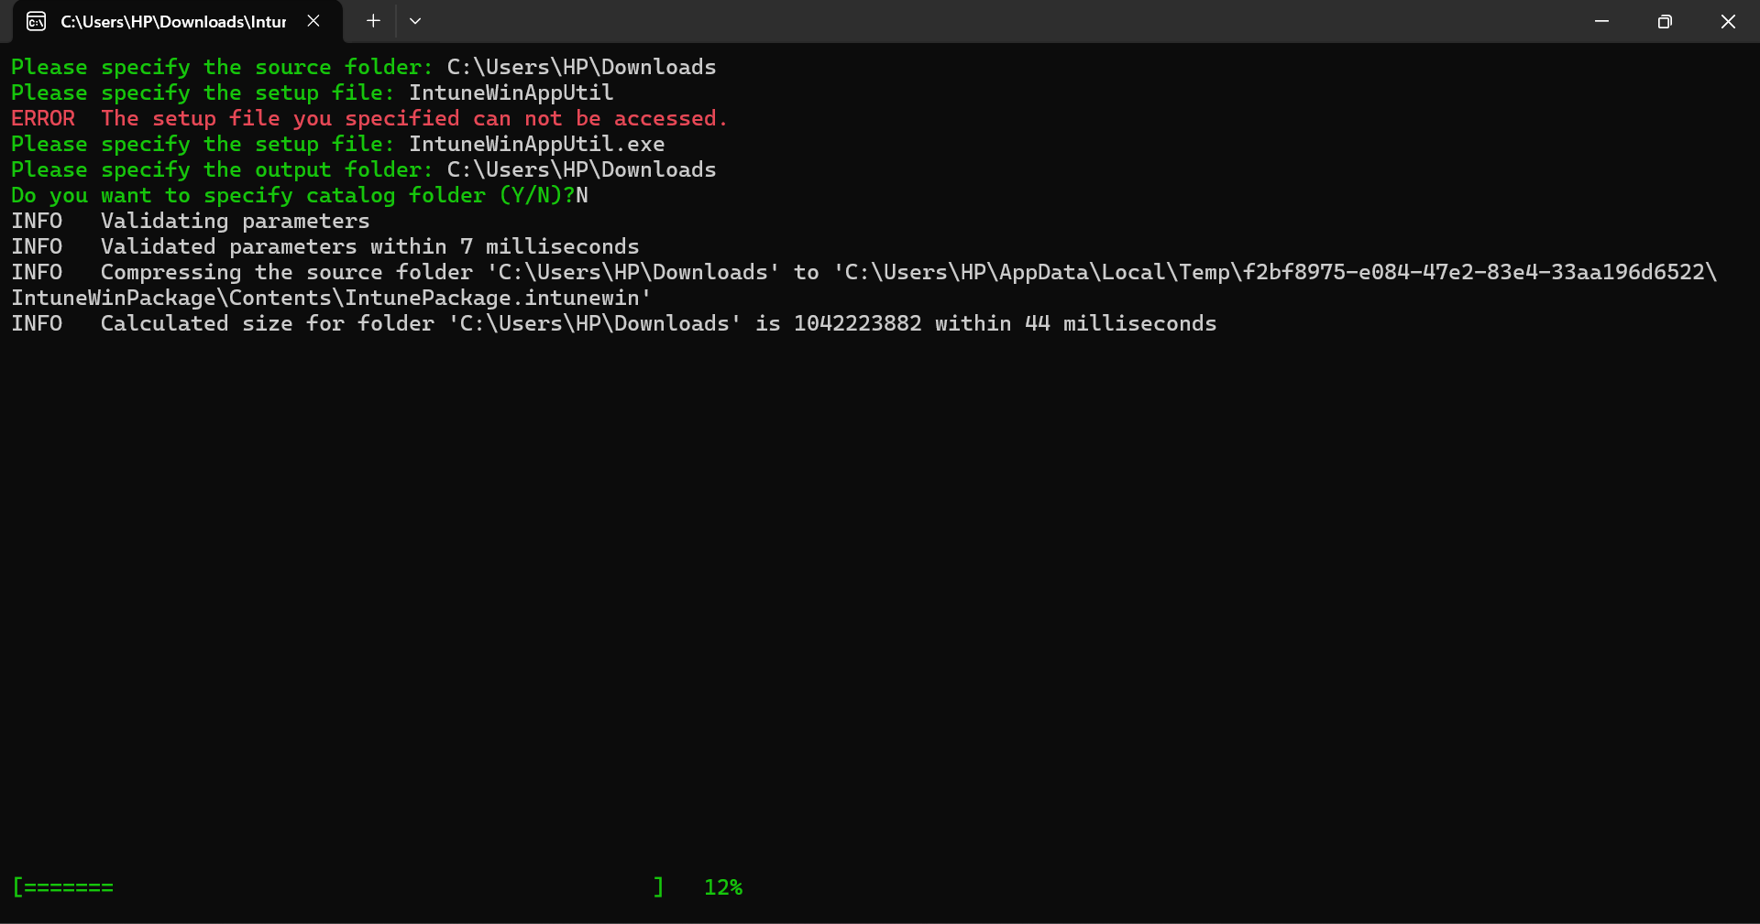

1. **Upload the .intunewin to Intune**

* Once the package is created, we can upload it to the Intune admin center to add it as a new app according to Microsoft.

1. **Configure App Details**

* We will need to provide information like the app's name, description, privacy policy and the commands to install and uninstall the app.

1. **Assign the App to Users or Groups**

* Finally, we will assign the app to the appropriate groups within your organization to ensure it gets deployed to the intended devices.