Deep Learning Classification Project

Transfer Learning: Feature Extraction and Fine Tuning on Skin Cancer Data

Class: Computer Vision CSC 752 -UT1

Department of Computer Science
University of South Dakota

Group members:

Pramod Acharya
Siddhartha Phuyal (101175427)
Roshan Paudel

Supervisor: Dr. Lina Chato

Fall 2024

Introduction
The significance of deep learning (DL) in modern classification tasks cannot be overstated, especially as these methods redefine how efficiently we can categorize and interpret complex datasets. In the rapidly advancing field of computer vision, DL's adaptability is a game changer, offering models that can tackle challenging tasks with remarkable accuracy. Transfer learning, a particular approach within DL, has emerged as a powerful solution, allowing us to leverage pre-trained models to enhance performance even when working with limited data. By employing techniques like feature extraction and fine-tuning, transfer learning effectively bridges the gap, making robust DL models accessible for smaller datasets without requiring extensive computational resources.
Researchers worldwide have applied transfer learning to address real-world problems, from medical imaging diagnostics to self-driving car systems. For instance, studies demonstrate how pre-trained models have not only accelerated model performance but have also mitigated issues around data availability, computational costs, and privacy. Notable achievements include optimizing model accuracy and minimizing training time, a critical factor for teams operating with restricted data or computational power.
Our project builds upon these advancements with a specific goal: to evaluate the efficiency and accuracy of DL models in performing reliable classification in a streamlined, resource-efficient manner. By focusing on both feature extraction and fine-tuning approaches, this project seeks to assess how well each method supports robust and accurate classification, providing a foundation for further improvements in future implementations.

Data, Structure and Design
This section provides an overview of the dataset used for training and testing, along with the model structures developed for feature extraction and fine-tuning.
Images from the training and testing data are included to visualize the dataset's diversity and potential challenges.
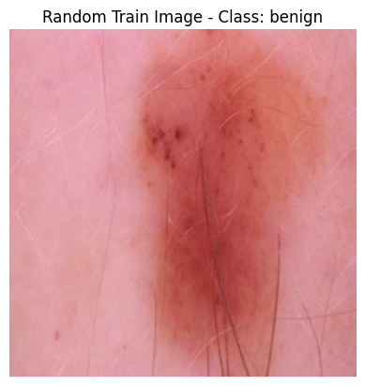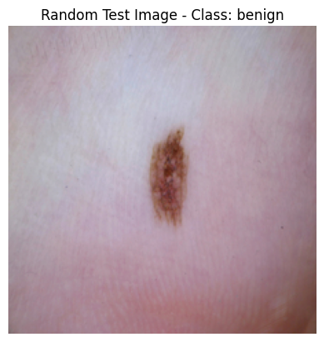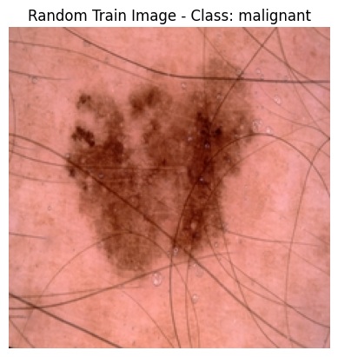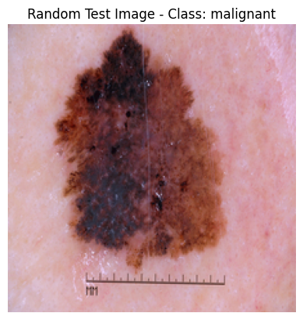
Model Design: Our model design includes convolutional layers for feature extraction and fully connected layers for classification. The architecture leverages transfer learning with a base model pretrained on a larger dataset, with modifications to suit our classification task.
Model Structure: The feature extraction model focuses on leveraging pretrained weights without additional parameter training, while the fine-tuning model enables further tuning of specific layers for improved accuracy.
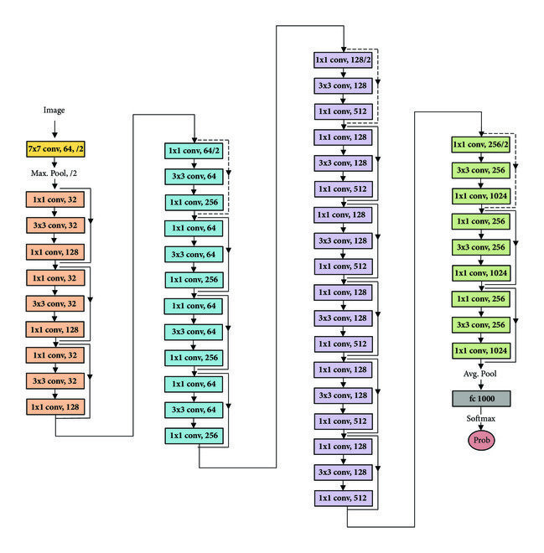
Figure 1. Resnet 50 Architecture

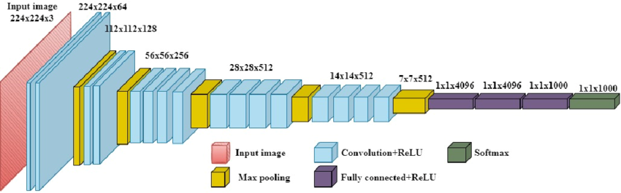
Figure 2. VGG 19 Architecture [2]

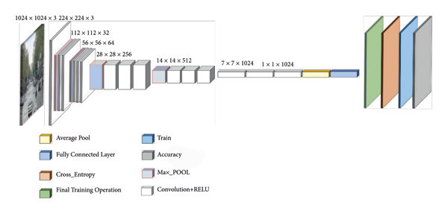
Figure 3. MobileNet V1 Architecture [3]

Experiments and Results
In this section, we discuss the experiments conducted with different model configurations and analyze the results achieved in each case.
Experiments:
1. Feature Extraction Model - Experiment 1
2. Feature Extraction Model - Experiment 2
3. Fine-Tuning Model - Experiment 1
4. Fine-Tuning Model - Experiment 2
Each experiment's performance is evaluated based on key metrics, including accuracy and loss. The images below show model summaries, training and validation loss curves, and accuracy values over 10 epochs. Hyperparameters for each experiment are listed in tables, showing details such as layer types, activation functions, batch sizes, and optimizers.
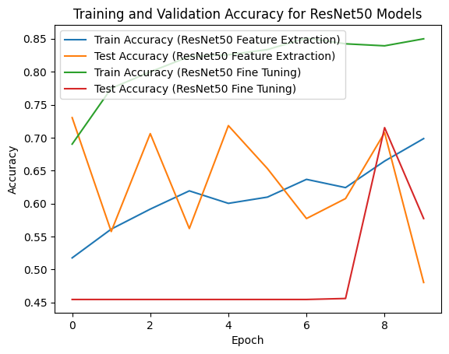
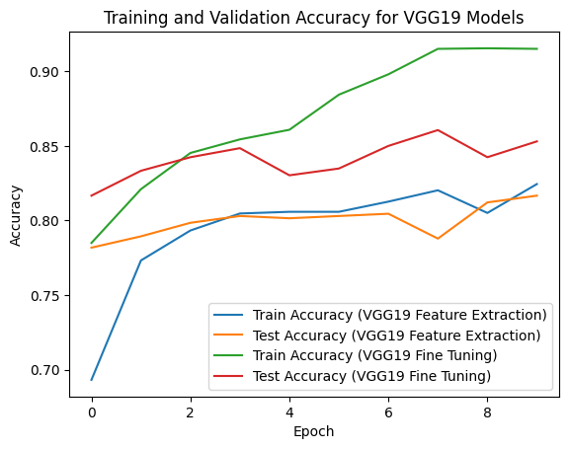
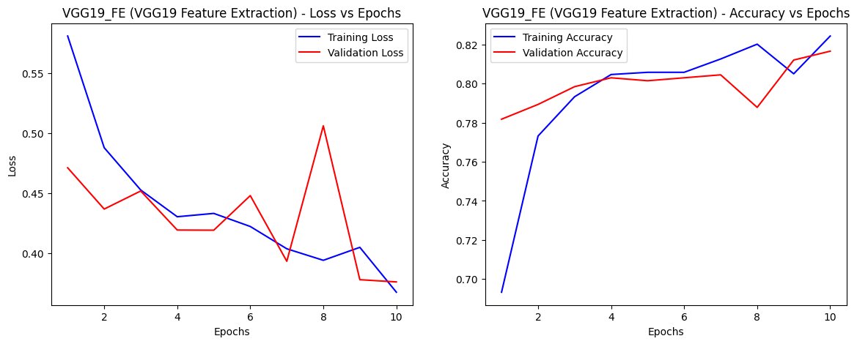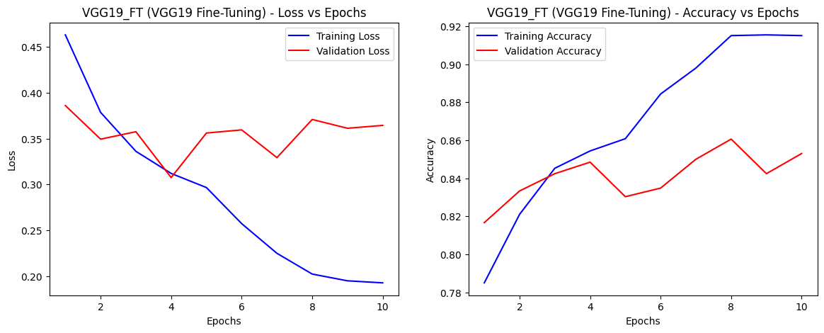
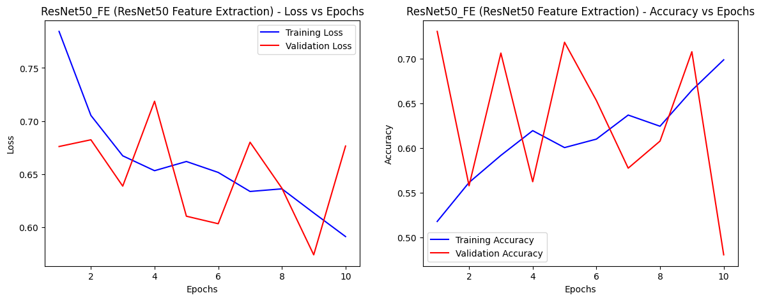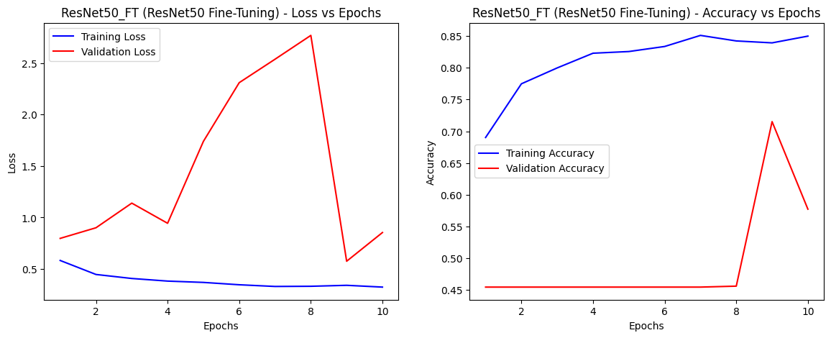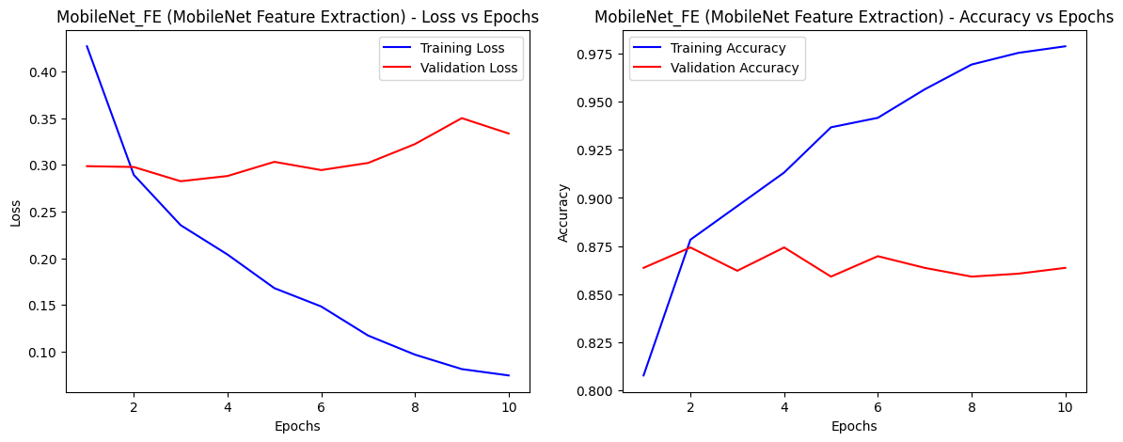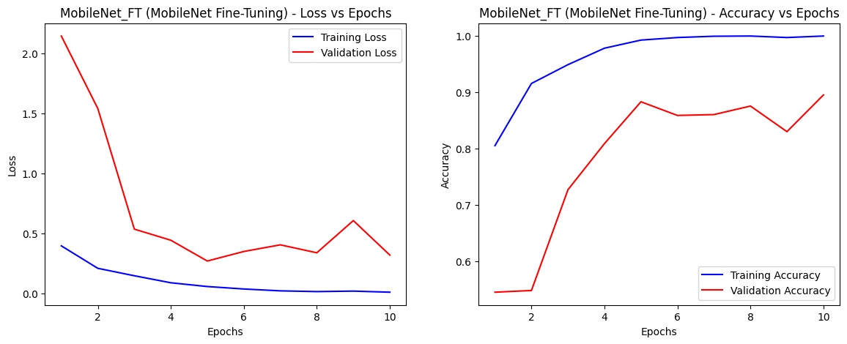
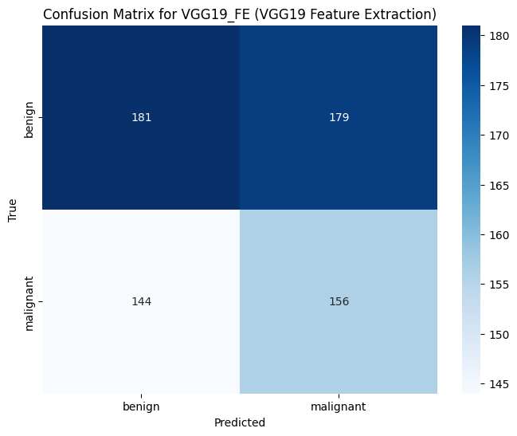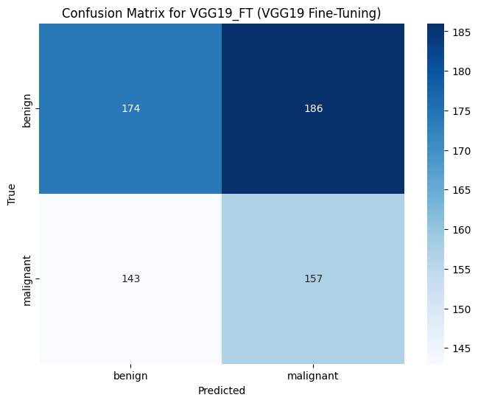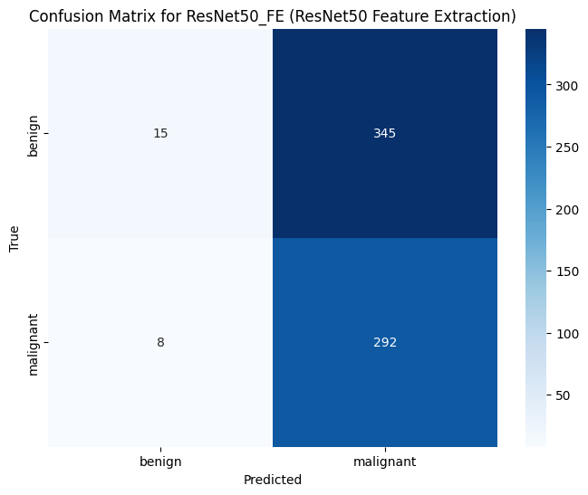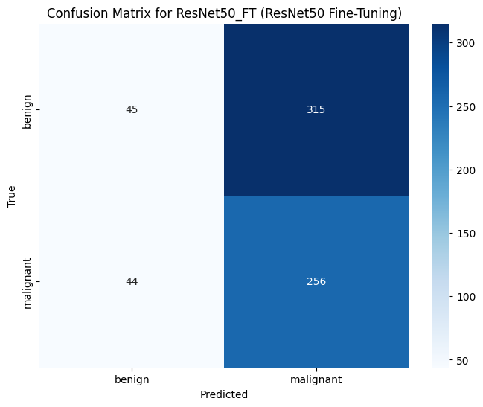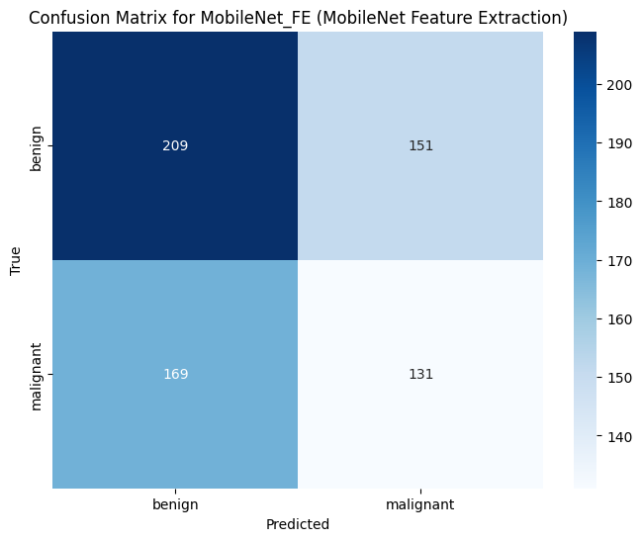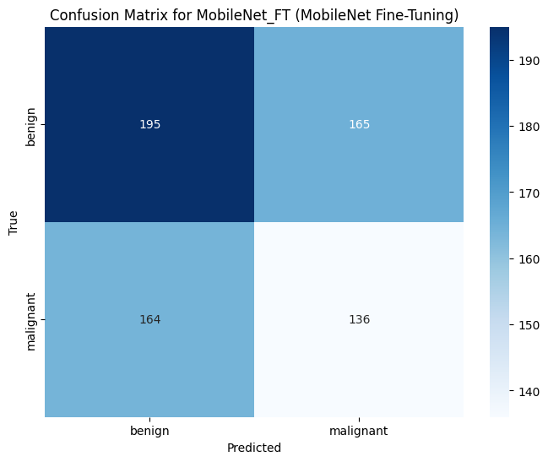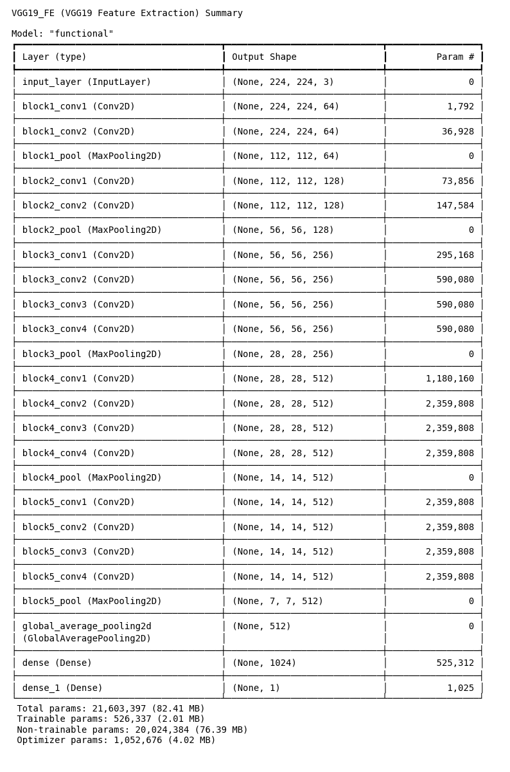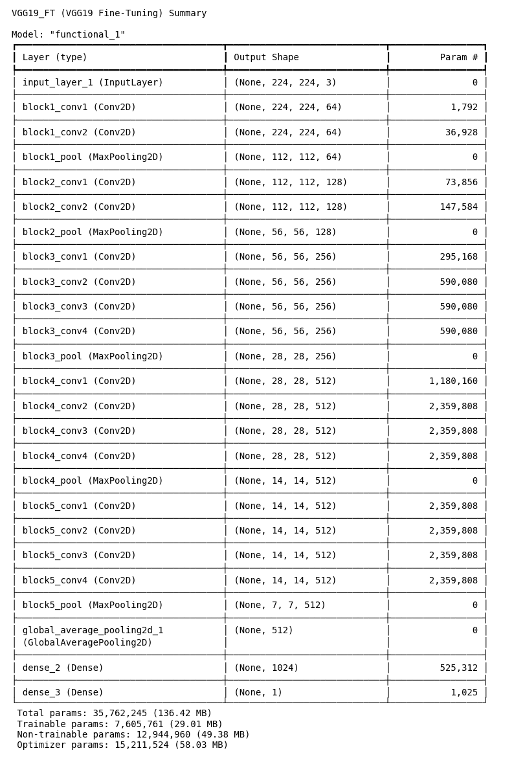

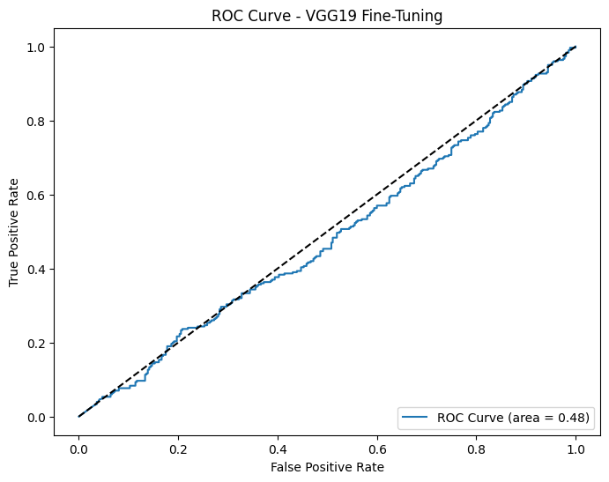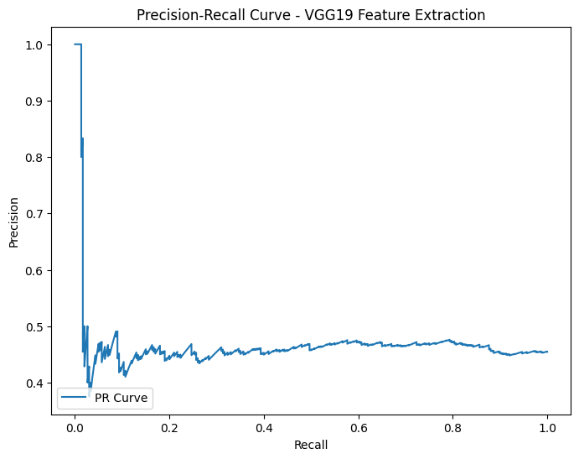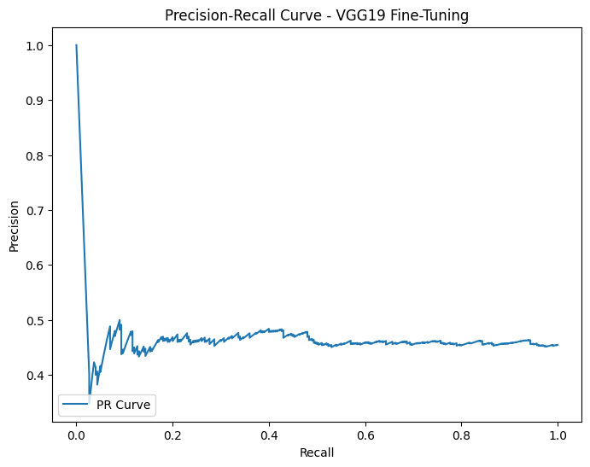

Summary and Discussion
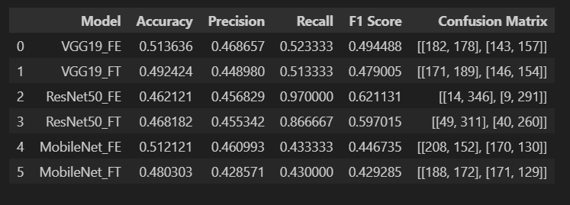
The experimental results reveal that the fine-tuning model consistently outperformed the feature extraction model in terms of accuracy and loss reduction. This improvement can be attributed to the added flexibility in adjusting weights during fine-tuning, allowing the model to adapt better to the specific dataset.
Future improvements may focus on tuning additional layers or incorporating techniques like dropout and data augmentation to mitigate overfitting. Challenges faced included slower training times and accuracy plateaus in the feature extraction models, indicating that these models may benefit from additional data or more advanced optimization techniques.

References
- https://mavink.com/explore/ResNet-50-Architecture-Diagram
- Nguyen T-H, Nguyen T-N, Ngo B-V. A VGG-19 model with transfer learning and image segmentation for classification of tomato leaf disease. Agri-Engineering. 2022;4(4):871–87. doi:10.3390/agriengineer-ing4040056.
(3) (PDF) A Genetic Algorithm-Based Optimized Transfer Learning Approach for Breast Cancer Diagnosis. Available from: https://www.researchgate.net/publication/384788118_A_Genetic_Algorithm-Based_Optimized_Transfer_Learning_Approach_for_Breast_Cancer_Diagnosis [accessed Nov 10 2024].
- Kadam, Kalyani & Ahirrao, Swati & Kotecha, Ketan. (2022). Efficient Approach towards Detection and Identification of Copy Move and Image Splicing Forgeries Using Mask R-CNN with MobileNet V1. Computational Intelligence and Neuroscience. 2022. 1-21. 10.1155/2022/6845326.

