Machine Failure Prediction Using Five Machine Learning Algorithms
Siddhartha Ankam
Registration Number 12405017
Abstract—This project compares five machine learning algorithms for machine failure classification using the AI4I 2020 Predictive Maintenance dataset. The dataset contains ten thousand simulated industrial records. A stratified split assigns eighty percent of records to training and twenty percent to testing. Numeric scaling and product type encoding are fitted within training pipelines. Logistic Regression, K Nearest Neighbors, Decision Tree, Random Forest and Support Vector Machine are evaluated using accuracy, precision, recall and F1 score. Training cross validation selects the Decision Tree, which achieves a test F1 score of 0.646. Random Forest achieves the highest test accuracy at 98 percent, while Support Vector Machine detects the largest proportion of failures. Seven chart types support interpretation of the dataset and results. The findings demonstrate an educational classification workflow rather than validated forecasting for industrial deployment.
Keywords—predictive maintenance, machine learning, classification, class imbalance, data visualization, Python

Introduction
Machine failure classification uses operating measurements to distinguish normal conditions from failure conditions. This project implements a reproducible comparison in Python that can be executed in Spyder. It combines data preparation, five classification algorithms, an 80/20 evaluation split and seven visualizations in a single program. The objective is to understand how different algorithms handle a rare failure class and how their predictions can be assessed fairly.
The AI4I 2020 dataset is a published synthetic benchmark representing industrial operating conditions [1]. It contains no explicit future failure horizon. Accordingly, the present task predicts the recorded machine failure label from measurements at that record; it does not estimate remaining useful life or establish how far in advance a failure can be detected. The principal finding is that model ranking changes when failure detection quality is considered instead of accuracy alone.

Dataset and Preparation

Dataset Description
The CSV file ai4i2020.csv contains 10,000 records and 14 columns. There are 9,661 non-failure records and 339 failure records, so failures account for only 3.39% of the dataset. The binary target is Machine failure, where zero indicates no failure and one indicates failure. The source dataset is distributed under the Creative Commons Attribution 4.0 license [1].
Six input variables are used: product quality Type with categories L, M and H; air temperature in kelvin; process temperature in kelvin; rotational speed in revolutions per minute; torque in newton metres; and tool wear in minutes. UDI and Product ID are excluded because they are identifiers. The flags TWF, HDF, PWF, OSF and RNF describe failure modes and are also excluded because they directly expose information about the target.

Preprocessing and Data Split
The program separates 8,000 records for training and 2,000 records for testing with test_size=0.20, stratify=y and random_state=42. The training set contains 271 failures and the test set contains 68 failures. Stratification approximately preserves class proportions, while a fixed random seed makes the split reproducible.
A ColumnTransformer applies StandardScaler to the five numeric inputs and OneHotEncoder to Type. Numeric features are transformed using training means and standard deviations. The encoder creates categorical indicators and ignores previously unseen categories. Each classifier receives its own pipeline so preprocessing is learned inside each training or cross-validation fold rather than from the test records.

Classification Algorithms

Logistic Regression
Logistic Regression models the probability of failure by applying the sigmoid function to a weighted linear combination of the encoded inputs [2]. A decision threshold converts this probability into a class label. This makes the algorithm a useful linear baseline with relatively simple interpretation. The implementation uses max_iter=1000 and class_weight="balanced", increasing the relative training penalty for errors on the rare failure class. Standardization helps its optimization. Its linear boundary may miss interactions between torque, speed and temperature. On the test set it detects many failures but produces many false alarms, giving high recall and low precision.

K Nearest Neighbors
K Nearest Neighbors, abbreviated KNN, assigns a label from nearby examples in the processed feature space [3]. This project uses five neighbors and the default uniform vote: each of the five contributes equally. It can capture local nonlinear structure without fitting a global boundary. Scaling is essential because otherwise a large numeric range, such as rotational speed, could dominate distance calculations. However, failures are rare, so neighboring normal records can outvote them. KNN has no class weighting in this implementation. Its high precision and low recall indicate relatively few alerts, with many failures missed.

Decision Tree
A Decision Tree recursively splits the feature space using measurement thresholds, selecting splits that reduce class impurity [4]. Each terminal region supplies a predicted class. The method can represent nonlinear rules and interactions, and individual decision paths can be inspected. The implementation uses class_weight="balanced" and random_state=42, with default tree depth. Scaling is included for pipeline consistency although threshold-based trees do not require it. A deep tree can overfit, so training-only cross-validation is used for comparison. This model obtains the strongest cross-validation F1 and the highest test F1 among the five evaluated configurations.

Random Forest
Random Forest combines multiple randomized decision trees [5]. Bootstrap training samples and random feature subsets reduce dependence between trees; their class probabilities are averaged to obtain the forest prediction. The implementation uses 100 trees, balanced class weights and random_state=42. The ensemble can learn nonlinear relationships and generally reduces the variability associated with a single tree. Its individual decisions are less directly interpretable. In this experiment it produces highly precise failure alerts and the highest overall accuracy, but its lower failure recall means it misses more failures than the Decision Tree.

Support Vector Machine
Support Vector Machine, abbreviated SVM, learns a separating boundary governed by support vectors and a margin-based objective [6]. The radial basis function kernel used here permits nonlinear boundaries. The implementation uses SVC(kernel="rbf", class_weight="balanced") with other parameters at their library defaults. Scaling is important because the kernel relies on distances. The balanced penalty increases attention to the minority class. SVM achieves the highest failure recall in this comparison, but many non-failures are also labeled as failures, reducing precision. Kernel and penalty tuning would need separate training-only validation.

Experimental Method and Results

Model Selection and Evaluation Measures
Five-fold StratifiedKFold cross-validation is performed within the training portion, using shuffle=True and random_state=42. Each candidate is scored by failure-class F1, and the highest mean selects the model before test results are inspected. No hyperparameter search or decision-threshold optimization is performed. Every model is then fitted on all 8,000 training rows and evaluated once on the same held-out 2,000 records.
Accuracy is the fraction of all correct classifications. Precision is TP/(TP+FP), recall is TP/(TP+FN), and F1 is 2TP/(2TP+FP+FN), where TP, FP and FN are true positives, false positives and false negatives for failure. Precision measures alert reliability; recall measures failure coverage. With 1,932 non-failures in the test set, always predicting no failure already yields 96.60% accuracy and zero failure F1.
Table I reports test metrics as percentages; CV denotes the mean training cross-validation F1 expressed as a percentage. Fig. 1 presents the four test metrics together. The results compare these specific model settings and do not establish a universal ranking.
- MODEL PERFORMANCE IN PERCENT
Model | CV F1 | Acc. | Prec. | Recall | F1
Logistic | 23.46 | 82.45 | 14.18 | 82.35 | 24.19
KNN | 45.22 | 97.40 | 83.33 | 29.41 | 43.48
Tree | 61.58 | 97.75 | 69.49 | 60.29 | 64.57
Forest | 52.96 | 98.00 | 96.67 | 42.65 | 59.18
SVM | 42.10 | 91.75 | 27.85 | 89.71 | 42.51

Interpretation of Results
The Decision Tree is selected by a mean training CV F1 of 0.6158. On the test set, its precision is 69.49%, recall is 60.29% and F1 is 64.57%, with 97.75% accuracy. It identifies 41 of 68 failures, misses 27 and generates 18 false alarms. This provides the strongest observed F1 balance, although the acceptable balance depends on the operational costs of missed failures and unnecessary maintenance.
Random Forest achieves 98.00% accuracy and 96.67% precision but detects only 29 failures, giving 42.65% recall. SVM detects 61 of 68 failures, giving 89.71% recall, but generates 158 false alarms. Logistic Regression detects 56 failures with 295 false alarms. KNN detects 20 failures with only four false alarms. These counts explain why high accuracy or high precision alone cannot identify the most useful maintenance model.

Visual Analysis
Seven chart types accompany the experiment. Fig. 1 is a grouped bar chart of model accuracy, precision, recall and F1. It makes the disagreement between accuracy ranking and failure F1 ranking visible. Fig. 2 is a scatter plot of rotational speed against torque, colored by failure outcome. The distributions overlap, so neither variable alone cleanly separates the classes.
Fig. 3 contains histogram panels showing the spread and frequency of all five numeric inputs. This supports inspection of scale differences and unusual values. Fig. 4 is a box plot comparing torque distributions across the two outcomes; it reveals differences in spread and extreme observations without implying that torque alone causes failure.
Fig. 5 is a pie chart showing the 96.61% non-failure and 3.39% failure proportions across the full dataset. This imbalance explains the need for failure-specific metrics. Fig. 6 is a line chart of air and process temperature for the first 200 records. Its horizontal axis is record ID, not measured elapsed time, and it is not a forecast.
Fig. 7 is a Pearson correlation heatmap. Air and process temperature show a strong positive correlation of approximately 0.876, while torque has a modest positive correlation of approximately 0.191 with the failure label. Weak linear correlations do not rule out nonlinear predictive interactions. All dataset charts are descriptive full-dataset summaries; they are not used to select features, thresholds or hyperparameters from test data.

Implementation and Reproducibility
The project uses pandas for CSV handling, scikit-learn for preprocessing and classification, and matplotlib for figures. The single main.py file loads the CSV from its own folder, trains and evaluates the models, saves reports and generates all seven charts. The recorded experiment used scikit-learn 1.8.0. In Spyder, the user opens main.py and presses F5 after installing the libraries listed in requirements.txt. Exact metrics may vary across library versions despite fixed random seeds.
Outputs include model_comparison.csv, test_predictions.csv, classification_reports.txt, the exact training_data.csv and testing_data.csv files, and seven PNG images in results/combined_charts. The split exports retain the original columns for reference, but only the six declared inputs enter the model pipelines. The example prediction uses the model selected on training CV F1.

Limitations and Future Work
The dataset is synthetic, and only 68 test failures support the reported recall estimates. A single random split does not quantify uncertainty or validate performance across machines, sites or future operating periods. Neighboring records have related temperature patterns, so randomly mixed records can give an optimistic view of temporal generalization. The results should therefore be treated as benchmark findings, not evidence of production readiness.
Future experiments should use chronological or machine-group validation when suitable identifiers and timestamps are available, compare precision-recall curves and report uncertainty across repeated or nested evaluations. Threshold selection, tree-depth control and kernel tuning should remain inside training validation. Any resampling must occur within training folds. Real industrial validation should also define a forecast horizon and the costs of missed failures and false alarms.

Conclusion
This project combines five classifiers and seven chart types in one reproducible Python workflow using a 10,000-row external dataset and an 80/20 split. The Decision Tree provides the best observed F1 balance and is selected using training cross-validation. Random Forest offers the highest test accuracy and precision, while SVM offers the highest recall. The comparison demonstrates that failure-specific evaluation is necessary for imbalanced maintenance data and that simulated-data performance requires further validation before practical use.

References
- UCI Machine Learning Repository, "AI4I 2020 Predictive Maintenance Dataset," 2020, doi: 10.24432/C5HS5C. [Online]. Available: https://doi.org/10.24432/C5HS5C
- Scikit-learn developers, "Linear models: Logistic regression," User Guide. [Online]. Available: https://scikit-learn.org/stable/modules/linear_model.html#logistic-regression. Accessed: Oct. 31, 2026.
- Scikit-learn developers, "Nearest neighbors," User Guide. [Online]. Available: https://scikit-learn.org/stable/modules/neighbors.html. Accessed: Oct. 31, 2026.
- Scikit-learn developers, "Decision trees," User Guide. [Online]. Available: https://scikit-learn.org/stable/modules/tree.html. Accessed: Oct. 31, 2026.
- Scikit-learn developers, "Ensembles: Forests of randomized trees," User Guide. [Online]. Available: https://scikit-learn.org/stable/modules/ensemble.html#forest. Accessed: Oct. 31, 2026.
- Scikit-learn developers, "Support vector machines," User Guide. [Online]. Available: https://scikit-learn.org/stable/modules/svm.html. Accessed: Oct. 31, 2026.

Complete Python Code

from pathlib import Path
import pandas as pd
import matplotlib.pyplot as plt
from sklearn.compose import ColumnTransformer
from sklearn.preprocessing import StandardScaler, OneHotEncoder
from sklearn.pipeline import make_pipeline
from sklearn.model_selection import train_test_split, StratifiedKFold, cross_val_score
from sklearn.linear_model import LogisticRegression
from sklearn.neighbors import KNeighborsClassifier
from sklearn.tree import DecisionTreeClassifier
from sklearn.ensemble import RandomForestClassifier
from sklearn.svm import SVC
from sklearn.metrics import accuracy_score, precision_score, recall_score, f1_score, classification_report, confusion_matrix

ROOT = Path(__file__).resolve().parent
NUMERIC = ["Air temperature [K]", "Process temperature [K]", "Rotational speed [rpm]", "Torque [Nm]", "Tool wear [min]"]
FEATURES = ["Type"] + NUMERIC

def preprocessing():
return ColumnTransformer([
("measurements", StandardScaler(), NUMERIC),
("product_type", OneHotEncoder(handle_unknown="ignore", sparse_output=False), ["Type"]),
])

def main(show=True):
data = pd.read_csv(ROOT / "ai4i2020.csv")
# Exclude identifiers and failure-mode flags to prevent target leakage.
X, y = data[FEATURES], data["Machine failure"]
X_train, X_test, y_train, y_test = train_test_split(
X, y, test_size=0.20, stratify=y, random_state=42)
output = ROOT / "results"
output.mkdir(exist_ok=True)
print(f"Records: {len(data):,} | Training: {len(X_train):,} (80%) | Testing: {len(X_test):,} (20%)")
algorithms = {
"Logistic Regression": LogisticRegression(max_iter=1000, class_weight="balanced"),
"K-Nearest Neighbors": KNeighborsClassifier(n_neighbors=5),
"Decision Tree": DecisionTreeClassifier(random_state=42, class_weight="balanced"),
"Random Forest": RandomForestClassifier(n_estimators=100, random_state=42, class_weight="balanced"),
"Support Vector Machine": SVC(kernel="rbf", class_weight="balanced"),
}
models = {name: make_pipeline(preprocessing(), model) for name, model in algorithms.items()}
cv = StratifiedKFold(n_splits=5, shuffle=True, random_state=42)
# Selection uses training data only, before inspecting the test scores.
cv_scores = {name: cross_val_score(model, X_train, y_train, cv=cv, scoring="f1").mean()
for name, model in models.items()}
selected = max(cv_scores, key=cv_scores.get)
rows, reports = [], []
predictions = X_test.copy()
predictions["actual_failure"] = y_test
for name, model in models.items():
model.fit(X_train, y_train)
predicted = model.predict(X_test)
predictions[name] = predicted
rows.append({"algorithm": name, "training_cv_f1": cv_scores[name],
"test_accuracy": accuracy_score(y_test, predicted),
"test_precision": precision_score(y_test, predicted, zero_division=0),
"test_recall": recall_score(y_test, predicted, zero_division=0),
"test_f1": f1_score(y_test, predicted, zero_division=0)})
matrix = pd.DataFrame(confusion_matrix(y_test, predicted, labels=[0, 1]),
index=["actual_no", "actual_failure"],
columns=["predicted_no", "predicted_failure"])
reports.append(f"{name}\n{classification_report(y_test, predicted, zero_division=0)}\n{matrix}\n")
comparison = pd.DataFrame(rows)
print(comparison.to_string(index=False, float_format=lambda value: f"{value:.4f}"))
print(f"\nSelected using training CV F1: {selected} (ties: first listed)")
print(f"Always predicting no failure gives {1-y_test.mean():.2%} test accuracy.")
print("Compare failure precision, recall and F1 as well as accuracy.")
example = pd.DataFrame([["M", 298.1, 308.6, 1551, 42.8, 0]], columns=FEATURES)
print("Example prediction (0=no failure, 1=failure):", models[selected].predict(example)[0])
comparison.to_csv(output / "model_comparison.csv", index=False)
predictions.to_csv(output / "test_predictions.csv", index_label="original_row_index")
data.loc[X_train.index].to_csv(output / "training_data.csv", index=False)
data.loc[X_test.index].to_csv(output / "testing_data.csv", index=False)
(output / "classification_reports.txt").write_text("\n\n".join(reports), encoding="utf-8")
make_charts(data, comparison, show=show)

def make_charts(data, comparison, show=True):
output = ROOT / "results" / "combined_charts"
output.mkdir(parents=True, exist_ok=True)

def save(fig, name):
fig.tight_layout()
fig.savefig(output / name, dpi=150, bbox_inches="tight")
if not show:
plt.close(fig)

# 1. Grouped bar chart from this run's model results.
fig, ax = plt.subplots(figsize=(12, 6))
comparison.set_index("algorithm")[["test_accuracy", "test_precision", "test_recall", "test_f1"]].plot.bar(ax=ax)
ax.set(title="Five algorithms: test performance", ylabel="Score (0 to 1)", xlabel="Algorithm", ylim=(0, 1.1))
ax.tick_params(axis="x", rotation=20)
save(fig, "01_bar_model_comparison.png")

# 2. Histograms show the range and frequency of each measurement.
fig, axes = plt.subplots(2, 3, figsize=(13, 7))
for ax, column in zip(axes.flat, NUMERIC):
ax.hist(data[column], bins=30, color="steelblue", edgecolor="white")
ax.set(xlabel=column, ylabel="Count", title=column)
axes.flat[-1].set_visible(False)
fig.suptitle("Distributions of machine measurements")
save(fig, "03_histograms.png")

# 3. Box plot of torque by outcome.
fig, ax = plt.subplots(figsize=(7, 5))
ax.boxplot([data.loc[data["Machine failure"] == group, "Torque [Nm]"] for group in [0, 1]],
tick_labels=["No failure", "Failure"])
ax.set(title="Torque grouped by machine outcome", ylabel="Torque [Nm]")
save(fig, "04_boxplot_torque.png")

# 4. Pearson correlations describe linear associations, not causation.
corr = data[NUMERIC + ["Machine failure"]].corr()
fig, ax = plt.subplots(figsize=(10, 8))
heat = ax.imshow(corr, cmap="coolwarm", vmin=-1, vmax=1)
ax.set_xticks(range(len(corr)), corr.columns, rotation=45, ha="right")
ax.set_yticks(range(len(corr)), corr.columns)
for row in range(len(corr)):
for col in range(len(corr)):
ax.text(col, row, f"{corr.iloc[row, col]:.2f}", ha="center", va="center",
color="white" if abs(corr.iloc[row, col]) > 0.6 else "black")
ax.set_title("Pearson correlations: inputs and machine failure")
fig.colorbar(heat, ax=ax, label="Correlation")
save(fig, "07_correlation_heatmap.png")

# 5. Draw failures last so they remain visible among common non-failures.
fig, ax = plt.subplots(figsize=(8, 6))
for group, color, label in [(0, "steelblue", "No failure"), (1, "tomato", "Failure")]:
subset = data[data["Machine failure"] == group]
ax.scatter(subset["Rotational speed [rpm]"], subset["Torque [Nm]"],
c=color, label=label, s=12, alpha=0.4 if group == 0 else 0.8)
ax.set(xlabel="Rotational speed [rpm]", ylabel="Torque [Nm]",
title="Torque versus rotational speed")
ax.legend()
save(fig, "02_scatter_speed_torque.png")

# 6. Pie chart of outcome proportions.
counts = data["Machine failure"].value_counts().reindex([0, 1], fill_value=0)
fig, ax = plt.subplots(figsize=(7, 6))
ax.pie(counts, labels=[f"No failure (n={counts[0]:,})", f"Failure (n={counts[1]:,})"],
autopct="%.2f%%", colors=["steelblue", "tomato"], startangle=90)
ax.set_title("Machine failure proportions")
save(fig, "05_pie_failure_proportions.png")

# 7. Line chart over record order, not elapsed time.
sample = data.head(200)
fig, ax = plt.subplots(figsize=(10, 5))
ax.plot(sample["UDI"], sample["Air temperature [K]"], label="Air temperature")
ax.plot(sample["UDI"], sample["Process temperature [K]"], label="Process temperature")
ax.set(title="Temperature across the first 200 records", xlabel="Record ID (not time)", ylabel="Temperature [K]")
ax.legend()
save(fig, "06_line_temperatures.png")

print(f"Plots saved to: {output}")
print("These full-dataset plots are descriptive. Keep test data separate when tuning models.")
if show:
plt.show()

if __name__ == "__main__":
main()

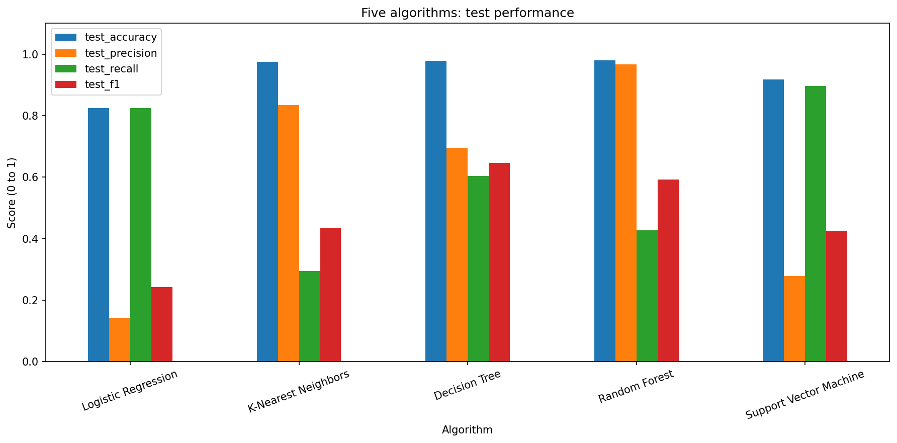
- Grouped bar chart comparing the five algorithms on held-out test data. Failure F1 differs substantially from overall accuracy.
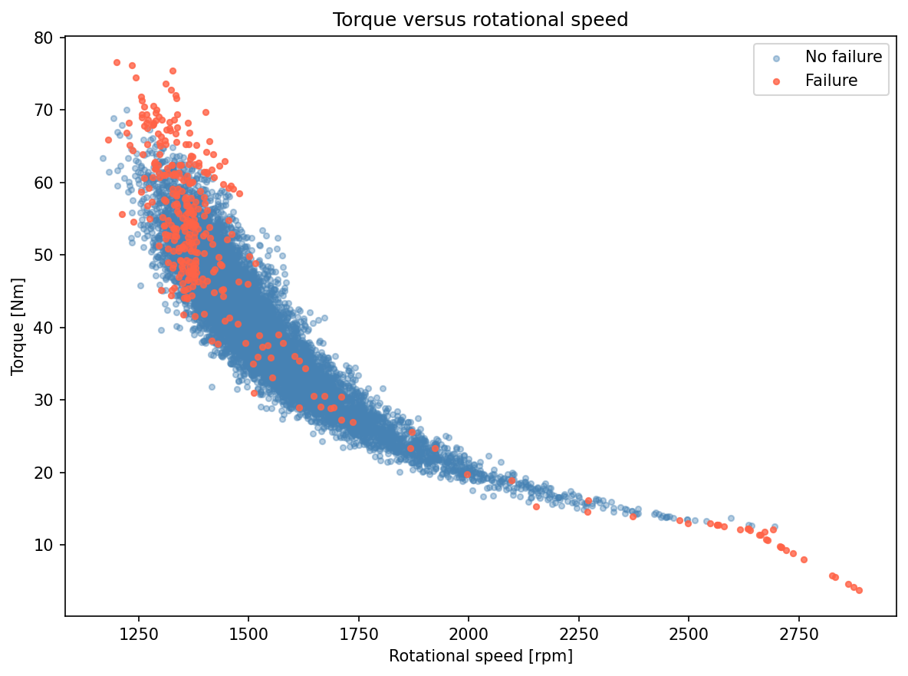
- Scatter plot of speed and torque across all 10,000 records. Red points indicate failure; blue points indicate no failure.

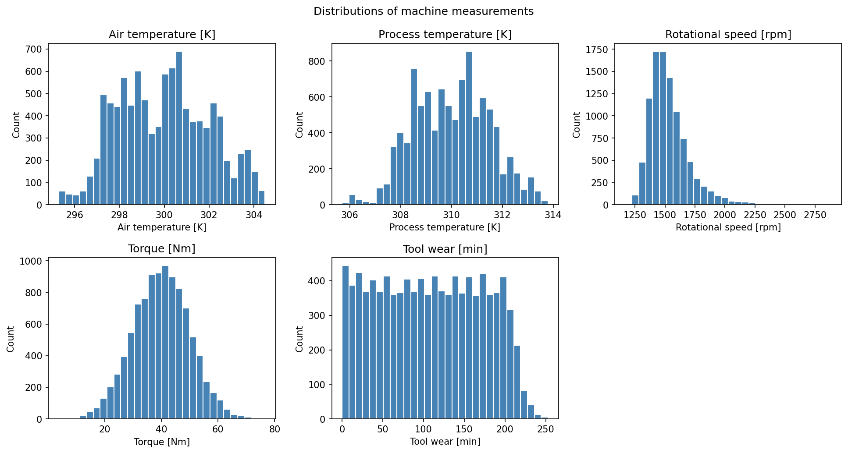
- Histograms of air temperature, process temperature, rotational speed, torque and tool wear. Each panel uses the units indicated on its axis.
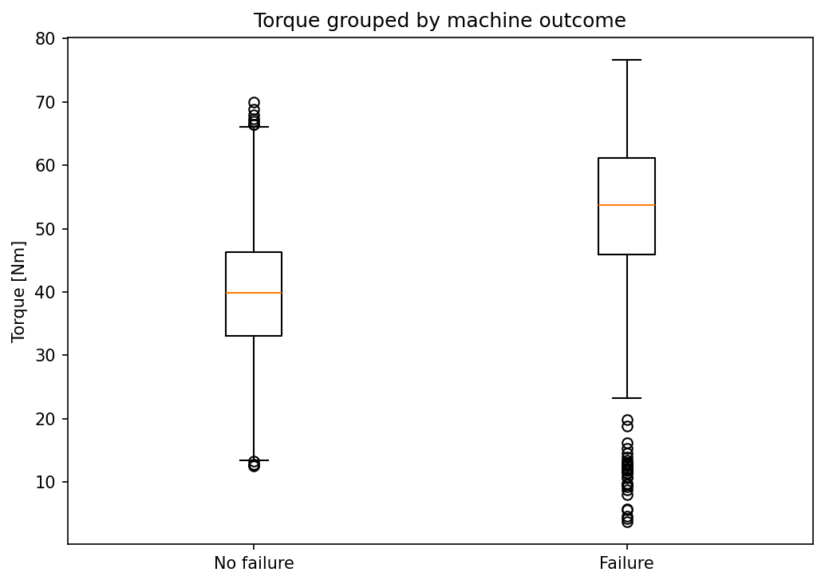
- Box plot of torque by machine outcome. Boxes show quartiles and median; points beyond the whiskers identify extreme observations.

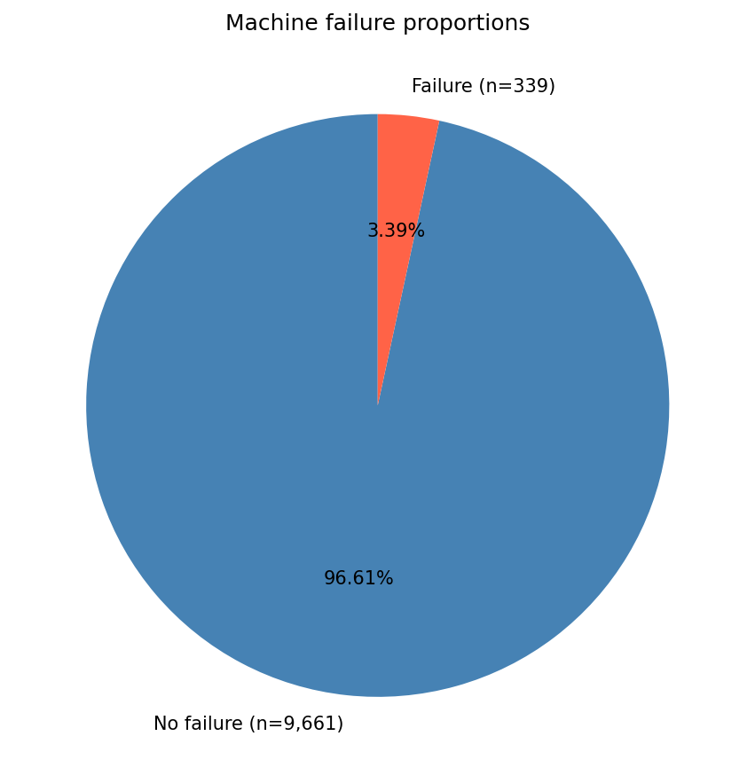
- Pie chart of all outcomes. Only 339 of 10,000 records represent failures, illustrating the class imbalance.
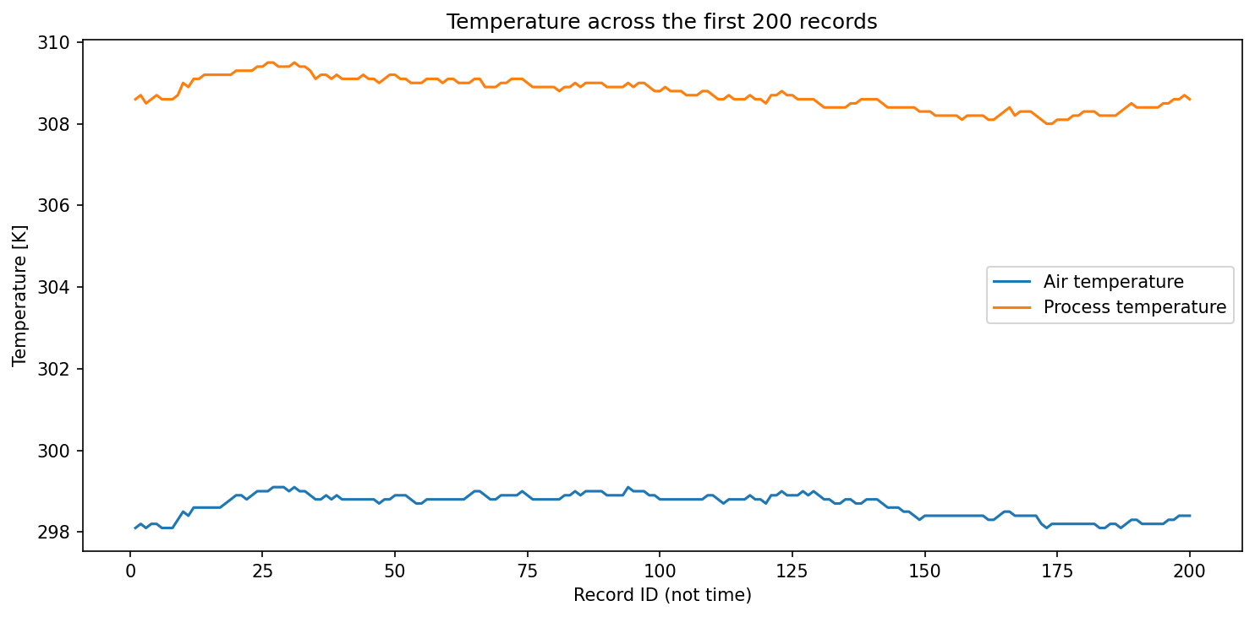
- Line chart of temperatures in the first 200 records. Record ID provides sequence order rather than elapsed time.

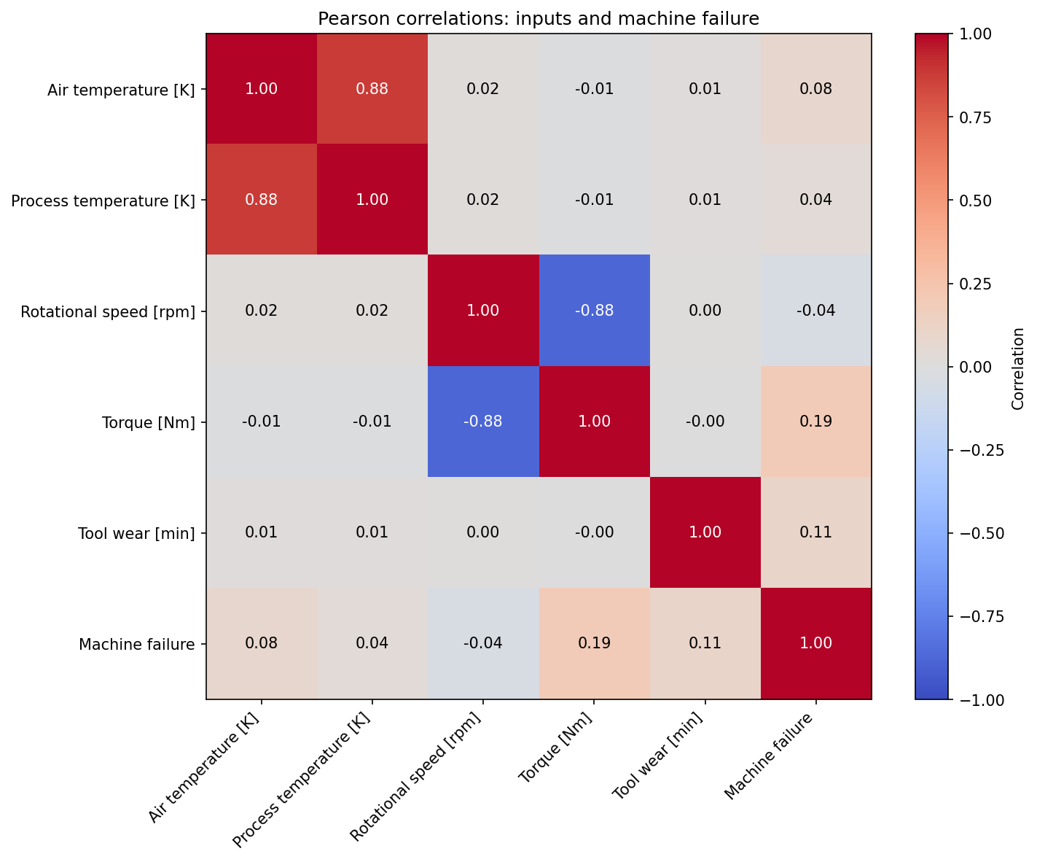
- Pearson correlation heatmap of the numeric measurements and the failure target. Correlations describe linear association rather than causation.
The heatmap complements the scatter plot and distributions. The small linear association between an input and the target should not be interpreted as proof that the input is unimportant to nonlinear models. Identifiers and failure-mode flags are intentionally omitted from the matrix.

Project Links
GitHub repository:

